[mgmensshed@gmail.com](mailto:mgmensshed@gmail.com)

**EXECUTIVE MEMBERS FOR 2020**

**PRESIDENT**: Robert Aldersey 0488311606

**VICE PRESIDENT**: Ben Katris

**TREASURER**: John Plunket

**SECRETARY**: Paul Edgeworth 0887256385

**FACEBOOK**

Shed broadcasts are now available on Facebook

*[Image result for facebook logo](https://www.google.com.au/url?sa=i&rct=j&q=&esrc=s&source=images&cd=&cad=rja&uact=8&ved=2ahUKEwjO9cWTtajeAhUafisKHT6JAHoQjRx6BAgBEAU&url=http://www.seacliffeinn.com/spa-boutique/find-us-on-facebook-logo/&psig=AOvVaw0duNjpvsqixE3Pzu1qEwe2&ust=1540791326821108)* Mens Shed Mount Gambier

Thanks to all Shedders for phoning and emailing others during lockdowns as well as those in self or required isolation.

**We know that the Shed is an important part of the week for many of our members.** We know that there were lots of clusters of Shedders operating outside shed hours, so thanks to those while we were not operating.

**Mt Gambier Mens Shed wishes to advise all Shedders that ROBERT ALDERSEY is the interim President from today until the AGM in 2021.**

**Safety: - Remember Safety begins at home.**

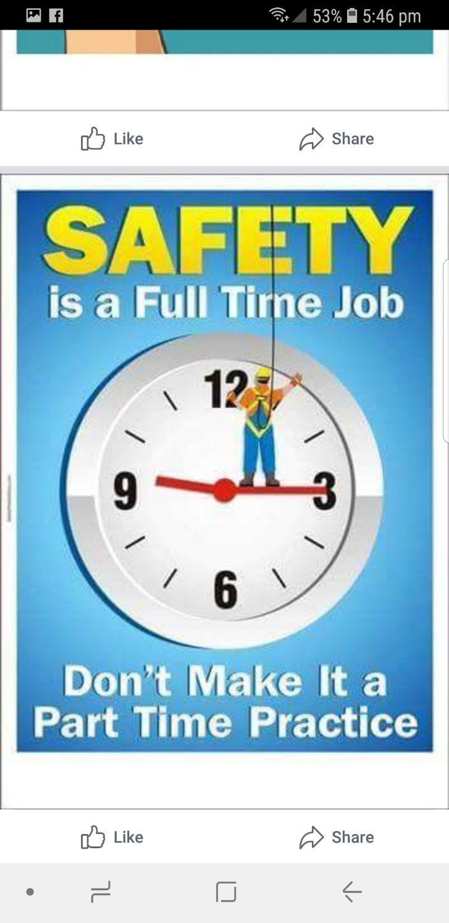

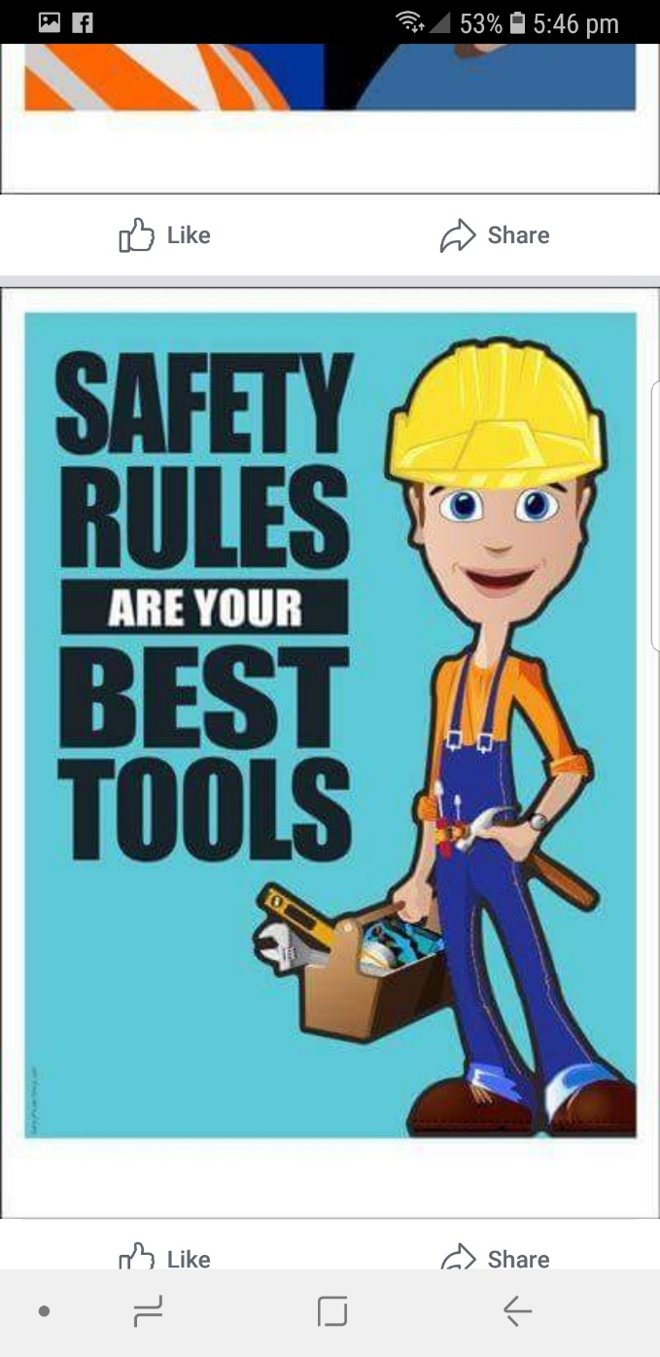

Tony P. 01/10

Allan V. 01/10

John P. 02/10

Laurie T. 10/10

Peter He. 14/10

Bruce A. 24/10

Trevor T. 24/10

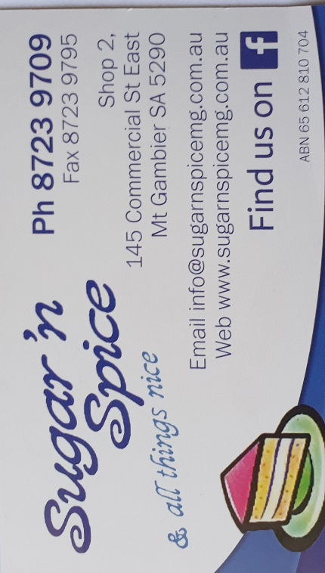

**Remember Sugar ‘n Spice support the Men’s shed with Birthday cakes so support them where you can.**

 

**While mentioning our supporters always remember how much Bunnings help our shed, so support them as well when you need a product they can supply for you.**

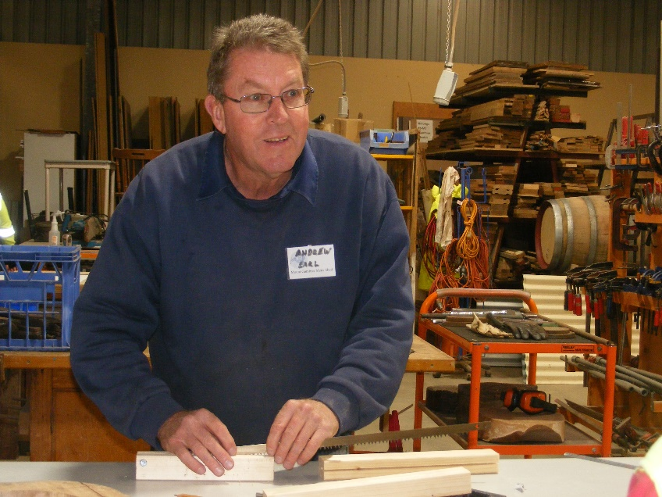

New member Andrew E making handles for a bow saw.

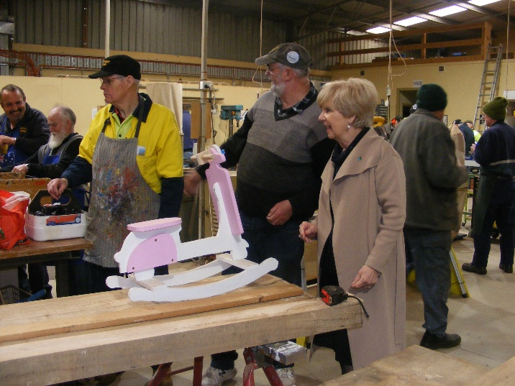

Mayor Lyn Martin came in for a chat and check out the toys for the Mayors Christmas appeal.

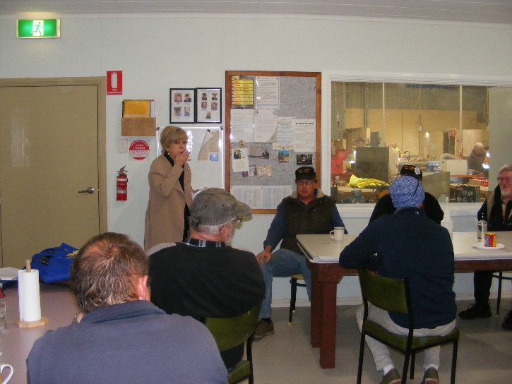

After a brief chat to Peter H and other shedders Mayor Lyn managed to get a photo at the most inappropriate moment. (Eating a scone).

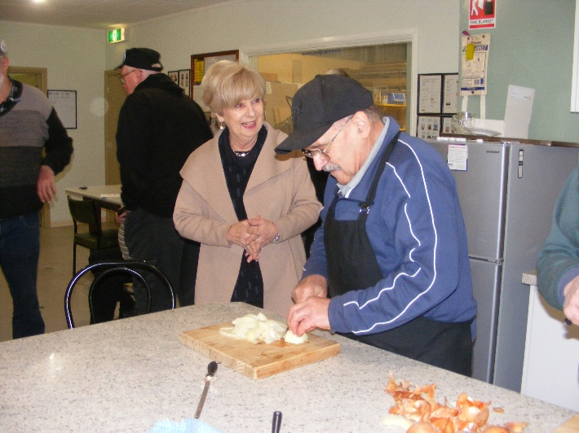

After finding out who Ben the scone maker was! Mayor Lyn then watched Ben cutting up onions for next Bunnings sausage sizzle.

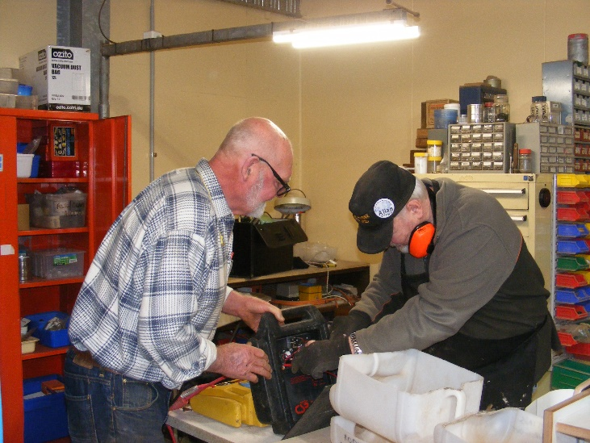

Bruce A. and Allen V. working on some testing equipment.

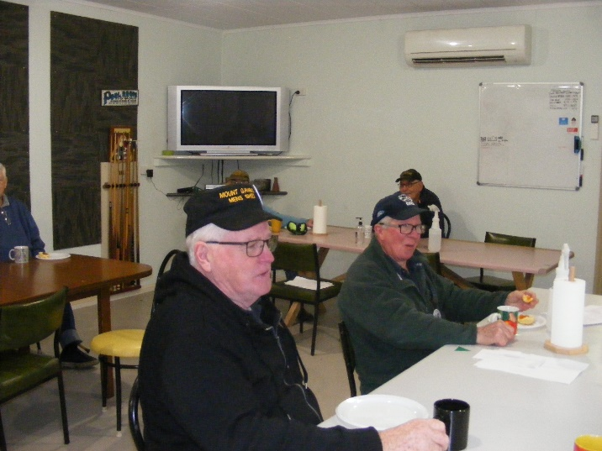

Grant S. and John K. social distancing over a cuppa.

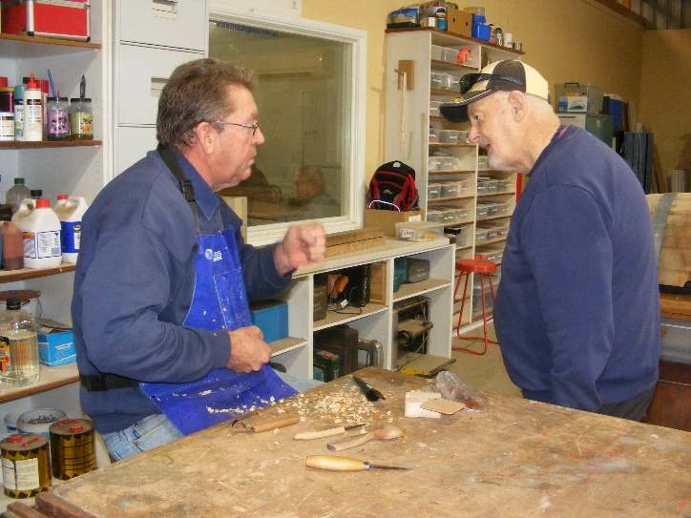

Andrew E explaining to Brian S that he is carving a spoon.

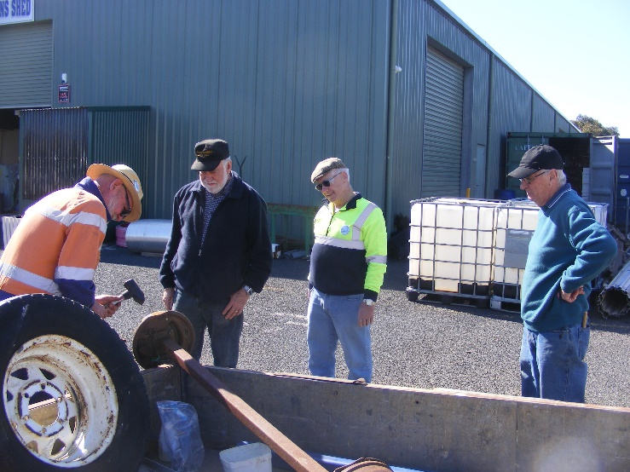

Only one worker here Bruce A. the rest are just curious onlookers.

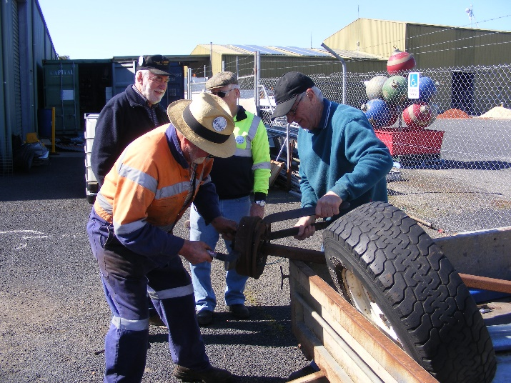

Well at least Geoff H. decided to help out.

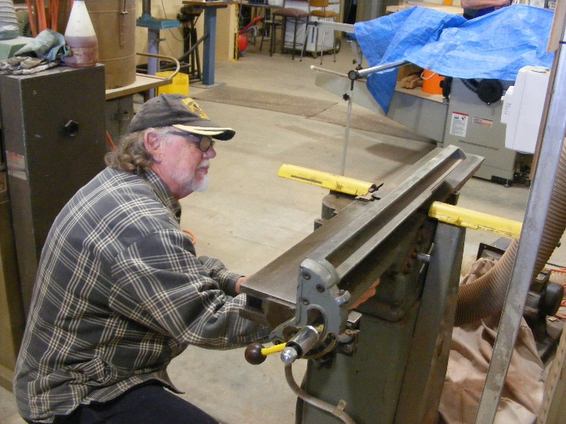

Matt J. about to use the planer.

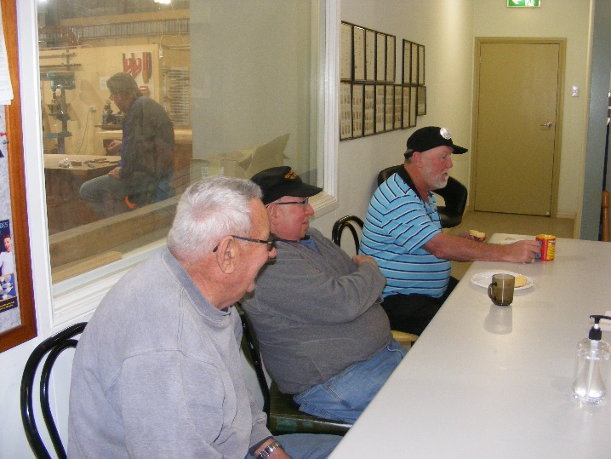

Paul C., Terry G. and Kevin M. enjoying a cuppa.

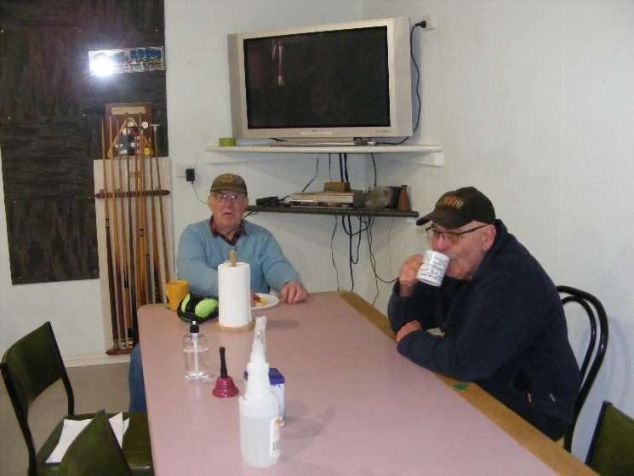

Rod L. and Ansi N. also enjoying a cuppa COVID style.

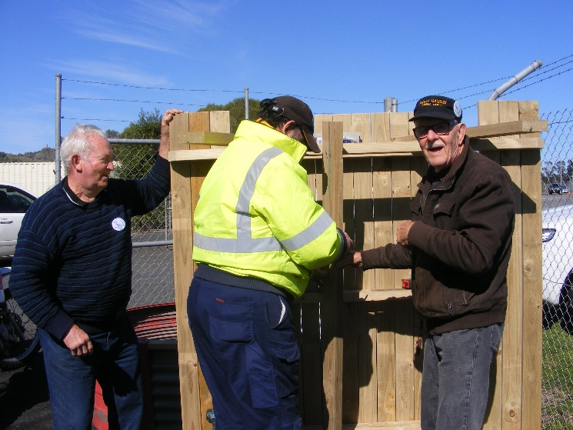

Roger T., David L. and Ray L. putting the finishing touches to another outdoor table.



Thanks for providing the lift of shipping containers on our Mens Shed site

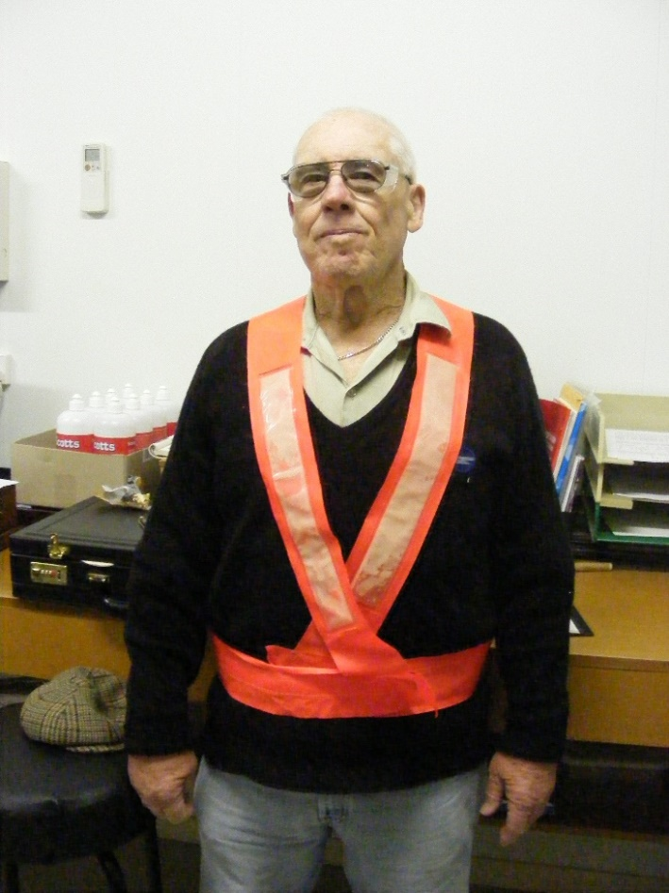

Tim is our COVID Marshall. Please support what he is telling you as it will stop us from closing down.

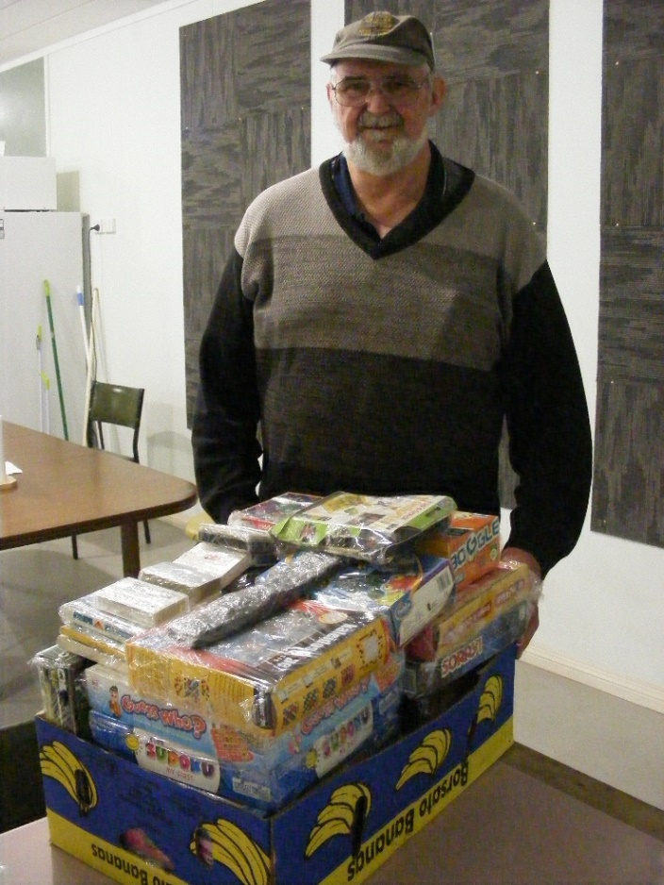

Peter Heness with a box of games donated for the Mayors Christmas Appeal.

**From the VMSA Web site.**

Remember we’re here to **HAVE FUN.**

So don’t worry and be happy.

Use our tools but don’t BE A TOOL.

No words in anger, be nice, tolerant & treat each other with respect.

Make visitors & new members feel welcome.

Be helpful in and outside the shed.

Bring solutions, not problems.

Share your knowledge, skills and experience.

If you are feeling unwell or depressed, tell someone.

Be tested for COVID if in any doubt and stay away until you are cleared

No smoking.

No illicit drugs or alcohol, so if affected stay home.

Be safe, act safely & look out for each other.

No fewer than two people in shed when in workshop.

Wash your cutlery, crockery & clean-up kitchen spills.

Wipe down basins in bathrooms after use.

Report any hazards, accidents, injuries, incidents or near misses.

No tool or machine use without instruction / authorisation.

Closed shoes and safety glasses must be worn in workshops.

If you don’t know how to do something, please ask for help.

Use the Shed’s Order Form for EVERY project

Use a job sheet for EVERY project, so cost can be agreed before starting.

If you use a tool, hardware or accessory, put it back where you found it.

If you make a mess, clean it up.

Label projects / work pieces & put them away for next time.

If something breaks or appears faulty, tell someone.

If we’re running low on something, order it, don’t wait ‘till we run out.

$1 /day for tea/coffee; $1 ea.

If you need reimbursement for something, provide a receipt.1