[mgmensshed@gmail.com](mailto:mgmensshed@gmail.com)

**EXECUTIVE MEMBERS FOR 2021**

**PRESIDENT**: Peter Halleday 0439500699

**VICE PRESIDENT**: Ian Bond

**TREASURER**: John Plunket

**SECRETARY**: Paul Edgeworth 0887256385

**FACEBOOK**

Shed broadcasts are now available on Facebook

*[Image result for facebook logo](https://www.google.com.au/url?sa=i&rct=j&q=&esrc=s&source=images&cd=&cad=rja&uact=8&ved=2ahUKEwjO9cWTtajeAhUafisKHT6JAHoQjRx6BAgBEAU&url=http://www.seacliffeinn.com/spa-boutique/find-us-on-facebook-logo/&psig=AOvVaw0duNjpvsqixE3Pzu1qEwe2&ust=1540791326821108)*

**Safety: - Remember Safety begins at home.**

**BIRTHDAYS**

A Earl 06/07

S Sylvester 11/07

K Reichelt 17/07

B McGregor 17/07

J Telfer 27/07

D Lawson 28/07



**Remember Sugar ‘n Spice support our Men’s Shed with Birthday cakes, so support them where you can.**

 



**Thanks to Sharp Cranes and Steeline for supporting our Mens Shed.**

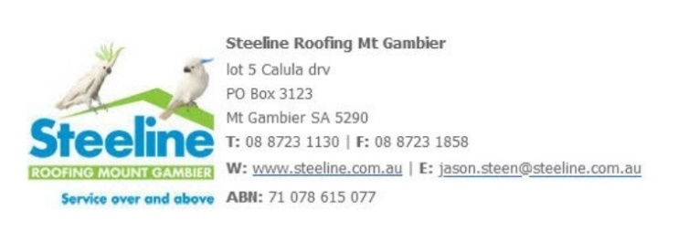



**A big supporter of Mount Gambier Mens Shed.**



**SUPPORT YOUR LOCAL BUSINESSES**

**THAT SUPPORT YOU.**

**DIARY DATES**: 2021

8th July Thursday 10.15 Members Meeting 14th July Wednesday 6.30Tea with partners Golden Chopsticks

30th August – 5th September Men’s Health Week

21st September – 23 September Spanner in the Works? Men's Health Checks, supported by Uncle Tobys’.

**MEMBERS PROFILE:-**

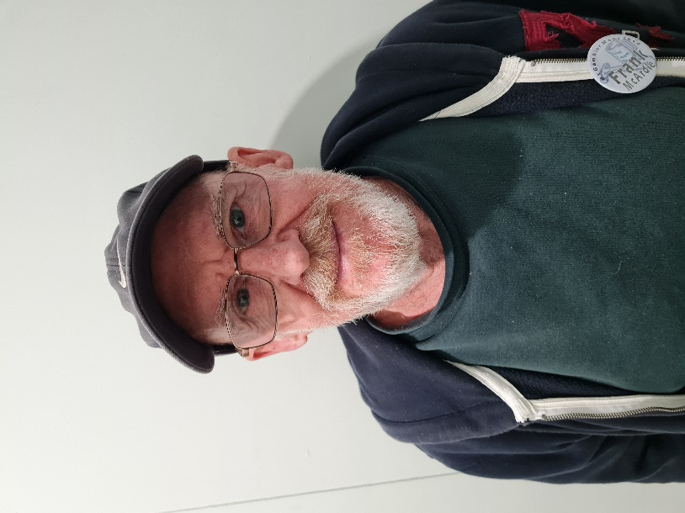

**NAME: -** Frank McArdle

**Where have you worked in your life: -** Mobile refinery at Altona Vic.

Air ride making Fuel tankers.

Car detailing.

**Something about you that others at the shed don’t know: -** Loves to play golf.

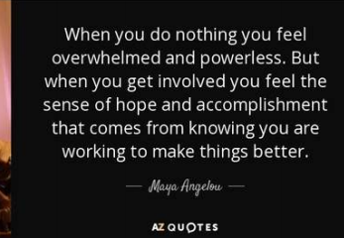**What do you wish to achieve at the shed: -** Make new friends.









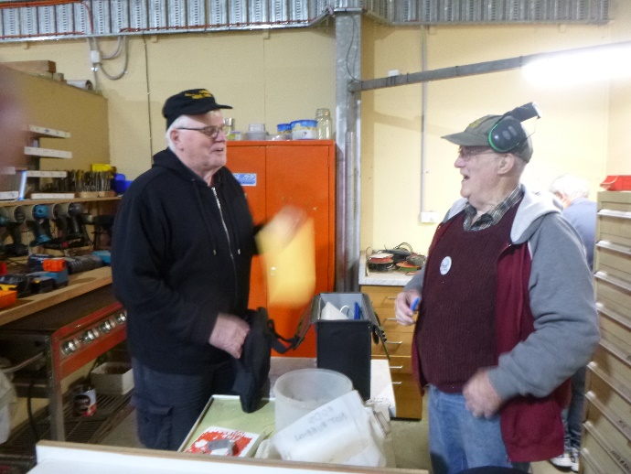

Grant telling Rod to hand it all over and fill the bag. But Rod laughing as he only has nut and bolts, that he has sorted to hand over.

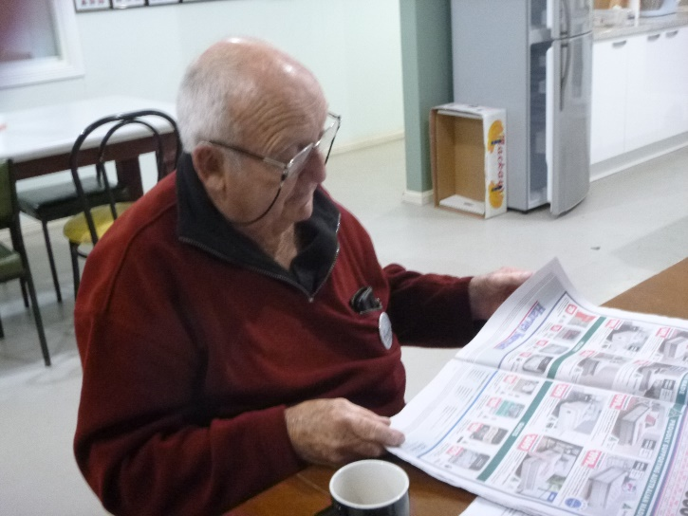

Graham found a quiet time to read the paper until other found him and asked what you doing. Then remarks followed about opening their eyes.

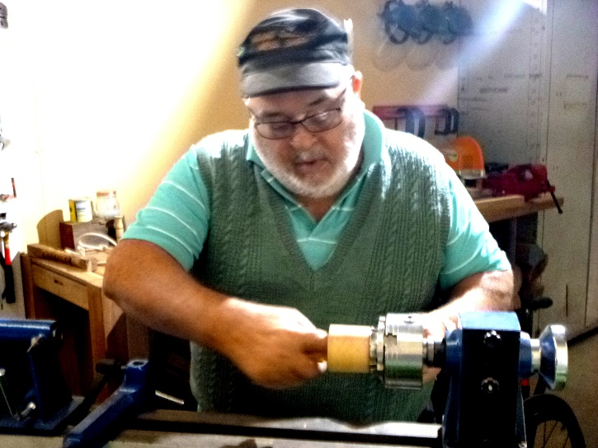

Laurie is a picture of concentration (as you should be on a lathe) sanding the inside of a small bowl.

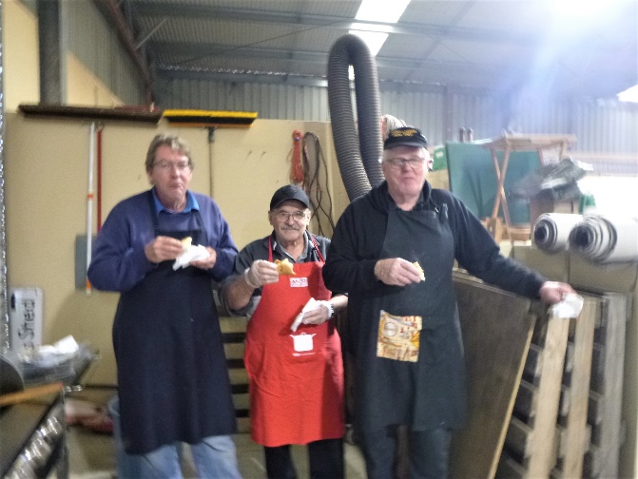

Andrew, Ben and Grant checking out the sausage sizzle before anyone else can try as they were the cooks.

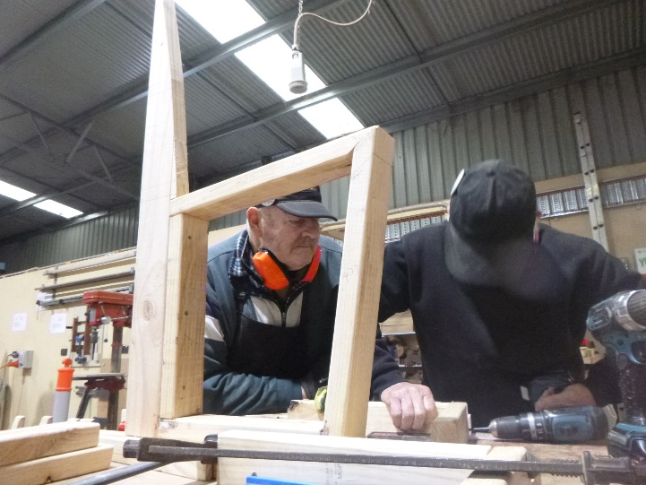

Allan supervising Jeff making a chair.

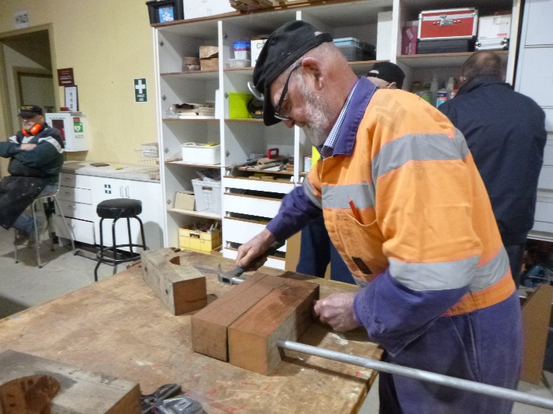

Bruce making bearing blocks.

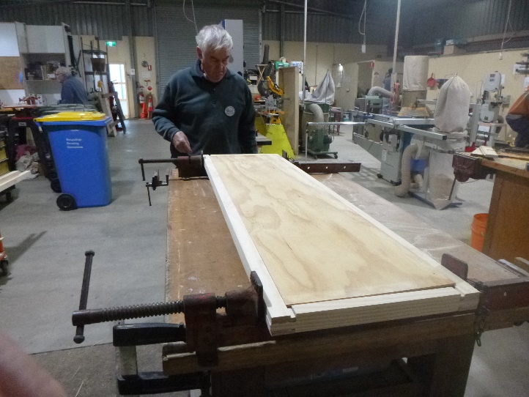

Dick in the process of making his cupboard. Above and Below.

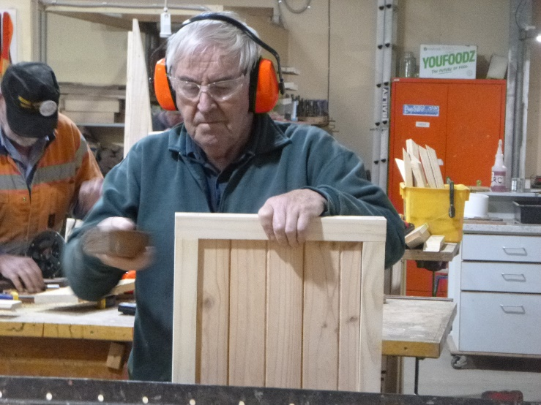

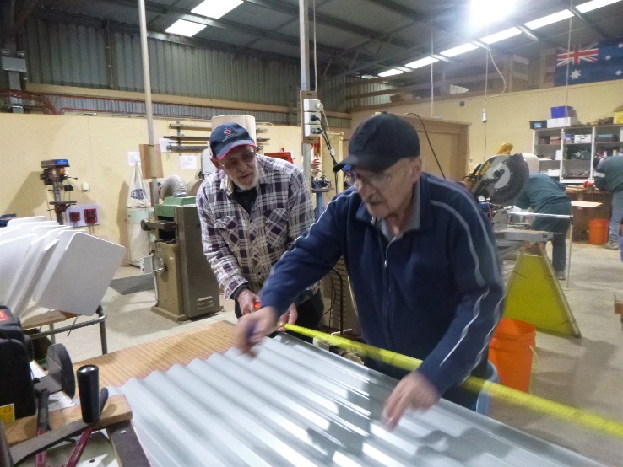

Ben, not just our scone maker, he is now lending his hand to making the raised garden beds.

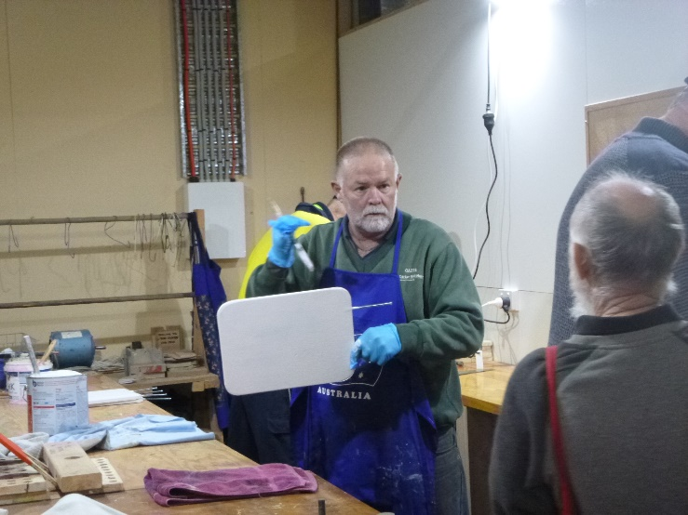

Gary explaining to Glen, this is not a bat it is a sign for the local Golf course.

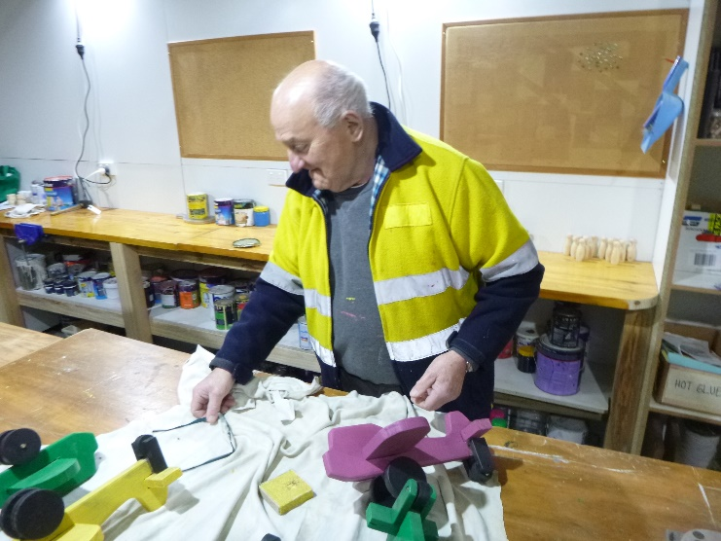

George flat out making toy planes for the Mayors’ Christmas Appeal.

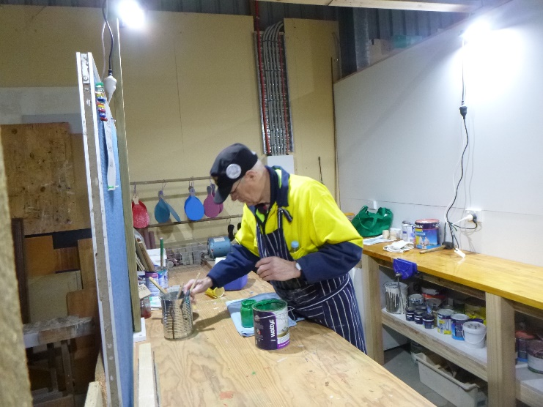

The toy boy himself, Ian, ready to do some more painting.

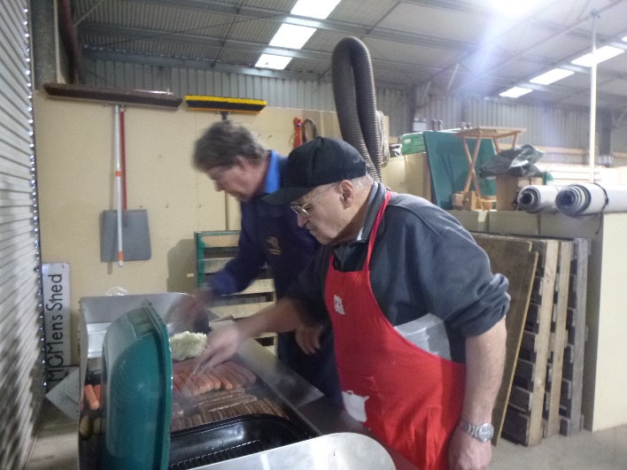

And he pops up again, the scone man, the raised garden bed man, now sausage sizzle cook. Are there no limits to Ben’s skills. Andrew is in the background.

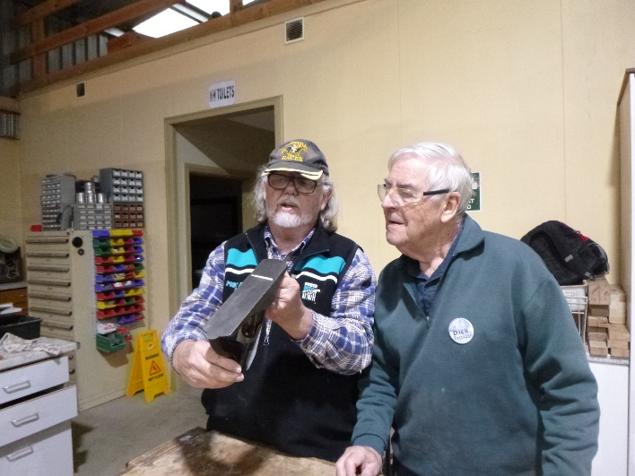

Matt giving Dick a demo on how to set up a hand plane.

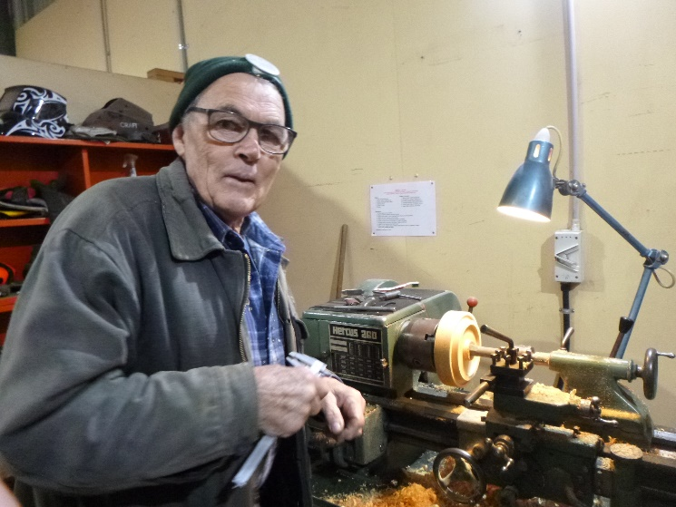

Trevor showing his skills on the metal lathe turning up a piece of wood.