[mgmensshed@gmail.com](mailto:mgmensshed@gmail.com)

**EXECUTIVE MEMBERS FOR 2021**

**PRESIDENT**: Peter Halleday 0439500699

**VICE PRESIDENT**: Ian Bond

**TREASURER**: John Plunket

**SECRETARY**: Paul Edgeworth 0887256385

**PHONE**: 0478614027

**FACEBOOK** Mens Shed Mount Gambier

Shed broadcasts are now available on Facebook

**PHONE**: 0478614027

**FACEBOOK** Mens Shed Mount Gambier

*[Image result for facebook logo](https://www.google.com.au/url?sa=i&rct=j&q=&esrc=s&source=images&cd=&cad=rja&uact=8&ved=2ahUKEwjO9cWTtajeAhUafisKHT6JAHoQjRx6BAgBEAU&url=http://www.seacliffeinn.com/spa-boutique/find-us-on-facebook-logo/&psig=AOvVaw0duNjpvsqixE3Pzu1qEwe2&ust=1540791326821108)*

**Safety: - Remember Safety begins at home.**

**BIRTHDAYS**

Peter K 01/12

Chris B 06/12

Graham C 22/12

Paul C 26/12

Terry G 27/12

Trevor P 28/12

[www.thesoutheastjunction.org.au](http://www.thesoutheastjunction.org.au)

Image result for facebook icon thesejunction

8th December Wednesday 6.30 Tea with partners - Jens

9th December Thursday 10.15 Members Meeting

12th December Sunday 8.30/12.00 Bunnings BBQ

16th December Thursday 11.30 Shed BBQ lunch with partners (1 vaccination certificate required)

Shed closed TBA

THE COMMON TYPES OF WOODWORM AND WOOD BORING INSECTS PART 2/12

So who are the ‘usual suspects’ when it comes to the types of wood boring insects snacking on the timber of your property?

We’ve identified 11 of the most common in this extensive list, and have provided a commentary on each one in order to help you understand a little better what you’re dealing with.

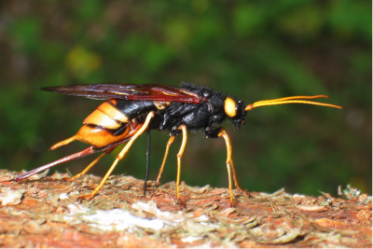#1. Wood Wasp Latin name: Urocerus Gigas

**Appearance**: Although obviously the only wasp on the list – and not therefore a woodworm – this large yellow and black insect just had to be featured due to the damage it can potentially cause to wood.

**Preferred timber**: The Wood Wasp goes exclusively for softwoods and rotting trees. Being adept in the air, these insects can fly long distances in search of new timber sources, which can include fresh logs or new timber stored in readiness for construction. However, once the wood has been treated, they stay away.

**Type of damage**: They create single-track tunnels deep into the wood, which can cause significant damage and kill host trees.

**Telltale signs**: With large flight holes of some 7 mm in width, Wood Wasp tunnels are packed with dense frass fibres which makes them hard to extract once discovered.

**Next Month - Common Furniture Beetle**

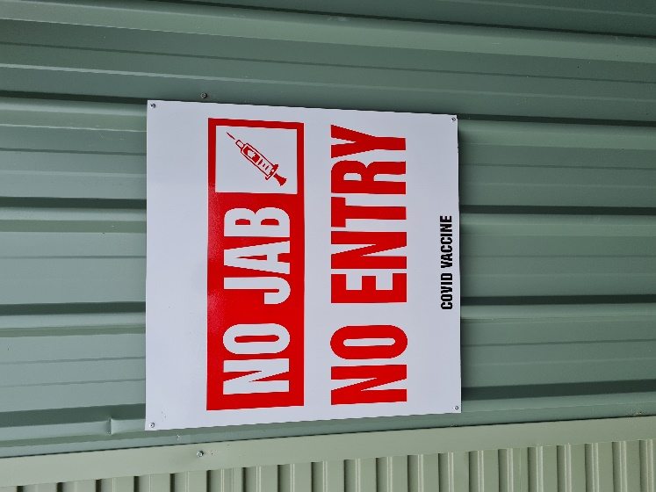

Regrettably the shed has put this sign up due to the care of some of our members who are in the vulnerable age group.

**Joke**

An 84-year-old man is having a drink in Harpoon Harry's. Suddenly a gorgeous girl enters and sits down a few seats away. The girl is so attractive that he just can't take his eyes off her. After a short while, the girl notices him staring, and approaches him. Before the man has time to apologize, the girl looks him deep in the eyes and says to him in a sultry tone: "I'll do anything you'd like. Anything you can imagine in your wildest dreams, it doesn't matter how extreme or unusual it is, I'm game. I want $100, and there's another condition."' Completely stunned by the sudden turn of events, the man asks her what her condition is. "You have to tell me what you want me to do in just three words." The man takes a moment to consider the offer from the beautiful woman. He whips out his wallet and puts $100 dollars into her hand. He then looks her square in the eyes, and says slowly and clearly: "Paint my house." Our needs change as we get older, and we tend to look for bargains

**A follow up to the Bailey chair Dick produced last month for Asha.**

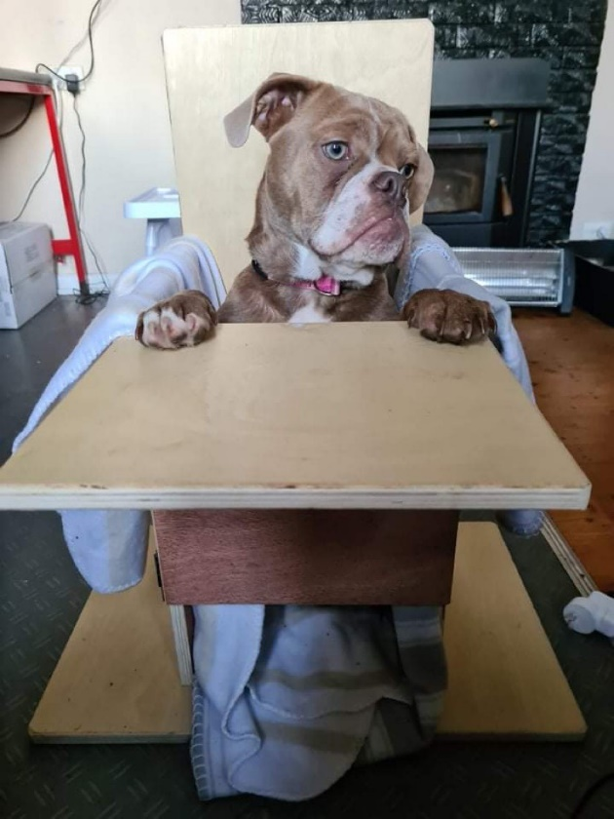

She loves it, gets very excited at food time.

I don’t even get time to open the door for her, she jumps up on the bench part and drops her butt into the seat from there and sits, barking at me until I give her her meatballs.

Seeing as she sits up better in it, she’s only regurgitated once since using it and that was only coz she decided to have a snack on her own poop while I was at work earlier that day because she’s a pain.

Other than that she’s kept all her food down since we switched to the chair, it’s definitely helped so we are so grateful they were able to make it for us.

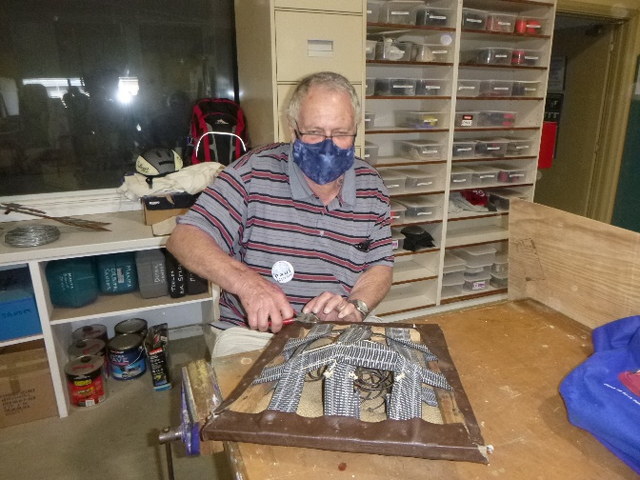

After all these years of doing the Newsletter finally got a picture of Paul working. Well done Paul.

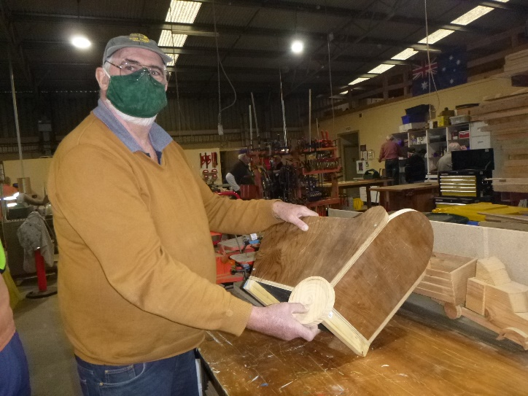

Peter assembling a new toy.

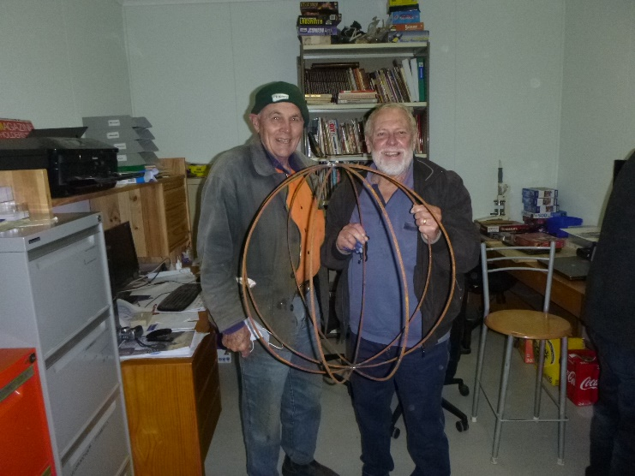

Asked and you shall receive. Paul holding the Topiary Work for Boandik made by Trevor.

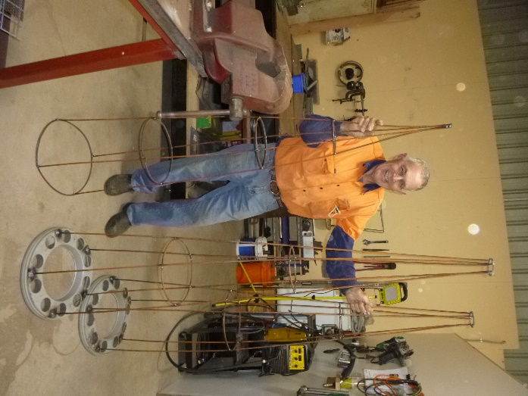

And more Topiary made by Trevor.

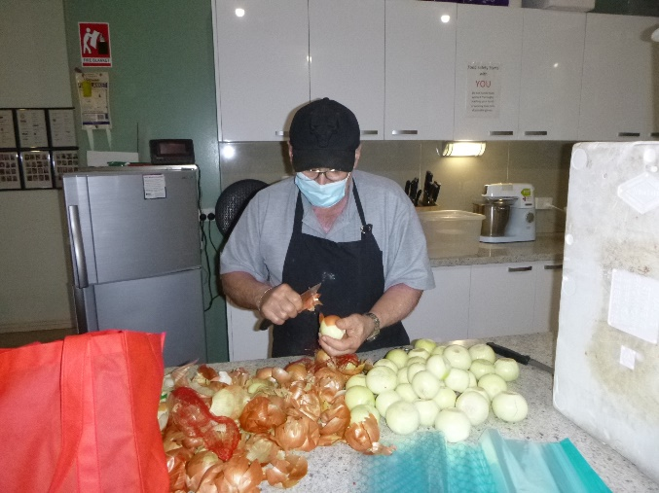

Even though we can’t see who it is only 1 person can peel onions like this without crying. Our mate Ben getting ready for another Bunnings Sausage sizzle.

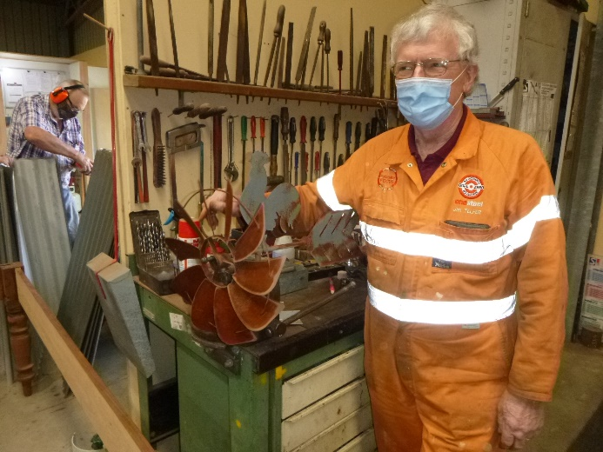

Jim about to repair and put in new bearings for a weather cock and windmill for Peter Ha.

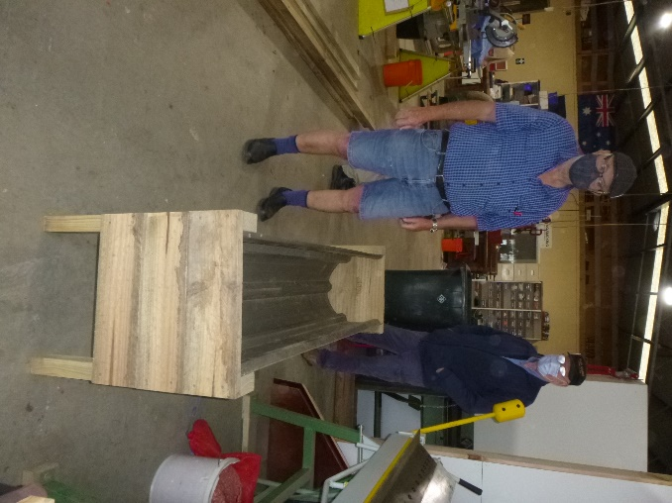

New garden bed design made by Jeff.

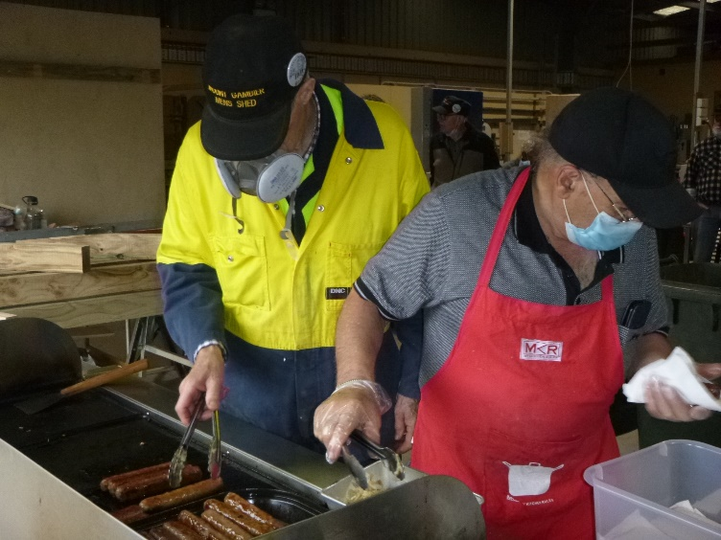

Ian and Ben cooking Golden sausages for the Men’s Shed sausage lunch.



Sauce anyone? Asks Matt.

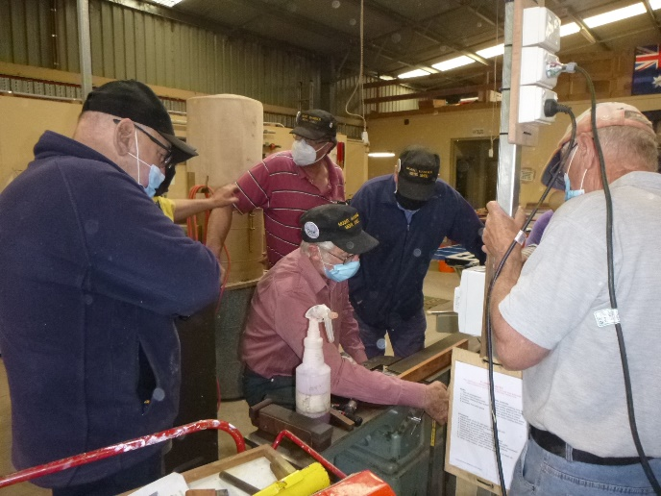

Don teaching a group how the planner works.

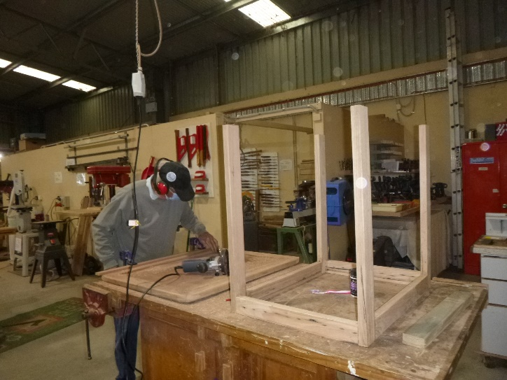

A dab hand at using recycled timber is Geoff making a table.

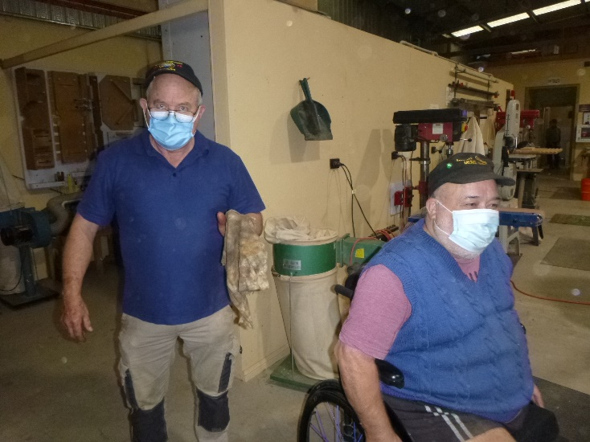

Watch out I am now doing skid dating Laurie says to Lindon after getting a grease up on his wheelchair.



Laurie about to open the new pen press and Equipment box.

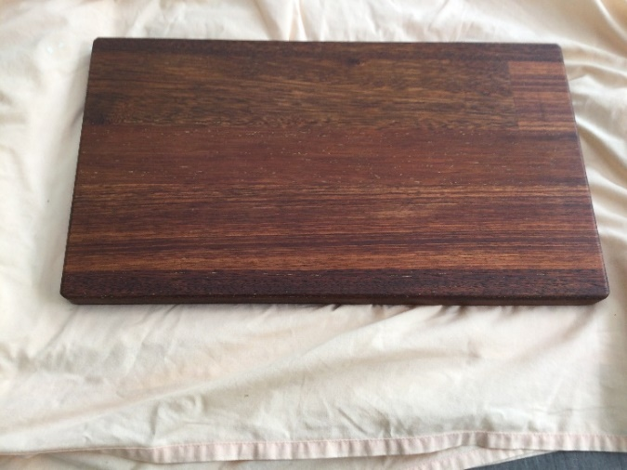

The Cutting board Dick has done for his wife 2 others Gary and Peter have also made one.

**President of the Men’s shed Peter Halleday.**

Another Year has passed with COVID playing a big part in the running of the shed.

Thanks to all the Committee, Members and the Community for all their help.

Good to see we are somewhere back to normal level of activity again and I will wish you all a Very Merry Christmas and a Happy New Year and will catch you all in the New Year.



Merry Christmas

&

Happy New Year





 



**Thanks to Sharp Cranes and Steeline for supporting our Mens Shed.**





**Big supporters of Mount Gambier Mens Shed.**

**SUPPORT YOUR LOCAL BUSINESSES**

**THAT SUPPORT YOU.**