[mgmensshed@gmail.com](mailto:mgmensshed@gmail.com)

**EXECUTIVE MEMBERS FOR 2021**

**PRESIDENT**: Peter Halleday 0439500699

**VICE PRESIDENT**: Ian Bond

**TREASURER**: John Plunket

**SECRETARY**: Paul Edgeworth 0887256385

**PHONE**: 0478614027

**FACEBOOK** Mens Shed Mount Gambier

Shed broadcasts are now available on Facebook

*[Image result for facebook logo](https://www.google.com.au/url?sa=i&rct=j&q=&esrc=s&source=images&cd=&cad=rja&uact=8&ved=2ahUKEwjO9cWTtajeAhUafisKHT6JAHoQjRx6BAgBEAU&url=http://www.seacliffeinn.com/spa-boutique/find-us-on-facebook-logo/&psig=AOvVaw0duNjpvsqixE3Pzu1qEwe2&ust=1540791326821108)*

**Safety: - Remember Safety begins at home.**

**BIRTHDAYS**

Paul M. 10/11

Geoff H. 19/11

Dale A. 24/11

Peter K. 01/12



**Remember Sugar ‘n Spice support our Men’s Shed with Birthday cakes, so support them where you can.**



 



**Thanks to Sharp Cranes and Steeline for supporting our Mens Shed.**





**Big supporters of Mount Gambier Mens Shed.**

**SUPPORT YOUR LOCAL BUSINESSES**

**THAT SUPPORT YOU.**

**For anyone wishing for more Mental Health help check out this site and see what they have to offer.**

**Phone: 04-77886450**

[www.thesoutheastjunction.org.au](http://www.thesoutheastjunction.org.au)

Image result for facebook icon thesejunction



It is with much sadness that we bid farewell to our mate Roger. Wish his family all the best from the shed members.

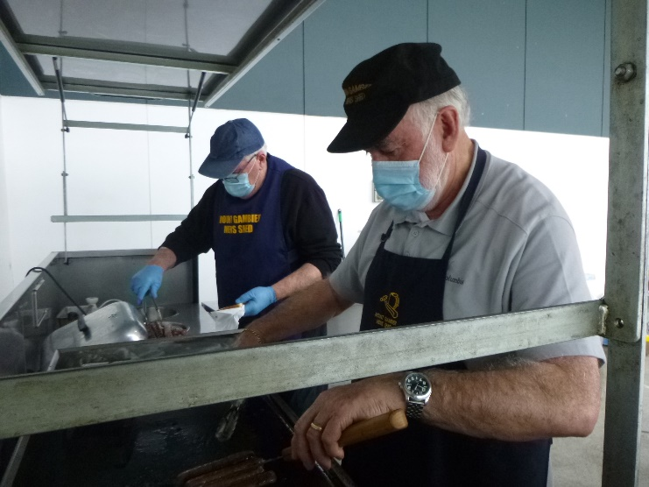

Grant and Rob Cheif cooks but definitely not bottle washers.

Prostrate help and support.

The word is ‘support’ And the prostrate support group meet every third Wednesday at 2.00pm in the RSL Meeting room, have coffee, cake, a chat and a good laugh.

We would warmly welcome any member of the Mens Shed who might not be aware that such a group as ours exists, and would like to catch up. Even if you do not have this atrocious disease you are more than welcome to come along.

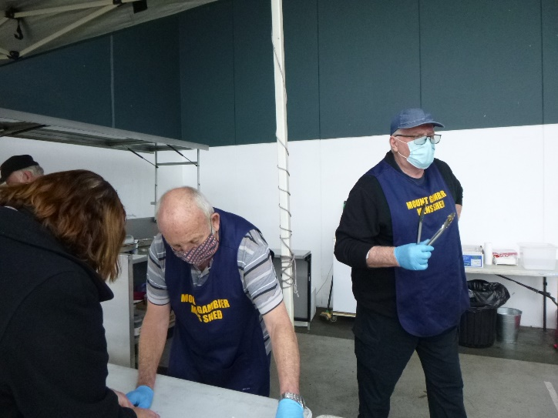

Graham and Grant at the Bunnings sausage sizzle.



Ian and Alan getting ready to do their bit cooking.

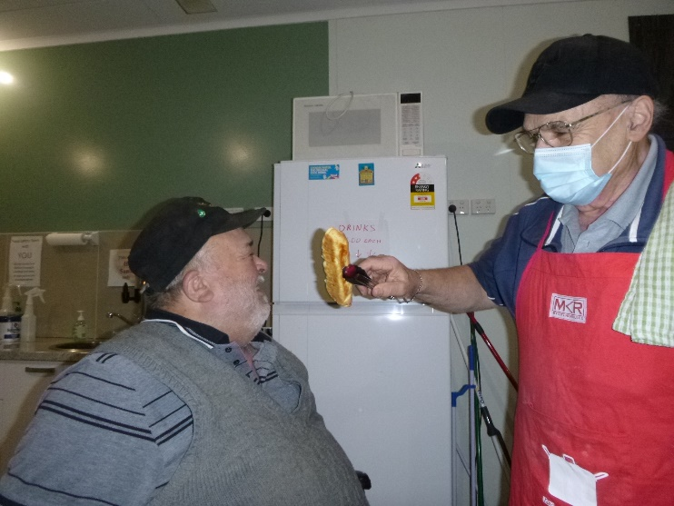

Our master scone maker Ben decided to make a special one for Laurie.

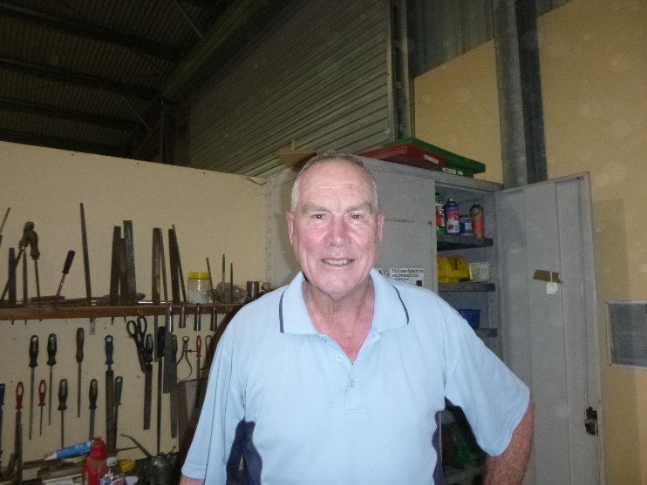New member Alan, big welcome to the shed.

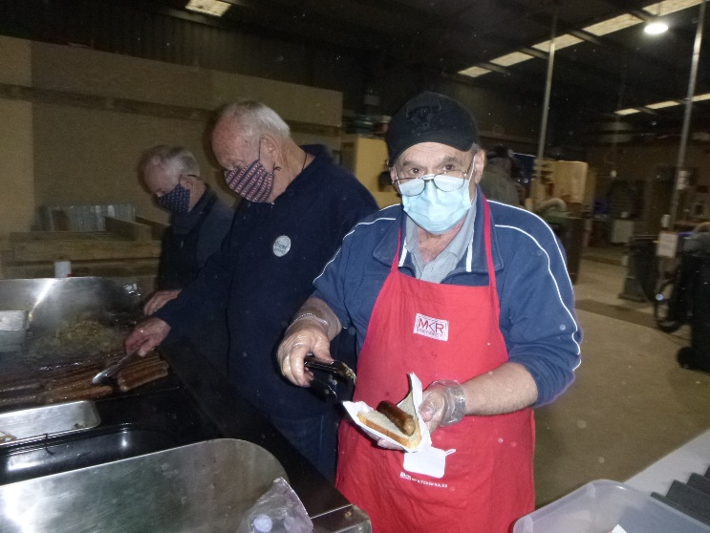

Glen, Graham and Ben cooking at the monthly shed BBQ.

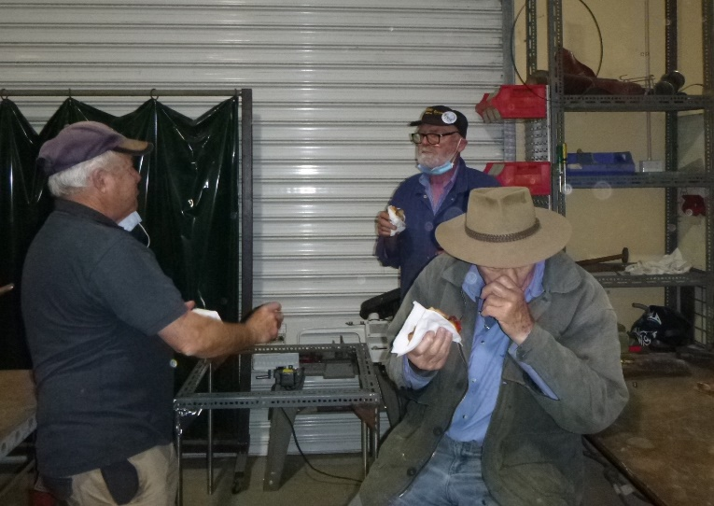

Lyndon, Bruce and Trevor enjoying the monthly BBQ at the shed.

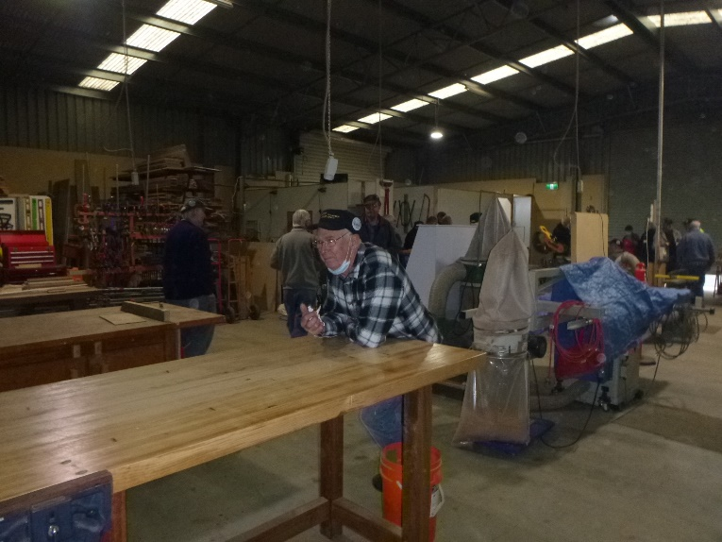

Andrew contemplating. Do I want to do anything today?

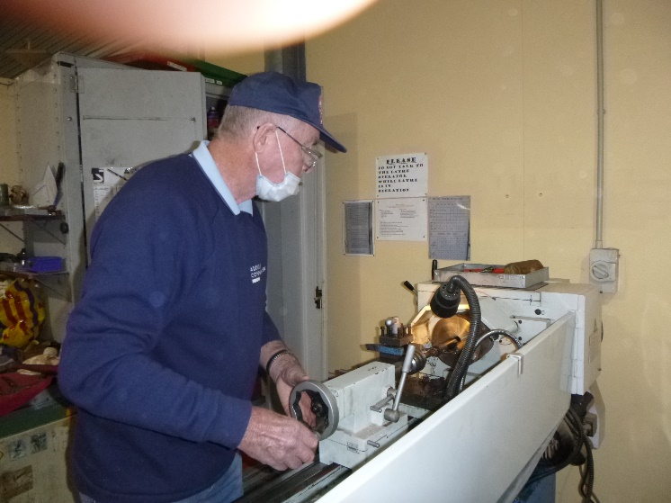

Alan turning up bearings for a washing trolley.

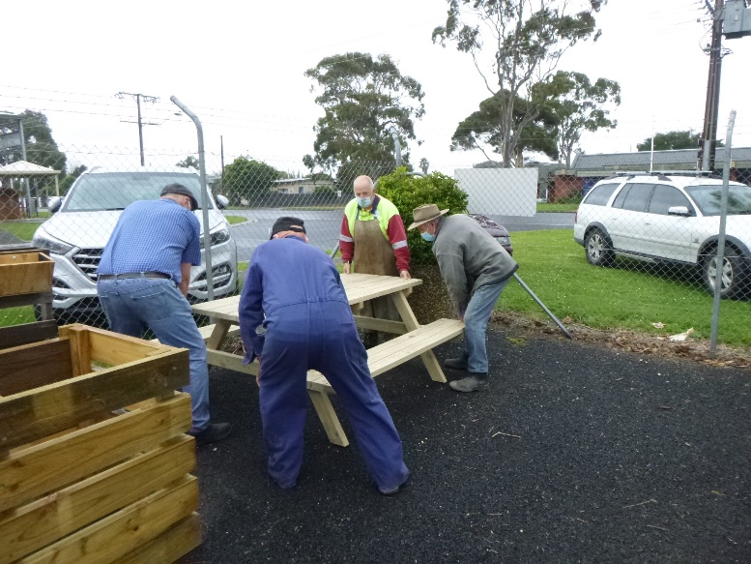

Another Park bench ready to go.

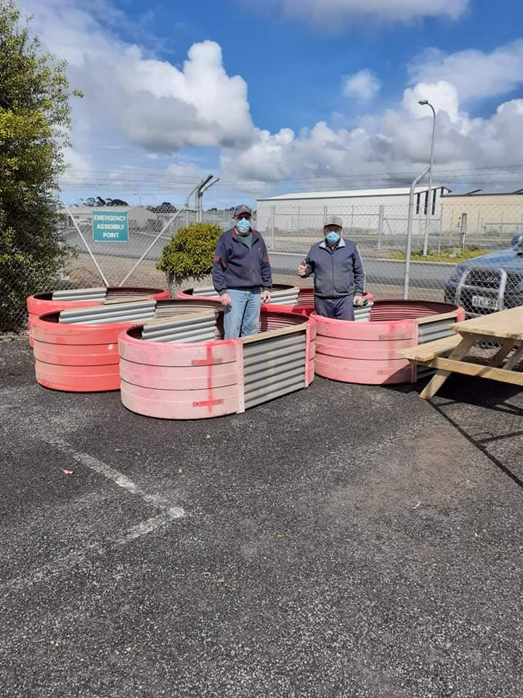

2 Amigo’s busy making more garden beds. Well done Ben and Frank.

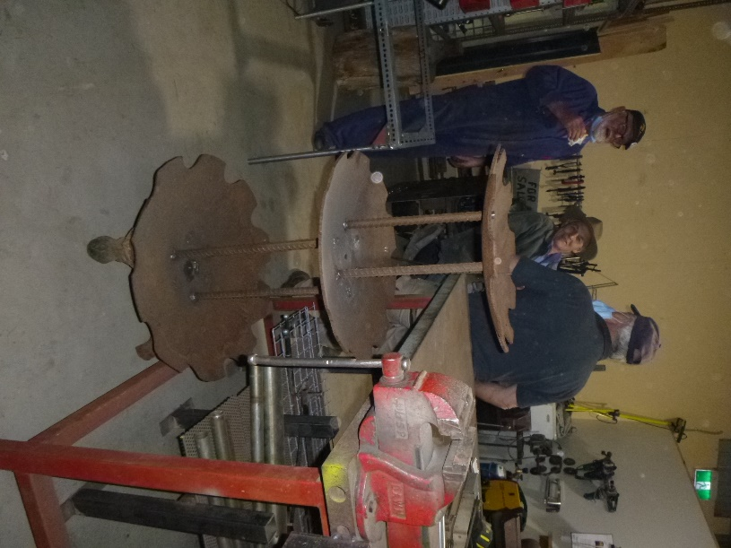

This is the water fountain being built by Trevor using old plough discs and the feet are from a claw bath.





Those in the know will know who this is referring to and he will see the Joke. Think Steptoe.

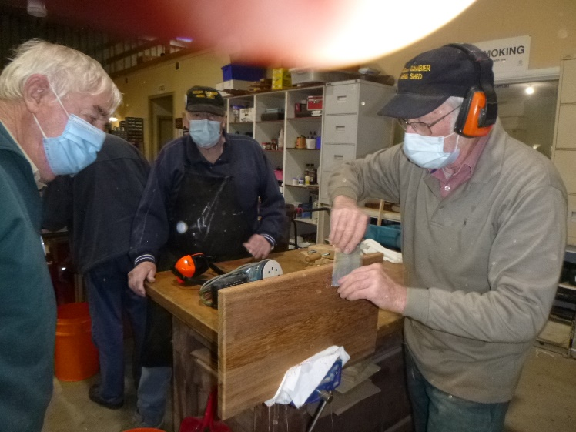

Don showing Dick how a scraper is used.

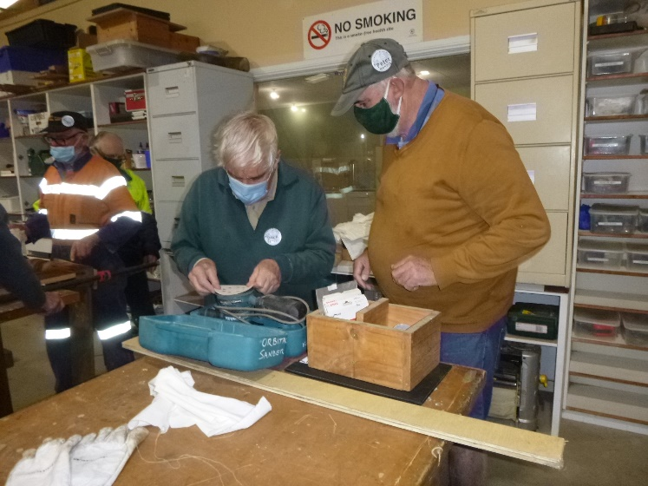

Peter showing Dick the right paper to use on his cutting board.

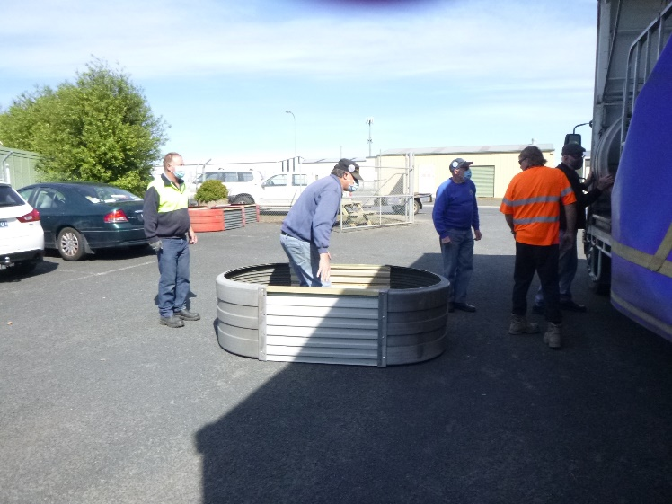

Garden beds are so popular that some people bring in trucks to carry off the investments.

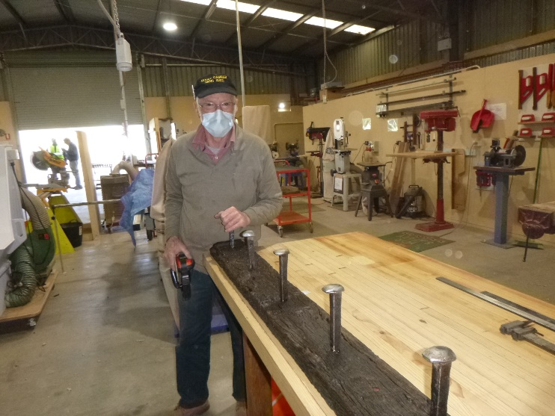

Don with his rustic coat hanger.

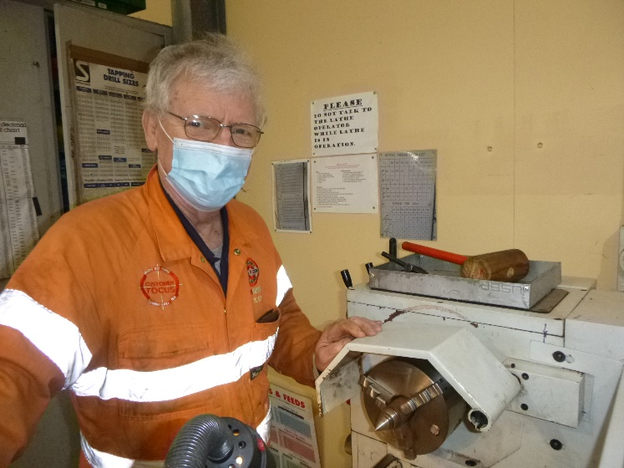

Jim turning up plumb bobs.

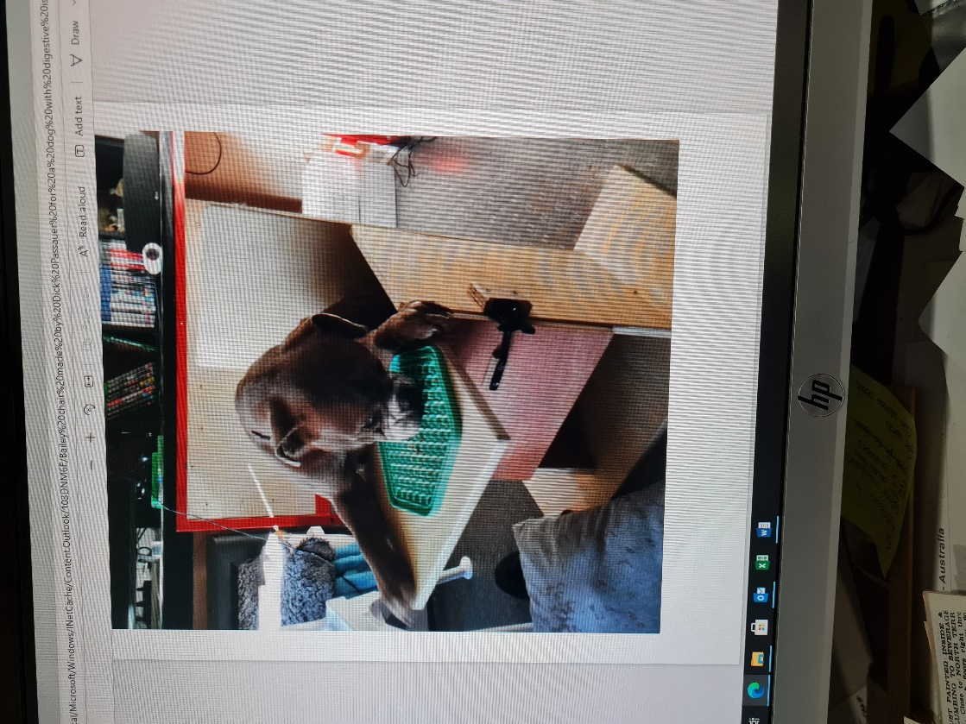

An interesting project was the Bailey Chair constructed for a Bulldog / Boxer cross dog named Asher. Asher’s problem is that she has constriction or folding of her oesophagus causing reflux during and after eating. This means that she has to be fed in an upright position. Therefore, the Bailey Chair, named after an American dog that was the first to have this type of chair made for it.  
Shed members discussed it, watched U-tube videos, etc. etc. to come up with a chair that was strong, large enough for Asher for some time, possibly piddle-proof, etc. And above is what they came up with. As you can see, Asher seemed to take to it very well and, hopefully, all the requirements have been met. So, another satisfied Mount Gambier Men’s Shed customer.

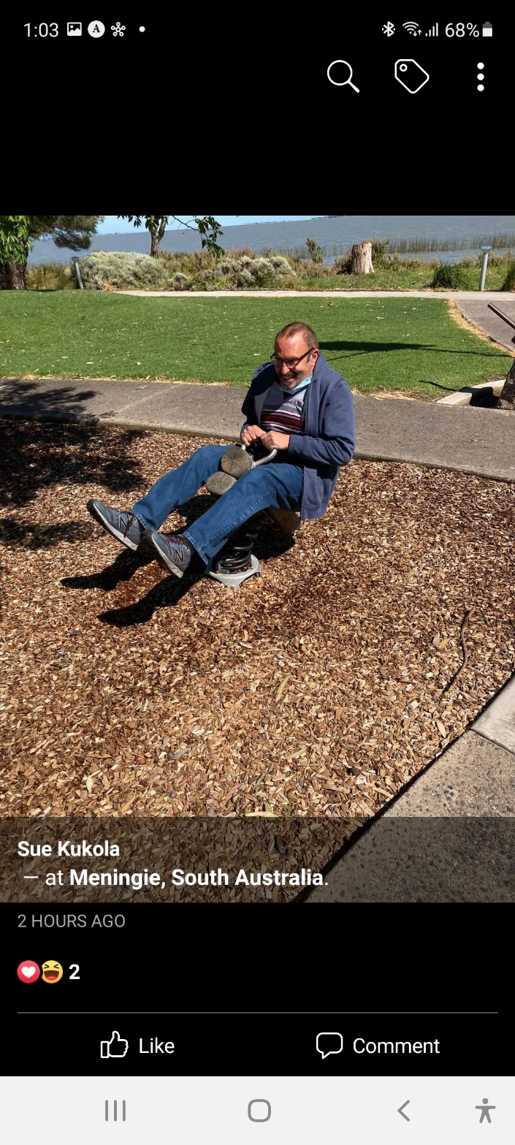

Some people you can never take the kid out of, as is the case with Peter.



This month and for the next 12 months thanks to Jeff we will be starting a new segment in out newsletter relating to wood worm.

# **WOODWORM IDENTIFICATION: 11 TYPES OF WOOD BORING INSECT THAT COULD BE EATING YOU OUT OF HOUSE & HOME – Part 1 of 12**

We’ve all seen those tiny woodworm holes in the timber beams of old houses, or bored into antique furniture – and we’ve no doubt thought nothing more of it…

…Until woodworm start damaging your own home or business property.

The most worrying aspect of a wood boring insect infestation is that these veracious beasts can be active in the timber beams and furniture of your house for years until you really notice them. This means they can be causing untold damage to the structure of your home before you have a chance to do something about it.

And even then, if you try and take the DIY approach to [woodworm treatment](https://www.londonhomecounties.co.uk/woodworm-treatment), you could end up merely prolonging the misery - as sprays bought from your local hardware store just aren’t up to the job.

That’s why if you’ve identified a problem with wood boring insects and aren’t sure about what to do, it’s always best to seek professional help. View the expense as an investment in your property, because leaving the problem alone and hoping it will go away is a recipe for disaster – and could end up costing you so much more in future.

## 

## **HOW TO IDENTIFY A WOODWORM INFESTATION**

Given what we’ve said above, the presence of tiny holes in the timber of your home or business premises – does not necessarily mean the woodworm are active – and by extension – causing any damage. However, it’s fair to assume that in most cases, timber holes equal trouble.

To assess if you’ve got a live infestation or not, you need to look out for the following telltale signs:

- New flight holes created by insects eating their way out  
  
- New holes in any under-carpet paper floor backing  
  
- Small wood dust build up outside bore holes – this is actually woodworm droppings, known as frass  
  
- Presence of damp in the room or in the timber itself (woodworm thrive in damp conditions)

**THE WOODWORM LIFECYCLE**

The various wood boring beetles have different lifespans and behave in various ways once inside the timber of your home or business, but in general they always follow the same lifecycle.

The four stages can be described as follows:

1. The adult woodworm lays an egg in a flight hole on the surface of the timber  
  
2. When the egg hatches out, the woodworm larvae get to work boring into the wood straight away  
  
3. To get the sugar starch it needs to grow; the larvae eat the timber – sometimes for years at a time – which can cause structural damage to your property  
  
4. After feasting for a certain time, the larvae pupates and once it has transformed into an adult woodworm, it bores its way out of the timber in order to escape

**Next month, the Wood Wasp**

Next is a few of the things we make at the shed that are for sale

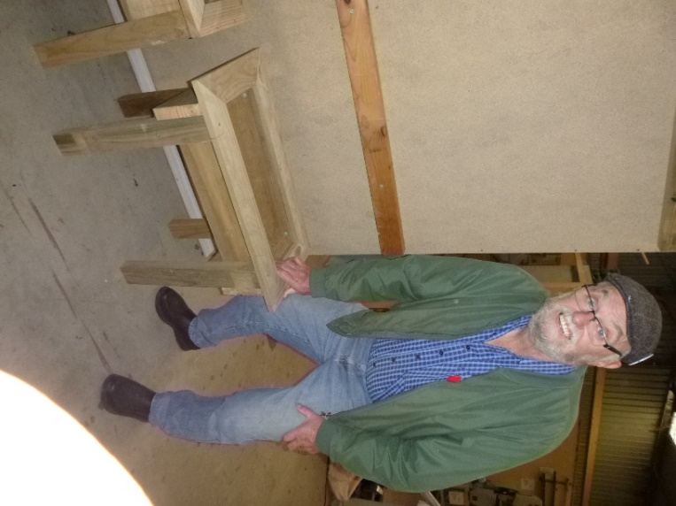

Planter Box.

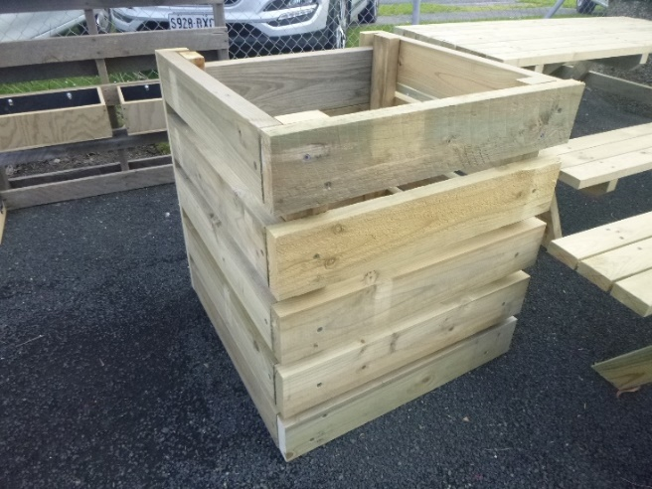

Compost bin.

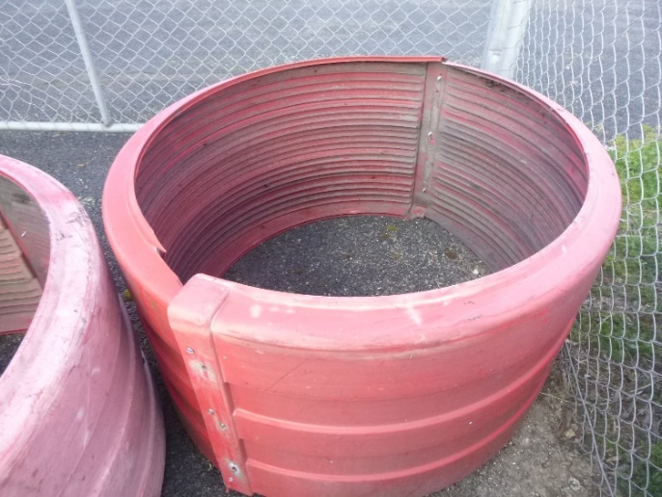

Small round raised garden bed.

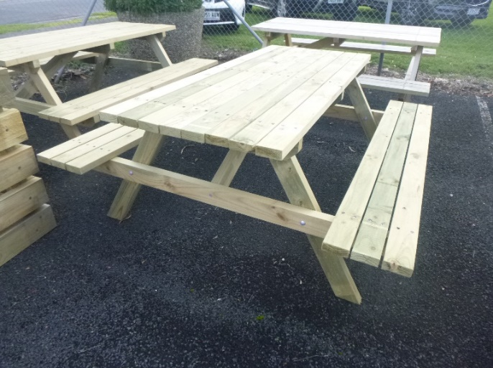

Picnic Table.

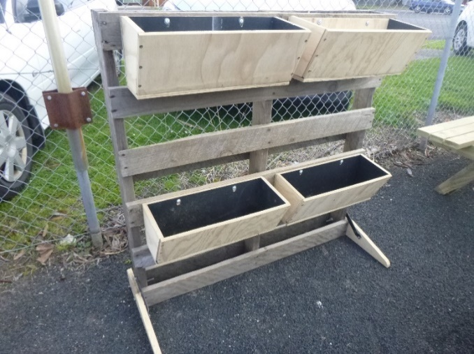

Wall planter boxes.

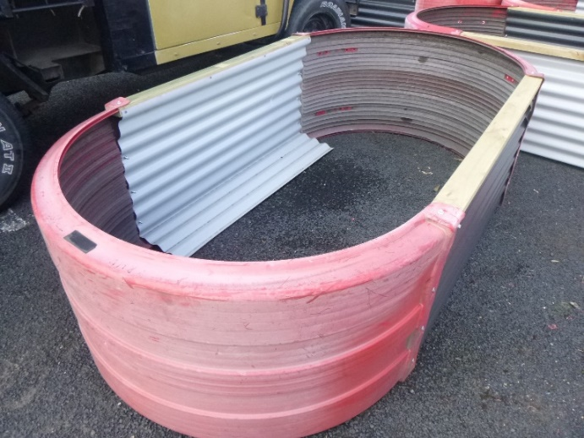

Large raised garden bed.

Contact the shed for details.

**PHONE**: 0478614027

**FACEBOOK** Mens Shed Mount Gambier

*[Image result for facebook logo](https://www.google.com.au/url?sa=i&rct=j&q=&esrc=s&source=images&cd=&cad=rja&uact=8&ved=2ahUKEwjO9cWTtajeAhUafisKHT6JAHoQjRx6BAgBEAU&url=http://www.seacliffeinn.com/spa-boutique/find-us-on-facebook-logo/&psig=AOvVaw0duNjpvsqixE3Pzu1qEwe2&ust=1540791326821108)*