**EXECUTIVE MEMBERS FOR 2022**

**PRESIDENT**: Ian Bond 0420859540

**VICE PRESIDENT**: Grant Sullivan

**TREASURER**: John Plunkett

**SECRETARY**: Paul Edgeworth 0497386846

**PHONE**: 0478614027 (prefer Tuesday and Thursday AM.)

**WE NOW HAVE A WEB SITE FOR THOSE WHO WISH TO LOOK. THIS WILL BE UPDATED FROM TIME TO TIME WITH NEW PHOTOS, NEWSLETTERS, RADIO REPORTS, CONTACTS AS WELL AS UPCOMING EVENTS AT THE SHED. Go to**

[**www.mgmensshed.com.au**](http://www.mgmensshed.com.au)

**FACEBOOK** Mens Shed Mount Gambier

[mgmensshed@gmail.com](mailto:mgmensshed@gmail.com)

**BIRTHDAYS**

Peter. K. 01/12

Graham. C. 22/12

Trevor. P. 28/12

Jim G 08/01

Bob P 16/01

Timothy C 17/01

Lyndon M 21/01

David N 31/01

**2022 Calendar**

2nd December Friday 2pm-7pm Glenburnie Race gates big event

8th December Thursday 10.15am Members Meeting

6-8pm Bunnings Community Event by invitation

December/January Shed Closed 22nd December2022 – 3rd January 2023

**2023**

7thFebruary Tuesday 11.00am Diabetes talk 15/20 min and screening

Until afternoon

March Garage Sale

March /April Bowel talk – Mattias Wichmann

**Furniture Damaging Insects Part 3**

**Carpenter Bees**

These insects are large and have yellow and black markings. Their smooth abdomens distinguish them from fuzzy bumblebees. Carpenter bees can be anywhere. Just like carpenter ants, they also delve into the wood from where they lay their eggs. The bees cause more superficial damage than structural damage. It’s also worth noting that the bees prefer unfinished wood over timber with a finish or paint.

To know that you’re encountering their infestation, you’re likely to notice faecal matter and wood shavings, piles of sawdust at entry points, and round holes of between 2.5 – 5 cm diameters in your wood furniture.

**Prevent Carpenter Bees Infestation**

It’s advisable to contact a pest control expert to immediately handle this problem if you notice infestation signs. These professionals will have a thorough check on your property for the things that trigger their thriving. You can cut down the back branches of your trees and ensure that you carry out regular rubbish removal. Dispose of any materials that assist the carpenter bees from creating a nest.

**Conclusion**

You’ll know that you’re having insect infestation when you notice any of the following signs; bore dust, holes in timber, crumbling wood, damaged or weak floorboards, or unusual sounds. Once you realize the type of fest that you’re dealing with, it is advisable to manage and control the insects as soon as possible; before they hatch and lay their eggs. Always remember that prevention is better than cure. In this case, curing the damage will be very costly.

**PROFILES:-**



Name:-John De Pree. Where have you worked:-Mental Community Health. Something about you people at the shed don’t know:-Loves Mountain bike and Cross country biking and has won some races here. What do you want to achieve at the shed:-Working with Pushbikes and woodworking.



Name:-Mark Woods Where have you worked:-Woods and Forest. Something about you people at the shed don’t know:-Loves doing woodwork. What do you want to achieve at the shed:-Not sure still feeling my way.



Name:-Tony Holdsworth Where have you worked:-Macs Trash Pak. Timber mill and for myself. Something about you people at the shed don’t know:-Loves fishing. What do you want to achieve at the shed:-Friendship, wood turning and some restoration work.

**Receipe:-**



**Apple Scones**

**Ingredients:-**

* 2 Cups Self Raising Flour.
* 1 tspn Baking Powder.
* 60 grams Butter Chopped.
* 1 tbsp Sugar.
* 1 Small Apple, Peeled,Cored and Diced.
* 1 tbsp Raisins Chopped.
* ¾ Cup Milk, plus extra for brushing.
* 1 tbsp Raw Sugar.
* 2 tsp Poppy Seeds.

**Method:-**

1. Combine the flour and baking powder in a bowl. Rub in the butter until mixture resembles fine crumbs.
2. Stir in sugar, apples and raisins. Mix in ¾ cup milk to make a soft, but not sticky dough.
3. On a floured surface, gentle roll or pat to a 2cm thickness. Cut into rounds with a 5cm diameter scone cutter. Arrange on a lightly greased tray. Lightly brush tops with extra milk
4. Combine raw sugar with poppy seeds, then sprinkle over the top of the scones.
5. Bake at 220⁰C for approximately 15 minutes, or ntil scones are golden and well risen.



Grant and Ben at the Bunnings sausage sizzle.

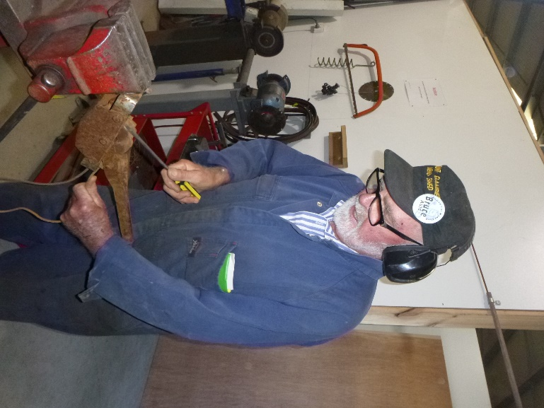

Bruce repairing a ratchet strainer.

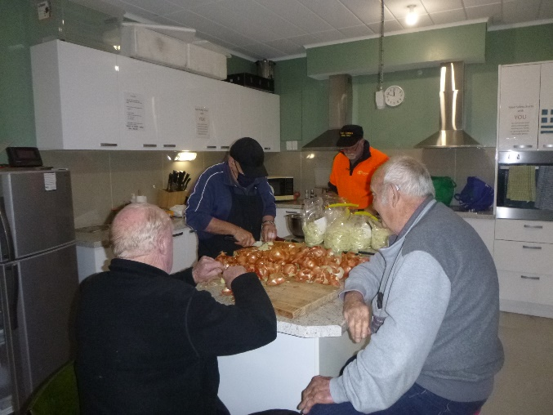

Bruce, Ben and Gary working, and Graham supervising as per normal, cutting onions for the next sausage sizzle.



The team at work like a well oiled machine at Bunnings.

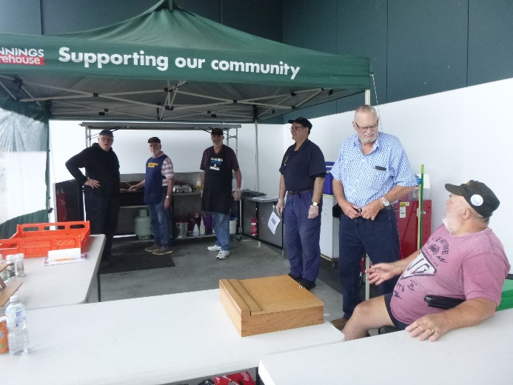

Well at least in the last picture they were working.This lot were taking it easy.

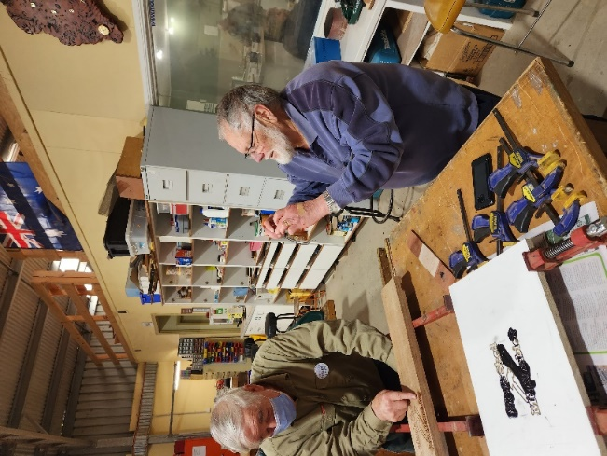

Everyone asks me who takes all your photos well at last I got a picture of Paul taking a picture of Dick.

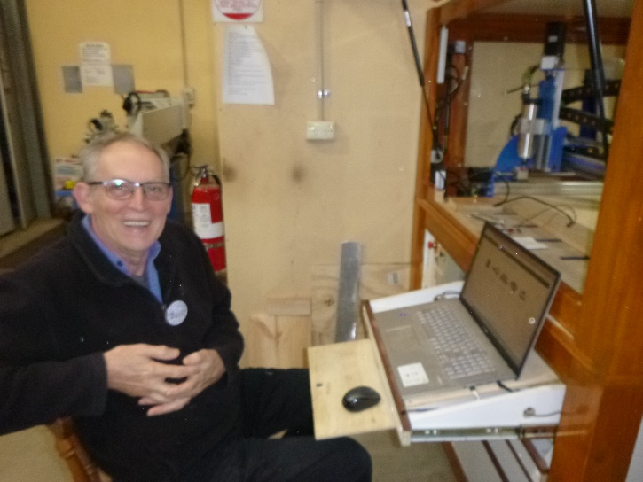

David H. starting to learn the CNC machgine.

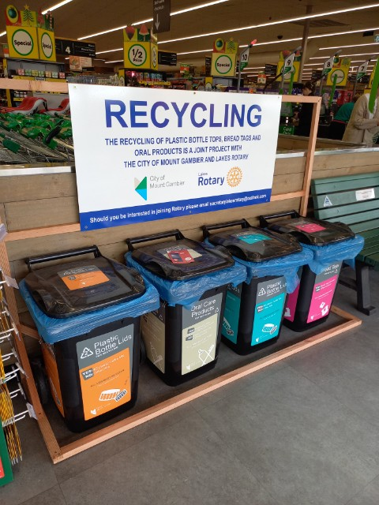

Recycle station at woolies made by Shed members.

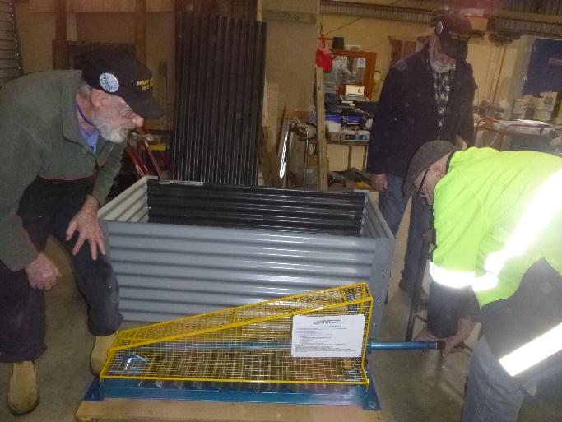

New guillotine being used for the first time by Frank and Jeff with Rob watching on.

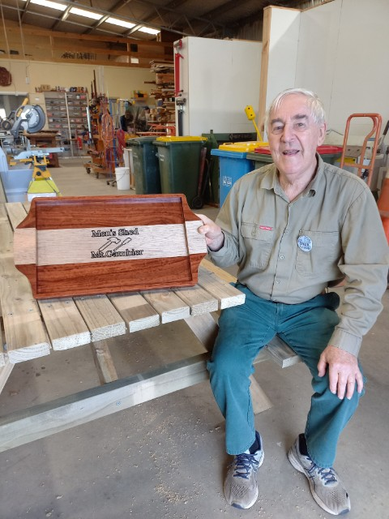

Dick with the tray he made for his wife, (showing off) the CNC etching.

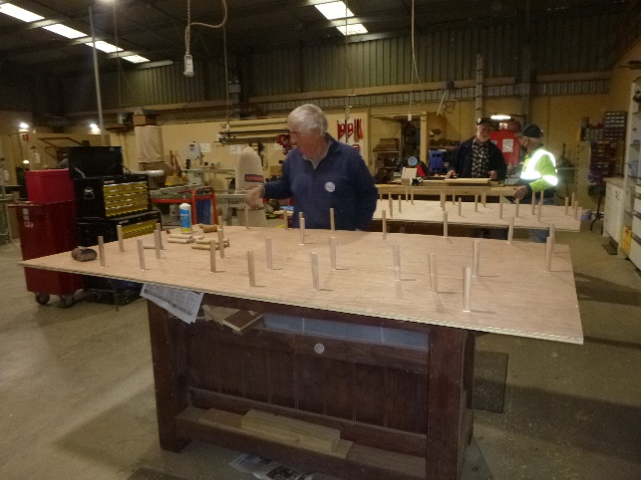

Dick likes getting his picture in the newsletter . Here he is again putting pegs into a peg tree for the local Riddoch art gallery.

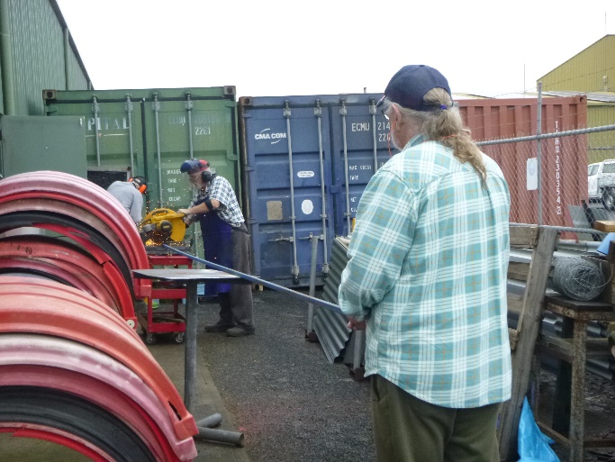

Mat and Ian cutting up steel for the dog club cart.

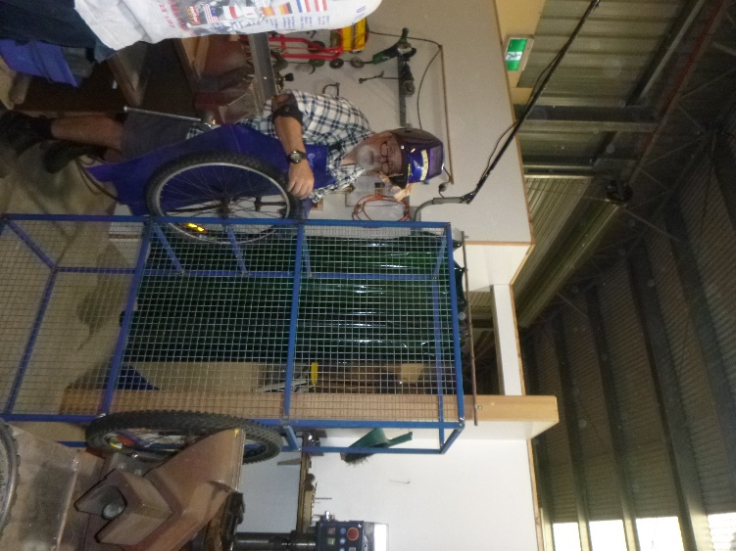

Ian finishing off the welding of the dog club cart.

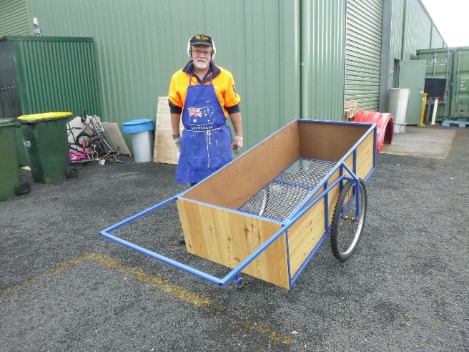

Gary with the finished dog club cart.

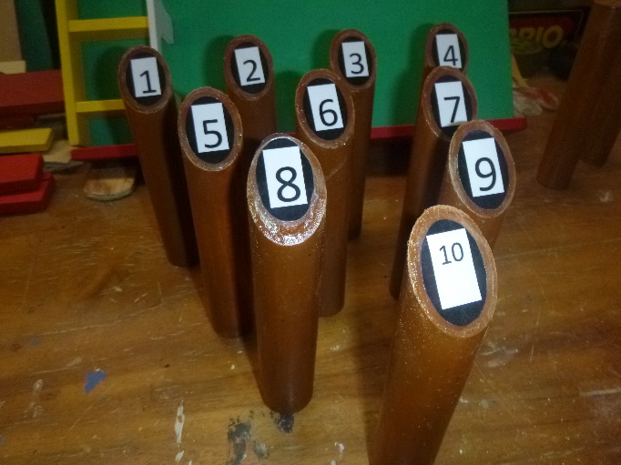

Fiskars Game made by Peter and ready to give to childrern at Christmas.

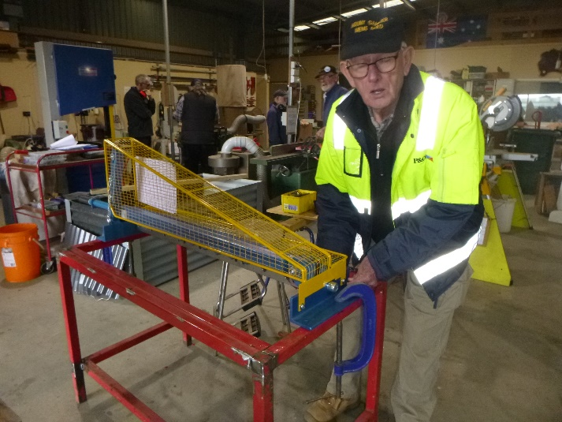

David attaching the guillotine to framework.

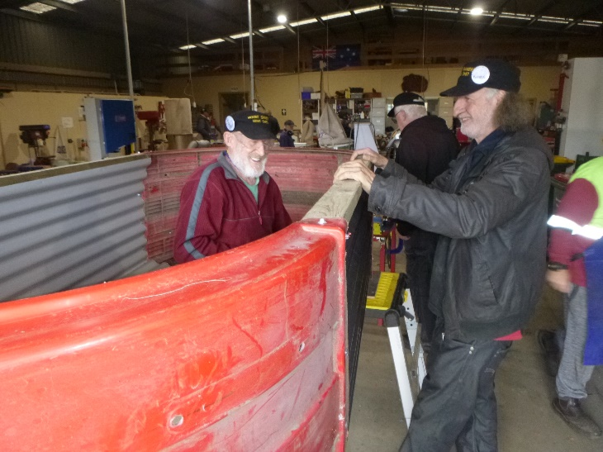

Frank, Russell and Grant building a new raised garden bed.

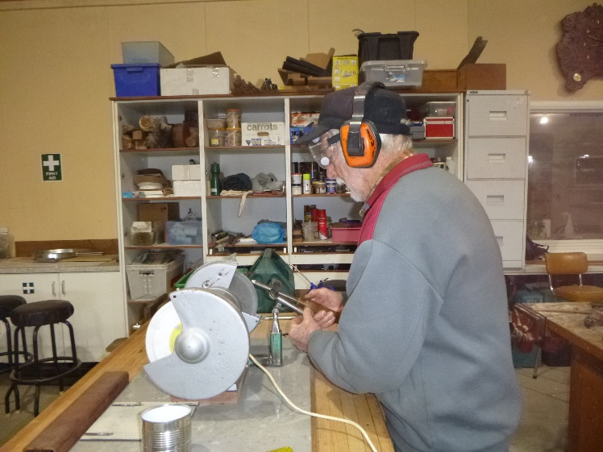

Don showing how to sharpen chisels.

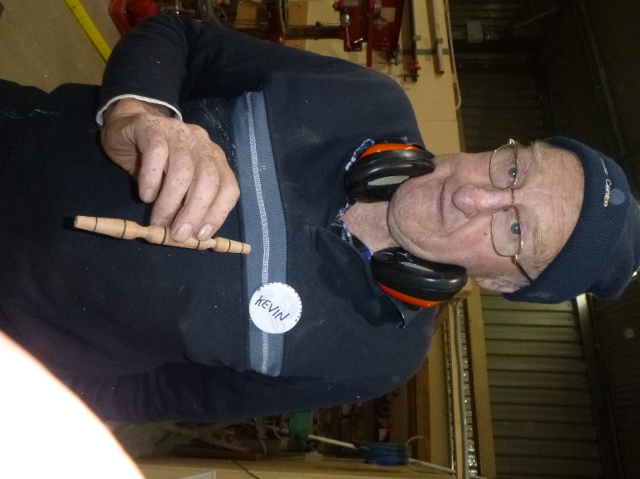

Kevin showing the bead picker upper he turned up.

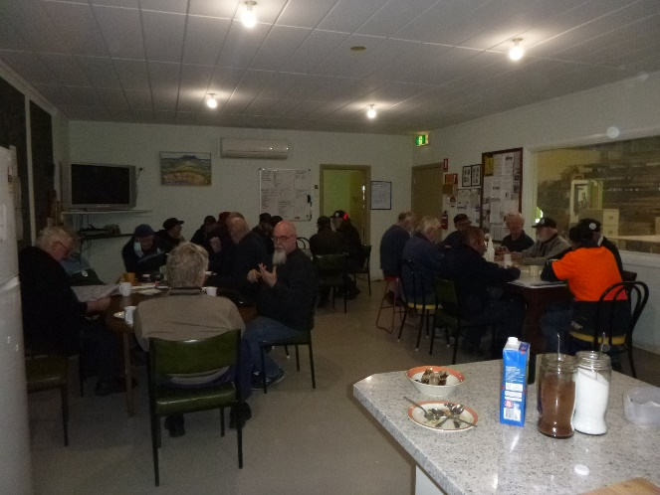

Morning tea. Scones are up.

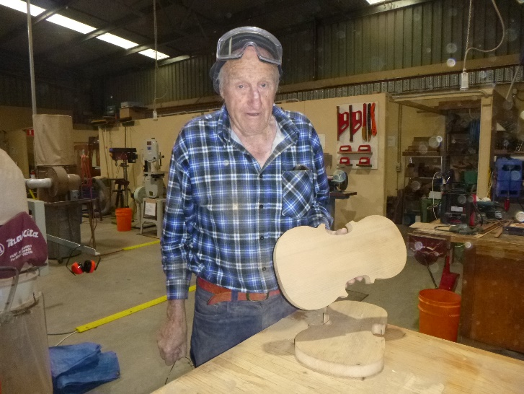

Kevin starting his Violin.

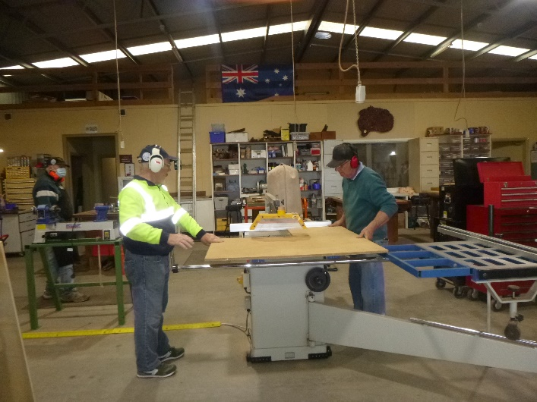

Tim and Geoff working on the table saw.

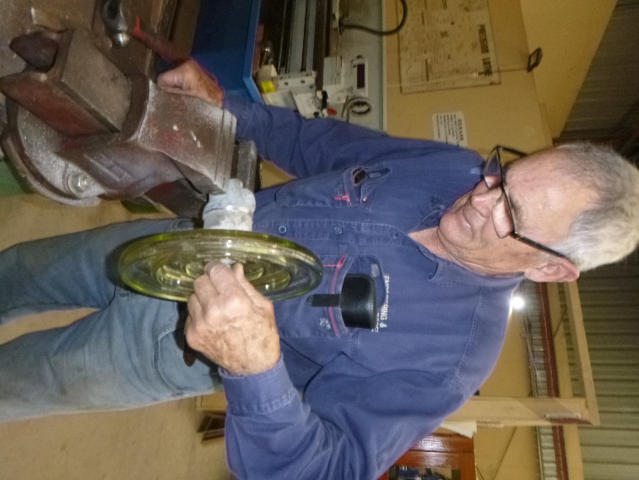

Trevor creating a Bird bath.

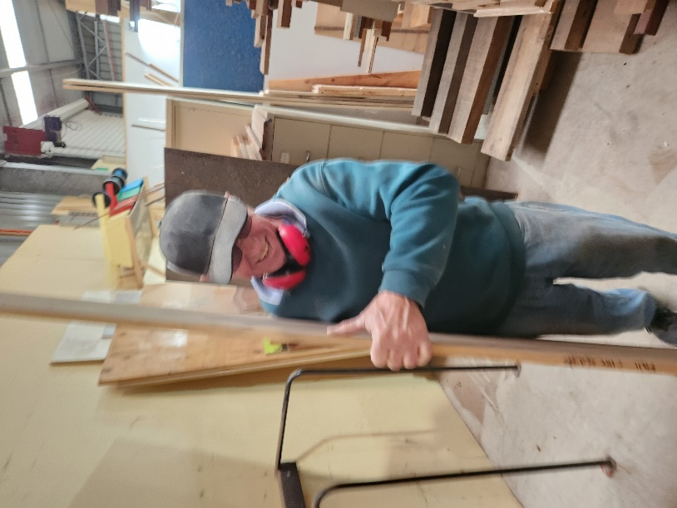

Just to show I am not the only one who gets a photo in the newsletter here is Geoff hard at work tiding up the panel area. ( He does not like his photo taken).









Please take this message as a personal message from me to anyone that needs it.



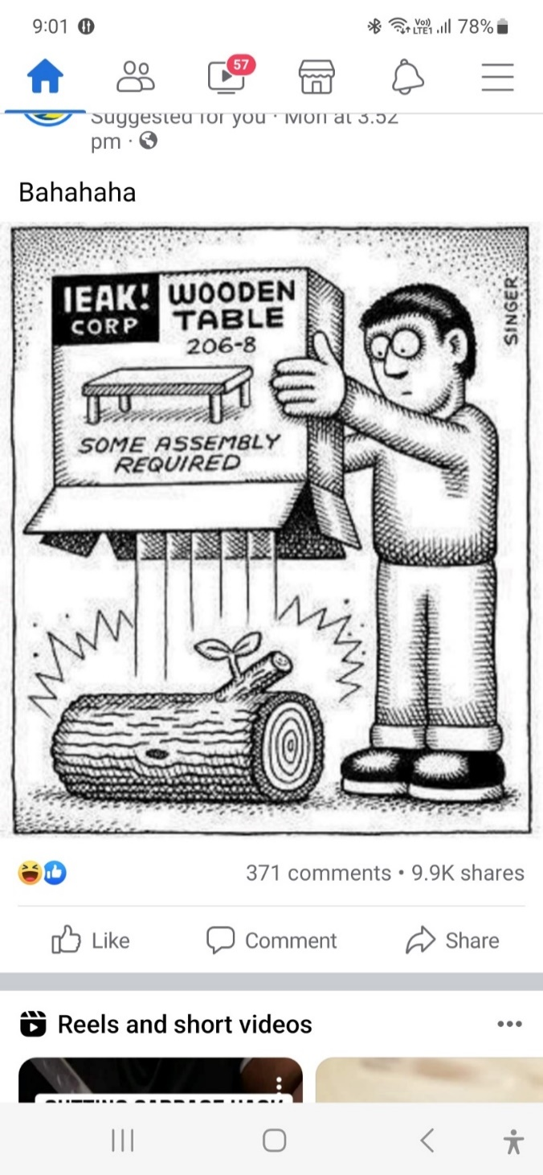



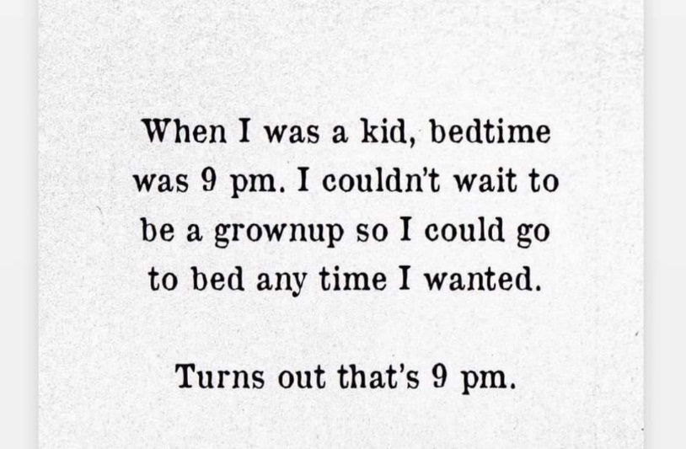



**Mount Gambier Men’s Shed will be closed for Christmas from 22/12/22 to 03/01/23**





 





**Big supporters of Mount Gambier Men’s Shed.**

**SUPPORT YOUR LOCAL BUSINESSES**

**THAT SUPPORT YOU.**