**OFFICE BEARERS FOR 2018.**

**PRESIDENT**: Peter Halleday 0439500699

**VICE PRESIDENT**: Ansi Nitz

**TREASURER** : John Plunket

**SECRETARY** : Paul Edgeworth 0887256385

**COMMITTEE** : Arthur Smith

Peter Young

Dave Lawson

Rob Burford

**APPOINTMENT OF LEADERS for 2018 –**

**Work Health Safety Officers -** Rob Burford/Geoff Hart / Ian Bond/ Tim Clarke

**Workshop Maintenance Manager and Tools and Machinery manager –** Don Clements

**Social Organiser –** Dave Lawson

**Historians –** Brian Short / Graham Carter

**Fund Raiser Leader –** Ansi Nitz

**Public Relations Officer –** Peter Heness

**Newsletter Editor –** Peter Heness

**Webmaster -** Dave Lawson

**Projects Manager –** Don Clements

**Assets Manager –** Geoff Hart

**Assets Reorders –** Rod Lockwood/Geoff Hart

**Senior First Aider –** Peter Heness

**First Aiders –** all who have trained

**Grant Monies Submission Writer** Graham Carter

**Membership Support Leaders –** Brian Short / Peter Halleday/ all Committee Members

**Kitchen Manager –** vacant

**Race Gates Organiser –**Paul Caines

**Bunnings Organiser -** Ansi Nitz

**Christmas Parade Organiser** – none 2018

**In house BBQ, meals Organiser** – Geoff Hart

**Ablutions Manager** – Geoff Hart

**Electrical Tester** – Rob Burford

**Toy Group Managers** - Ian Bond/Peter Heness

**Badge Makers** – Rod Lockwood/Geoff Hart/Tony Potts

**Storeman, nuts and bolts** - Rod Lockwood

**Constitution, Policy, Rules Group** – Graham Carter/Geoff Hart/Scott Turner/ Ray Lazenby

**UPCOMING / ONGOING/ COMPLETED PROJECTS**

**Toy Making** for Mayors Christmas Appeal 2019 –

**Sharp Cranes -** 2 sets of steps to get into their portable building Peter Halleday to organise in thanks for the loan of their cranes

**Hand rail** for our oldest members back steps

**BIRTHDAYS.**

Bernard R 02/02

Ansi N 04/02

Ross S 04/02

Ces J 18/02

Joe C 24/02

**SAFETY HEALTH and WELLBEING**

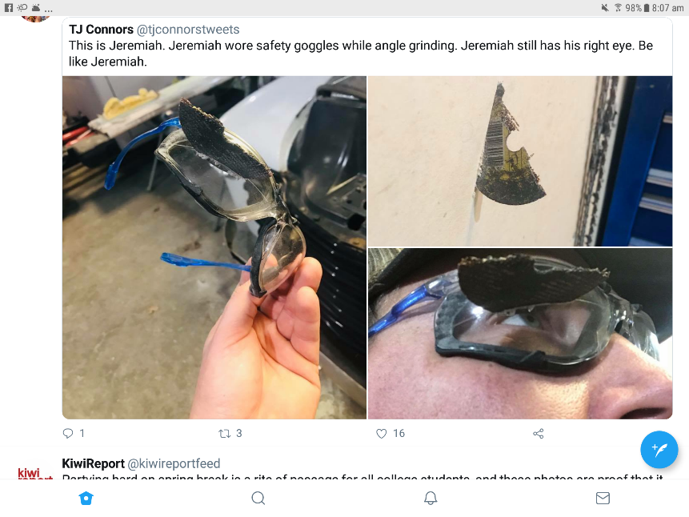**THANKS to**

**ABC live radio** and **5SE taped** District Men’s Sheds’ reports and newsletter - Peter Heness

**Scones** – Terry R & Terry G

**Please do not forget the AGM on the 14th February. If you can help out fill in the forms and remember many hands make light work and all hands are appreciated.**

Other REMINDERS ALL BORROWINGS must be authorised by a member of the Management Committee and entered in the book by the ‘sign in’ book. DAMAGED MACHINES – let someone know. NAME BADGES – please wear TOOLS AFTER USE – please return to correct storage CAPS for sale $17

**Public relations –** two monthly district Shed reports by Peter Heness **ABC (‘am’ radio - 1476)** first Thursday of the month – just after 9.30 am.

**Triple M – 963** was taped by the radio station on 21st November and to be replayed over time.

Peter Heness is also the monthly **‘SA Correspondent’** about Men’s Sheds in our district for the **Victorian Men’s Shed Association ‘live streaming’** programme on **FM 3WBC** Box Hill. It is the first Saturday of each month (Next one – 3rd March).

Periodically a live broadcast is done with Rick Blackburn CEO Victorian Men’s Shed Association.

**Dates to remember**

**17th February Sunday** 8.30-4.00 **Bunnings Sausage Sizzle**

**Early 2019** **Strokes Foundation Australia - ‘Stroke Safe’**

**Early 2019 - Australian Hearing testing**

**- Garage Sale**

**March/April** **U3A visit**

**2019** **Road Safety through SA Police**

**HEALTH AND WELLBEING** Support and contact as you are able and as Shedders wish

**Members returned** from medical/brain conditions this last month Peter Young, Glen B’s wife, Brian Short, Kelvin Smibert, Ray Lazenby’s wife and Noe Mattner

Those with longer term/serious physical/brain issues – Peter Schutz, Keith Reichelt, Peter Young, Peter Marttinen, Kevin Walters (Kevin will not walk again but is positive about all the things he can do), Don Latty, Ben Katris (mobile and returned to the Shed today)

Remember spouses and partner also needing support

Thanks to all Shedders making home visits, hospital visits, phoning and emailing - supporting other Shedders

**Garage Sale** is deferred till 2019

**Insurance policies** are being reviewed for 2019 by Paul E and John P

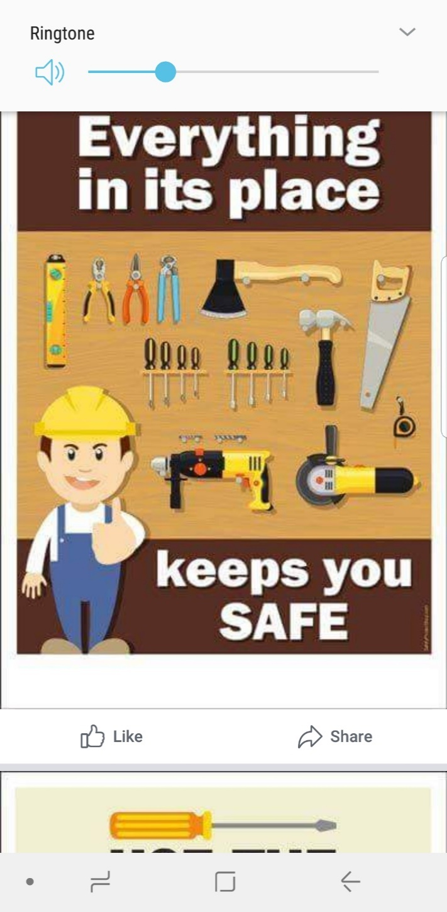

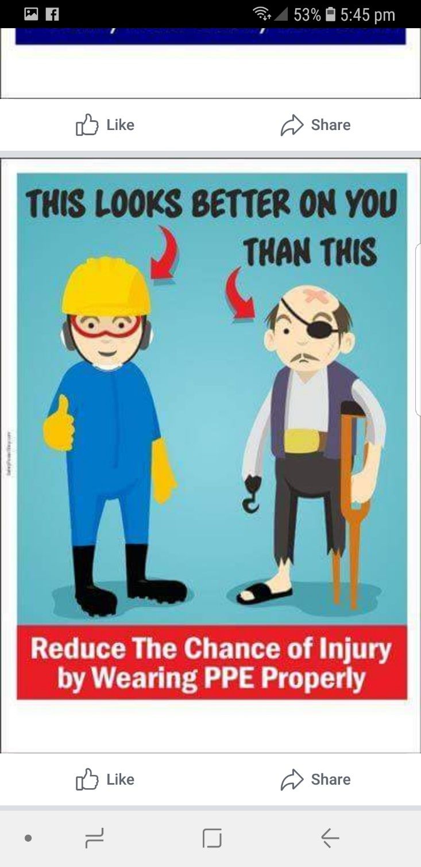

As I have been away on holidays this month is short on articles so thanks to Pat J for these funnies.

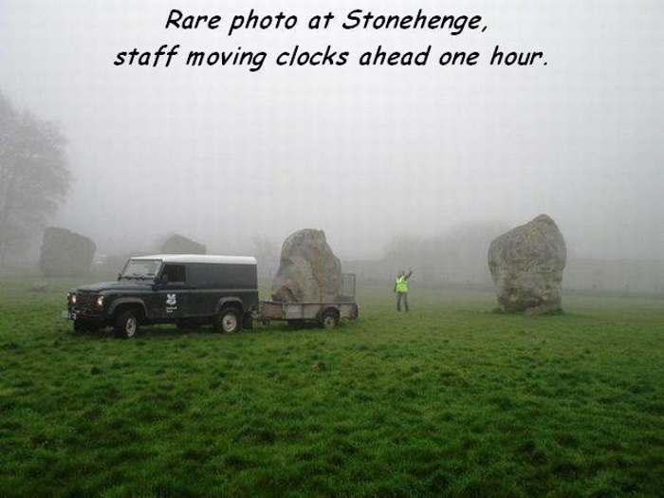

The wedding ceremony came to the point where the minister asked if anyone had anything to say concerning the union of the bride and groom.

The moment of utter silence was broken when a beautiful young woman carrying a child stood up. She starts walking slowly towards the minister.  The congregation was aghast - you could almost hear a pin drop.

The groom's jaw dropped as he stared in disbelief at the approaching young woman and child.

Chaos ensued.

     The bride threw the bouquet into the air and burst out crying.

Then the groom's mother fainted.

The best men started giving each other looks and wondering how to save the situation.

The minister asked the woman, "Can you tell us, why you came forward?   What do you have to say?

There was absolute silence in the church. The woman replied, "We can't hear you in the back.

And that illustrates what happens when people are considered guilty until proven innocent.

**Analytical Approach to Life**









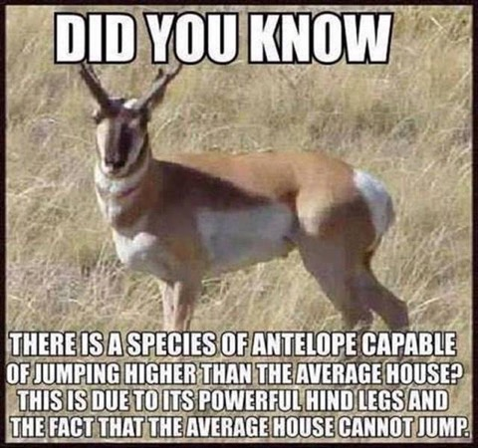









**COSTUME PARTY**

|  |
| --- |
| **A couple was invited to a swanky costume party.**  **The Mrs. got a terrible headache and told her husband**  **to go to the party alone.**  **He being a devoted husband protested, but she**  **argued and said she was going to take some aspirin**  **and go to bed and there was no need for his good**  **time being spoiled by not going. So he took his**  **costume and away he went.**  **The wife, after sleeping soundly for about an**  **hour, awakened without pain and, as it was still**  **early, decided to go the party.**  **Since her husband did not know what her costume**  **was, she thought she would have some fun by**  **watching her husband to see how he acted when she**  **was not with him.**  **She joined the party and soon spotted her husband**  **cavorting around on the dance floor, dancing with**  **every nice looking woman he could, and copping a**  **little feel here and a little kiss there.**  **His wife sidled up to him and being a rather**  **seductive babe herself, he left his current partner**  **high and dry and devoted his time to the new babe**  **that had just arrived. She let him go as far as he**  **wished naturally, since he was her husband.**  **Finally, he whispered a little proposition in her ear**  **and she agreed.**  **So off they went to one of the cars and had a quickie.**  **Just before unmasking at midnight , she slipped**  **away, went home, put the costume away and got**  **into bed, wondering what kind of explanation he**  **would make for his behaviour.**  **she was sitting up reading when he came in, and**  **She asked what kind of a time he had...**  **He said: 'Oh, the same old thing. You know I never**  **have a good time when you're not there.**  **'Did you dance much?’**  **I'll tell you, I never even danced one dance. When I**  **got there, I met Pete , Bill Brown and some other**  **guys and we went into the den and played poker all**  **evening.**  **But you're not going to believe what happened to**  **the guy I loaned my costume to.....** |

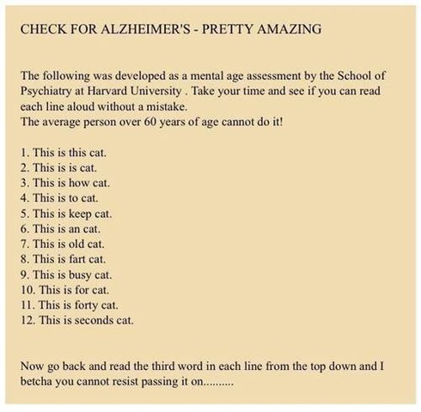

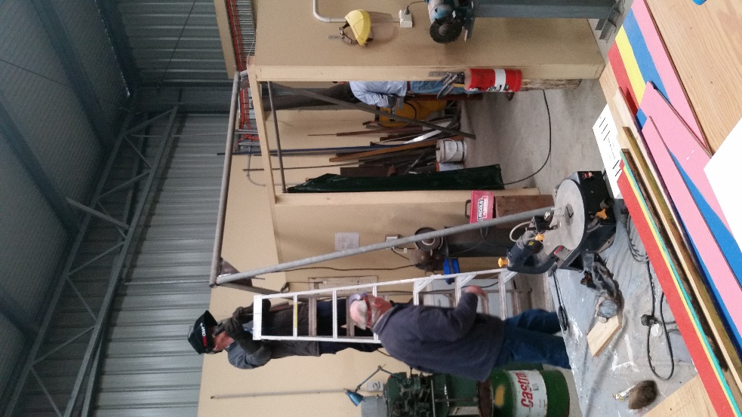

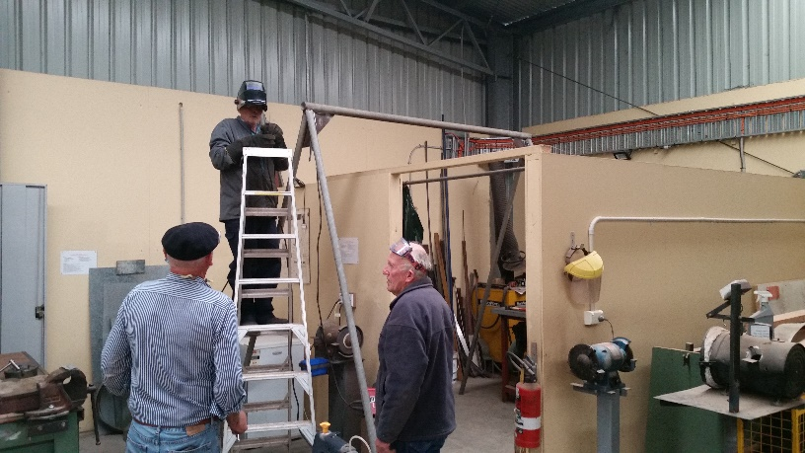

Fellows working on the swing for the disabled client.

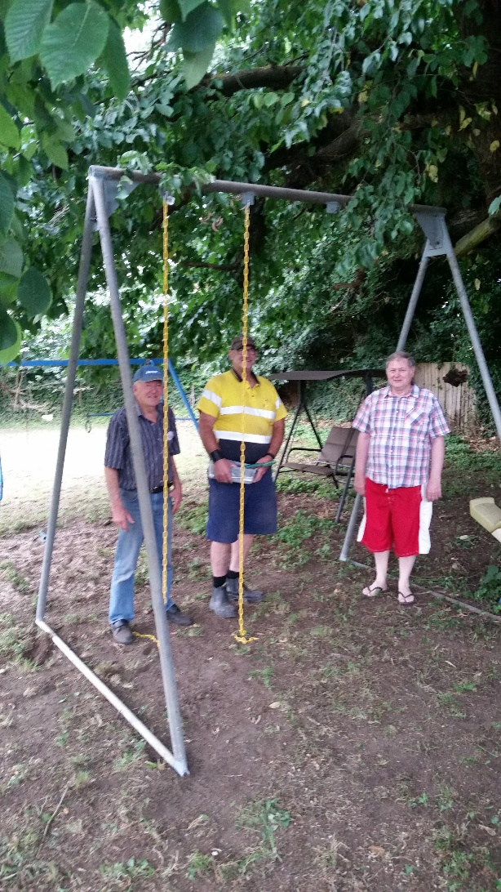

Trevor and Dave with the father of the disabled adult.

Copied from the VMSA newsletter

**PLEASE NOTE** The VMSA has received a number of queries and requests to find an avenue that sheds can easily list and advertise surplus items they have, that they wish to donate to other sheds, or to promote activities that the shed are involved in - such as market days, or fundraisers. The VMSA has recently created and trialled a Facebook page, “VMSA Public Notices”. This is now available for all sheds and shedders to join, and to place your ads and info on. Please note this is not the avenue if you wish to sell your surplus good, it is only if you want to donate goods. The VMSA now has a Buy/ Swap and Sell Page on its website for shedders to use.

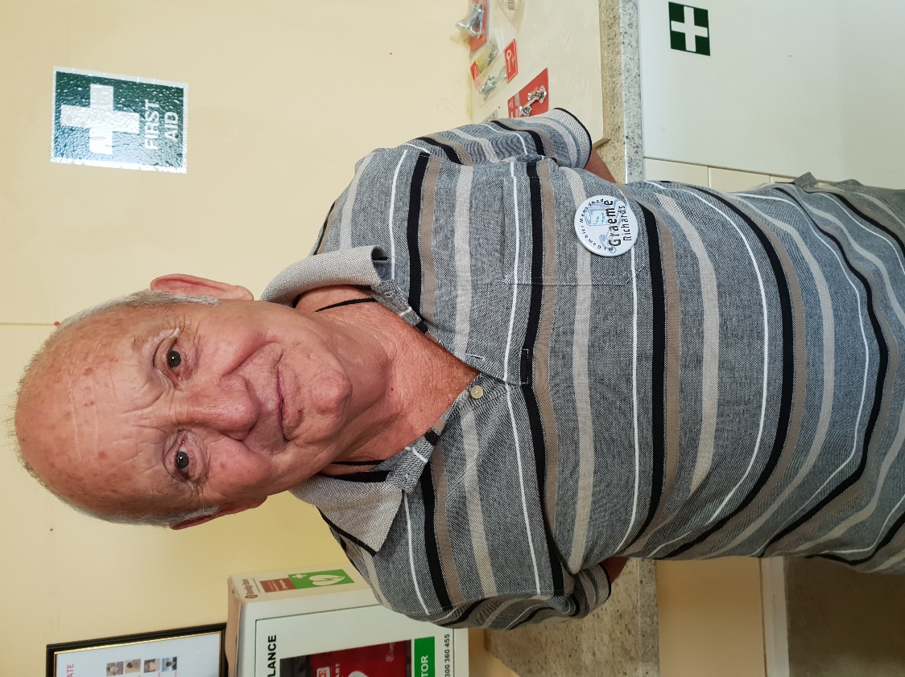

**Name:-** Graham Richards.

**Where Have You Worked:-**As a stock agent then as a drainage contractor, I then worked at KCA making Paper.

**Something About You Others At The Shed Do Not Know:-** Still play and love Tennis.

**What do you Wish to Achieve at the Shed:-** Only to join in and help out others where possible.

**SHED SUBS ARE NOW DUE**

It has been kept the same as for 2018.

**$45 from 1st January**

**$22.50 from 1st July**

Payment to John Plunket.

Should you wish to make payment by direct debit here are the detail

**Bendigo Bank BSB 633 000 Ac No. 140403379**

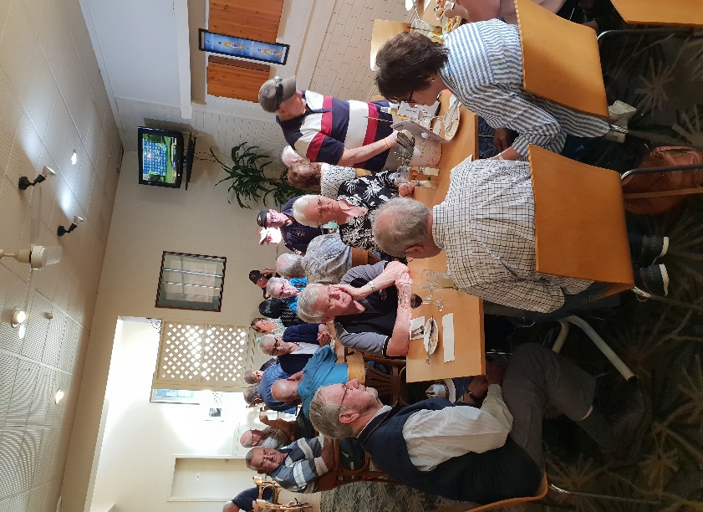

Tea at Park Hotel on the 9th Jan with 25 turning up.

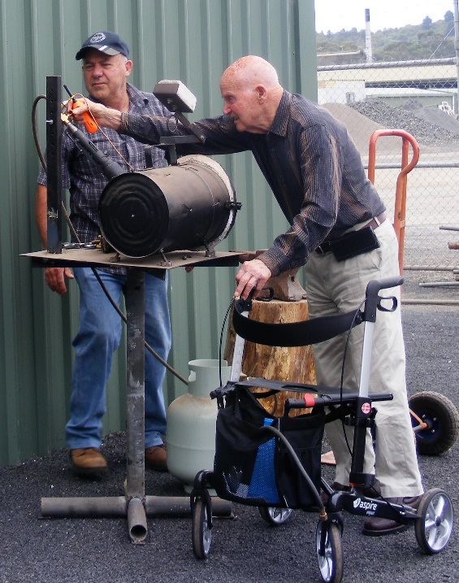

Lyndon and Kelvin checking out the forge.

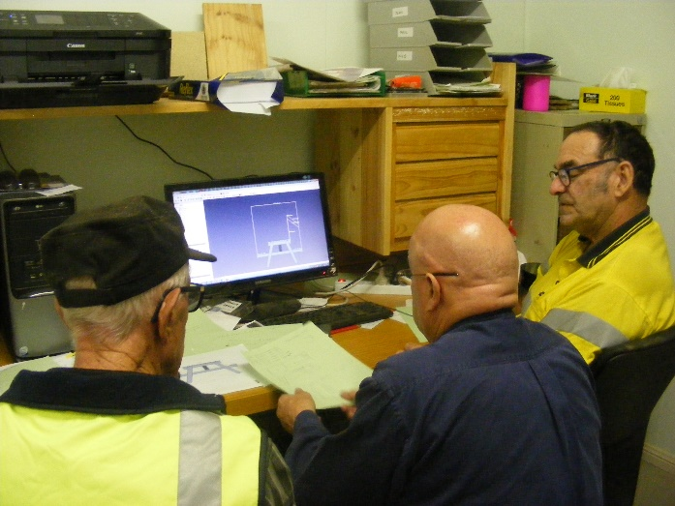

After many pain staking hrs on the computer Dave has finally found a CAD program to draw designs on the computer. Here he is showing Ray and Robert how it works.

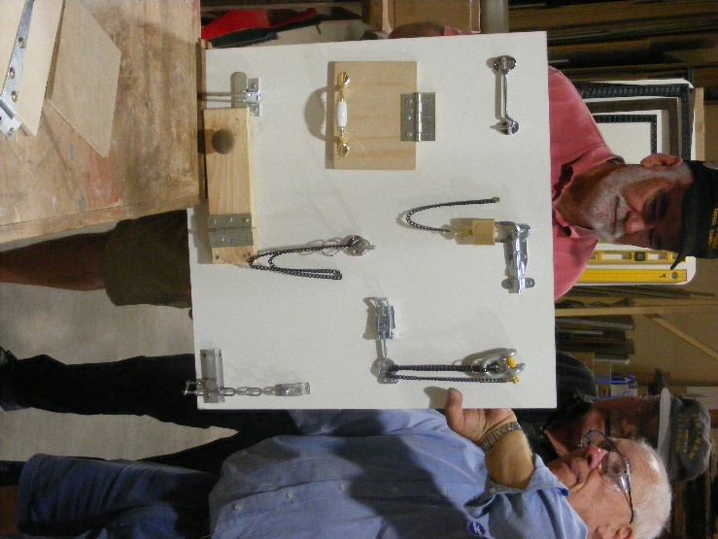

Tim and Rob work on an activity board for an aged care centre.

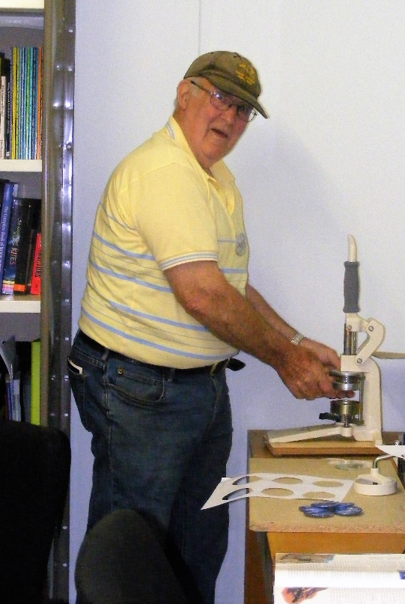

Rod making 1 of 500 badges for Community Health.