**EXECUTIVE MEMBERS FOR 2022**

**PRESIDENT**: Ian Bond 0420859540

**VICE PRESIDENT**: Grant Sullivan

**TREASURER**: John Plunkett

**SECRETARY**: Paul Edgeworth 0497386846

**PHONE**: 0478614027 (prefer Tuesday and Thursday AM.)

**WE NOW HAVE A WEB SITE FOR THOSE WHO WISH TO LOOK. THIS WILL BE UPDATED FROM TIME TO TIME WITH NEW PHOTOS, NEWSLETTERS, RADIO REPORTS, CONTACTS AS WELL AS UPCOMING EVENTS AT THE SHED. Go to**

[**www.mgmensshed.com.au**](http://www.mgmensshed.com.au)

**FACEBOOK** Mens Shed Mount Gambier

[mgmensshed@gmail.com](mailto:mgmensshed@gmail.com)

**BIRTHDAYS**

Grant S 17/11

Geoff H 19/11

Graham R 17/11

Dale A 24/11

**2022 Calendar**

9th November Wednesday 6.30 Shedders and partner tea – Foodie Bar

10th November Thursday 10.15 Members meeting

23rd November Wednesday 11am Murray Bridge Shed ‘Spanner in the Works’ 3pm Invitation cluster meeting

27th November Thursday 11.30 BBQ lunch

**2023**

7th February Tuesday 11.00 Diabetes talk 15/20 min and screening

until afternoon

March /April Bowel talk – Mattias Wichmann

**Furniture Damaging Insects Part 2**

**Carpenter Ants**

These are the culprits behind lots of structural damage. They have powerful jaws that hollow out solid woods pine or fir to make nests. Other than targeting solid wood, the carpenter ants sometimes nest behind insulation or inside doors. Nonetheless, if your furniture is made from firm lumber or pine, you’re at risk of the ants munching on them.

**Prevent Carpenter Ants Infestation**

Be sure to repair all your plumbing problems and roofing leaks. Also, cut down the overhanging tree branches that help the ants come in contact with your roof’s openings. Like any other pest, the ants can also be prevented by sealing openings and cracks, especially near piping.

**Conclusion**

You’ll know that you’re having insect infestation when you notice any of the following signs; bore dust, holes in timber, crumbling wood, damaged or weak floorboards, or unusual sounds. Once you realize the type of fest that you’re dealing with, it is advisable to manage and control the insects as soon as possible; before they hatch and lay their eggs. Always remember that prevention is better than cure. In this case, curing the damage will be very costly.



Name: -David Hayton Where have you worked:-S.A. Railways and in solar turbines Something about you people at the shed don’t know:-Like renovating Houses and old Holden’s. What do you want to achieve at the shed:-Companionship and learn new skills.

**Receipe:-**

**Lemon Butter Spread**

**INGREDIENTS:-**

I Cup Butter.

1 ½ Cups Caster Sugar.

3 Eggs, Lightly Beaten.

½ Cup Lemon Juice.

1 Tablespoon Grated Lemon Zest.

**DIRECTIONS:-**

* In the top of a double boiler over boiling water, melt butter. Stir in sugar,eggs slowly (while using a whisk), lemon juice and zest. Cook over simmering water for 1 hour or untill mixture is thickened and coats the back of a spoon.
* Poor into glass jars. Put on lid and allow to cool. Store in refrigerator. Use over cakes, on toast, muffins scones and home made biscuits. It even goes well on Icecream.

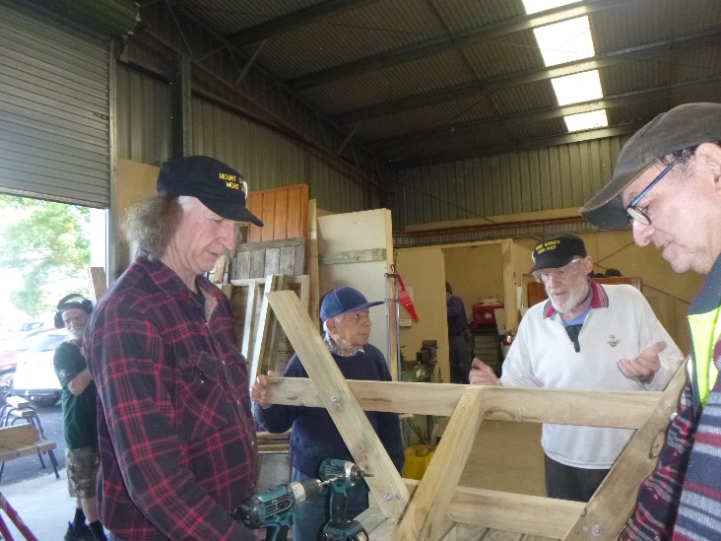

New member to the team Russell is fitting in well, seen here assisting Joe, Frank and Dave making another Table.

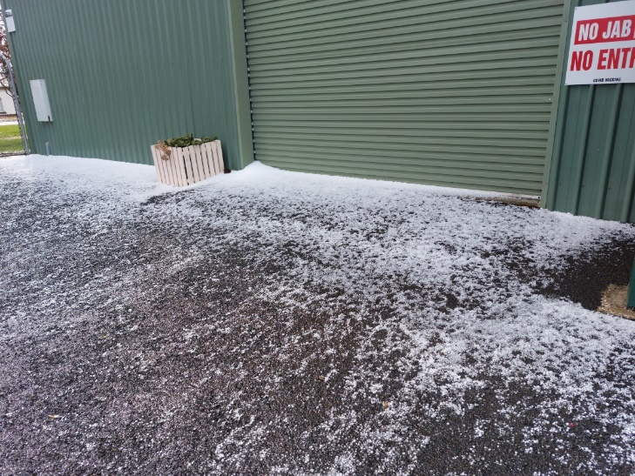

Some people think it is nearly summer but I think the Gods have different ideas after this hail storm came through.

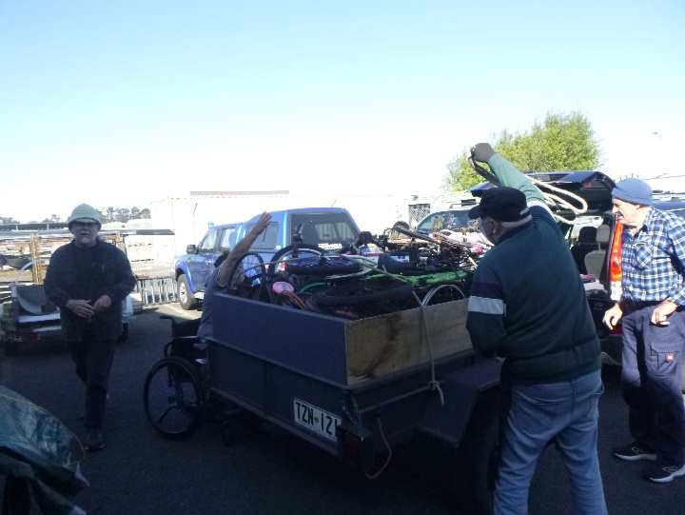

Bicycles have been coming and going of late with Matt ready to catch Alan’s rope.

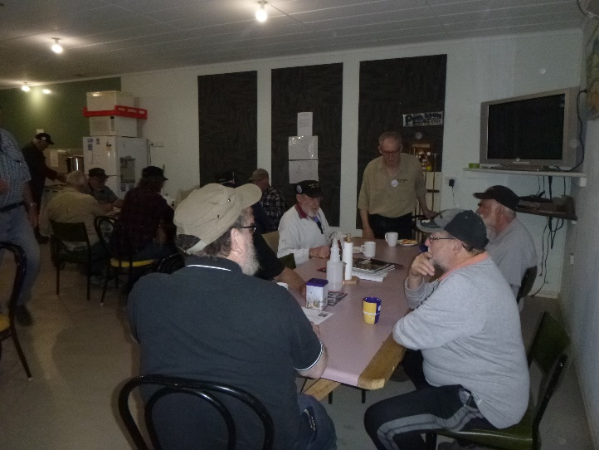

Ben’s scones must be getting a reputation with these men sitting waiting for the roll out at morning Tea.

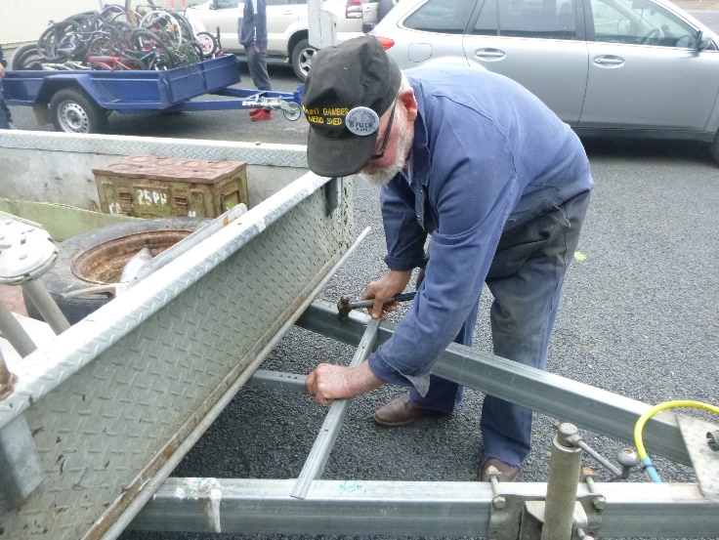

Bruce fitting a bracket to hold a tool box on his trailer.

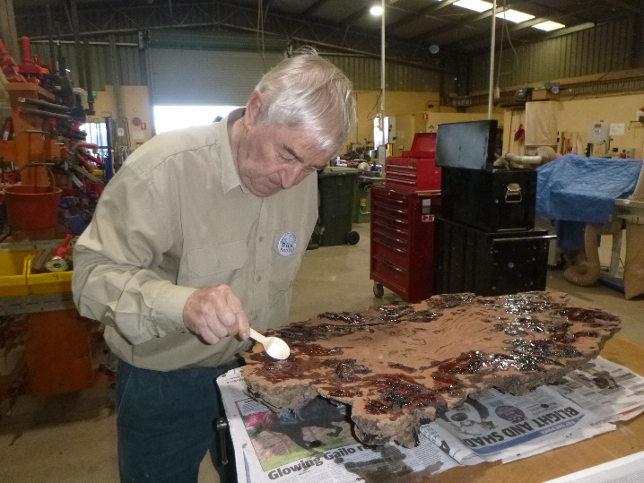

More on this project later as Dick prepares a Burl for his project.

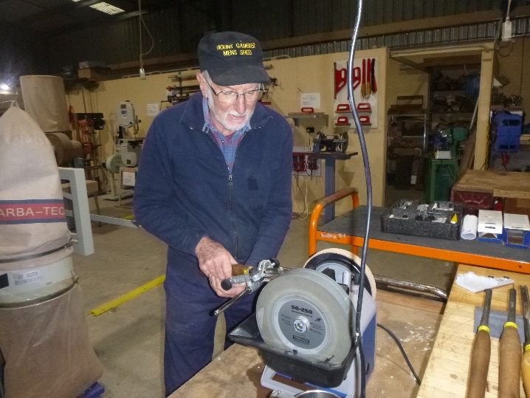

Don showing the tool sharpening capabilities with a tool stone and leather.

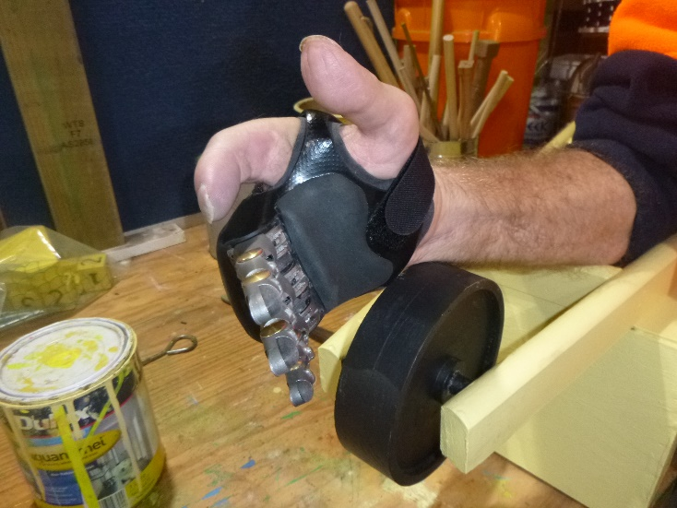

Gary using his new hand, showing how it can assist with his toy making.

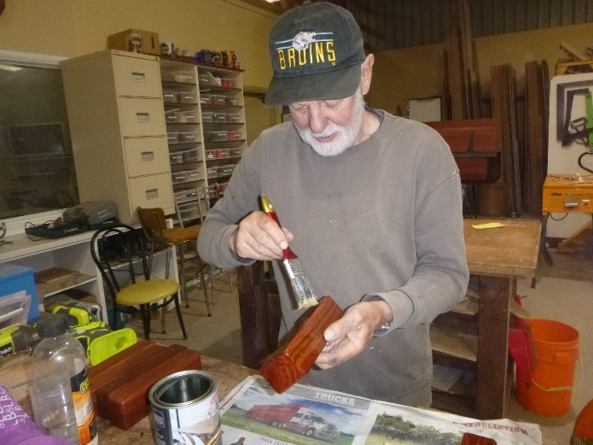

Herman doing the finishing touches to the handles of his coffin.

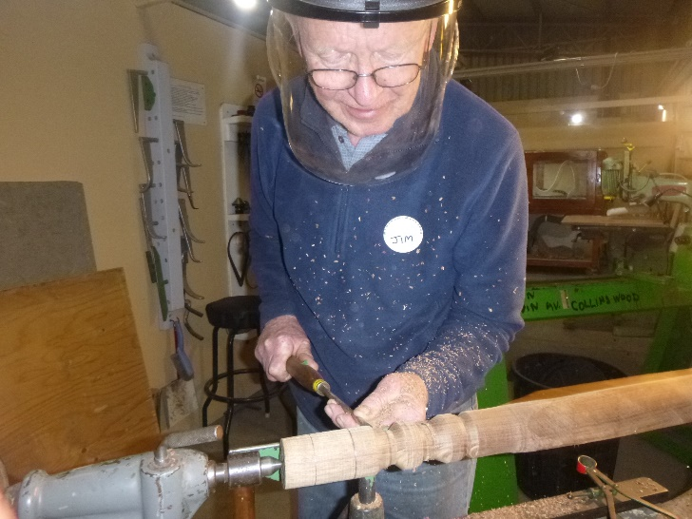

New member Jim tries his hand at wood turning.

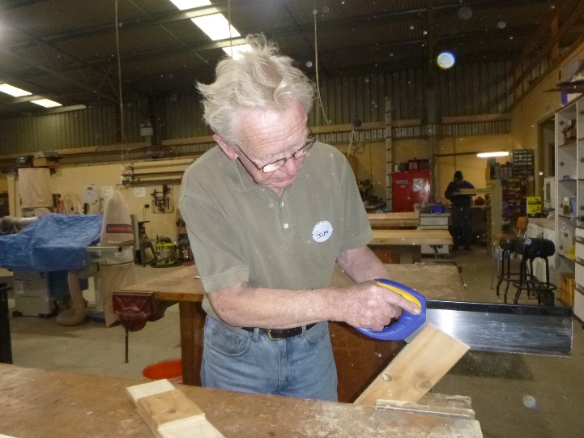

Jim is also trying his hand at different wood joins.

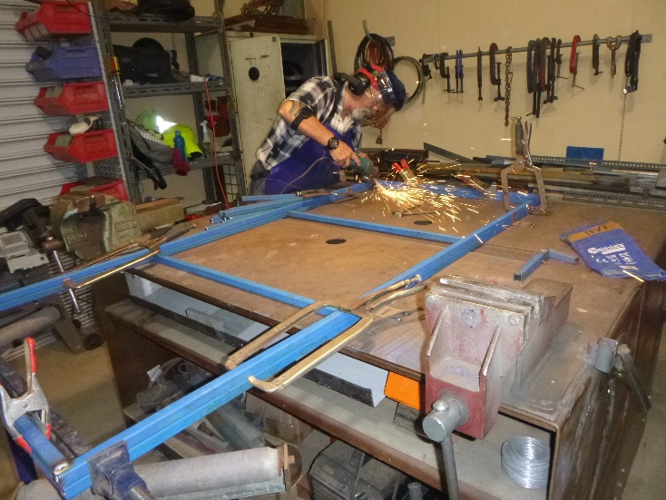

Ian making the frame for the Dog club cart so they can move things around.

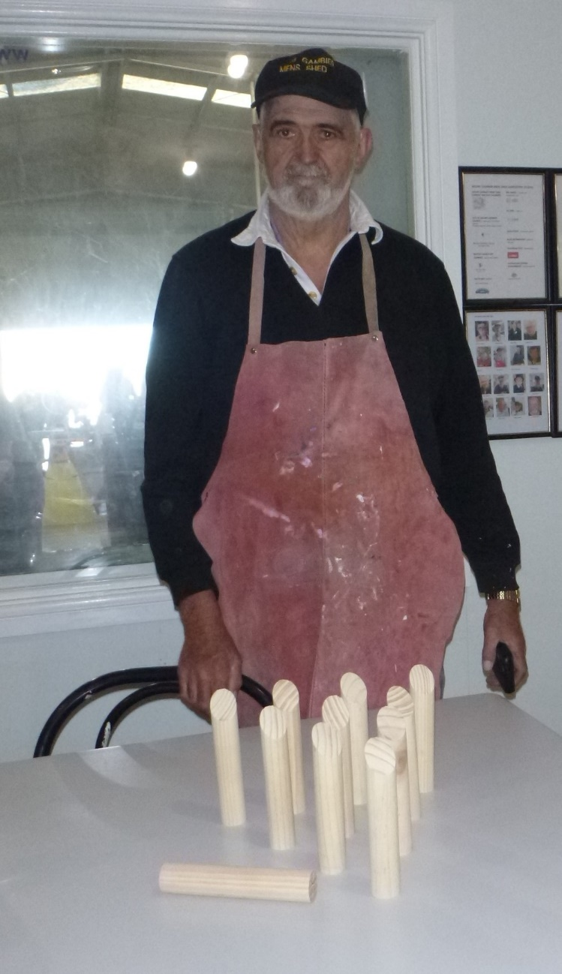

Peter showing off the new toy he had seen in one of the shops and had copied.

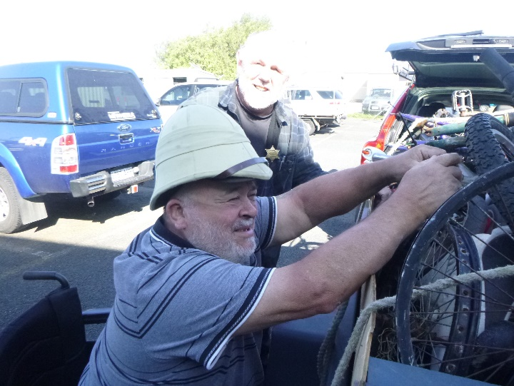

Laurie doing a Laurie thing and wearing a pith hat while tying a truckie knot all while sitting in his wheelchair.

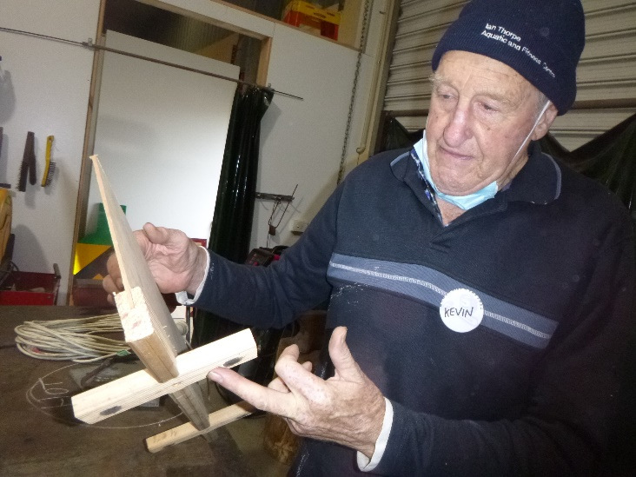

Kevin showing off his welding shield with magnetic feet.

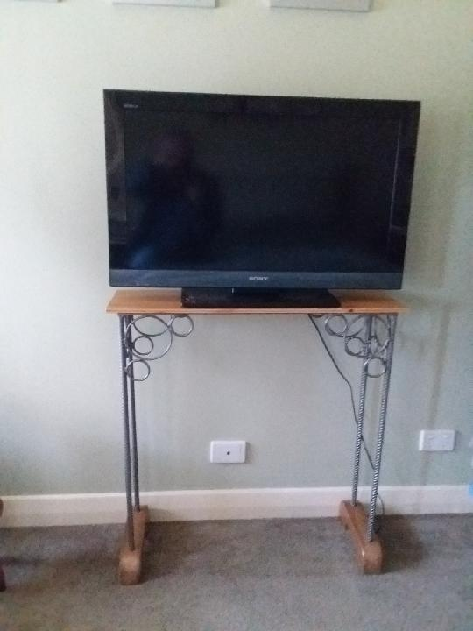

Trevor’s TV stand made in the welding bay.

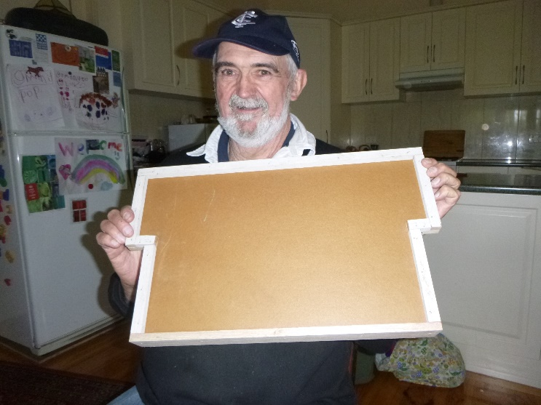

Peter showing the Tray for mobility walkers with soft seating. Designed by Kelvin made by Peter, painted and delivered by Paul.

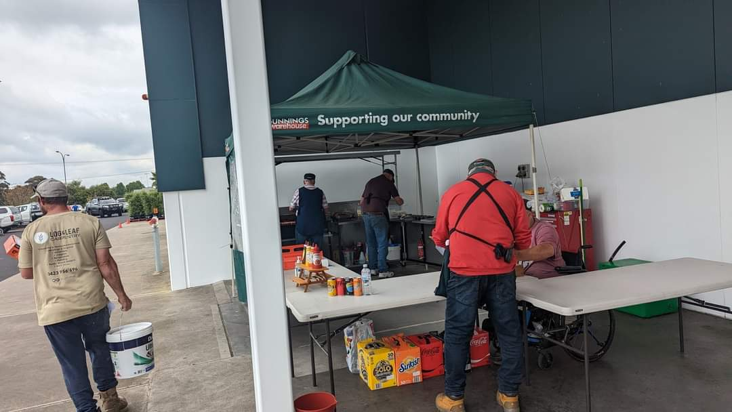

Bunnings sausage sizzle, heads down bottoms up working hard.

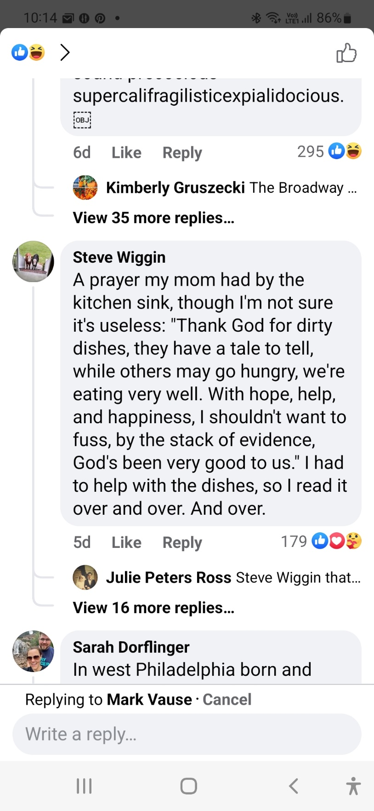

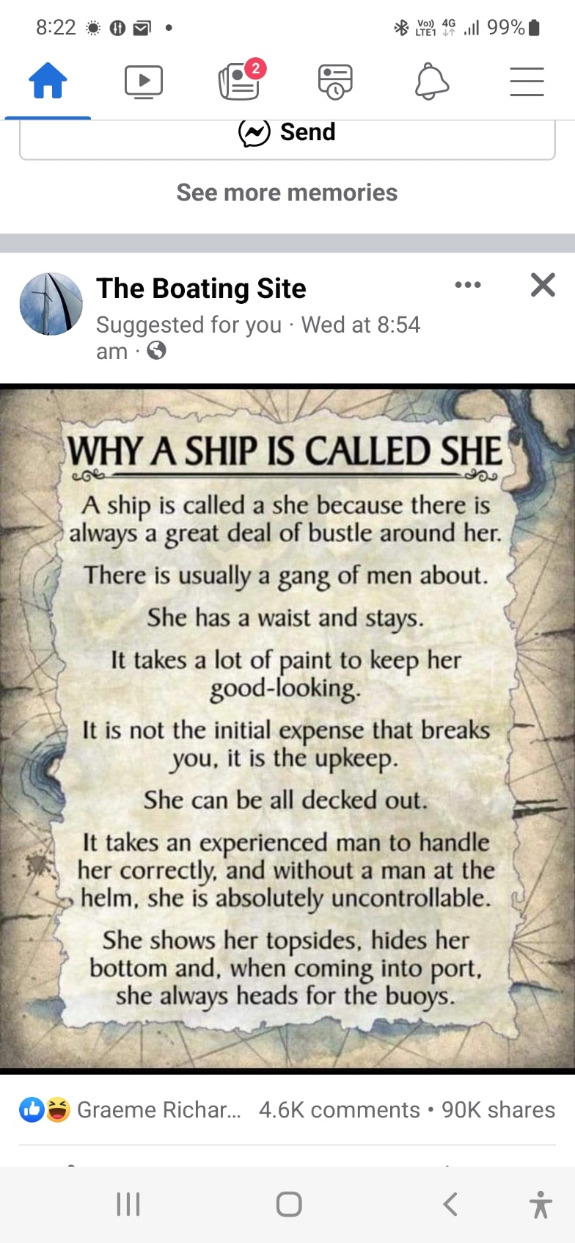

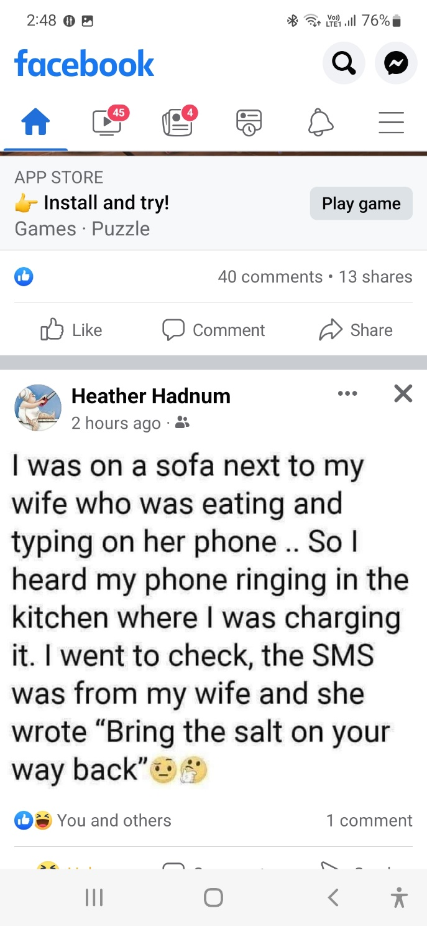



 





**Big supporters of Mount Gambier Mens Shed.**

**SUPPORT YOUR LOCAL BUSINESSES**

**THAT SUPPORT YOU.**