[mgmensshed@gmail.com](mailto:mgmensshed@gmail.com)

**EXECUTIVE MEMBERS FOR 2021**

**PRESIDENT**: Peter Halleday 0439500699

**VICE PRESIDENT**: Ian Bond

**TREASURER**: John Plunket

**SECRETARY**: Paul Edgeworth 0887256385

**FACEBOOK**

Shed broadcasts are now available on Facebook

*[Image result for facebook logo](https://www.google.com.au/url?sa=i&rct=j&q=&esrc=s&source=images&cd=&cad=rja&uact=8&ved=2ahUKEwjO9cWTtajeAhUafisKHT6JAHoQjRx6BAgBEAU&url=http://www.seacliffeinn.com/spa-boutique/find-us-on-facebook-logo/&psig=AOvVaw0duNjpvsqixE3Pzu1qEwe2&ust=1540791326821108)*

**Safety: - Remember Safety begins at home.**

**BIRTHDAY”S**

Jim M 9/05

Neville F 12/05

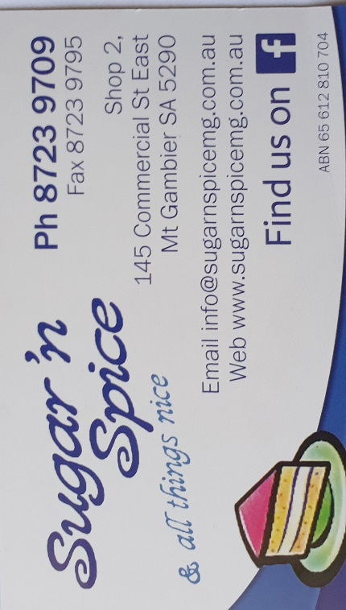

**Remember Sugar ‘n Spice support our Men’s Shed with Birthday cakes, so support them where you can.**

 

**While mentioning our supporters always remember how much Bunnings help our shed, so support them, as well, when you need a product that they can supply for you.**



**Thanks to Sharp Cranes and Steeline for supporting our Mens Shed.**

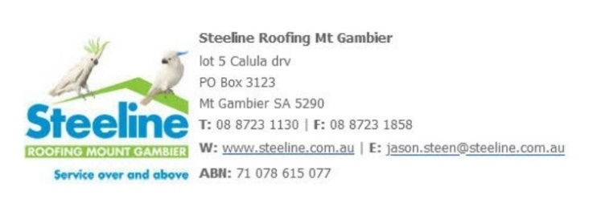



**A big supporter of Mount Gambier Mens Shed.**



**SUPPORT YOUR LOCAL BUSINESSES**

**THAT SUPPORT YOU.**

**DIARY DATES**: 2021

12th May Wednesday 6.30 Tea with partners TBA

13th May Thursday 10.15 Members Meeting

27th May Thursday 10.15 Management Committee meeting

**MEMBERS PROFILE:-**

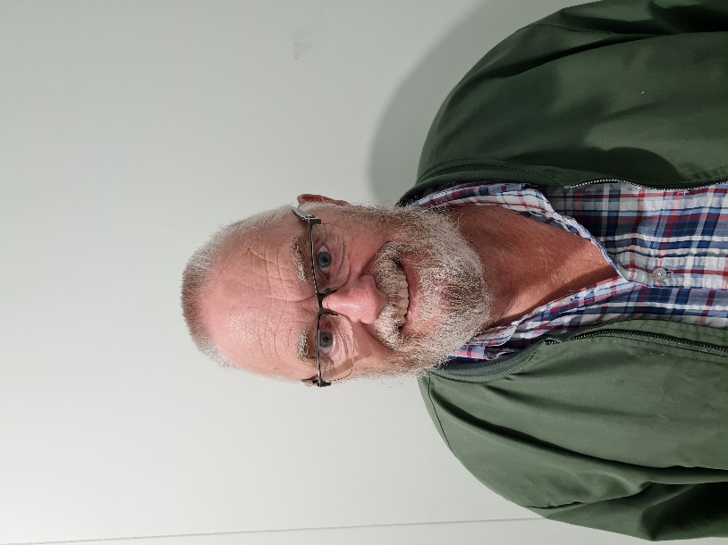

**NAME: -** Jeff Redwood

**Where have you worked in your life: -**.Victoria railways, Truck driver, construction worker and a supervisor for a local council

**Something about you that others at the shed don’t know: -**Collector of matchbox toys**.**

**What do you wish to achieve at the shed: -**as he is new to the area all he would like to do is enjoy everyone’s companionship

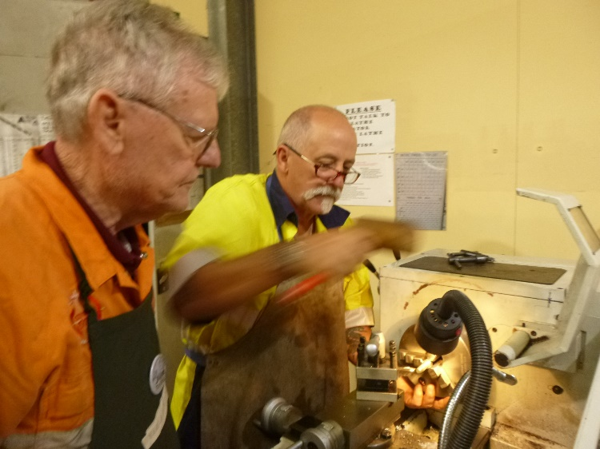

Jim supervising Ian on the metal lathe.

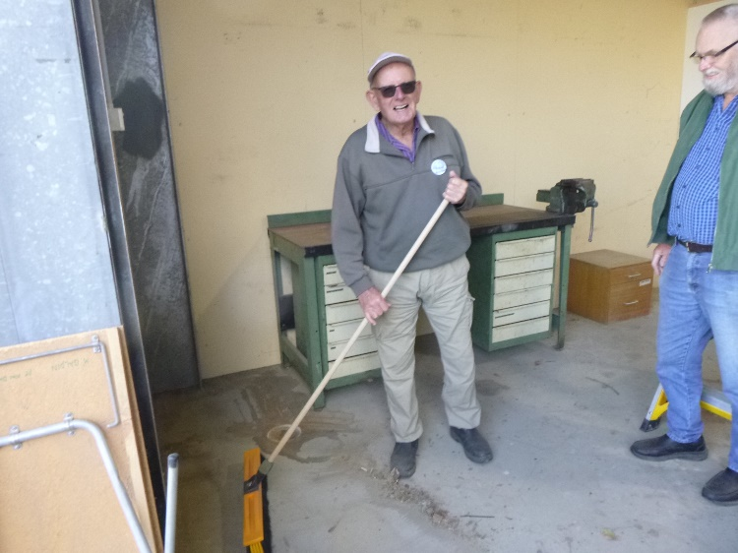

Dave cleaning and Jeff supervising the cleaning of the new welding bay.

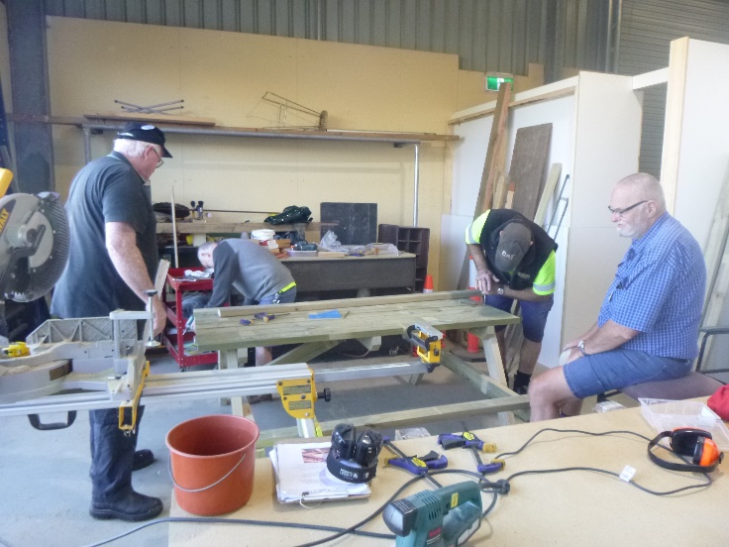

We can all see who is doing all the work. Dave making another outdoor setting while the rest supervise.

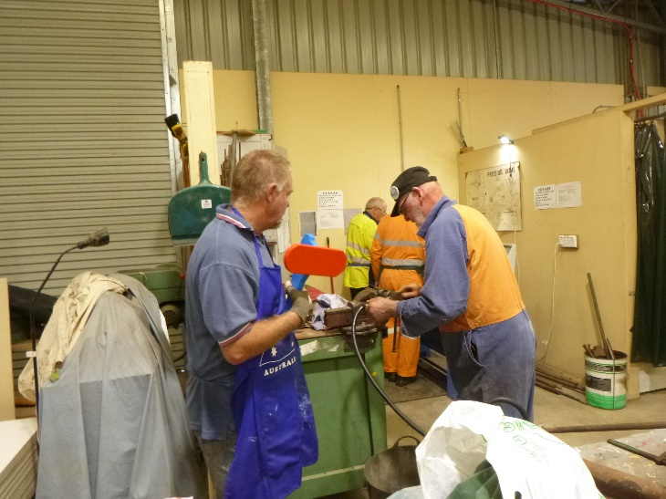Garry holding a toy plane while watching Bruce repair a hydraulic hose.

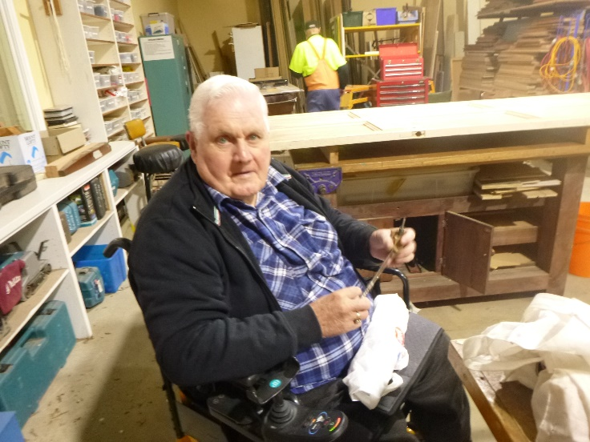

Kevin making pen cases.

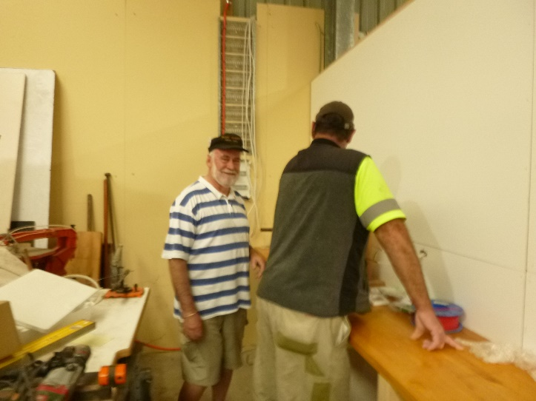

Rob and Dave working on wiring for the new toy area.

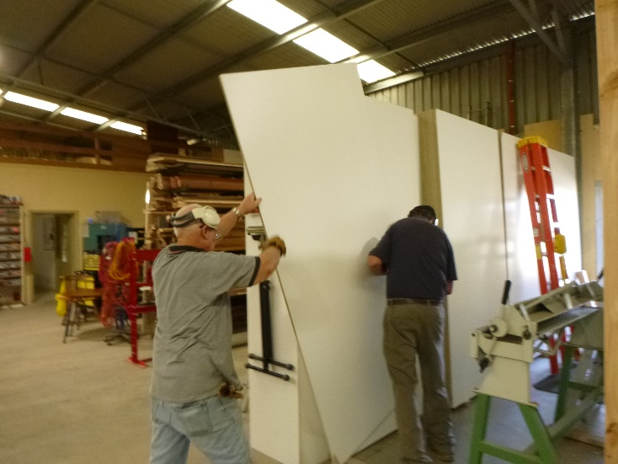

Tim and Peter manoeuvring another piece for the wall in the new area.

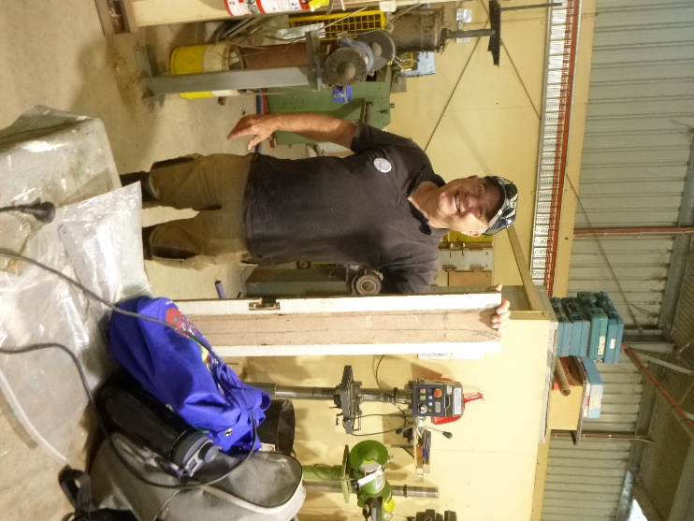

Lyndon holding a piece of wall making out he has been helping.

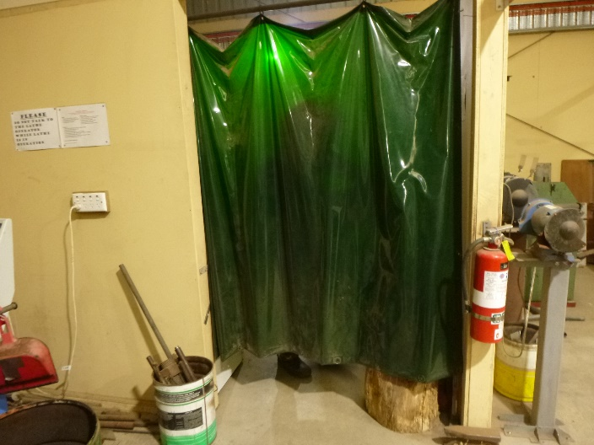

The word is don’t open the curtain you may see a flasher or two.

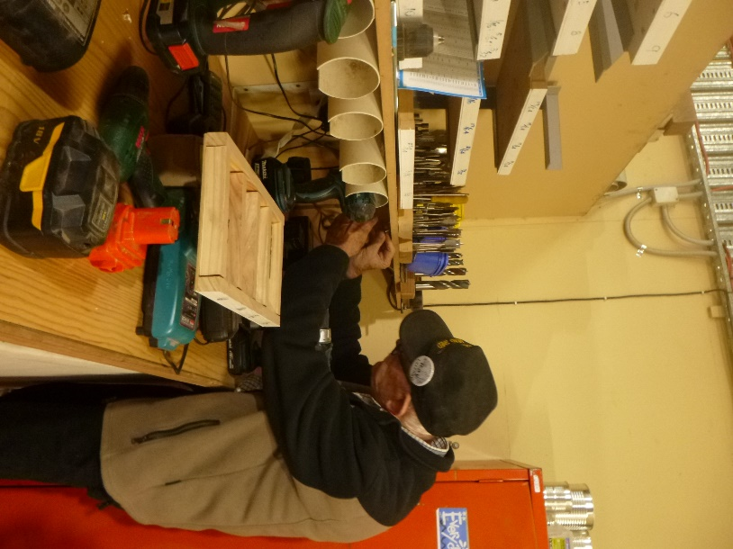

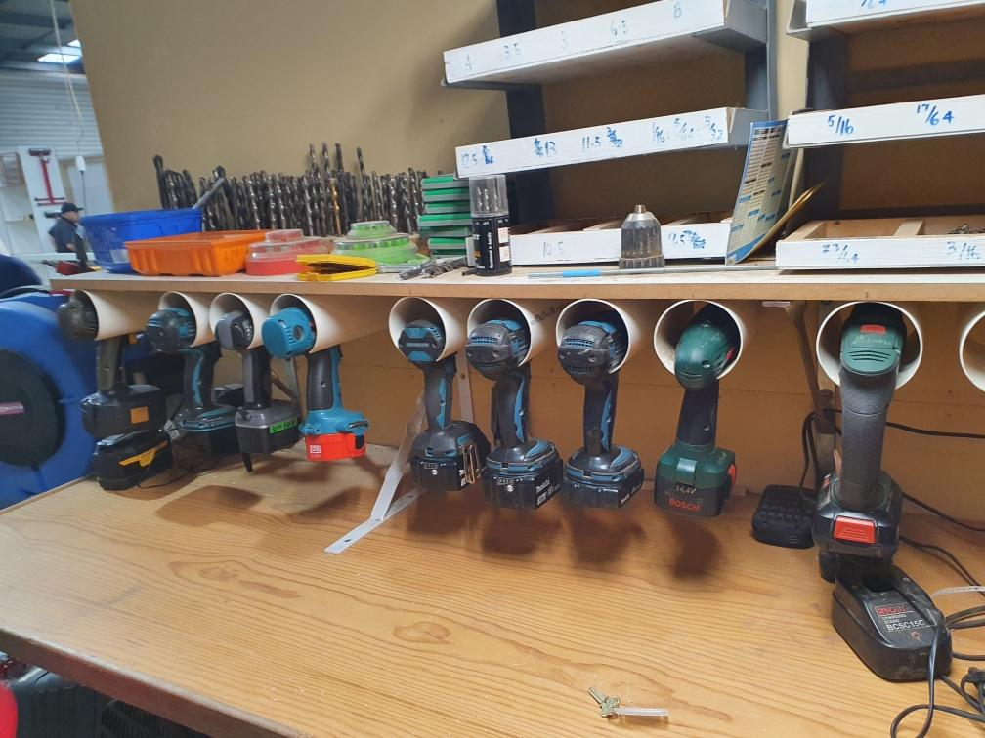

Ray adding more drill holders.

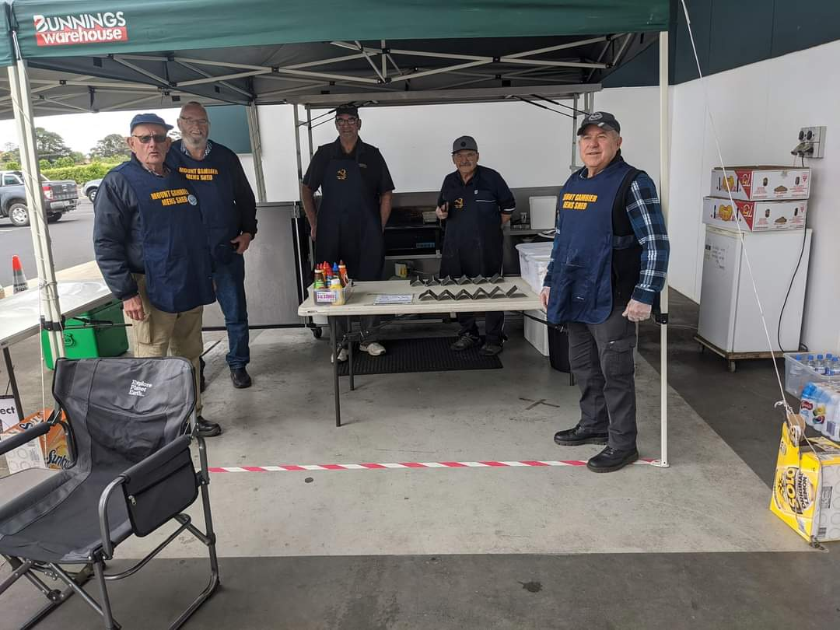

Photo of team one at the latest Bunnings sausage sizzle.

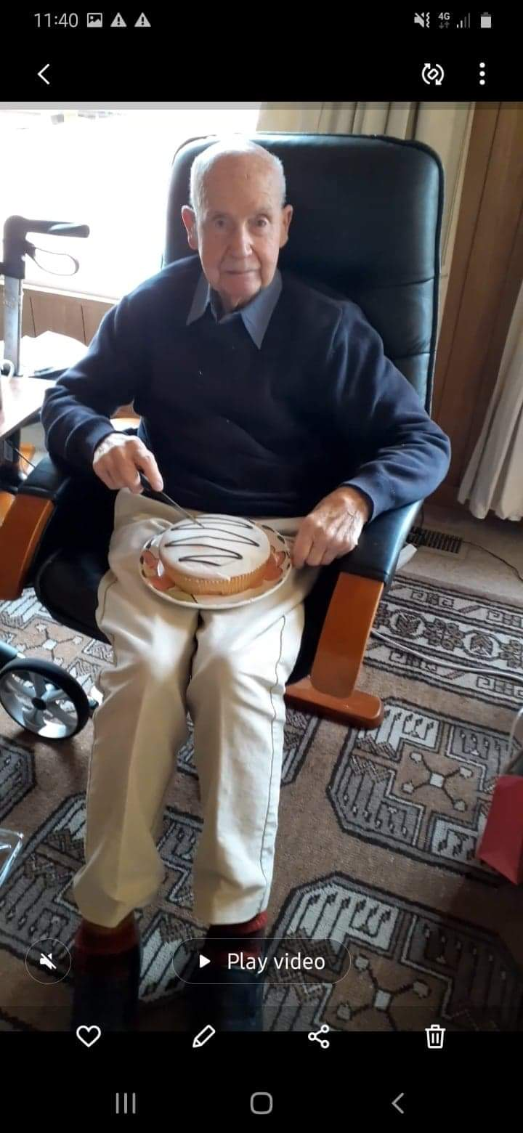

This gentlemen our oldest member Kelvin turned 97 the other day so Ben the scone man got him a cake.

Congratulations from the whole team at the shed.

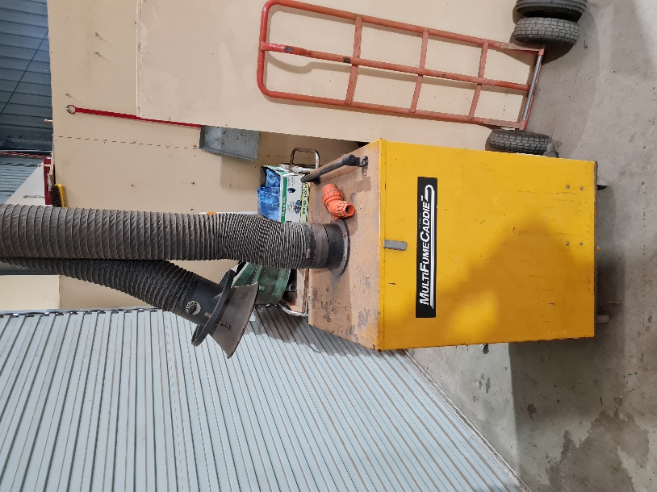

The Mount Gambier men’s shed has to give away a 3 phase dust extraction all you need to do is arrange to pick it up and it is yours.

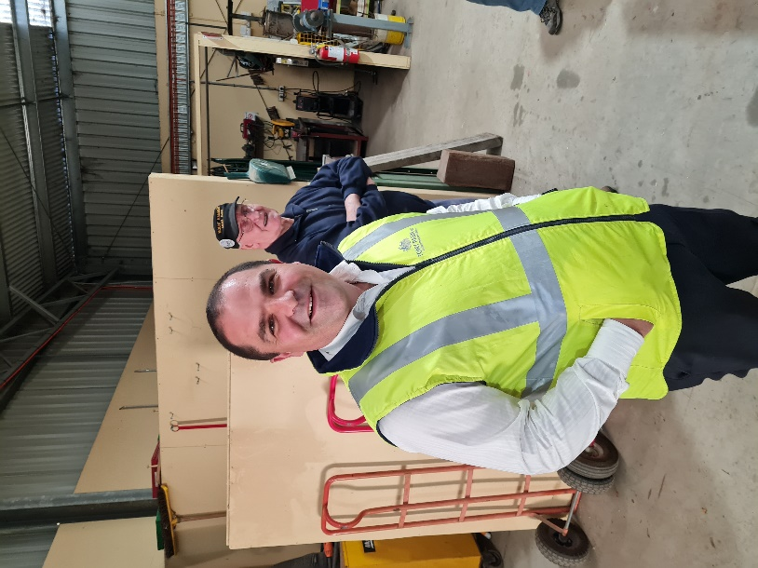

On Thursday the 29th April the shed had the honour of local Liberal Member of Parliament Tony Pasin visit while members were having a sausage sizzle to raise money for Cancer Council morning tea fundraiser.

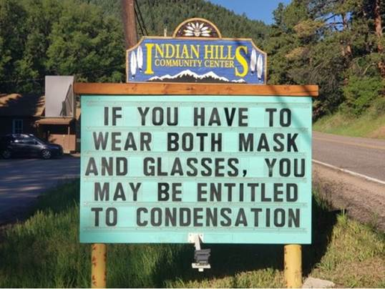

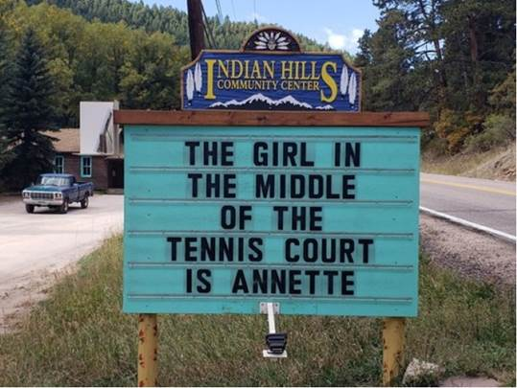

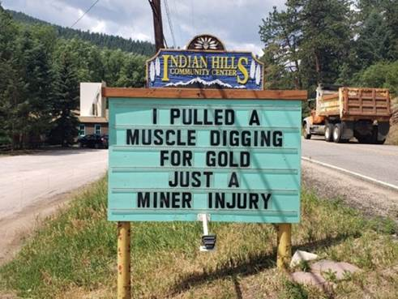

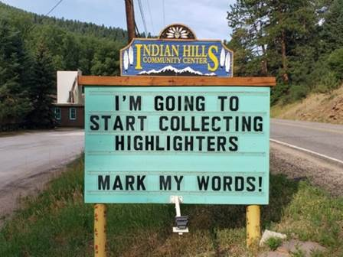

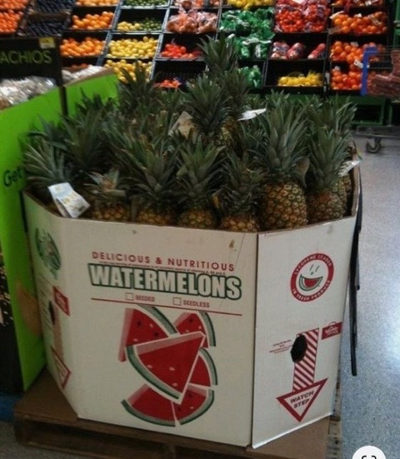

**Hope you have a good laugh with these pictures.**





