**EXECUTIVE MEMBERS FOR 2022**

**PRESIDENT**: Ian Bond 0420859540

**VICE PRESIDENT**: Grant Sullivan

**TREASURER**: John Plunkett

**SECRETARY**: Paul Edgeworth 0497386846

**PHONE**: 0478614027 (prefer Tuesday and Thursday AM.)

**WE NOW HAVE A WEB SITE FOR THOSE WHO WISH TO LOOK. THIS WILL BE UPDATED FROM TIME TO TIME WITH NEW PHOTOS, NEWSLETTERS, RADIO REPORTS, CONTACTS AS WELL AS UPCOMING EVENTS AT THE SHED. Go to**

[**www.mgmensshed.com.au**](http://www.mgmensshed.com.au)

**FACEBOOK** Mens Shed Mount Gambier

[mgmensshed@gmail.com](mailto:mgmensshed@gmail.com)

**2023 Calendar BIRTHDAYS**

Jim G 08/01

Bob P 16/01

Timothy C 17/01

Lyndon M 21/01

David N 31/01

Ansi N 04/02

Ross S 04/02

Paul C 04/02

Craig V 15/02

Gary A 19/02

Joe C 24/02

**7th Februar**y Tuesday - 11am Diabetes screening **15th February** Wednesday 10am (Vic) Heywood Shed cluster get together speaker Trevor Dobbin President Victorian Mens Shed Assoc (5 Sheds invited). **22 February** Wednesday 12pm to 6pm Race Gates. March Garage Sale

March /April Bowel talk Mathias Wichmann

**Woodworking is all about the touch of the woodworker’s hands. There is no alternative to the tasks which are best done manually. Such tasks require specialized tools for performing each job. Hand tools make a lot of works easier for the woodworker. All it requires is to have the perfect tool for each job.** The woodworking requires some[**compulsory hand tools**](https://thetoolspick.com/types-of-hand-tools/) within reach for effortless woodworking. Some of the woodcraft tools will be mentioned in the next 11 newsletters. Let’s check them out. **1. Chisel**

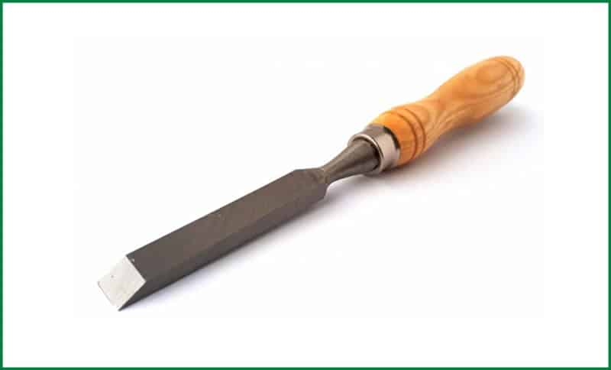

A woodworking chisel is a small hand tool with a categorically shaped blade. The edge of the blade bears different angles and sharpness for serving different cutting purposes. The blade remains mounted on a handle typically made of wood but can be of other materials too. To cut the wood, the chisel is forced into the wood piece by striking on the handle with a wooden mallet. Chisels can be of different types based on their shape, size, structure, and cutting edge angle. Such as mortise chisel, socket chisel, bench chisel, [framing chisel](https://thetoolspick.com/best-timber-framing-chisels/), paring chisel, skew chisel, and so on. Uses of Chisel Chisels play a vital role in woodworking. It is used for carving out wood. The outline of the design is laid using a chisel. It helps in making small detailed cuts with the help of smaller chisels. It can also help in creating Tenon’s, pairing and scraping.



**Receipe:-**

When you make this mix all together and put spoonfulls onto a baking tray.

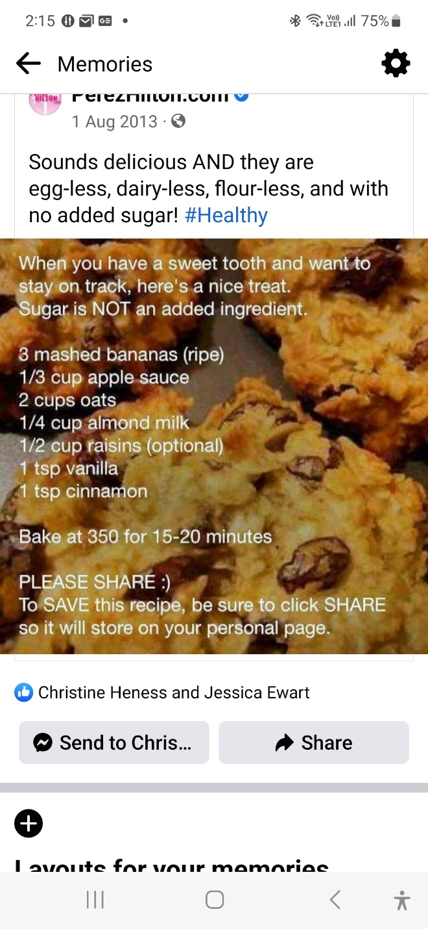

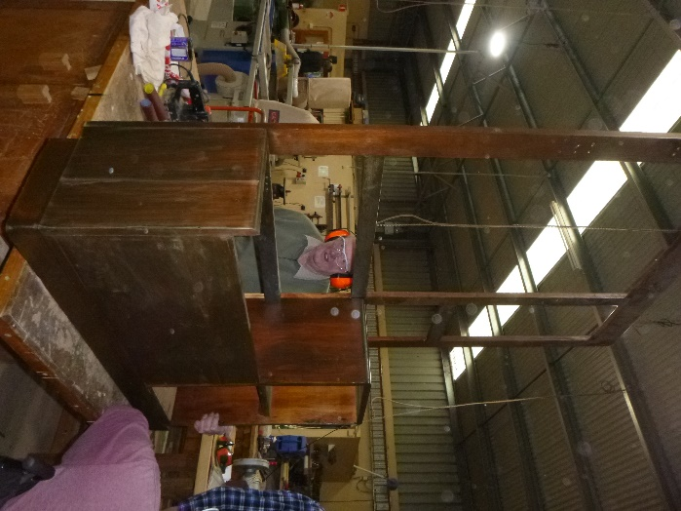

The hall stand Bruce is restoring.

**PROFILES:-**

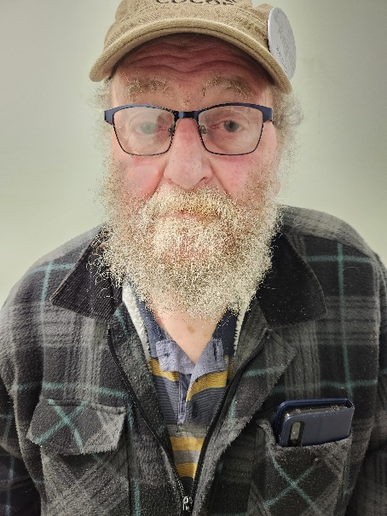

Name:-Stan Blachut Where have you worked:-Beaurepaires and S.E. Batteries Something about you people at the shed don’t know:-Played squash for years. What do you want to achieve at the shed:-Friendship and help where needed.

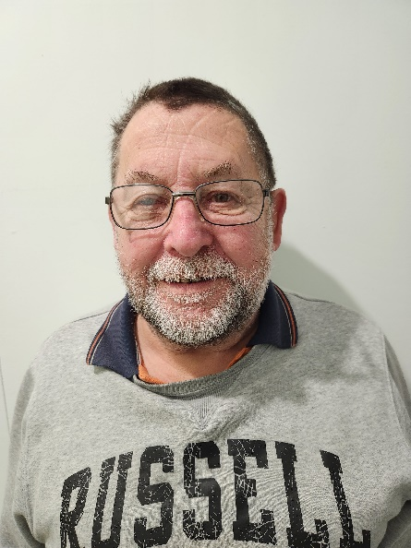

Name:-Angelo Morandin. Where have you worked:-Plumber, Woods and Forrest S.A Gas section Something about you people at the shed don’t know:-Carer for years loves a punt on the horses and loves gardening. What do you want to achieve at the shed:-Somewhere to go and make friends.

Below. Towards the end of last year Ian, Paul, Russell and David attended Murray Bridge for the AMSA Shed Cluster.

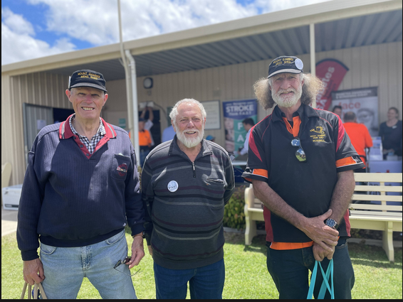

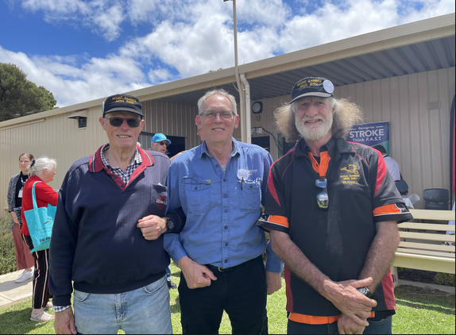

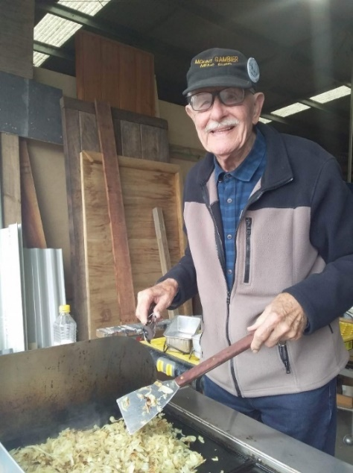

Ray decided it was time he did some work and let Ben relinquish his tonges at the last BBQ for members.

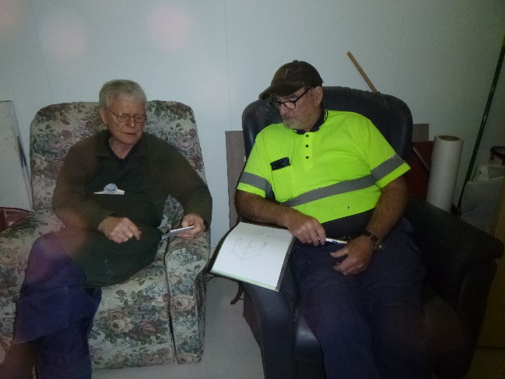

Jim and Dave sharing construction info.

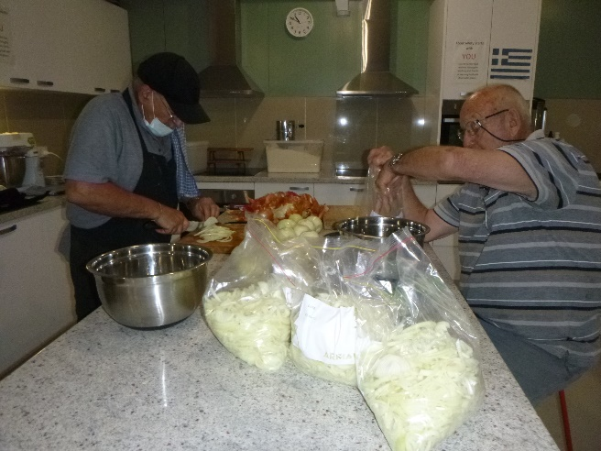

Must be another Bunnings sausage sizzle coming up with Ben and Graham cutting up onions again.

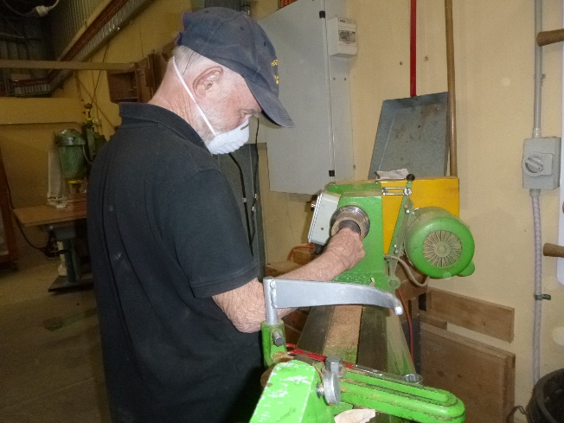

Glen doing the finnishing touches on a cup he is making.

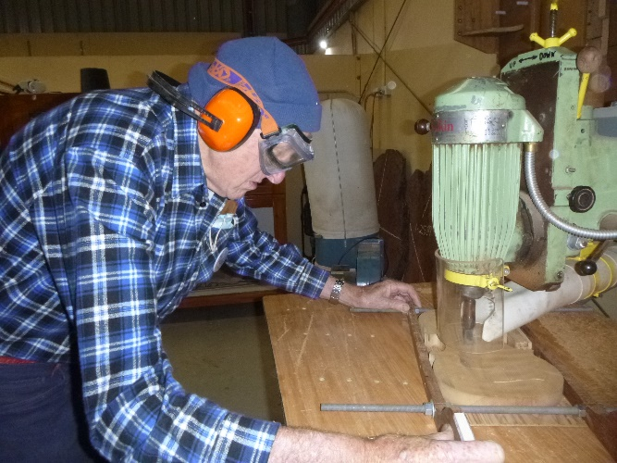Kevin working on the violin he is making.

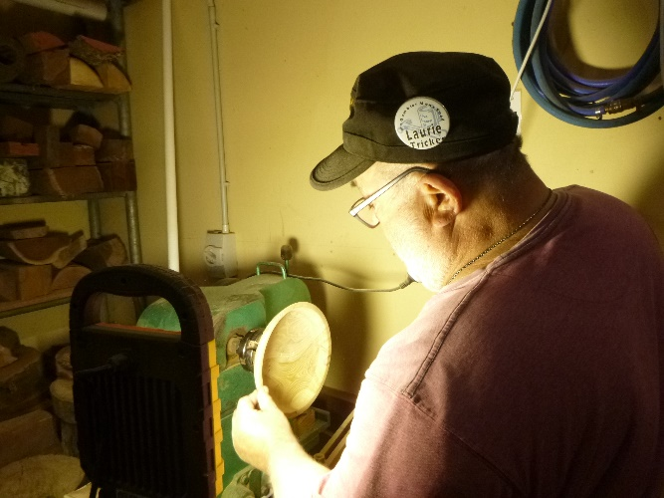

Laurie turning a bowl for shed supporter “Sugar and Spice” for their birthday.

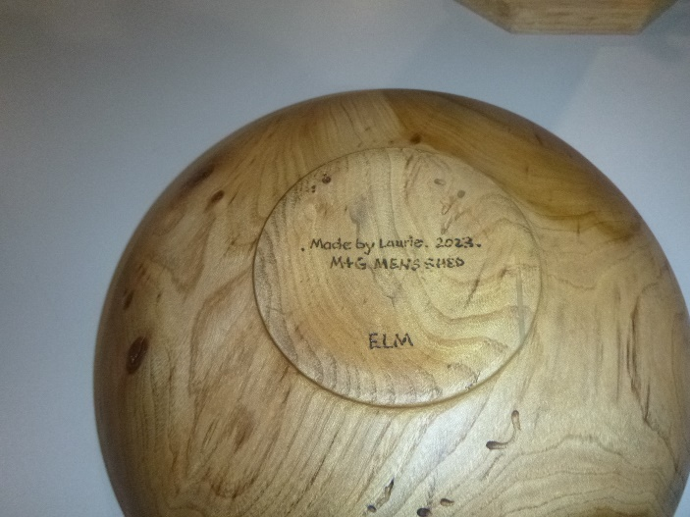

The back of Laurie’s finished bowl

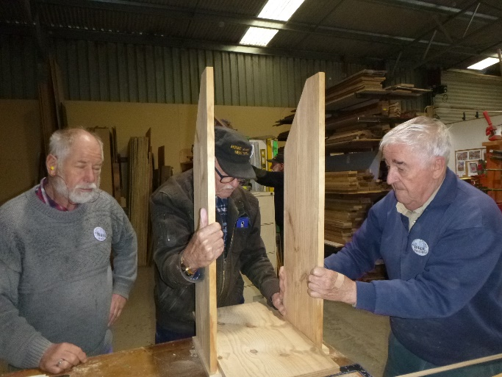

Mark and Ray helping Dick to make his vegetable tidy.

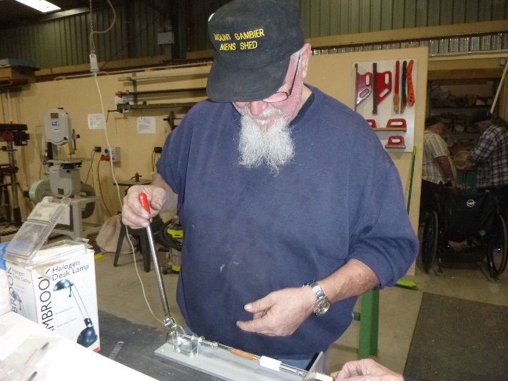

Tony making 1 of the many pens he is wanting to make.

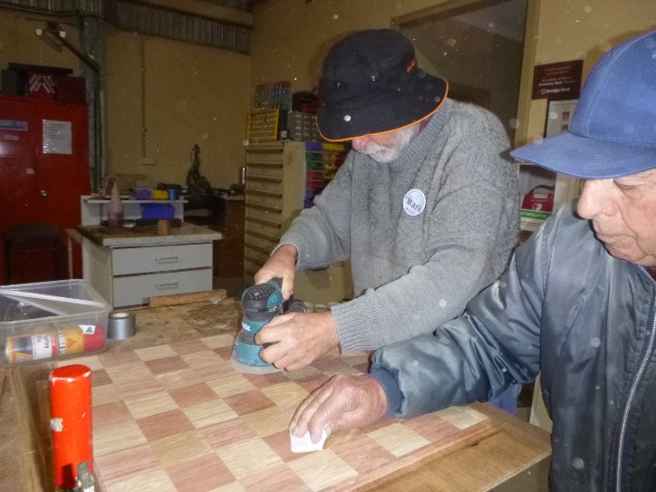

Mark and Joe helping to sand a chess board.

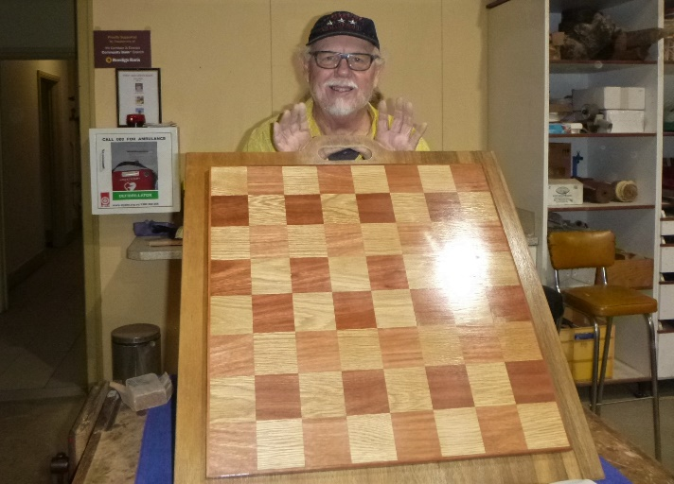

Matt with his finished chess board.

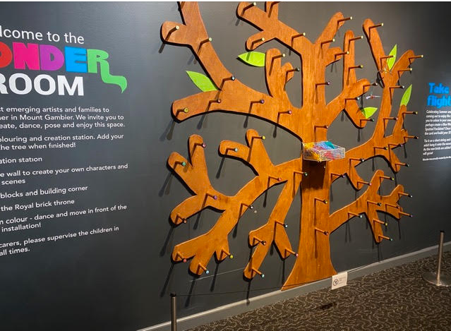

The peg tree made by Dick and Kevin on display at the Riddoch Art Gallery.Well done.

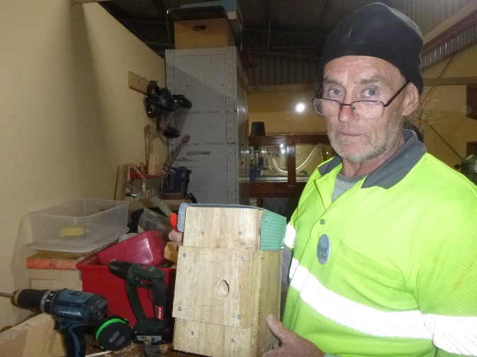

Ron with the bird box he is making.

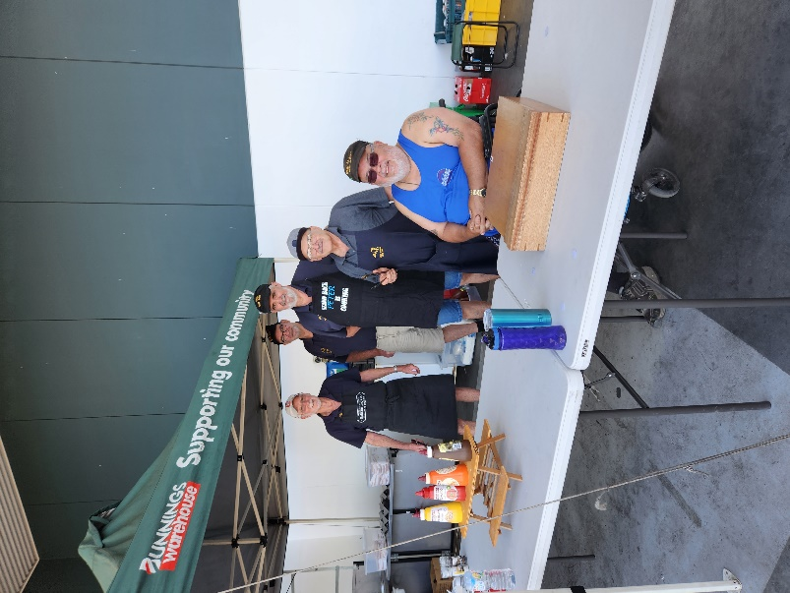

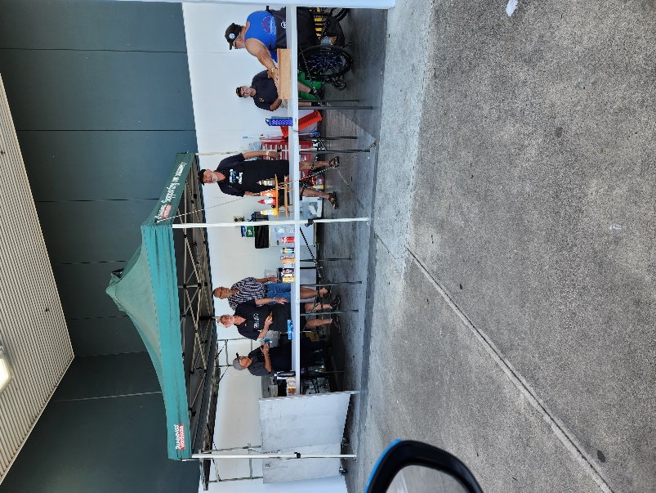

It was 39deg at the last Bunnings sausage sizzle but one group seem to be working the other group decided a sit down was the go. Well done to you all in the adverse conditions.

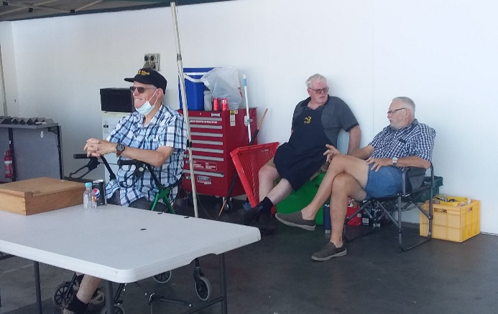

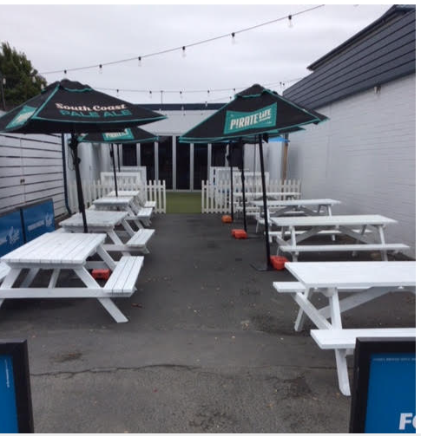 Nice to see some of the many outdoor tables the boys at the shed make, being used.

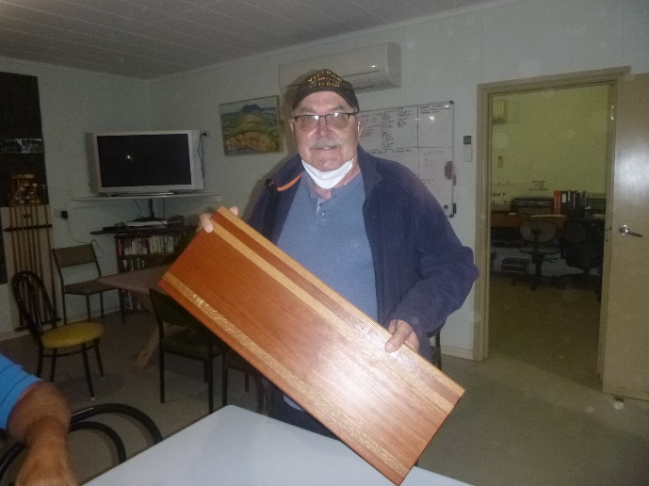

Ansi with the serving board he made.

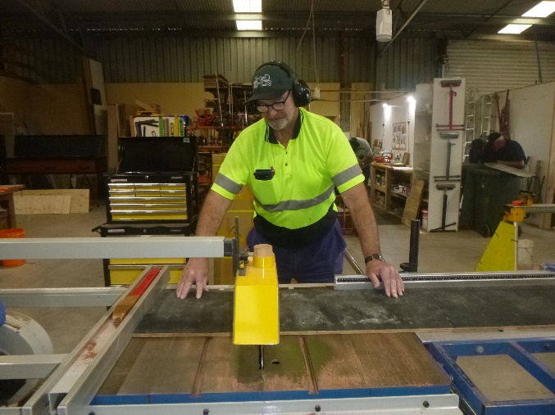

Dave using the table saw.

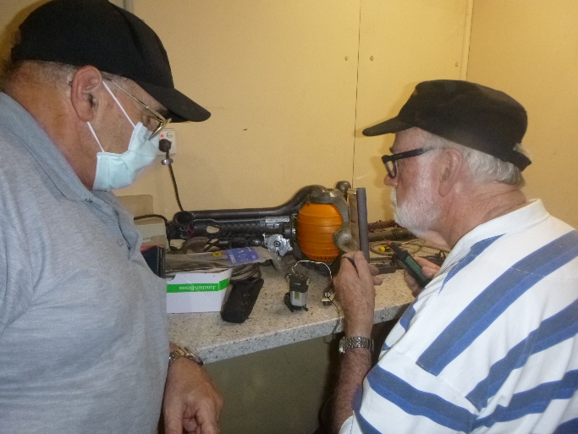

Rob repairing a vaccum cleaner while Ben is watching on.

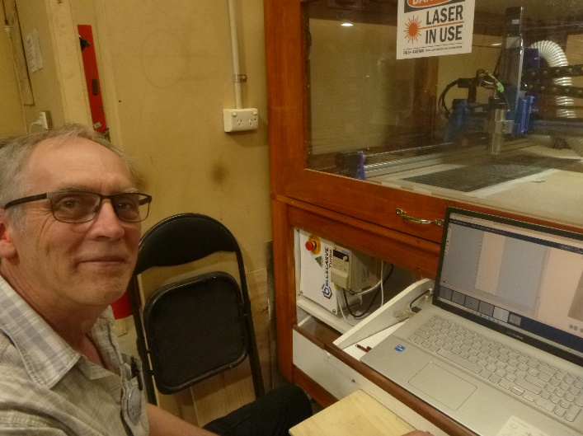

Dave working on the CNC macghine.

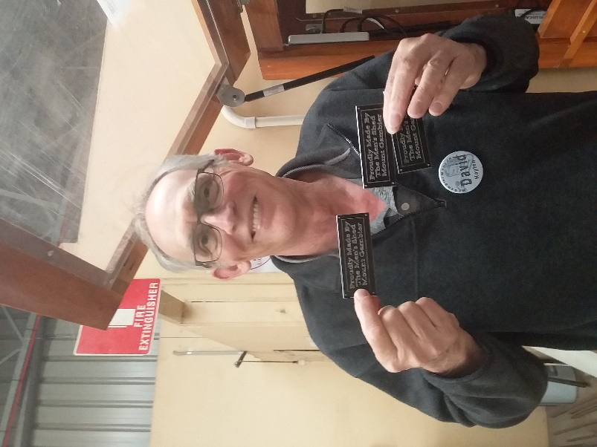

Very proud Dave showing off some of his handy work on the CNC.

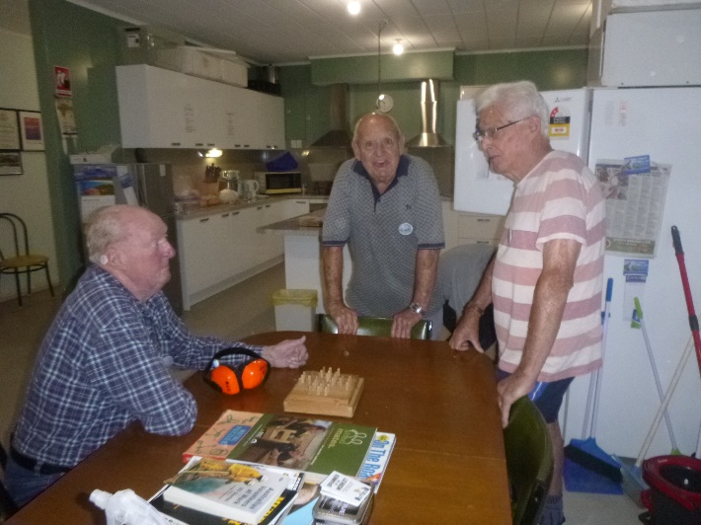

These fellows know how to talk. Neither Bruce, Graham or Graham know what each is talking about. But they are having a good time doing it.

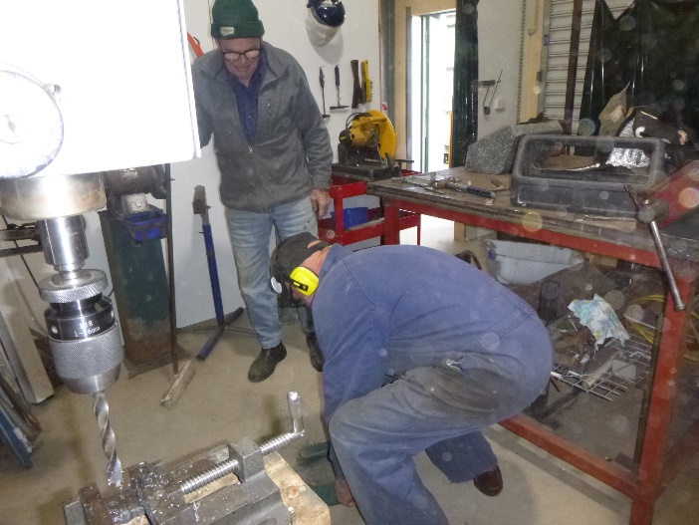

Bruce cheaning up his area while Trevor looks on.

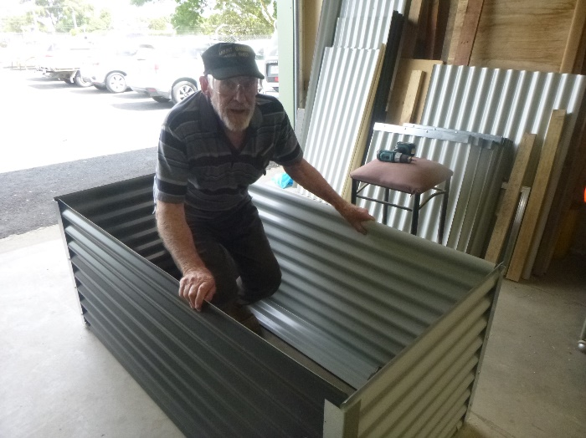

Frank showing of the new raised garden bed. Think he is about to sleep in it.

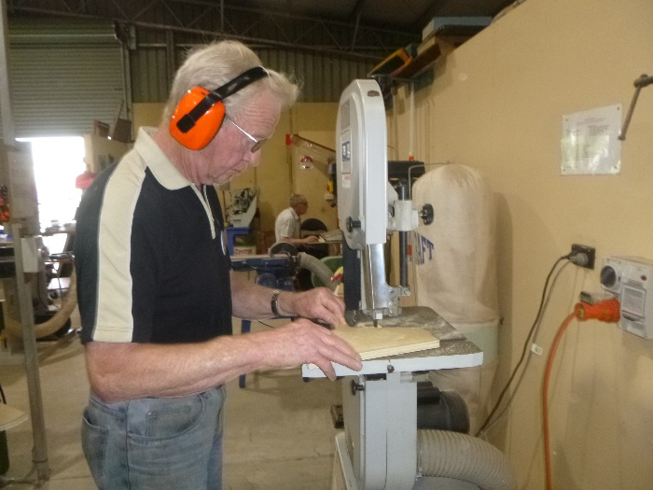

New member Jim helping out the toy boys cutting a horses head out.

Below is an excerpt from Jeffery Huddlestone and was recently put into the BorderWatch.

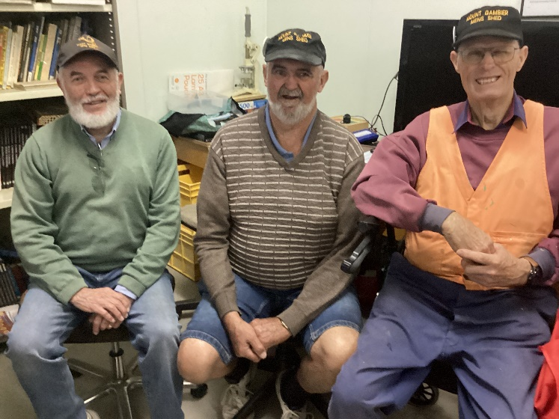

Mateship at the Men’s Shed. By Jeff Huddlestone. The first meeting of the year for the Mount Gambier Men’s shed on January 10th was very well attended at the facility on McDonnell drive. The large shed is leased from the City council and has been the group’s most recent home for the last six years. A member of the Australian Men’s Shed Association, the idea is to help the social and mental health of all men. The movement is funded by the Federal Government, supported by the local council and also assisted by membership subscriptions. Locally, it has around 75 members and contrary to current trends of dwindling membership, closure and talk of mergers of other groups, the Men’s shed is hopeful of expansion. The shed currently operates on Tuesdays and Thursdays and would also like to open on Wednesdays for the benefit of new members. A local tradition is enjoying hot scones and a cuppa at the start of each meeting, and the men really like the fellowship and mateship that ensues. The tradition began at the shed’s first home many years ago at the Mount Gambier Baptist Church. The genesis of the local men’s shed began in February 2009 , when then community health officer of the city council, Christine Plunkett , the wife of current treasurer John Plunkett, organised the first stakeholder meeting. Later 8 local men became Men’s Shed Members.

Thanks to the efforts of Graham Carter, the local organisation was incorporated in 2010 and the history of the Mount Gambier Men’s shed grew from there. As well as the Baptist church, the shed has had other homes, including the Quickmix and Roccla sites and the Council depot on Commercial street West. Former Councillor, Ian Von Stanke was a driving force in securing the move to its current site. After the cuppa and chat, members turn their attention to practical tasks, such as wood and metal work, with the use of machinery, lathes, tools and other equipment, following training and safety clearance. Publicity officer, Peter Heness, said about 150 wooden toys are made for the Mayor’s Christmas

Aappeal, for distribution to local children each year and is well received by the community. “We keep in touch with the council to find out what it and the different charities need and we build to what they require” Mr Heness said. The Men’s shed concept was developed around 30 years ago by a female doctor in the Goolwa Strathalbyn region of South Australia. “This lady had seen a problem with the mental health of men who had retired. “So she got in touch with all the service clubs and had a meeting to start a shed”, he said. The concept has grown around Australia and internationally. “With more than 1300 sheds in Australia and expanded to 20 countries around the world, including America”, Peter said. Men’s Shed member for the last nine years is David Lawson. Mr Lawson has seen the benefits of helping his own social and mental health. He moved here from Tasmania in 2006, because of health issues. Rejection of job applications caused depression and with the support of a friend, he joined the Men’s shed. “The aim of the shed is to socialise and talk to one another. “ Mental health is number one. The workshop is number two if you want to get involved and learn new skills and trades, “Mr Lawson said. He encourages other men to come and visit the Men’s Shed and see it for themselves. The first two visits are free and there is a subscription after joining. Local Men’s Shed President, Ian Bond, proudly showed a record of projects completed for the benefit of many community organisations. They include boards to help dementia patients, rebuilding a shed for the Church of Christ and building a mud kitchen for Reidy Park school He said the biggest project was making a wooden peg board and a camera box to show the exhibits at a the Riddoch gallery in their best light. Men’s shed members also man the gate at the Glenburnie races to boost funds. Mr Bond is optimistic about the local Men’s Shed’s future, of which the City Council is aware “They can see that we need more room. So it is in their hands as to when and if it happens. We hope it does, because it will be bigger and better”, he said Ian sees benefits for more men to attend the Men’s Shed on Wednesdays “ Whether it’s sitting at a table having a coffee and a yarn. “ What can I learn and conversely, what can I teach. It’s a matter of passing on your knowledge and experience,” Mr Bond said.

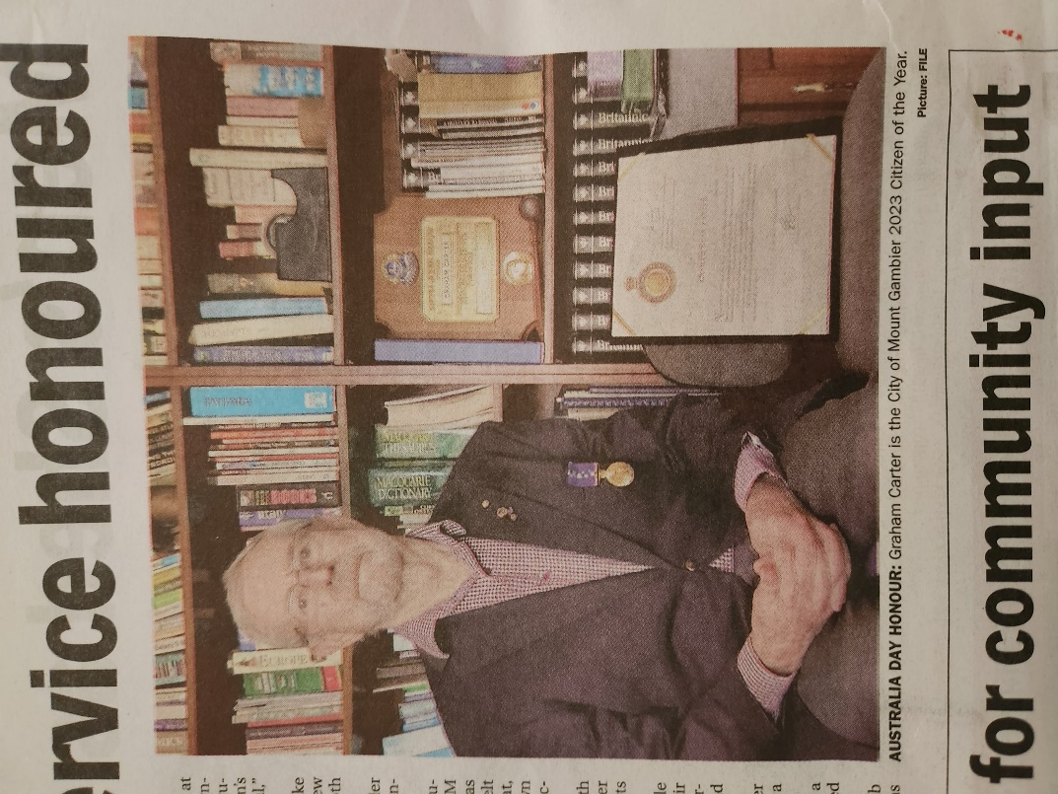

Inaugural Men’s Shed member Graham Carter honoured with Australian of the year this year.



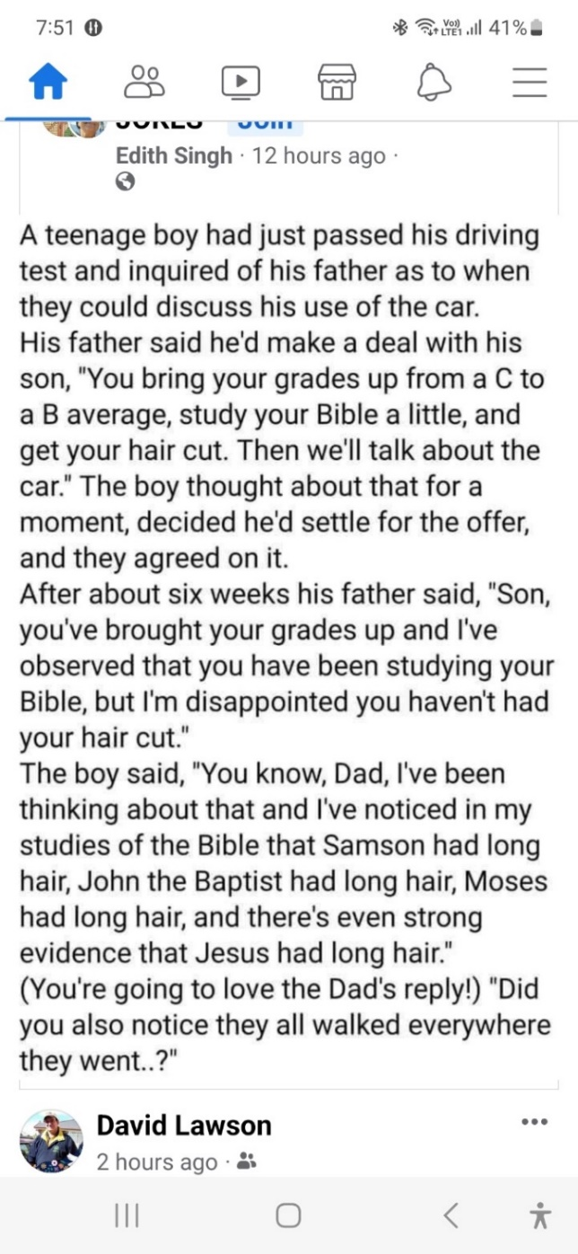

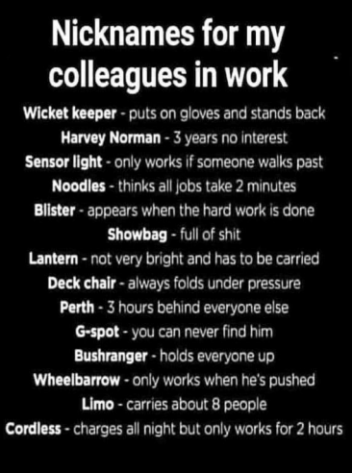



 





**Big supporters of Mount Gambier Men’s Shed.**

**SUPPORT YOUR LOCAL BUSINESSES**

**THAT SUPPORT YOU.**