**EXECUTIVE MEMBERS FOR 2023**

**PRESIDENT**: Ian Bond 0420859540

**VICE PRESIDENT**: Grant Sullivan

**TREASURER**: John Plunkett

**SECRETARY**: Paul Edgeworth 0497386846

**PHONE**: 0478614027 (prefer Tuesday and Thursday am)

**Tuesday, Wednesday & Thursday** 9am– 12pm

**1a McDonnell Drive**

Website [www.mgmensshed.com.au](http://www.mgmensshed.com.au)

FacebookMens Shed Mount Gambier

Email [mgmensshed@gmail.com](mailto:mgmensshed@gmail.com)

**BIRTHDAYS**

Peter K 01/12

Graham C 22/12

Trevor P 28/12

**CALENDAR - December**

6th December Wednesday 9.10am Radio program Tune in to ABC AM1153 or AM147

13th December Wednesday 6.30 Meal with partners

at Ba-Mi Vietnamese Restaurant 3B Commercial St West

14th December Tuesday 10.30 Members Meeting

21st December Thursday last day of Shed year

**2024**

4th January Thursday Shed reopens

If you would like to contribute information or an article to your newsletter, talk to Editor David N or email [mgmensshed@gmail.com](mailto:mgmensshed@gmail.com)



**11. Sanding Block**

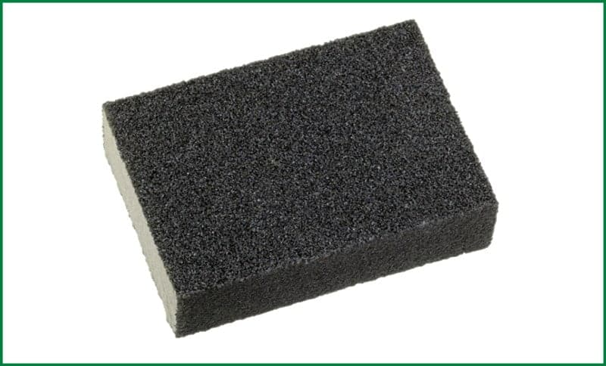

[A sanding block](https://thetoolspick.com/best-sanding-blocks/) is a sandpaper holding device. It is one of the most basic woodworking tools. The typical sanding block is square in shape, but the structure and shape changes based on usability. Woodworkers normally make it with wood. The block with sandpaper on it helps to remove the rough grains from the wood surface to make the layer smooth.

**Yesterday I lost 100 sheets of sandpaper...**

**but I have a rough idea where they are**

**Alan**

**Brian Glen**

**Andrew Grant**

**Herman Allan Graham**

**Dale John Ian Peter Trevor**

**Ansi George Wayne Paul Vince**

**Ben Graeme Jim Mat Ross Joe Bert**

**Jeff Bruce Gary Don Ray Tony Phil Michael**

**Bill Geoff Frank Bob Kevin Laurie Lyndon Rob**

**Dick Craig Dave Rod Shane Tim Ron Mark Russell David Angelo Stan Des**

**Coffee**

**Scones**

**NEW MEMBER PROFILE 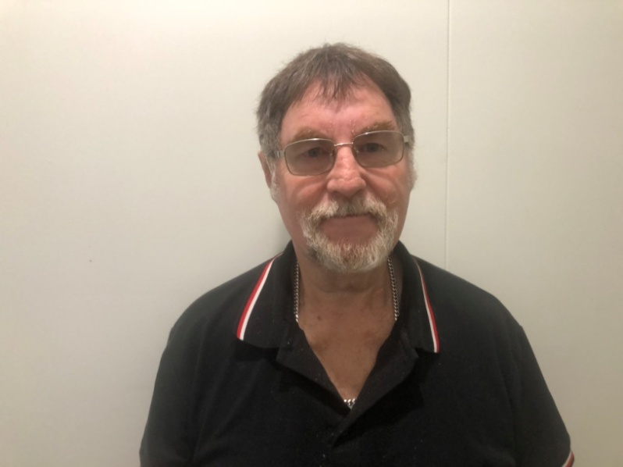John Kirby** spent 12 years in the RAAF and did one tour of Vietnam. He grew up in Maidstone, Victoria, is married with a son and 2 grandchildren. John loves working with wood and creating things. He follows Richmond in AFL and is looking forward to friendship and having a good laugh with everyone at the shed.

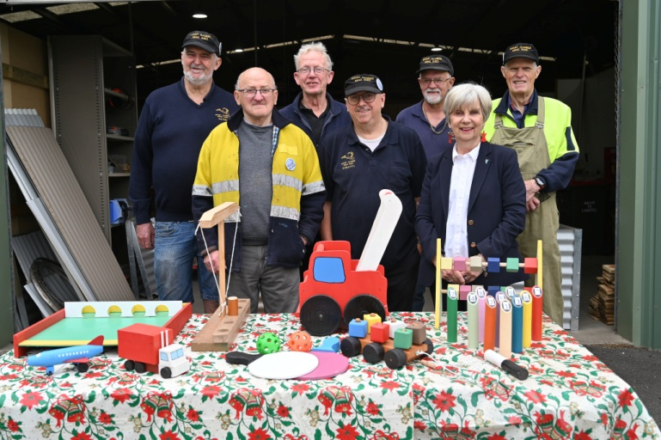

Peter, George, Jim, Shane, Gary and Ian spent hundreds of hours crafting 130 handmade wooden toys to donate to the 2023 Mount Gambier Community Mayor's Christmas Appeal. Mayor Lynette Martin accepted the toys at the shed and thanked the volunteers for their contribution. Over the past seven years the volunteers have made 1000 toys for children in our community.

Used with permission Mt Gambier City Council

My mate built himself a motorbike.

It's got a wooden frame, wooden engine, wooden wheels, and a wooden gas tank.

Did he ride it?

No, it wooden start!

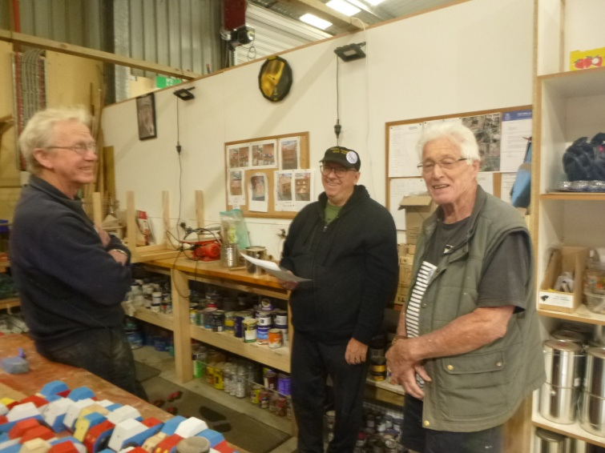

In the toy shop – Jim, Shane & Graham

|  |  |
| --- | --- |
| 2023 11 Jeff Redwood with the  Christmas tree's Star made by Trevor adams.JPG | 2023 11 Christmas trees - multiple designs Grant Sullivan Jeff Redwood.JPG |

|  |  |
| --- | --- |
| 2023 11 Jeff Redwood Christmas tree - original design.jpg | Top left – Jeff with Christmas tree, star made by Trevor  Top right – Grant and Jeff  Left – original design by Jeff  Christmas tree and stars.jpg |

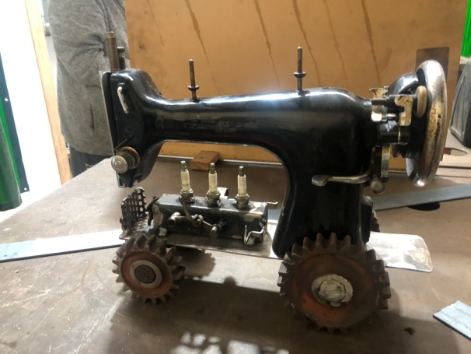

Ians finished tractor

**HEAD TO HEALTH**

A new Federal government initiative has just opened in Mt Gambier. It is a free, walk in **MENTAL HEALTH** service located at 7/165 Commercial Street, open Monday to Friday 9am to 5pm

Finding the right services for you can be hard. Head to Health is here to help you find and access services that meet your needs – including free and low cost mental health services where appropriate. This service is available to all adults living in Mount Gambier who may be experiencing distress or mental ill health, and their families, carers or support networks.

Call 1800 595 212 or go to your local centre.

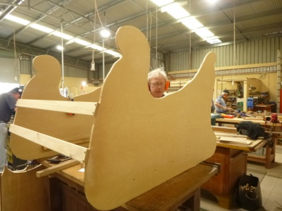

Is that Santa’s helper

in the sleigh?

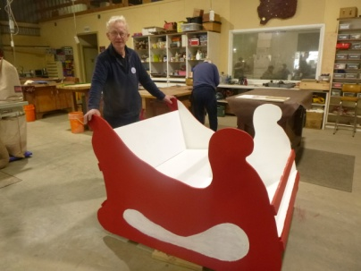

Jim – one of the team who constructed a sleigh for Mulga Street Primary School

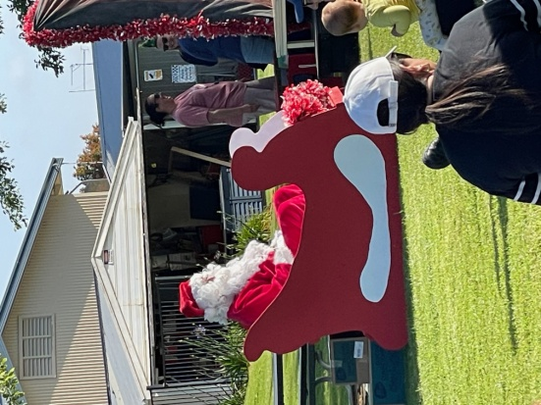

Santa in the sleigh at Mulga Street Primary School



**“I just got new hearing aids” Fred boasted, “they’re absolutely fabulous.**

**I can even hear the plane shaving the wood.”**

**“that’s wonderful,” said Bill, “what brand are they?”**

**“about four o’clock.” said Fred**

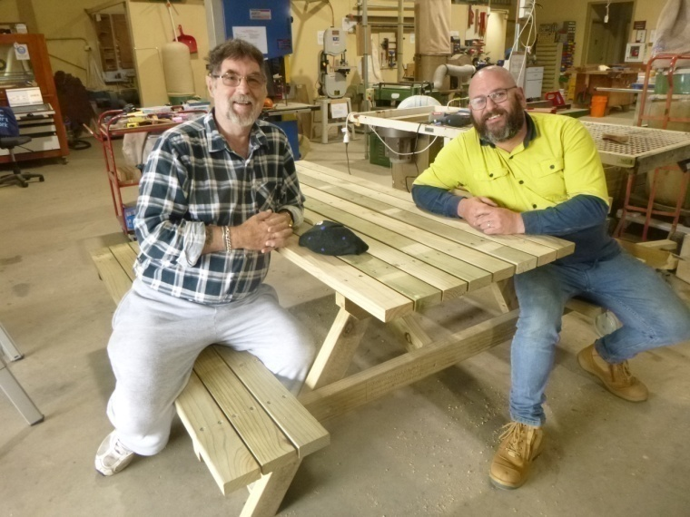

Another picnic table ready to go out the door – John & Mark

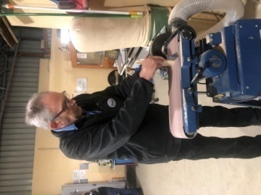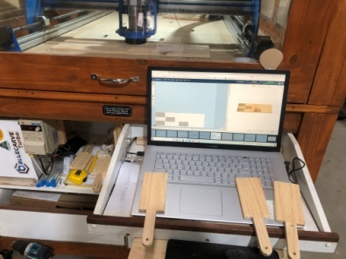

Above left - David sanding Gnocchi boards designed on computer and made on CNC machine above

Left – box of finished gnocchi boards with CNC laser engraving.

Well done David.

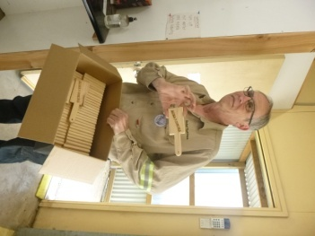

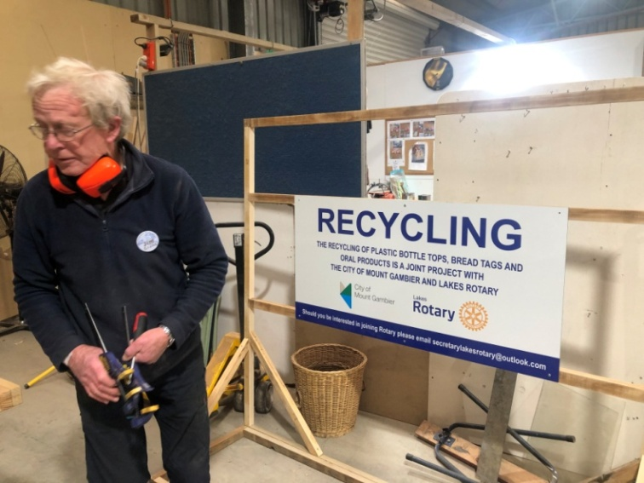

Jim - Check out the finished project at Woolies Marketplace

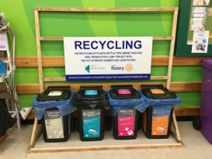

**I tried to recycle a broken pencil . . .**

**but it was pointless!**

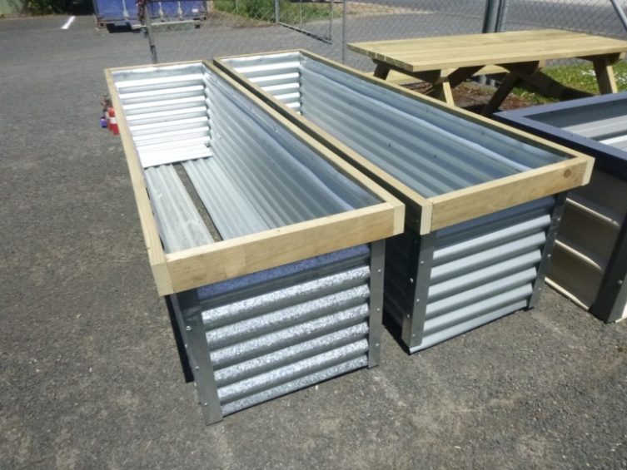

An improved design & finish on raised garden bed design

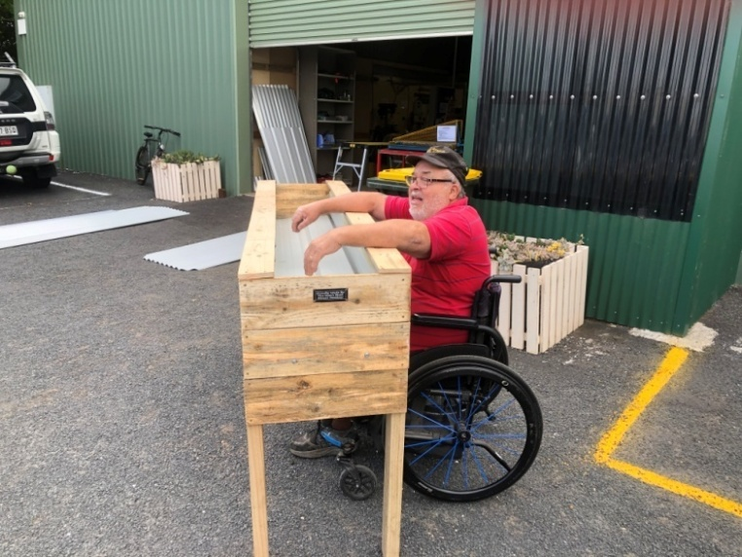

Laurie with wheelchair friendly raised garden bed

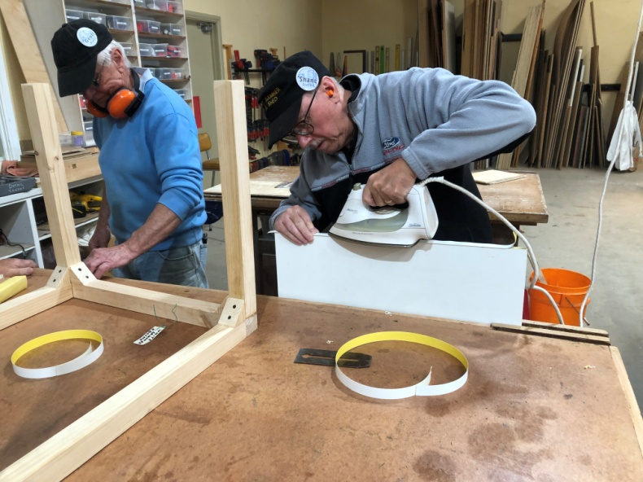

Is it true Stratty does the ironing at home?

**Don’t be irreplaceable . . .**

**if you can’t be replaced,**

**you can’t be promoted.**

**It is far more impressive when others discover your good qualities . . .**

**without your help**

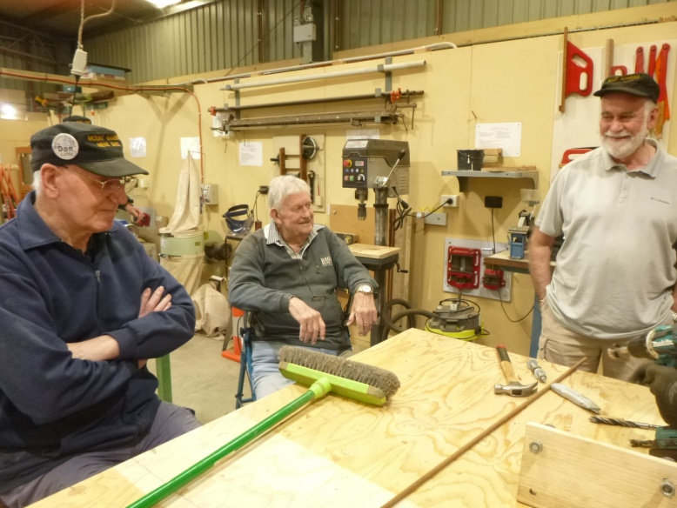

“How do you start the broom?” Don, Ian & Rob

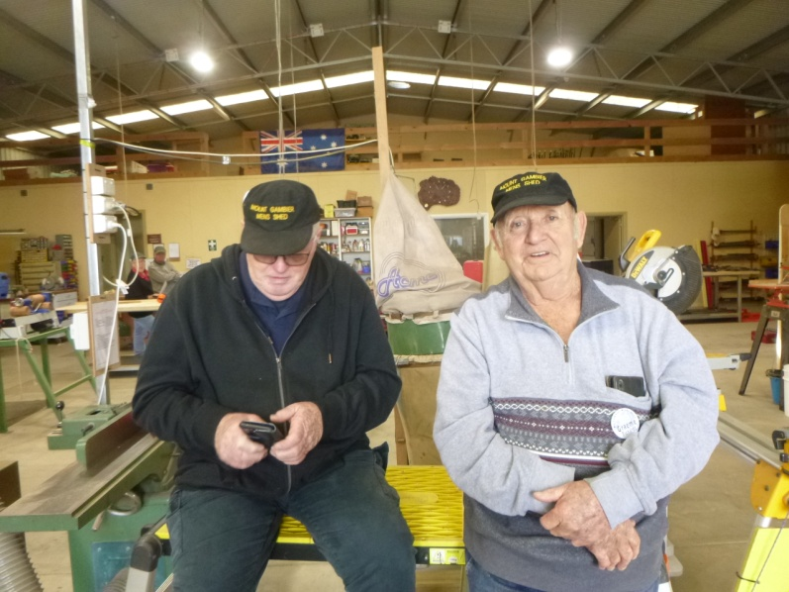

Caught on the hop – Grant & Graeme

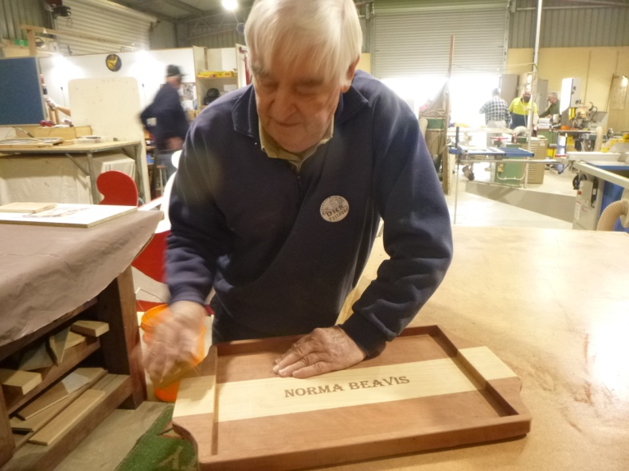

Dick with one of his embossed serving trays

oregon, pine & red gum

**‘BARRY DAY’**

Towards the end of each year, our Shed remembers and celebrates the lives of those Shedders who are no longer with us. This is called ‘Barry Day’

Barry Tuffnell was our first Shedder to die. We recognise all who have passed away and those who can no longer attend due to health conditions of themselves or their partners.

There is a photographic display of all these men on a Shed wall so that newer Shedders can refer to images of those we remember and talk about.

This year we invited all partners of these Shedders to join us in a BBQ lunch together with our own partners.

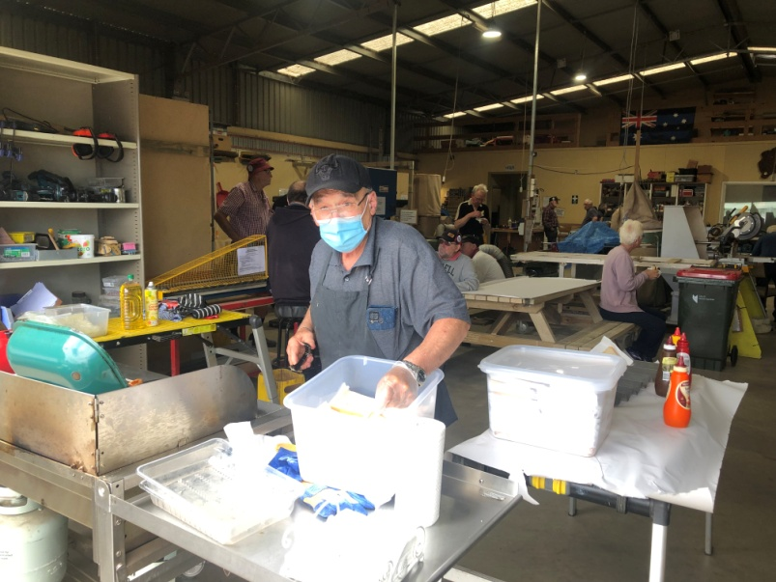

Ben at the BBQ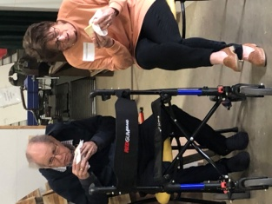Everyone enjoyed the sausages,onions and delicious biscuits

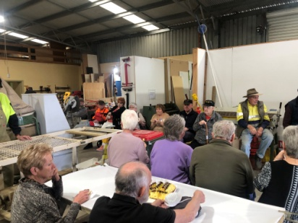

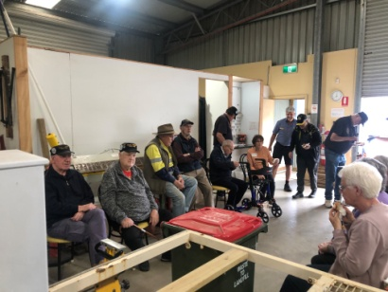

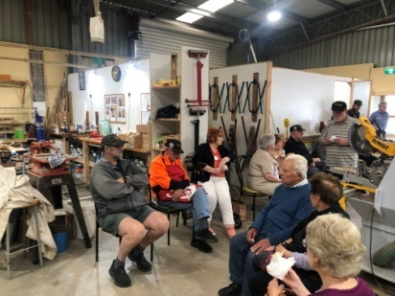

Partners appreciated the food, hospitality, meeting shedders and the opportunity to see where all the work (??) and talking happens.

Barry Day continued . . .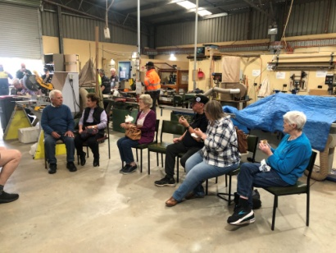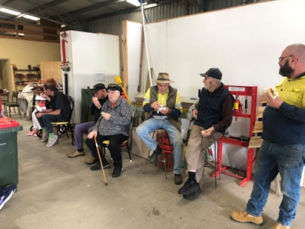

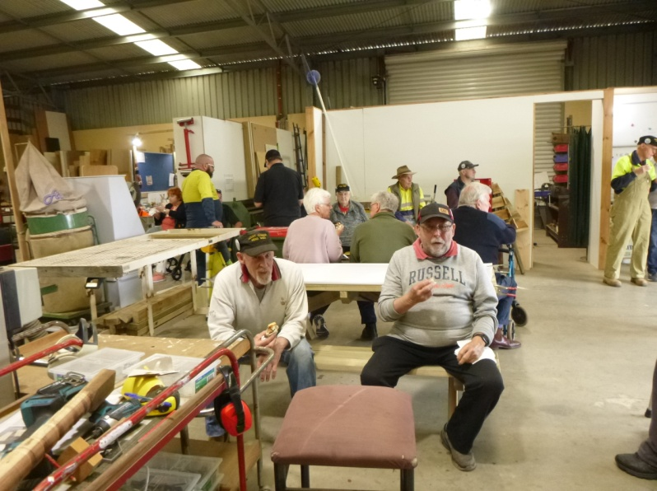

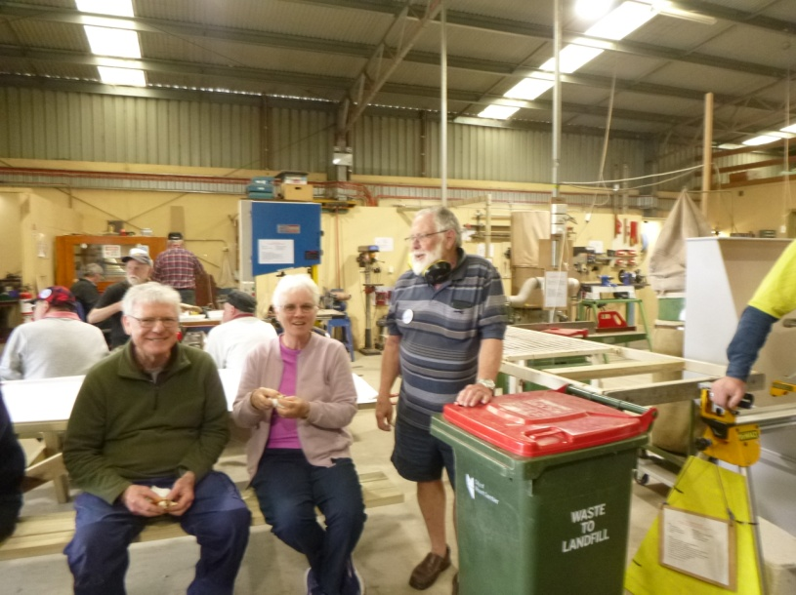

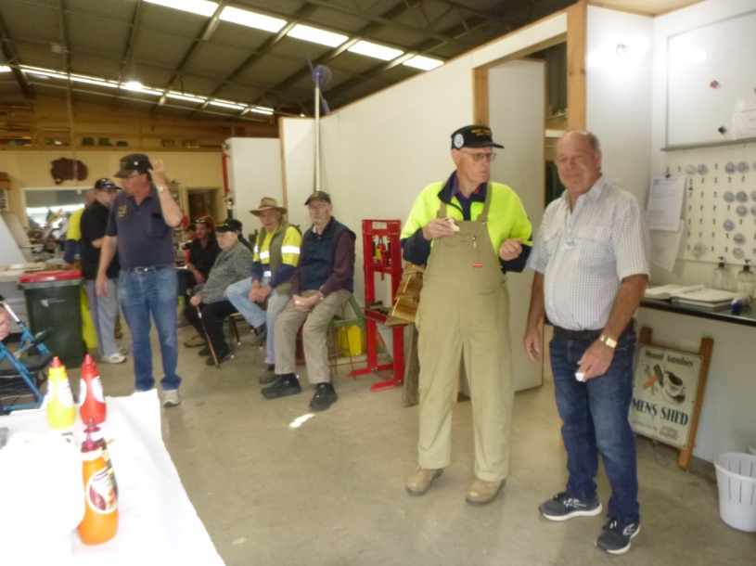

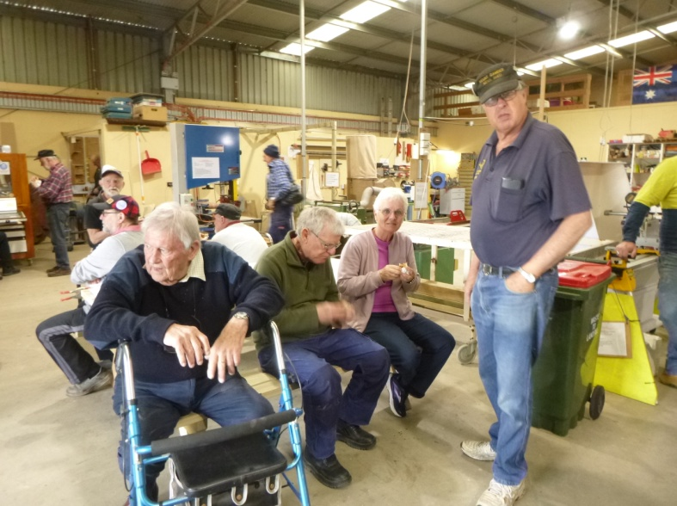

Barry Day - what a great way to recognise and remember past members.

**A man and his wife had a shed in their backyard. The neighbour asked which of them built it and they both replied that they had built it, leading to a massive argument. It was a real He-Shed She-Shed situation.**



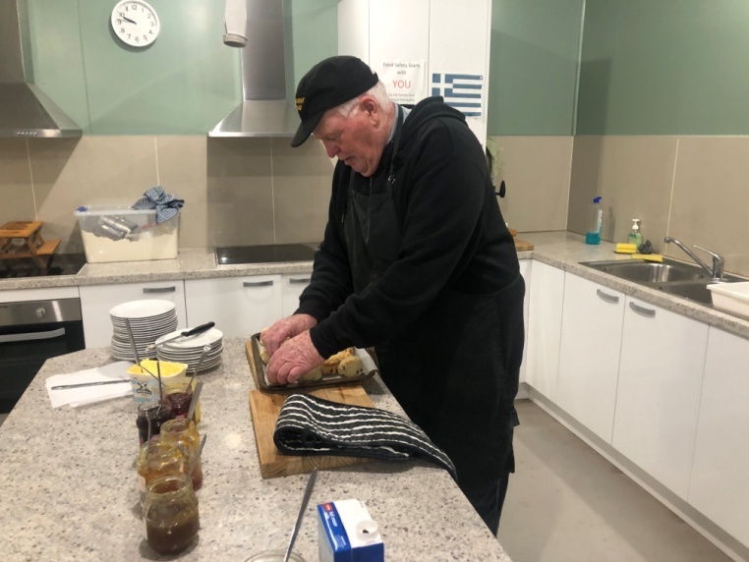

Grant perfecting his scone making skills

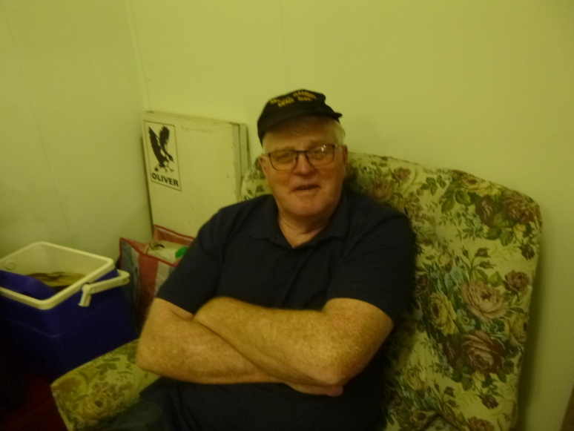

Grant perfecting his relaxing skills

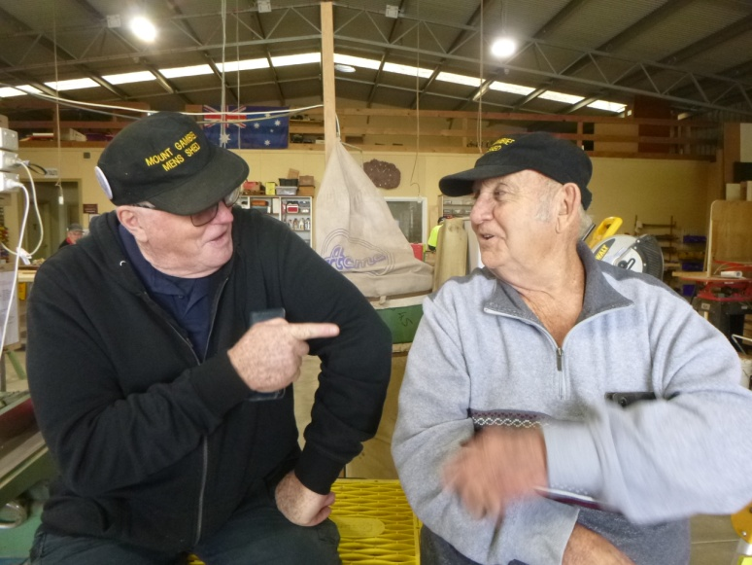

Grant all refreshed and ready for discussion with coffee maker Graeme – doesn’t Graeme know how to make coffee by now?

**You cannot force someone to comprehend a message that they are not ready to receive.**

**Still, you must never underestimate**

**the power of planting a seed.**

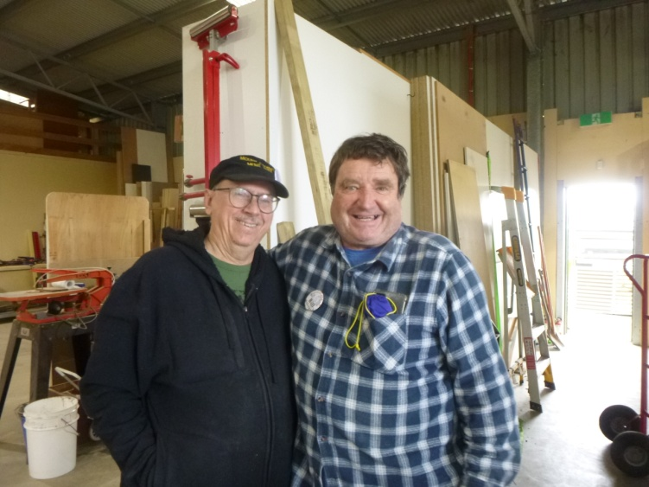

Great mates – Shane & Bill

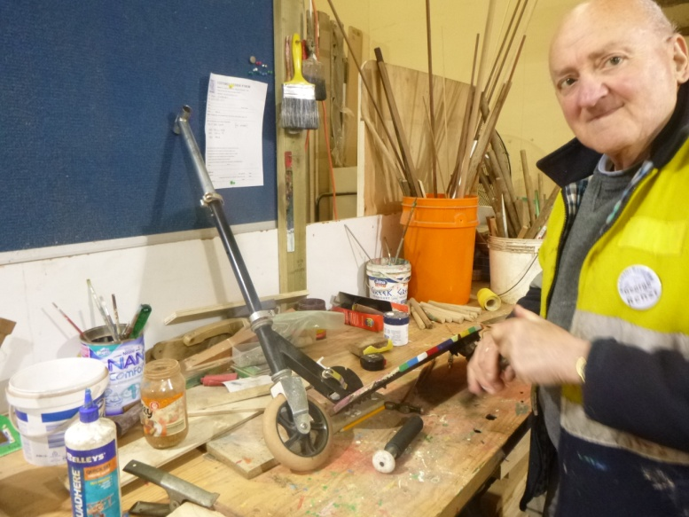

George repairing a scooter

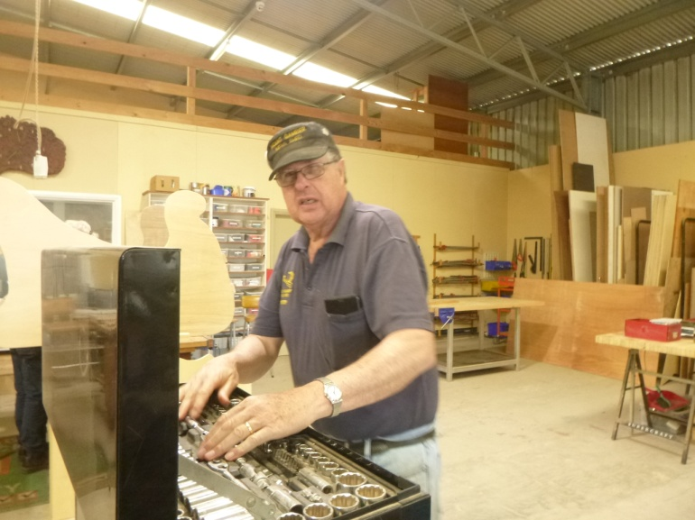

“You can’t hand a man a grander spanner than a Sidchrome”

Peter



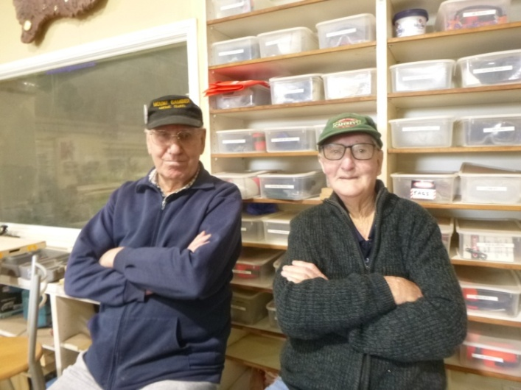

Don & Alan relaxing or are they pretending to be supervisors?

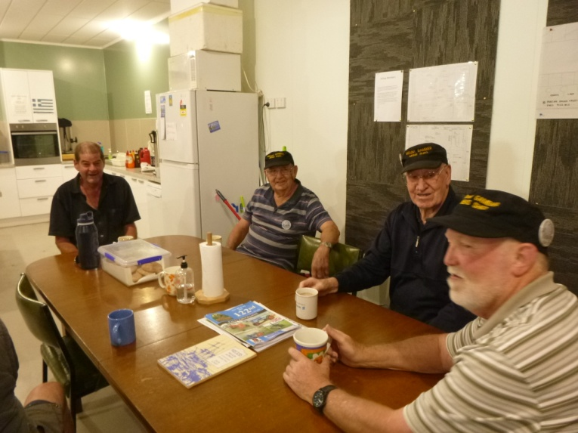

Morning chat – Trevor, Graeme, Don & Kevin

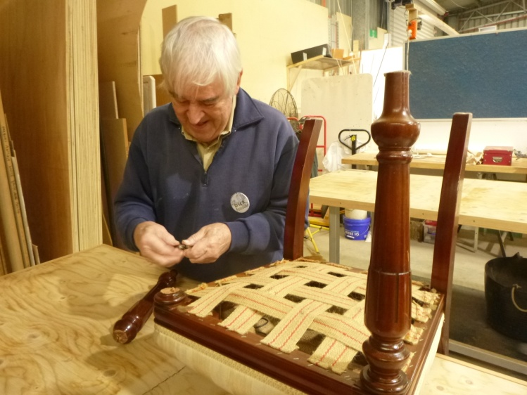

Dick mending broken chair leg

**Before you criticise someone, you should walk a mile in their shoes . . . that way, when you criticise them, you are a mile away and you have their shoes.**

**SPONSORS**











**Big supporters of Mount Gambier Mens Shed**

**SUPPORT OUR LOCAL BUSINESSES**

**THAT SUPPORT YOU**