[mgmensshed@gmail.com](mailto:mgmensshed@gmail.com)

**EXECUTIVE MEMBERS FOR 2020**

**PRESIDENT**: Robert Aldersey 0488311606

**VICE PRESIDENT**: Ben Katris

**TREASURER**: John Plunket

**SECRETARY**: Paul Edgeworth 0887256385

**FACEBOOK**

Shed broadcasts are now available on Facebook

*[Image result for facebook logo](https://www.google.com.au/url?sa=i&rct=j&q=&esrc=s&source=images&cd=&cad=rja&uact=8&ved=2ahUKEwjO9cWTtajeAhUafisKHT6JAHoQjRx6BAgBEAU&url=http://www.seacliffeinn.com/spa-boutique/find-us-on-facebook-logo/&psig=AOvVaw0duNjpvsqixE3Pzu1qEwe2&ust=1540791326821108)*

**Safety: - Remember Safety begins at home.**

Geoff H 19/11

Dale A 24/11

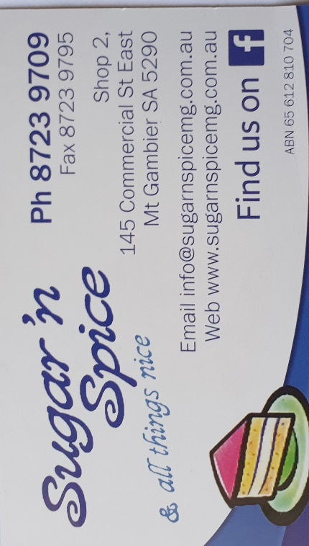

**Remember Sugar ‘n Spice support the Men’s shed with Birthday cakes so support them where you can.**

 

**While mentioning our supporters always remember how much Bunnings help our shed, so support them as well when you need a product they can supply for you.**



Thanks for providing the lift of shipping containers on our Mens Shed site.

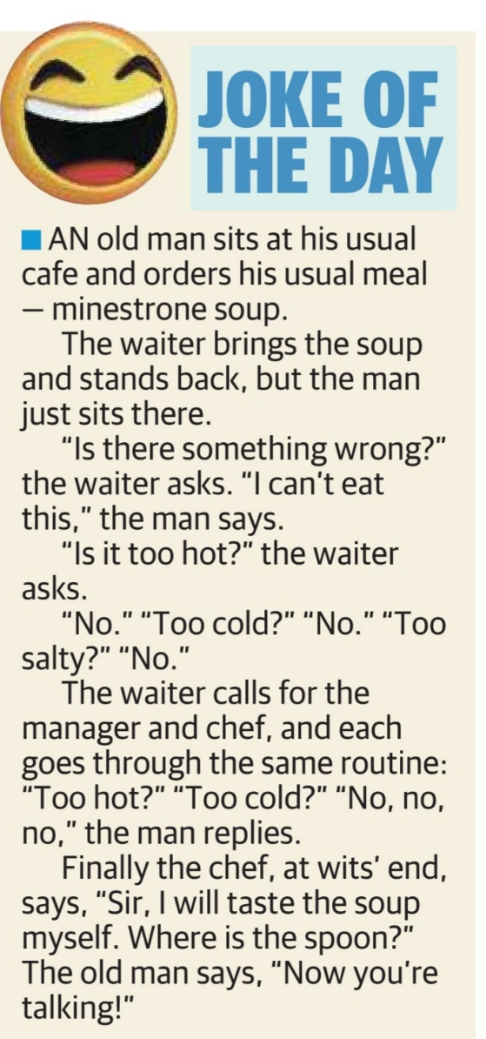

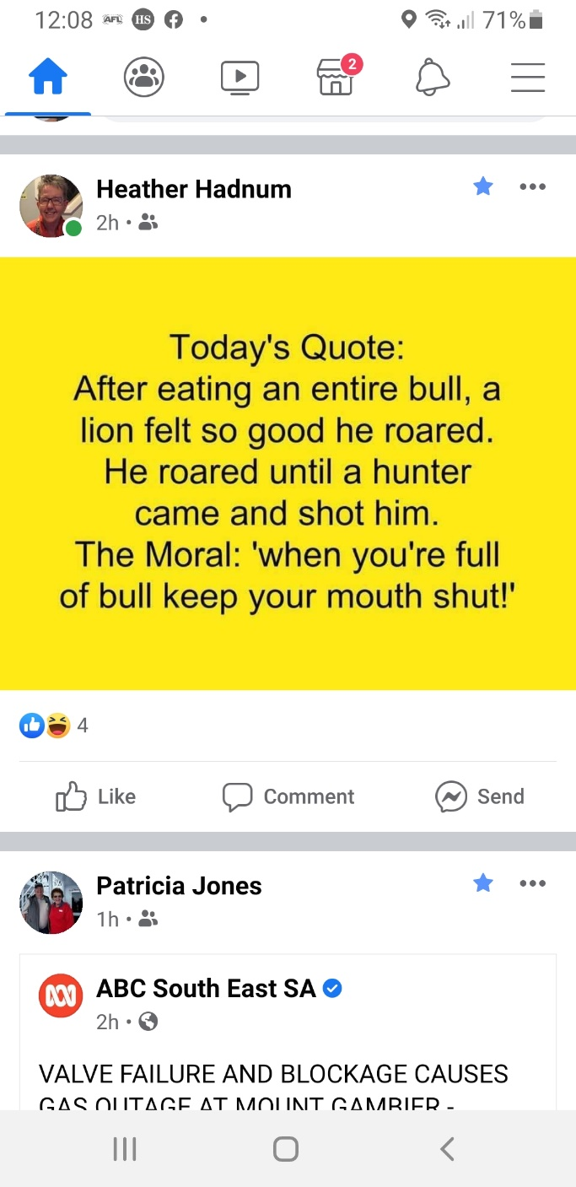

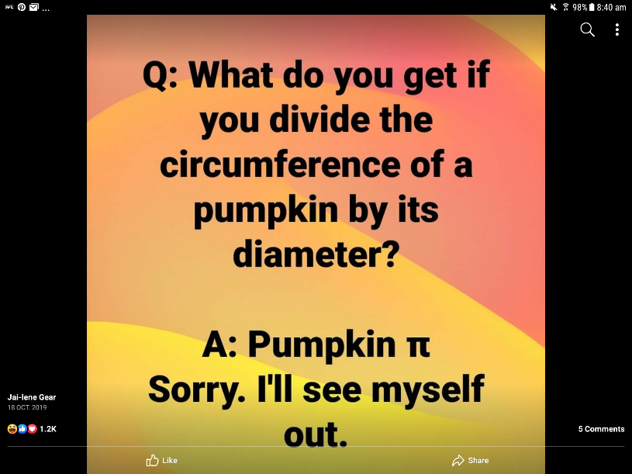

Quarantine has turned us all into dogs. We roam around all day looking for food, we are told “NO” if we get too close to strangers. And we get really excited when about to go for a car ride.

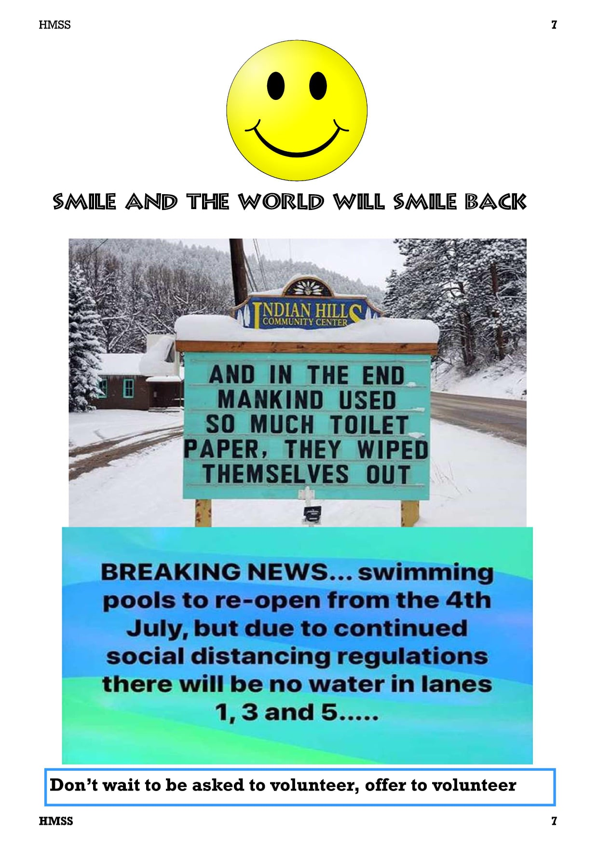

From Phil Keily

**MEMBER PROFILE**

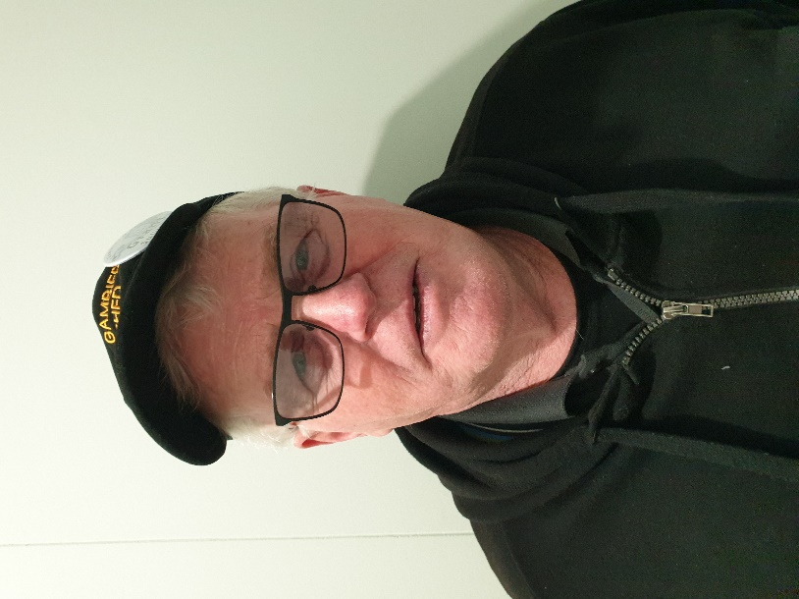

Name: - Grant Sullivan.

Where have you worked: - Forestry S.A. since 1981.

Something about you people at the shed may not know: - Keen gardener and loves to read books and collect shells at the beach.

What do you wish to achieve at the shed: - Mainly make new friends and talk to guys about what they have done and achieved in their career.

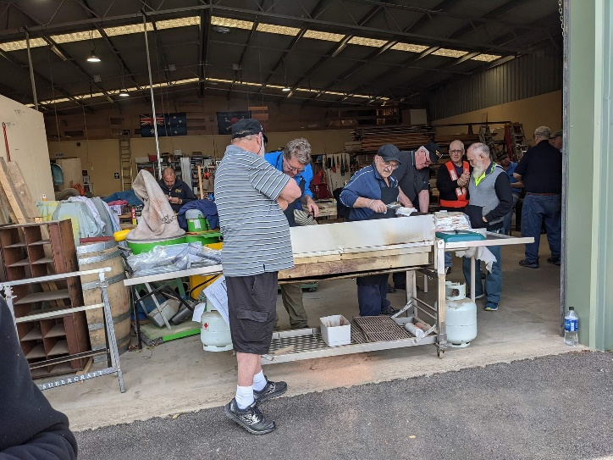

Plenty of members at the BBQ and all being watched by our very own COVID marshal.

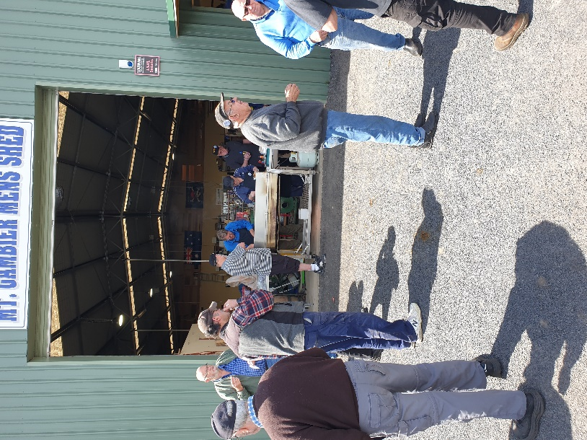

Thank you BBQ for the members after COVID.

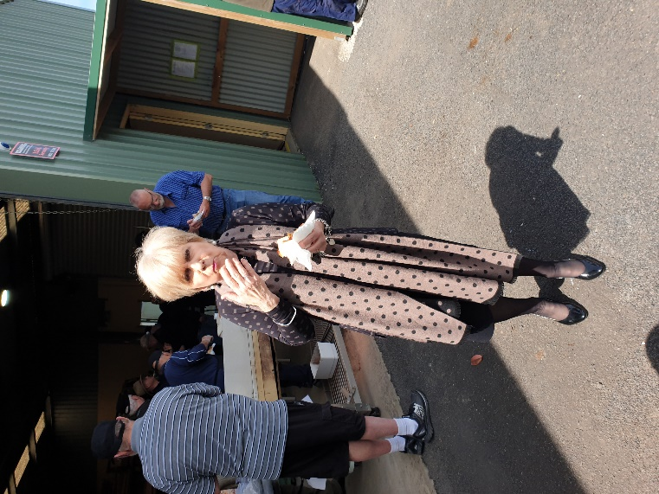

After taking this photo Mayor Lynette Martin implied I only take photos of her eating so yes, that is true and included below is one where she is actually talking shop with one of our members. Sorry Lady Mayor.

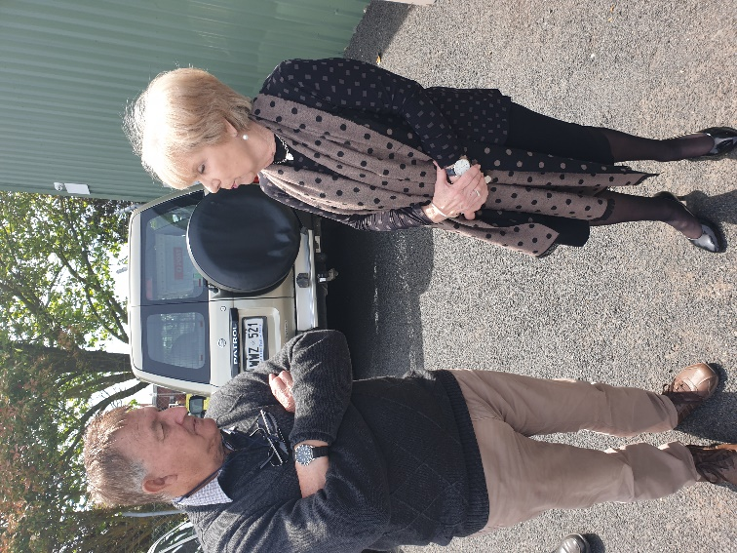

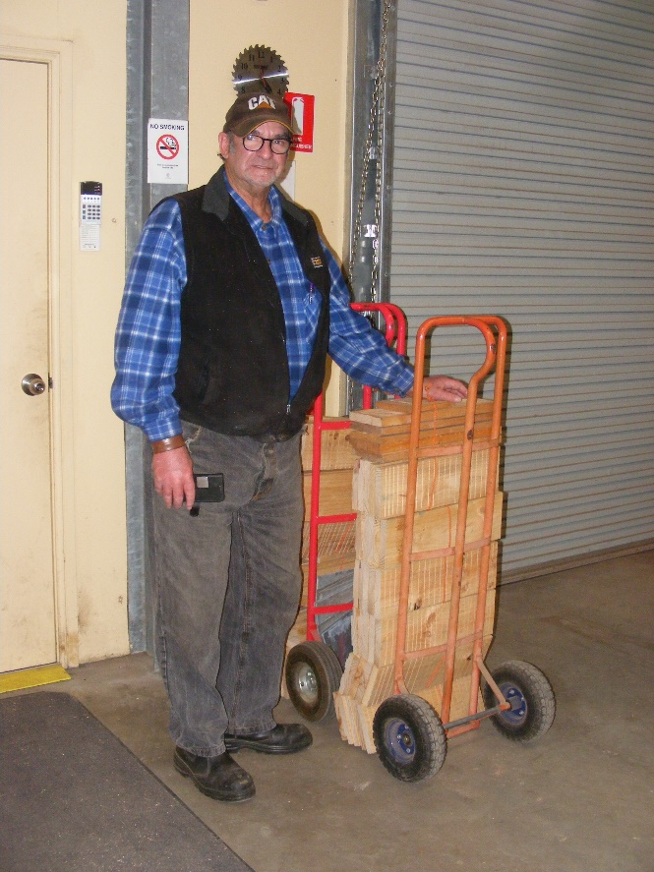

Bat boxes ready to be delivered. Well done Dave and his team.

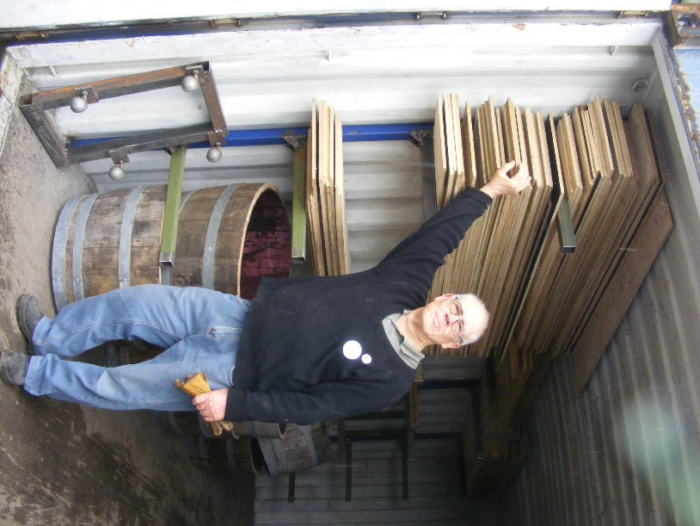

Job well done. Tim looking pleased with himself after finishing putting the timber in the container.

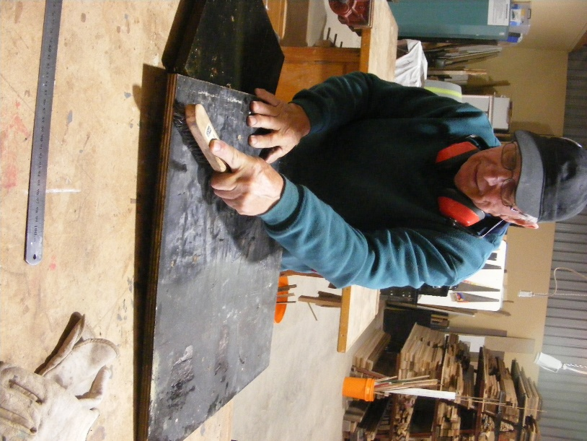

Secret squirrel stuff going on with Geoff. Only he knows what is being made here.

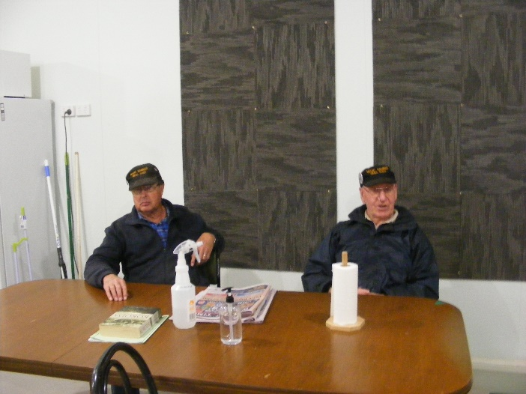

Peter and Don decided posing for the camera was better than being caught sitting talking.

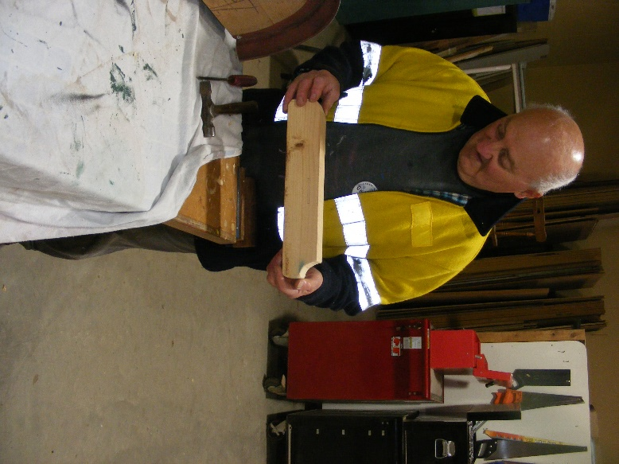

George getting in early doing a prototype plane for next year’s toys.

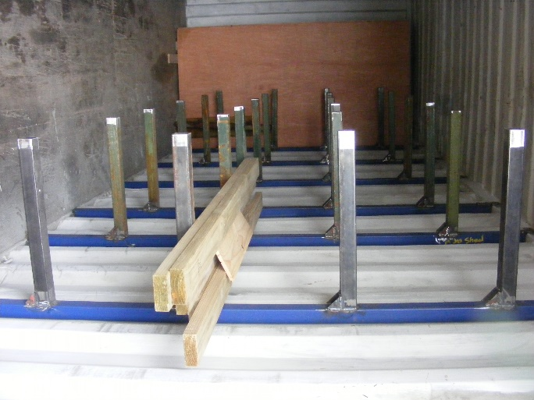

Ian has done a mighty job on welding the frames for the new container.