[mgmensshed@gmail.com](mailto:mgmensshed@gmail.com)

**EXECUTIVE MEMBERS FOR 2021**

**PRESIDENT**: Peter Halleday 0439500699

**VICE PRESIDENT**: Ian Bond

**TREASURER**: John Plunket

**SECRETARY**: Paul Edgeworth 0887256385

**FACEBOOK**

Shed broadcasts are now available on Facebook

*[Image result for facebook logo](https://www.google.com.au/url?sa=i&rct=j&q=&esrc=s&source=images&cd=&cad=rja&uact=8&ved=2ahUKEwjO9cWTtajeAhUafisKHT6JAHoQjRx6BAgBEAU&url=http://www.seacliffeinn.com/spa-boutique/find-us-on-facebook-logo/&psig=AOvVaw0duNjpvsqixE3Pzu1qEwe2&ust=1540791326821108)*

**Safety: - Remember Safety begins at home.**

**BIRTHDAYS**

Ian B 06/09

Ray L 08/09

Peter Ha 18/09

Brian S 26/09

Rod L 28/09

Tony P 01/10

Allan V 01/10

John P 02/10

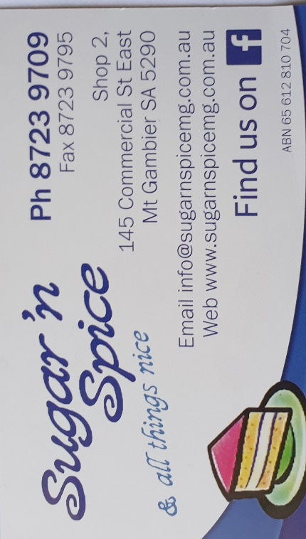

**Remember Sugar ‘n Spice support our Men’s Shed with Birthday cakes, so support them where you can.**

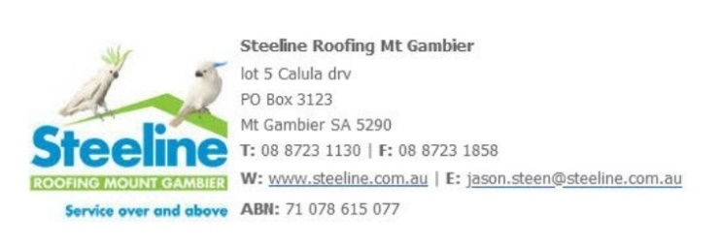

 



**Thanks to Sharp Cranes and Steeline for supporting our Mens Shed.**



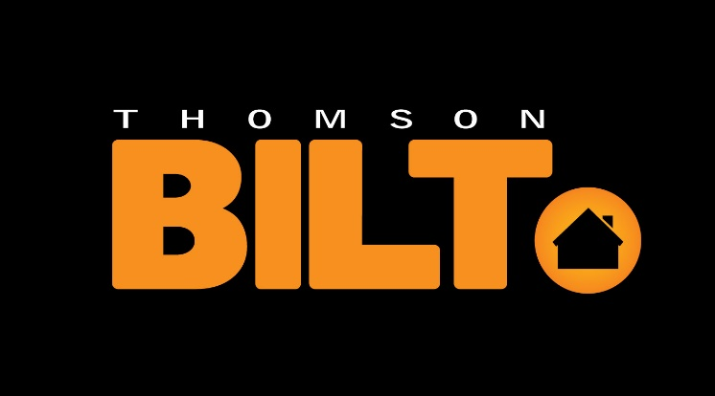

**Big supporters of Mount Gambier Mens Shed.**

**SUPPORT YOUR LOCAL BUSINESSES**

**THAT SUPPORT YOU.**

**DIARY DATES**: 2021

8th September Wednesday 6.30 Tea with partners – Southern Thai

21st September – 23rd September Spanner in the Works? Men's Health Checks, supported by Uncle Toby’s.

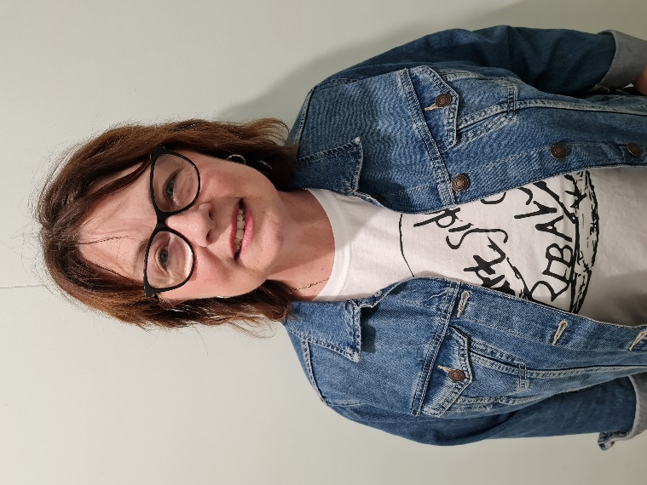

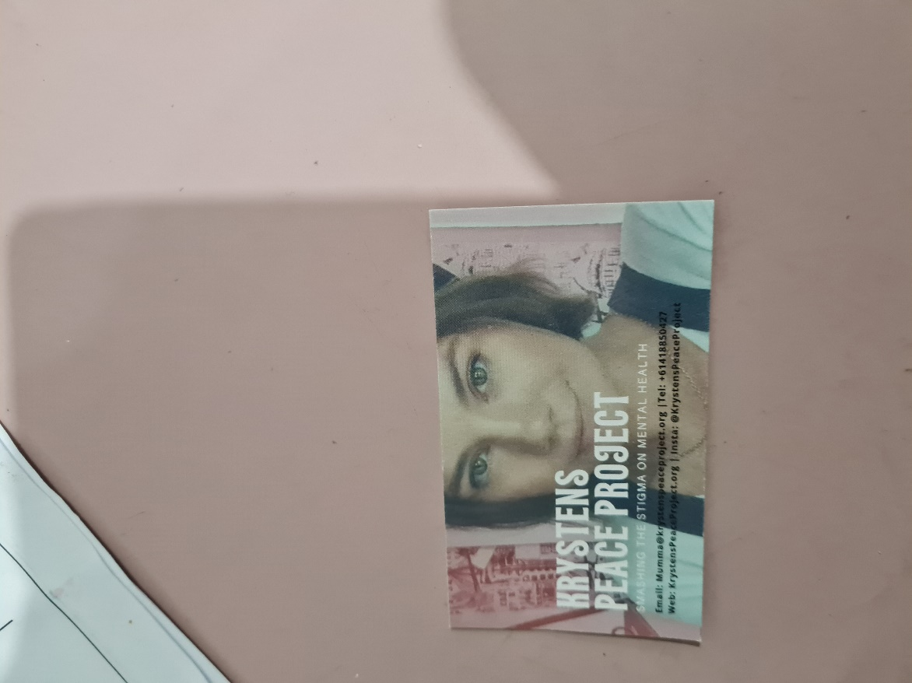

My name is Leanne Farnden and I am looking at assisting the Men’s Shed with the purchase of a Pen Press through the Foundation devoted to my daughter whom I sadly lost to suicide in 2020. Going through the grieving process I got myself to a point of “finding meaning” and decided to dedicate my life now to Mental Health Awareness.

I’ve created the Krysten Jean Telford Foundation and have set about creating different projects that shine a light on mental health. I was born and grew up in Mt Gambier and Krysten was born here too.

I was approached by the South Aussie Hotel and Joe has offered to support a Project.  I researched and come across the Men’s Shed and the idea of it just really struck my heart. I made contact here and visited and decided this would be a great opportunity to help the gorgeous men that come here every week to have a rest, to help wipe some thoughts from their minds, enjoy each other’s company, and build all sorts of different things. I was very impressed with what I saw and heard at the Men’s Shed, it’s truly a brilliant concept.

The special night will be on the 1st October at the South Aussie Hotel, so if you’re free please come along for tea and some fun. I also have created some merchandise including stubbie holders with Krystens photo on them. They can be purchased on the night or from the Facebook or Instagram store @krystenspeaceproject or the website KrystensPeaceProject.org.

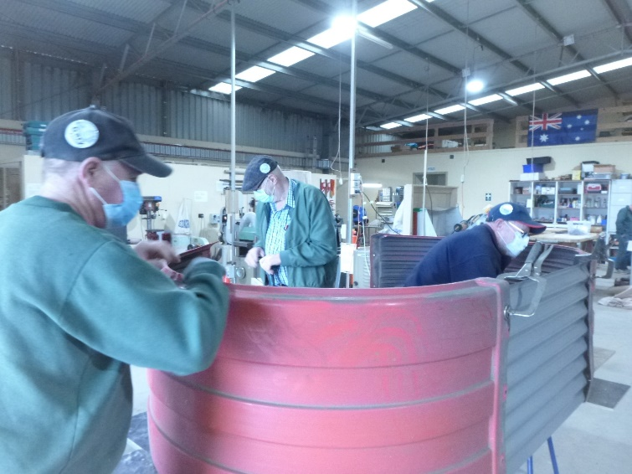

The garden bed production line with Gary Jeff and Ben working this has been a great earner for the shed with well over 75 made this year.

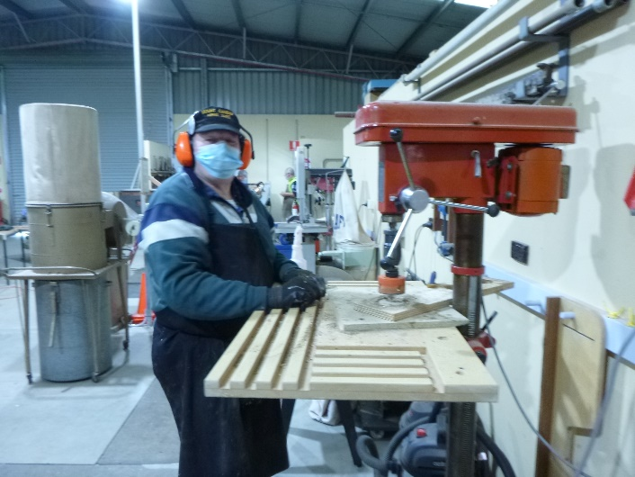

The man in the mask is Alan making wheels for toys.

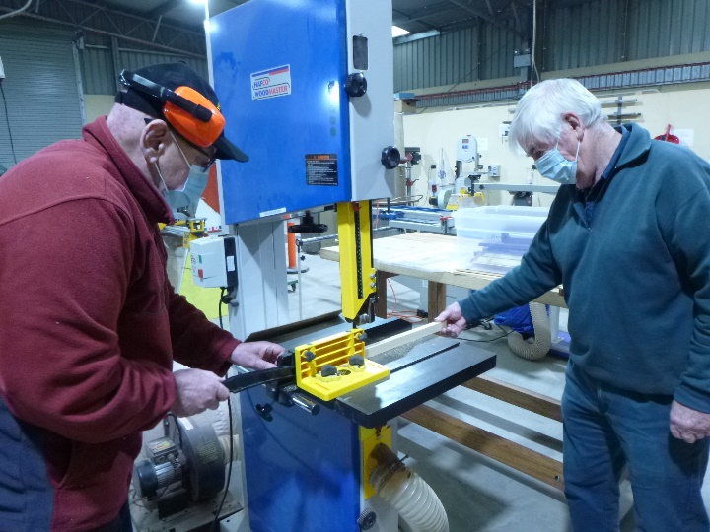

Ansi and Dick machining timber for a bread board.

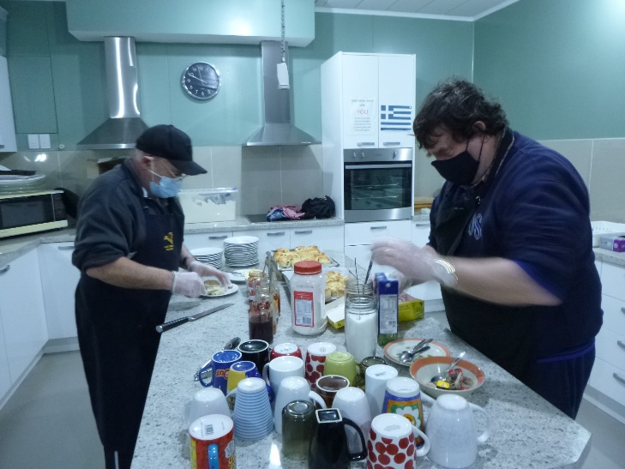

Another picture of Bill and Ben the flour men this time wearing masks while making scones for morning tea. Found it hard to eat them with a mask though so may have to go on a diet.

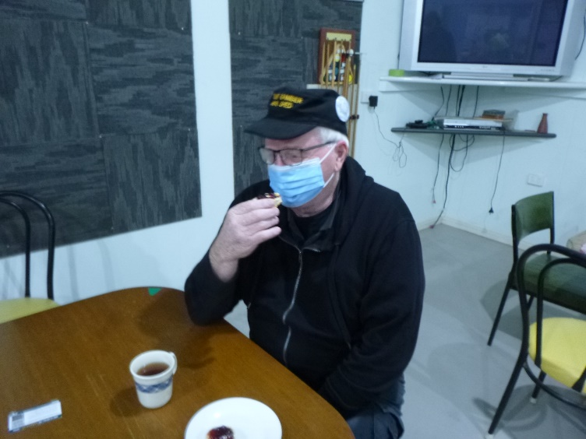

As mentioned in the last photo Grant appears to be having trouble eating with his mask.

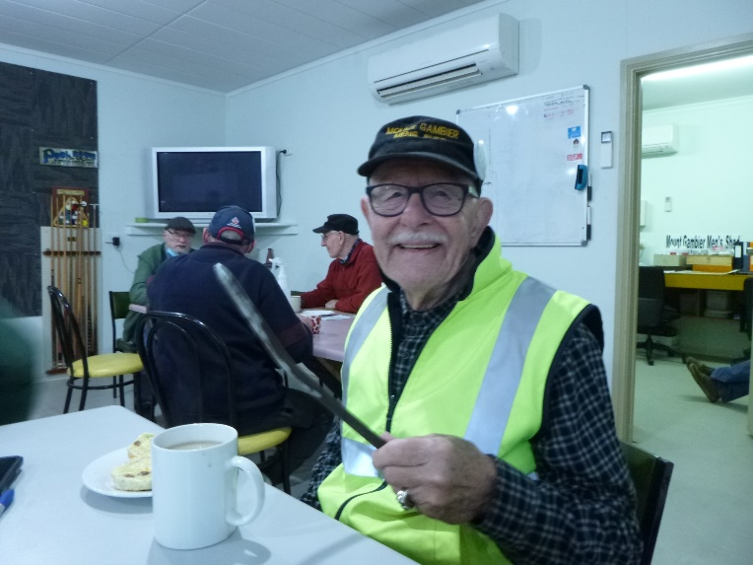

Well one smart person in the group. Ray says take your mask of to eat you silly boys.

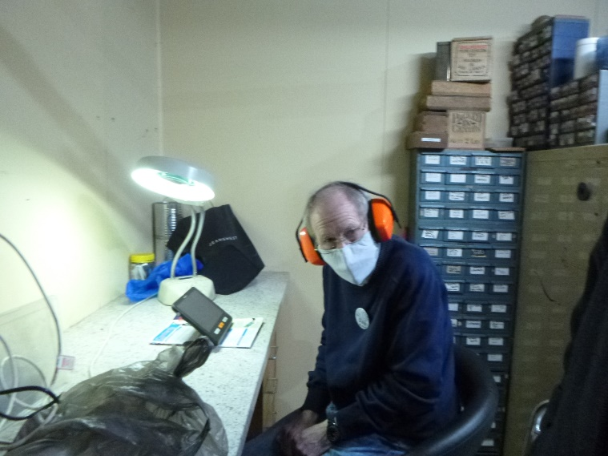

Sometimes even the most accomplished radio ham has to read up on how to repair radios as Dale is doing here.

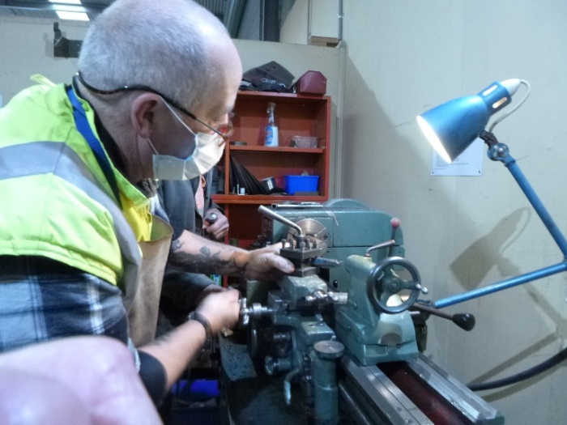

Ian working on the metal lathe.

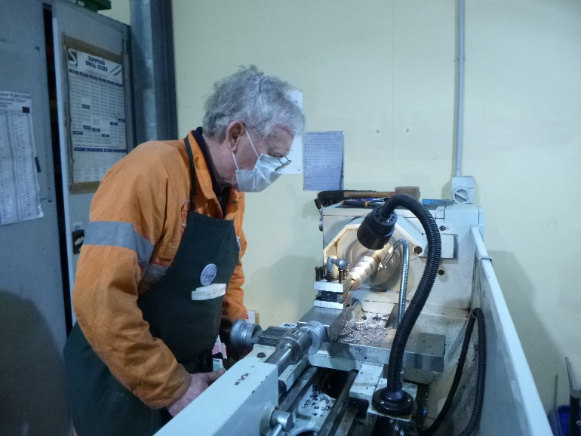

Jim making a candle holder on the metal lathe.

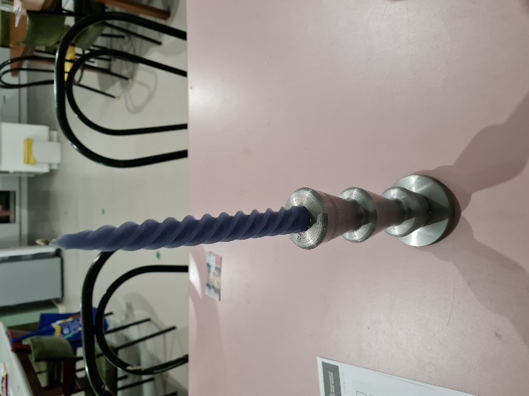

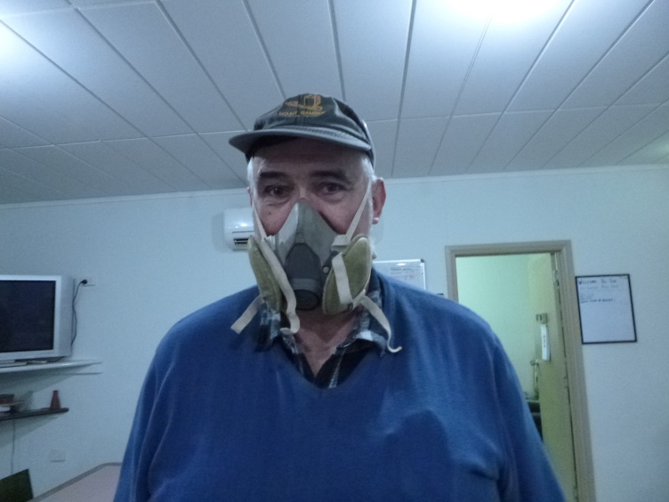

Sometimes the blue masks are not ideal and the full mask works like Peter is wearing.

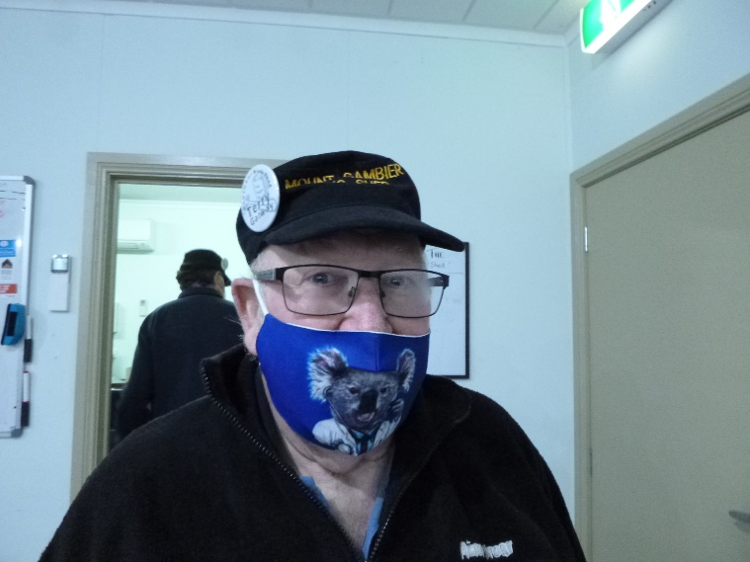

Terry getting into the swing of things and used his own unique mask.

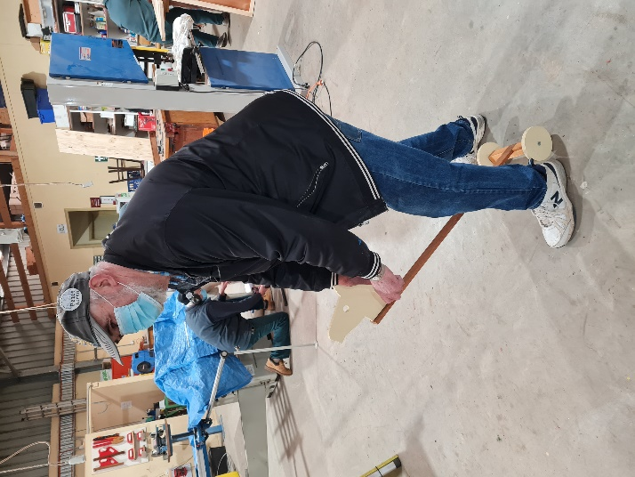

Peter remembering that he was a horse trainer once upon a time.

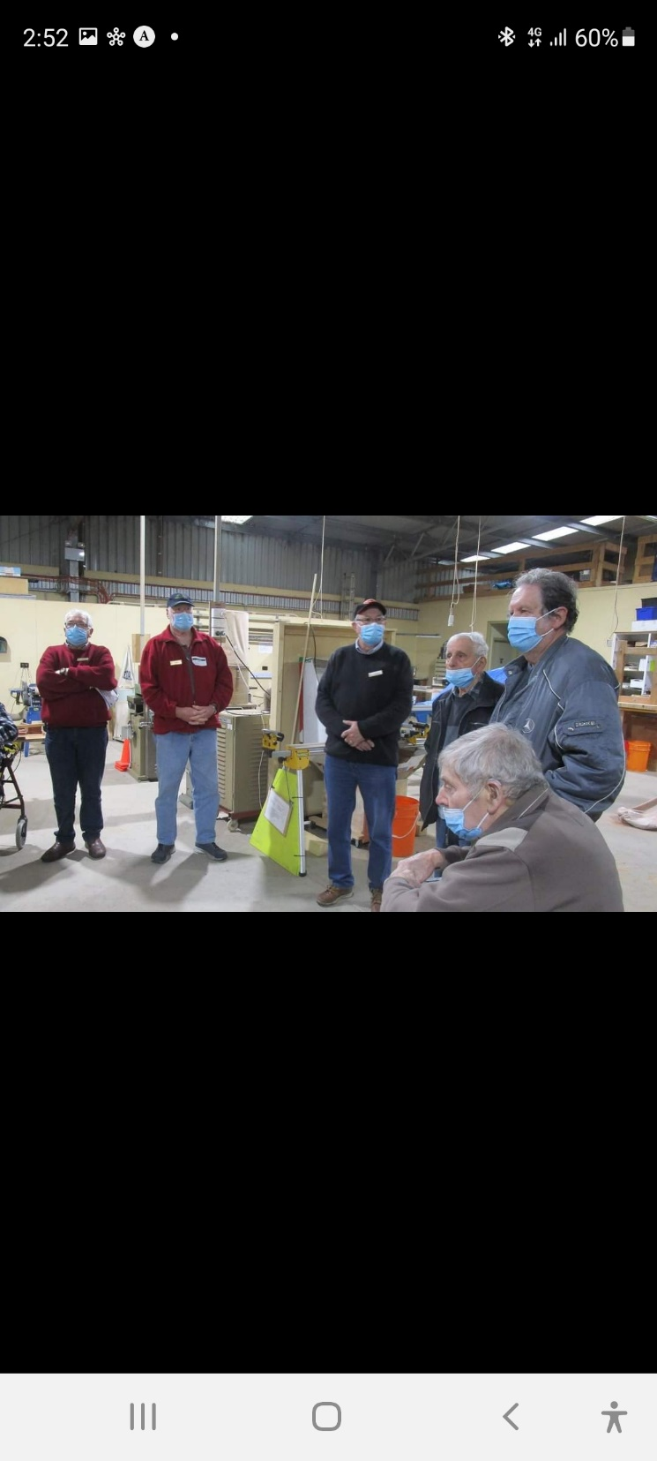

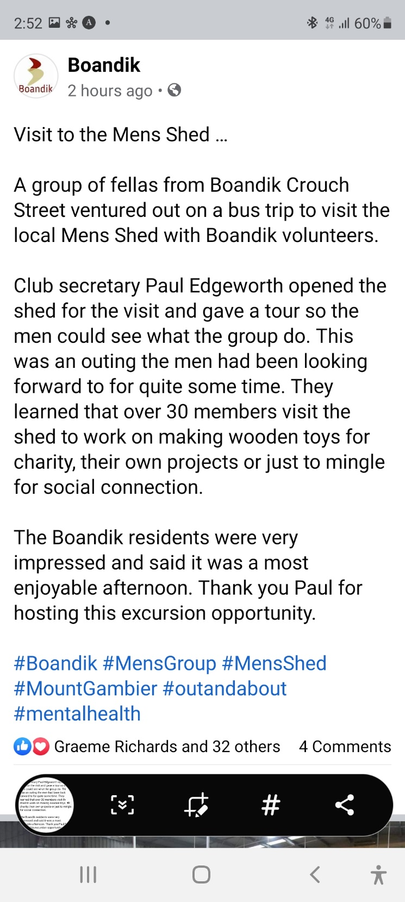

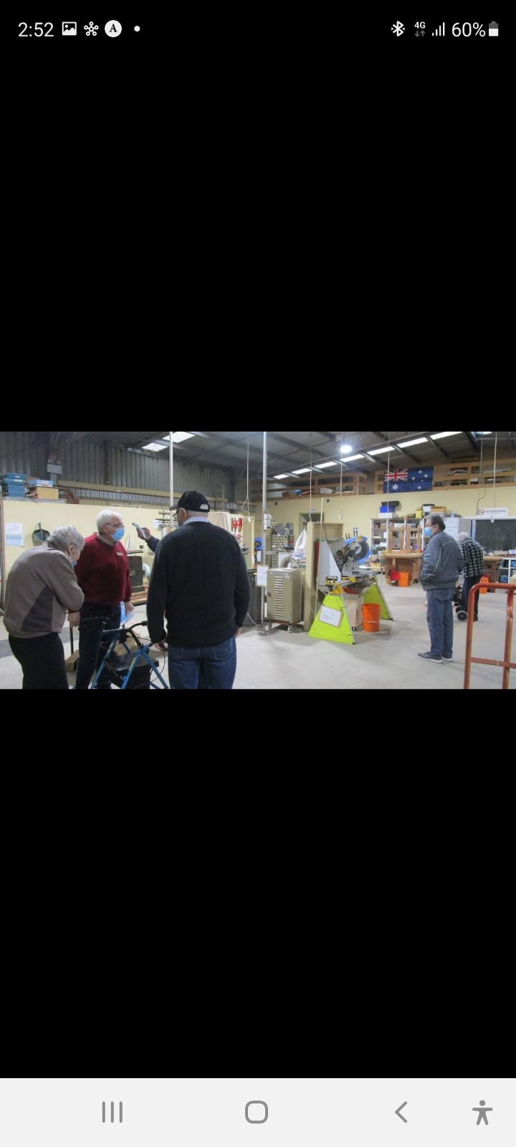

**JOKES**

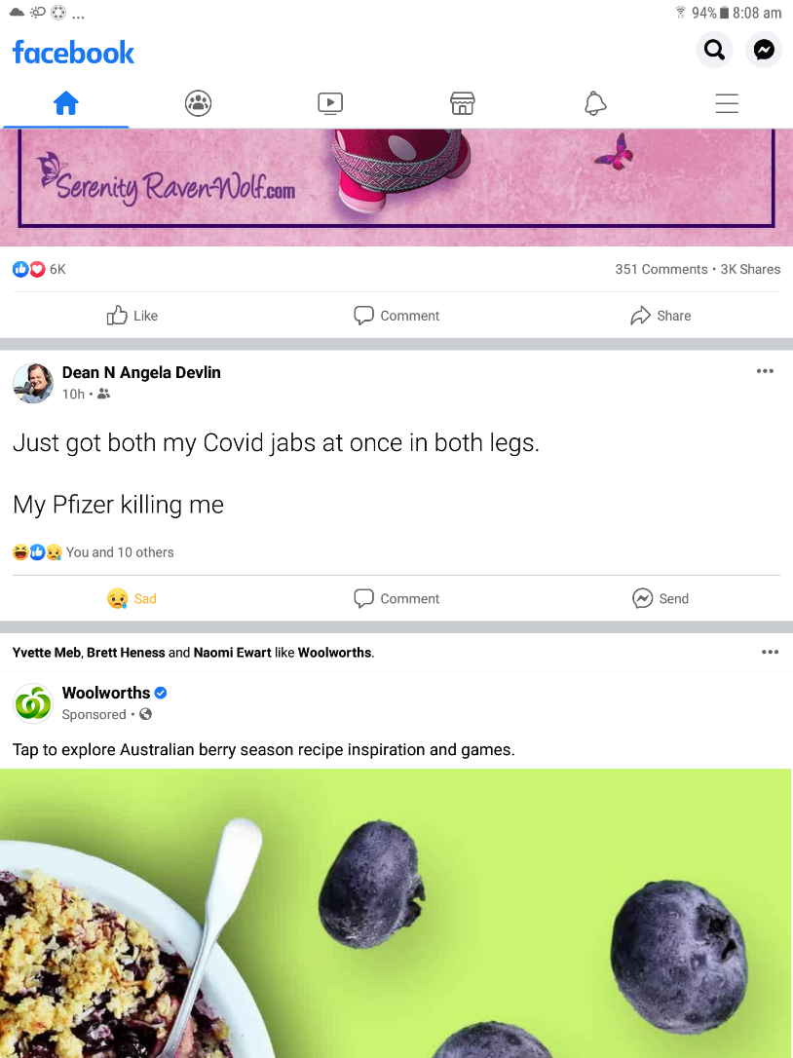

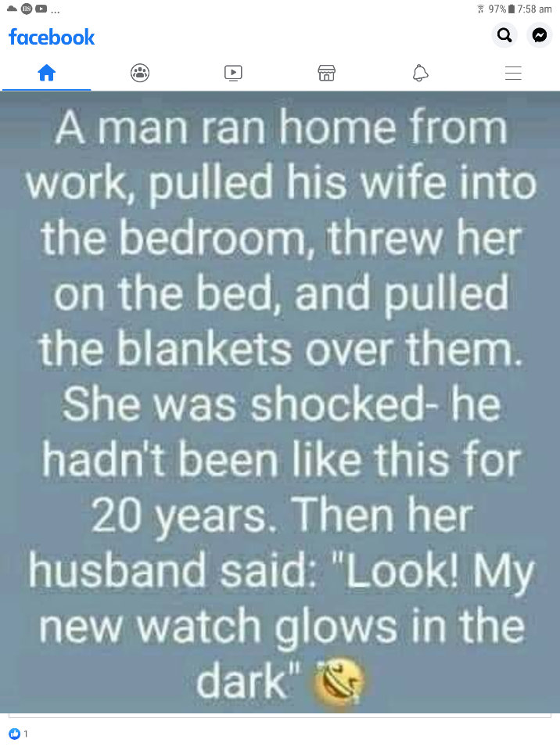

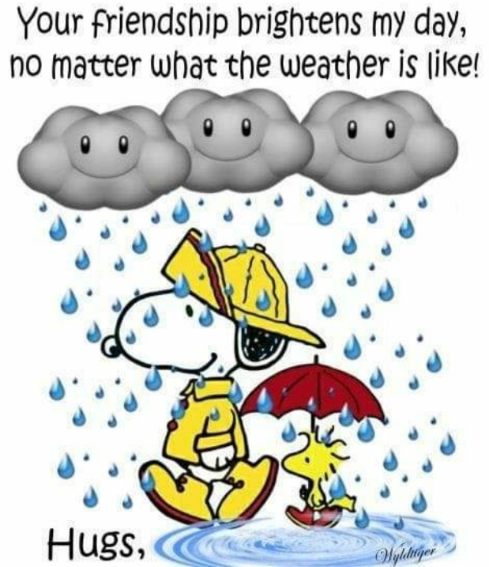

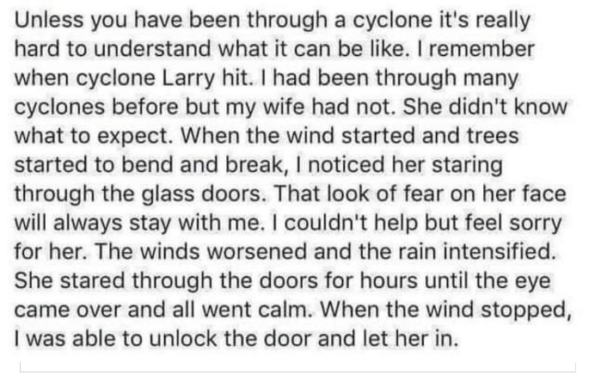

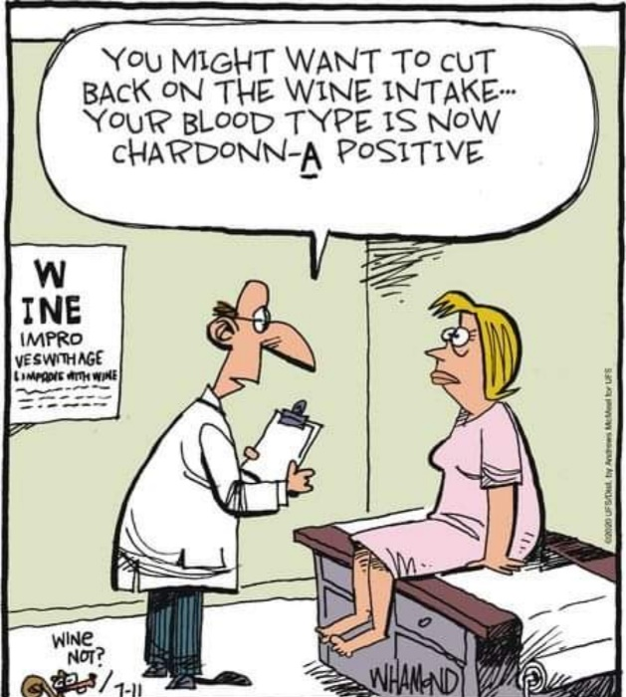

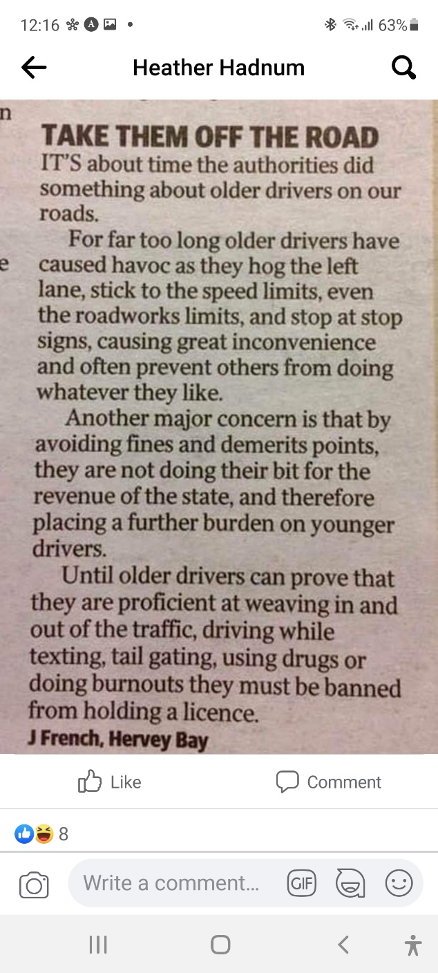

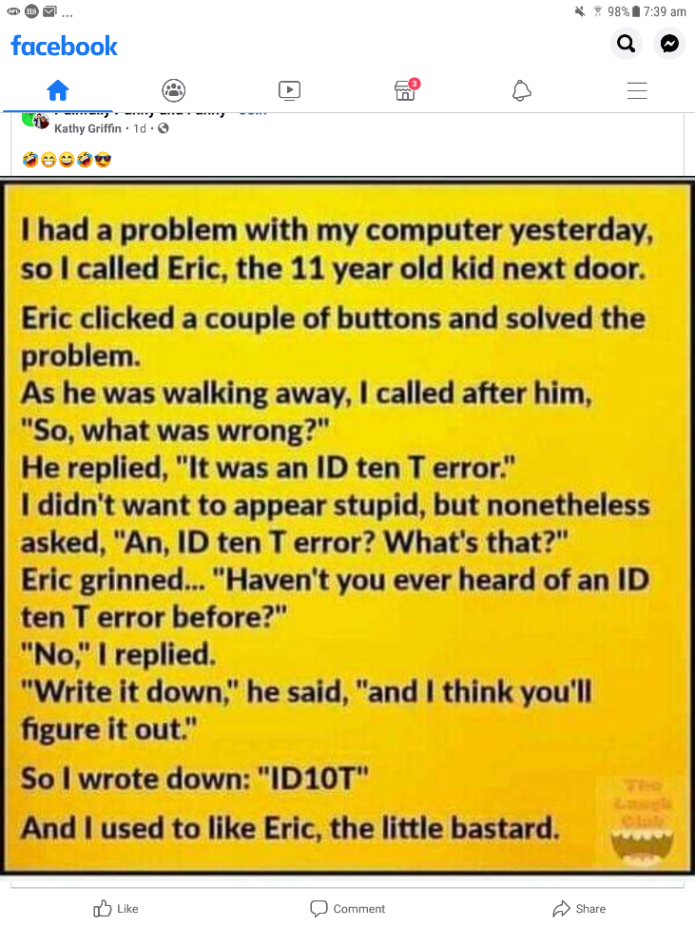

**Recipe**







