[mgmensshed@gmail.com](mailto:mgmensshed@gmail.com)

**EXECUTIVE MEMBERS FOR 2019**

**PRESIDENT**: Ansi Nitz 0439816074

**VICE PRESIDENT**: Ben Katris

**TREASURER**: John Plunket

**SECRETARY**: Paul Edgeworth 0887256385

**FACEBOOK**

Shed broadcasts are now available on Facebook

*[Image result for facebook logo](https://www.google.com.au/url?sa=i&rct=j&q=&esrc=s&source=images&cd=&cad=rja&uact=8&ved=2ahUKEwjO9cWTtajeAhUafisKHT6JAHoQjRx6BAgBEAU&url=http://www.seacliffeinn.com/spa-boutique/find-us-on-facebook-logo/&psig=AOvVaw0duNjpvsqixE3Pzu1qEwe2&ust=1540791326821108)* Mens Shed Mount Gambier

**HEALTH AND WELLBEING**

Good to have Dave and Terry back after surgery. **The SHED IS IN LOCKDOWN until further notice**

Contact as you are able and as Shedders wish, those with longer term/serious physical/brain issues – Keith Reichelt, Cec Jones Thanks to all Shedders for phoning and emailing others. Remember to keep in touch with those members in facilities’ lockdowns and those in self or required isolation. Check for those needing groceries and other essential supplies and leave them at the door-step

**We know that the Shed is an important part of the week for many of your members, but the health and wellbeing of our community is the priority.** Try to connect with isolated members in other ways – via a phone call, online or drop over any supplies if they may be running short. Every Shedder now has the ‘Contact List’ for every other Shedder either hand delivered (8) or emailed (64). Yes, our numbers had climbed to 72 with attendances hovering around 40 on Tuesdays and Thursdays. Our Wednesday session had been growing. With smaller groups on most other days. For our mental health and wellbeing please keep in contact with others and stay healthy. We know that there are lots of clusters of Shedders operating outside shed hours so keep these going. Think of those who may not be attached to one and give them a call or send an email.

**We want to see every one back when this is over.**

**BIRTHDAYS**

Tony P 13/04

Kelvin S 24/04

Graham P 28/04

**At the Shed**

Following information from the Federal Department of Health, we recommend that you **take extra precautionary measures at the shed (and in public) to minimise the spread of the coronaviru**s. At the shed, this includes (but not limited to):

Make it easy for members to practice good health hygiene.

Ask members to regularly wash their hands. Wash thoroughly with soap and water and use hand sanitiser where appropriate. Wherever possible, ensure soap and/or hand sanitiser is readily available at the shed.

Remind members to cough or sneeze into their arm or a tissue. Securely bin the tissue and wash hands.

Ask all shed members feeling unwell or displaying cold/flu-like symptoms to stay home.

**If you, or any members at your shed, are sick – please seek medical advice immediately.** This is especially important for members who have underlying health conditions.

You can find more detailed information and resources in last week’s member update (Coronavirus (COVID-19) Information for Men's Sheds) or visit our website [**mensshed.org/coronavirus-covid-19-information-for-mens-sheds-march-2020**](https://login.visionscapedirect.com.au/t/i-l-xjkhlut-guhidhjiu-j/)**.**

**We know that the shed is an important part of the week for many of your members, but the health and wellbeing of our community is priority.** Try to connect with isolated members in other ways – via a phone call, online or drop over any supplies if they may be running short.

The Shed is now closed until the government lifts restrictions. Every Shedder now has the ‘Contact List’ for every other Shedder either hand delivered (8) or emailed (64) Yes, our numbers had climbed to 72 with attendances hovering around 40 on Tuesdays and Thursdays. Our Wednesday session had been growing. With smaller groups on most other days. For our mental health and wellbeing please keep in contact with others and stay healthy. We know that there are lots of clusters of Shedders operating outside shed hours. Think of those who may not be attached to one and give them a call or send an email. We want to see every one back when this is over.

**NEED TO KNOW**

SECOND HAND WOOD – every piece must be MAGNETICALLY CHECKED before putting through any machine.

SECOND HAND WOOD that has varnish, paint, sand or gravel embedded must be wire brushed, pressure cleaned before putting through the thicknesser, sander or saw.

NEW WOOD should also be checked for embedded sand or gravel.

Repairs and replacement of the machine and resharpening of components will be paid for by the user.

Thanks: Vicki Lazenby for the yummy slices (those who got them). Ansi and Geoff for picking up two dust extractor’s from MS Hein. Ansi, Peter Ha and Glen for picking a load of excellent donated timber. Don C for preparing the workshop (lubricating everything) for the shutdown. Committee members who will check the safety of the building periodically.

**SAFETY:**-

CLEANING OF MACHINES. Machines must be STOPPED and TURNED OFF AT THE POWER POINT before any cleaning is done by brush or vacuuming.

CLEANING OF WORK SPACES includes

* bench top
* floor

And where possible separate metal from wood,

Tools and materials.

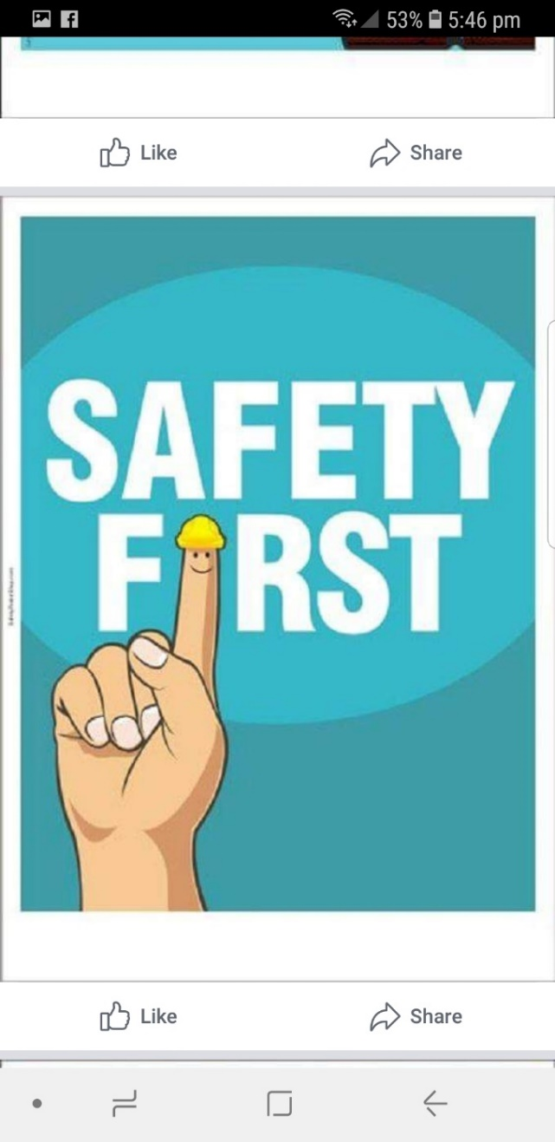



**APPOINTMENT OF LEADERS 2020**

**Work Health Safety Officers** (Mandatory) – Geoff Hart, Timothy Clarke, Ian Bond, Rob Burford

**Membership and Welfare Support manager** – Peter Halleday, Ansi Nitz, Paul Edgeworth

**Workshop Maintenance Manager** – Geoff Hart

**Social Organiser** Ian Bond

**In house BBQ/ meal organiser** Peter Young, Ben Katris

**Birthday organiser** – Geoff Hart

**Fund Raiser leader** – Ansi Nitz

**Bunnings Manager** Ansi Nitz

**Christmas Parade organiser** when needed

**Race Gates organiser** – Paul Caines

**Webmaster/IT** – Dave Lawson

**Administrators** – Dave Lawson, Peter Heness

**Facebook** Dave Lawson, Peter Heness

**Public Relations Officer** – Peter Heness

**Publicity – local manager** Peter Heness

**VMSA, AMSA publicity manager** Peter Heness

**Newsletter Editor** – Peter Heness

**Projects Managers** – wood – Don Clements

Metal – Trevor Adams

**Workshop Managers** -Wood – Peter Halleday, Don Clements, Mat James,

Geoff Hart

Metal – Trevor Adams, Geoff Hart

**Workshop Maintenance Manager –**

Machinery, metal, wood, otherGeoff Hart

**Machinery Trainers/Testers** Don Clements, Rob Burford

**Security Manager** Geoff Hart

**Assets Manager** – President and Committee

Assets Recorder – Rod Lockwood

**First Aiders** – Geoff Hart, Peter Heness, Ansi Nitz, all current certificate holders

Graham Carter, Ross Spencer, Glen Bowmer,

Brian Short, Lyndon Manser, Ian Bond, Geoff Hart

**Grant submission writers** – when needed

**Photographer** – Paul Edgeworth

**Membership leaders** – President and Committee

**Kitchen Managers** and mess area Ben Katris, Peter Young

Assistant Kitchen managerKevin Walters

Chief scone maker Ben Katris

Assistant scone maker Peter Young

Cleaning organiser Ben Katris

**Ablutions Manager** Ian Bond

**Electrical tester organiser** –Rob Burford

**Electricians** – Rob Buford, Ansi Nitz, Dave Lawson

**Historian** Paul Edgeworth

**Badge maker**/organiser –Rod Lockwood, Tony Potts

**Toy making manager** – Ian Bond

Deputy manager– Peter Heness

**JOKES**

<https://vimeo.com/399564066>      only about 2 minutes

Those who wish should go to this site on their computer and see President Ansi at his best.

 

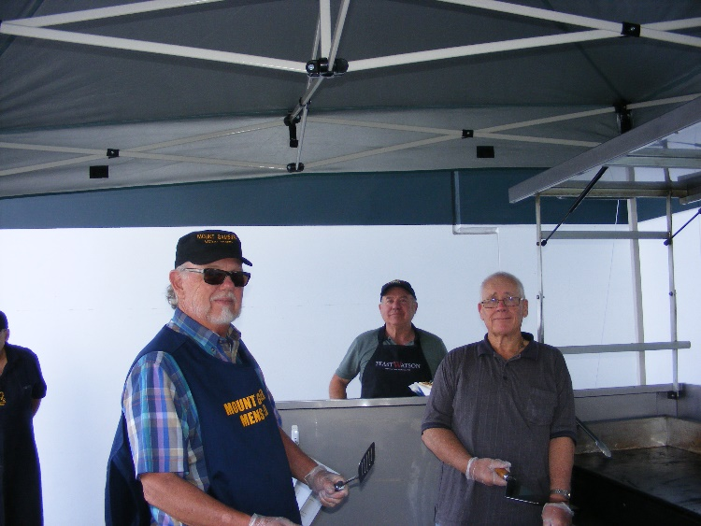

Mat Lyndon and Tim at Bunnings.

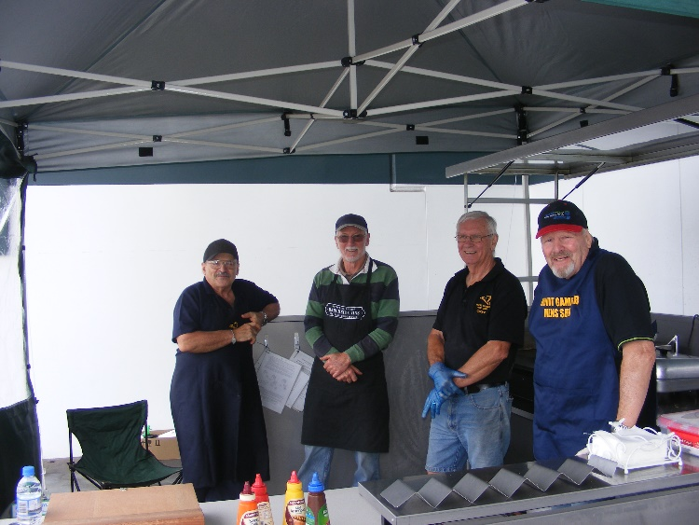

Ben, Don, Geoff and Allen at Bunnings.

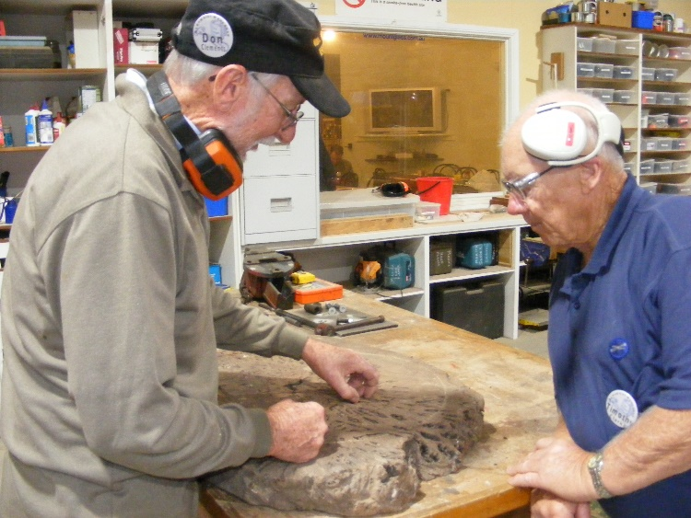

Don and Tim looking a piece of timber to work out how best to use it.

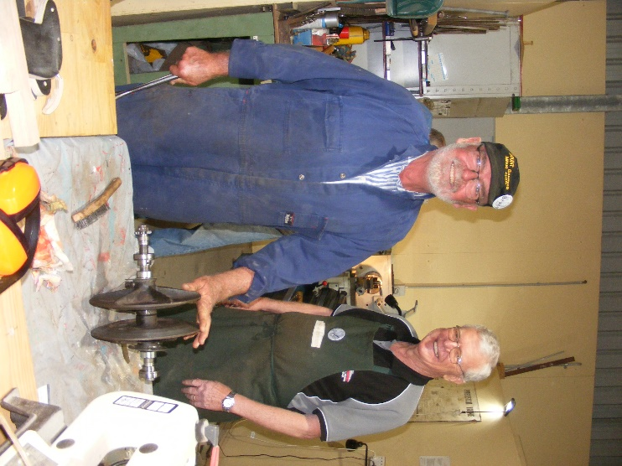

Bruce and Jim working on getting a lawnmower going.

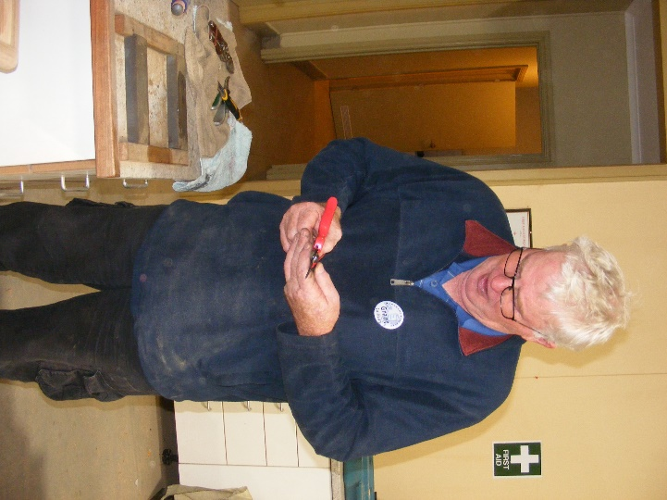

Grant inspecting his newly sharpened secateurs.

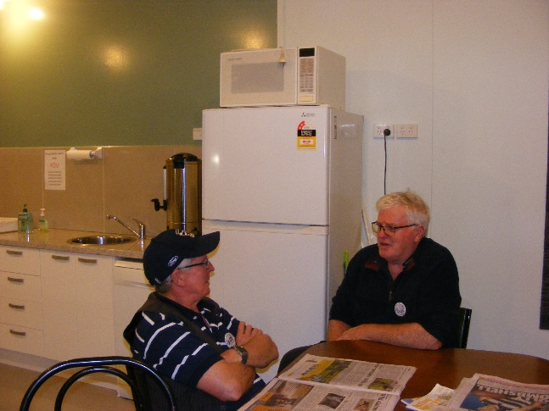

John and Grant having a bit of talk time.

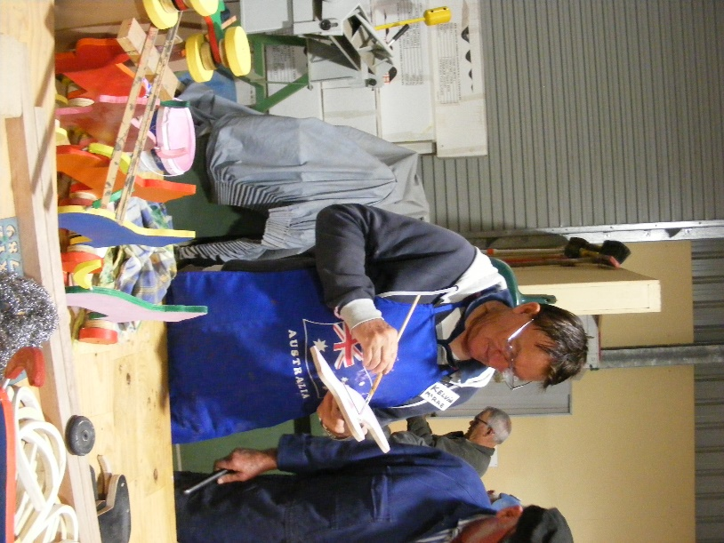

Kelvin showing off his painting technique.

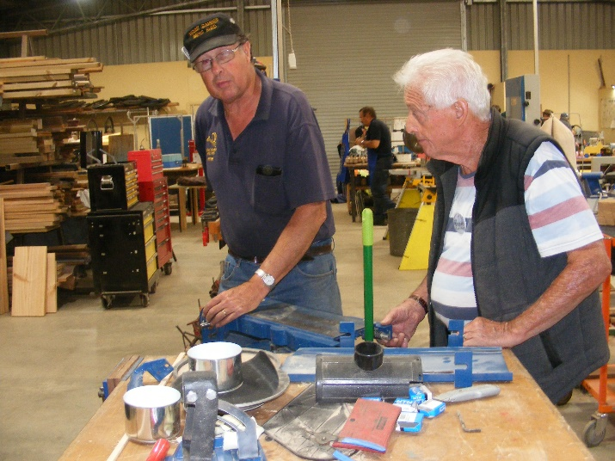

Peter and Graham working on repairing our belt sander.

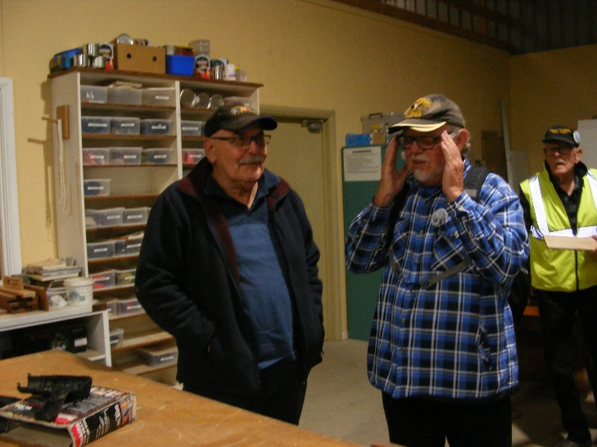

What is Matt trying to telepathically send through to Ansi.

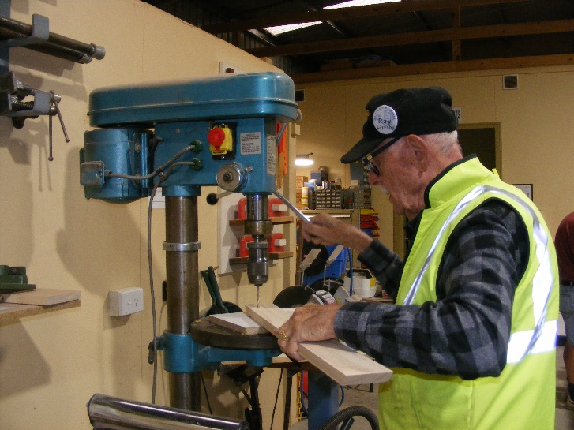

Ray working with the drill press (above) and fitting to the washing basket table he is making (below).

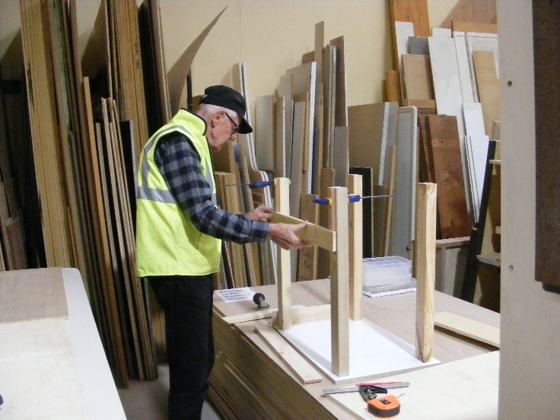

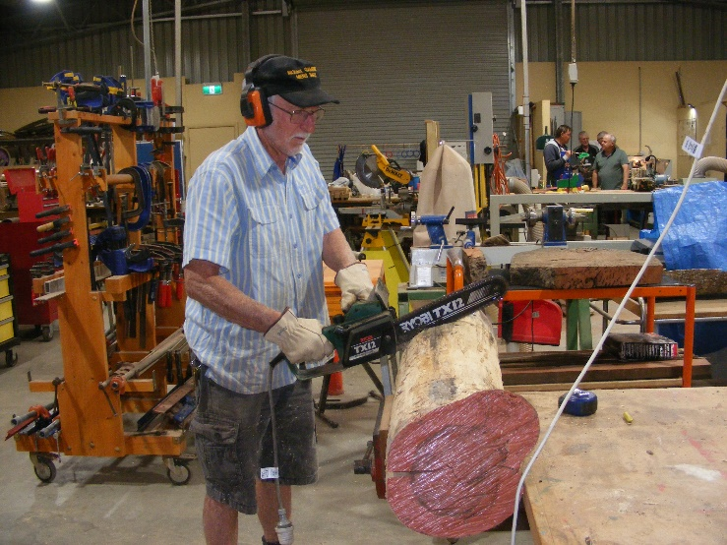

Don using an electric chainsaw to cut a slab from this lovely coloured timber.

**Recipe**

As yet I have not tried this one.



**Ingredients:-**



**Method:-**



Where it says Crisco use vegetable shortening.