[mgmensshed@gmail.com](mailto:mgmensshed@gmail.com)

**EXECUTIVE MEMBERS FOR 2019**

**PRESIDENT**: Peter Halleday 0439500699

**VICE PRESIDENT**: Ansi Nitz

**TREASURER**: John Plunket

**SECRETARY**: Paul Edgeworth 0887256385

**FACEBOOK**

Shed broadcasts are now available on Facebook

*[Image result for facebook logo](https://www.google.com.au/url?sa=i&rct=j&q=&esrc=s&source=images&cd=&cad=rja&uact=8&ved=2ahUKEwjO9cWTtajeAhUafisKHT6JAHoQjRx6BAgBEAU&url=http://www.seacliffeinn.com/spa-boutique/find-us-on-facebook-logo/&psig=AOvVaw0duNjpvsqixE3Pzu1qEwe2&ust=1540791326821108)* Mens Shed Mount Gambier

**BIRTHDAYS**

Bernard R 02/02

Ansi N 04/02

Ross S 04/02

Craig V 15/02

Cec J 18/02

Gary A 19/02

**NEED TO KNOW**

SECOND HAND WOOD – every piece must be MAGNETICALLY CHECKED before putting through any machine.

SECOND HAND WOOD that has varnish, paint, sand or gravel embedded must be wire brushed, pressure cleaned before putting through the thicknesser, sander or saw.

NEW WOOD should also be checked for embedded sand or gravel.

Repairs and replacement of the machine and resharpening of components will be paid for by the user.

**DATES TO REMEMBER**

**SAFETY:**-

CLEANING OF MACHINES. Machines must be STOPPED and TURNED OFF AT THE POWER POINT before any cleaning is done by brush or vacuuming.

CLEANING OF WORK SPACES includes

* bench top
* floor

And where possible separate metal from wood,

tools and materials.

**HEALTH AND WELLBEING**

Support and contact as you are able and as Shedders wish

**Members returned** from medical/brain conditions last month

Those with longer term/serious physical/brain issues – Peter Schutz, Keith Reichelt, Cec Jones, Stephen Sylvester, Noe Matter, Glen Bowman’s wife

Thanks to all Shedders making home visits, aged care facility visits, hospital visits, phoning and emailing supporting other Shedders.

**THINGS YOU NEED TO KNOW**

February 4th and Thursday 6th - **10 Year Membership Recognition** – (at morning tea)

February 13th Thursday - 10.10 – **Mount Gambier Mens Shed AGM**

February 13th Thursday (following AGM) **Members**

The **MANAGEMENT COMMITTEE 2019/2020 (**Rules 2019) has determined the 2020/2021 Management Committee will consist of and there will be nominations received for

President,

Vice President,

Secretary,

Treasurer

Four (4) Committee Members from

Membership and

Immediate Past President - Peter Halleday

(a Management Committee appointment)

**A HEALTH TIP**





**Recipe**

[](https://www.bing.com/search?q=Easy+Sausage+Rolls&filters=ufn:%22Easy+Sausage+Rolls%22+sid:%22c0cbd7c1-0fe2-6e5d-8028-57d8e3339fcb%22+segment:%22generic.carousel%22+secq:%22sausage+rolls+recipe+easy%22+supwlcar:%221%22+tsource:%22EntitySegments%22+catesegtype:%22recipe%22+cack:%22864543ac-c894-4c9b-8d4a-6049f2f93f55%22+segtype:%22UmVjaXBl%22+ctype:%220%22+mltype:%220%22+eltypedim1:%22Recipe%22&FORM=SNAPCR)

**Ingredients:-**

3-Puff pastry squares. (Thawed)

9- Thin Sausages flavour of your choice.

**Method:-**

Cut pastry squares in half put 1 ½ of your sausages on each half.

Roll up and seal with egg on edge and top, Place in oven at 180⁰C for about 30 mins until golden brown and enjoy

PS..Sausages do not have to be skinned just put on as they come.

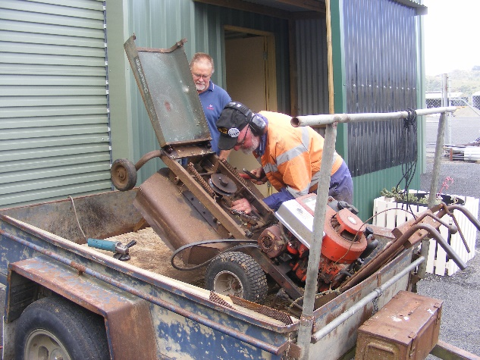

Steptoe Bruce is at it again with Garry looking on.

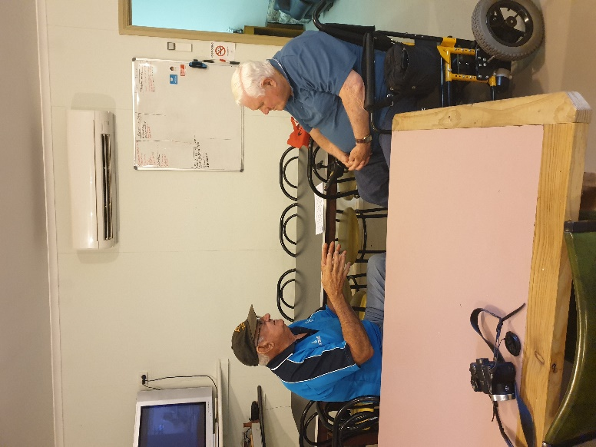

Welcome back to Kevin after his long illness.

**Member Profile**

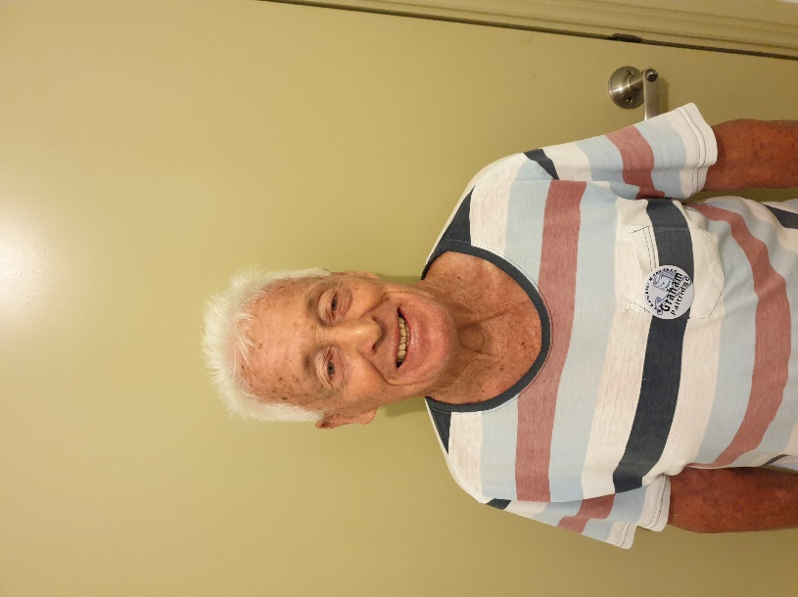

**Name: -** Graham Paltridge

**Where have you worked:**-Family Farm, then Teagle excavations after that went to Darwin to work on a prawn trawler before moving to Queensland to work in the mines.

**Something about you no one at the shed knows:** -Volunteers for Millicent Community Health and was a member of Millicent Men’s shed before moving to Mount Gambier.

**What do you wish to achieve at the shed: -** The main thing is to make new friends and help out where ever I am needed.

**THANKS**

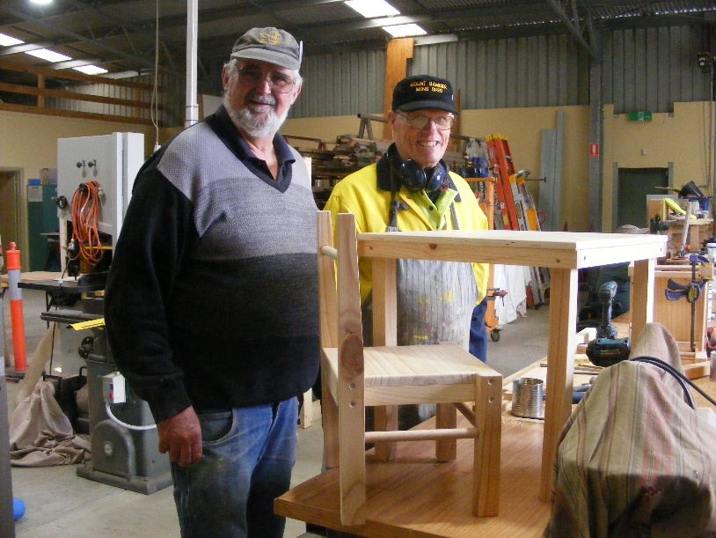

Childs table and chair made by Ian and Peter.

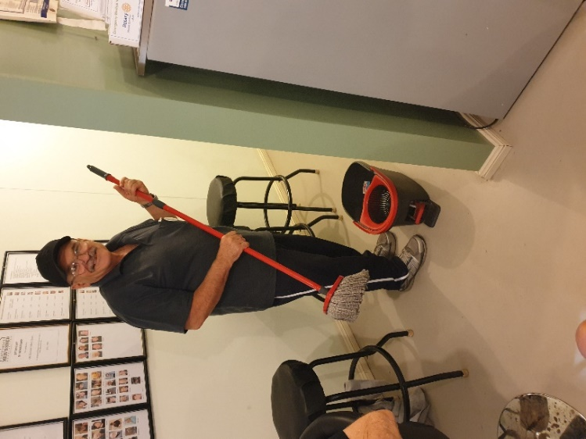

Ben not only the scone maker but also cleans the floor.

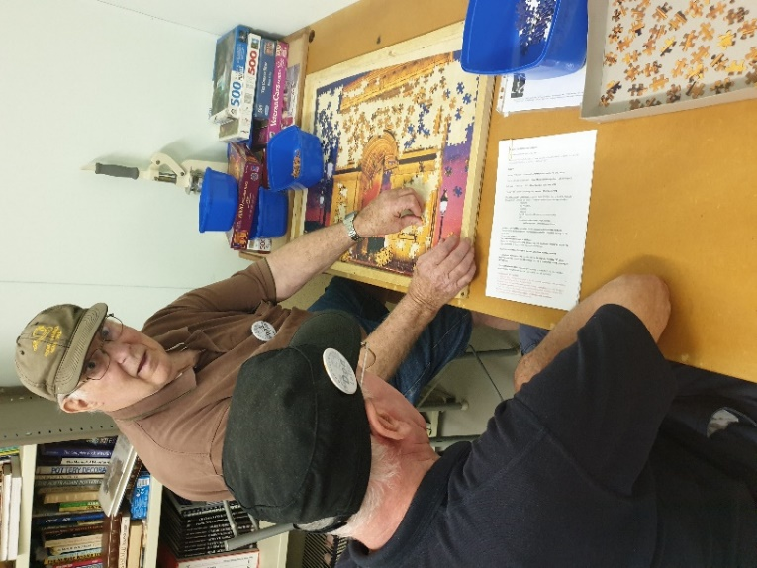

Rod and Don doing a jigsaw.

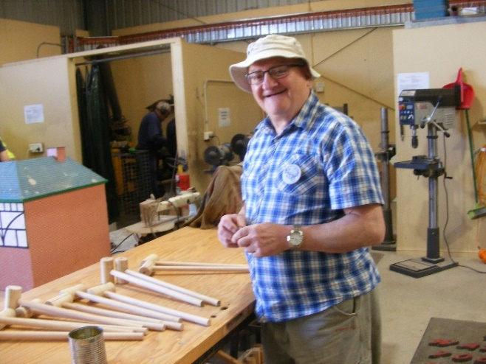

George taping up mallets ready to paint.

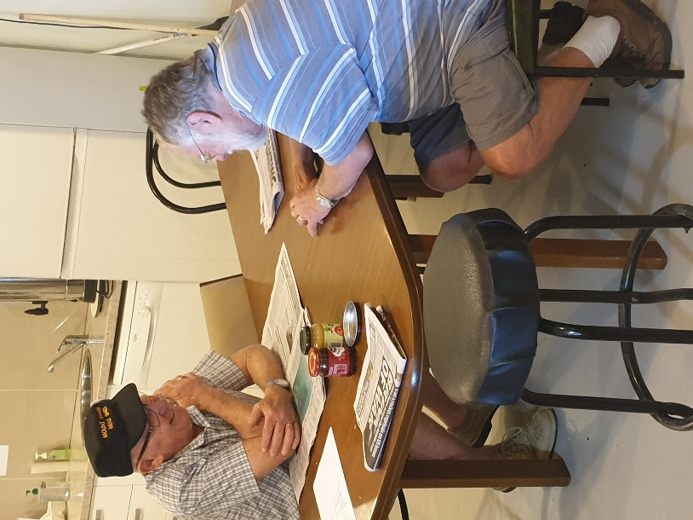

Normally Paul takes the photos but this time he got caught talking.

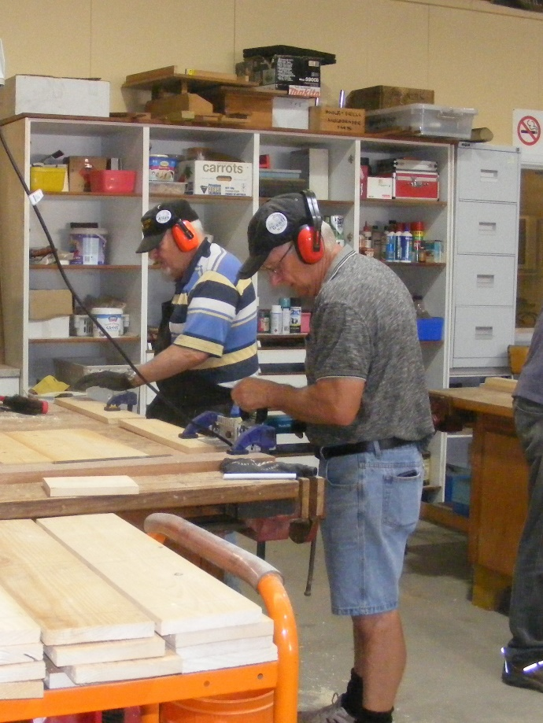

Geoff and Allen working on a project.

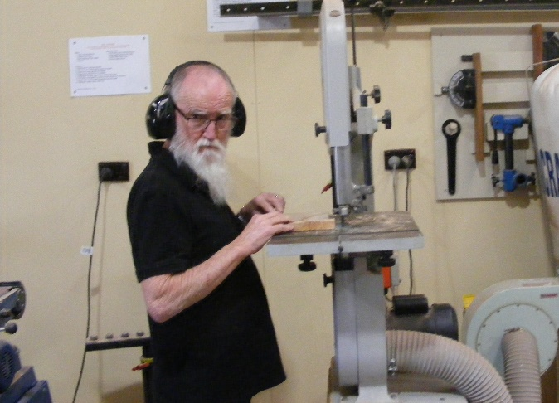

Glen roughing out a new toy shape.

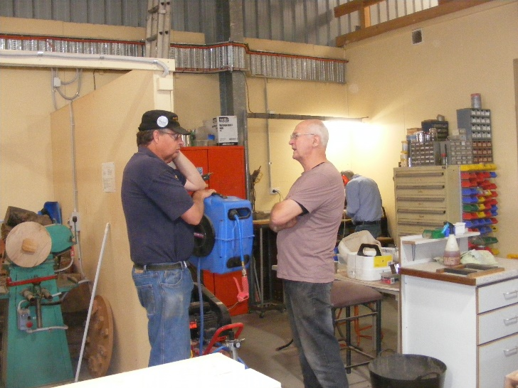

Not sure what is talked about but Peter and Andrew are in deep thought.

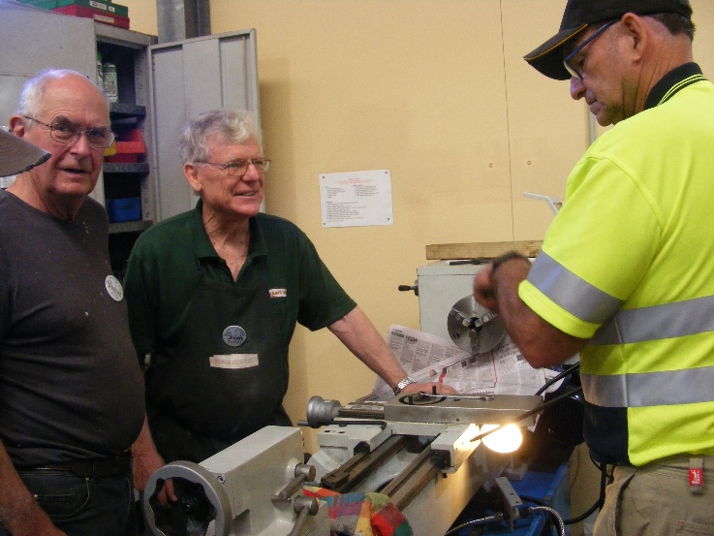

The new lathe is taking shape with the help of Andrew, Jim and Dave.

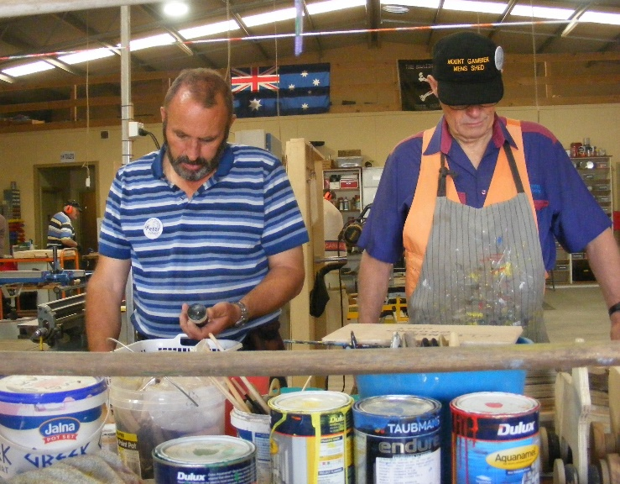

Peter and Ian have not got a clue but it will work in the end.

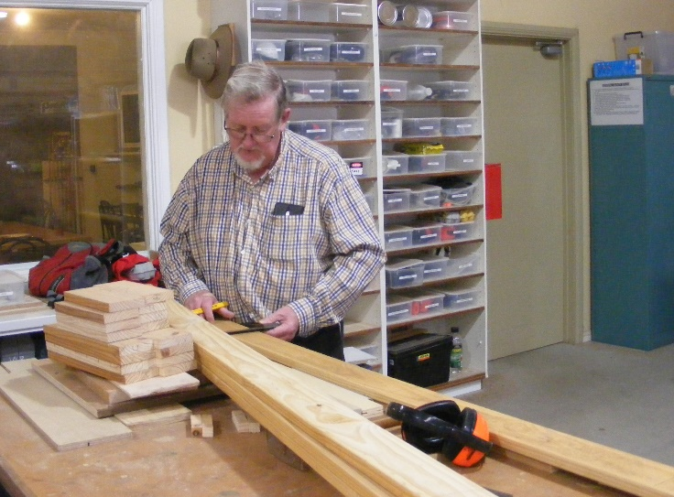

Phillip starting on a new table.

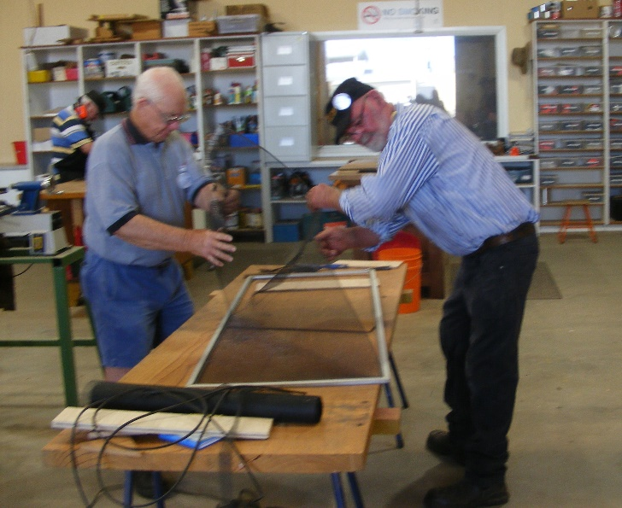

Tim and Bruce repairing a flywire door.

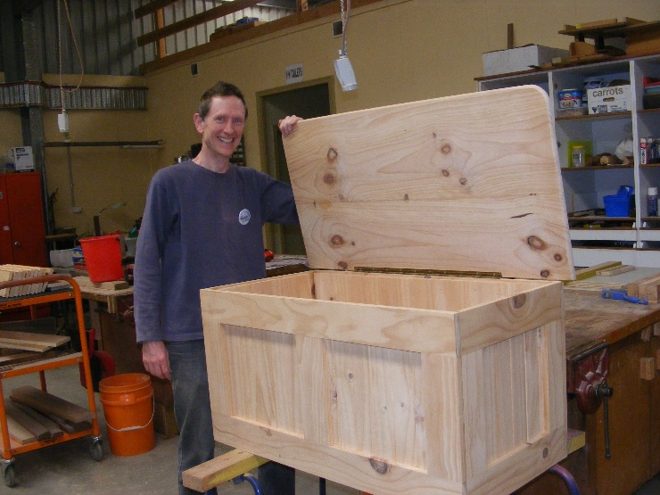

Richard showing off his pine trunk he made.

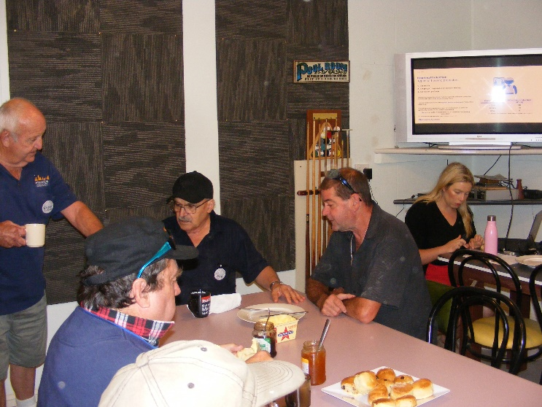

Graham giving advice to Ben, Trevor and Bill while Angela sets up for hearing demo in the background.

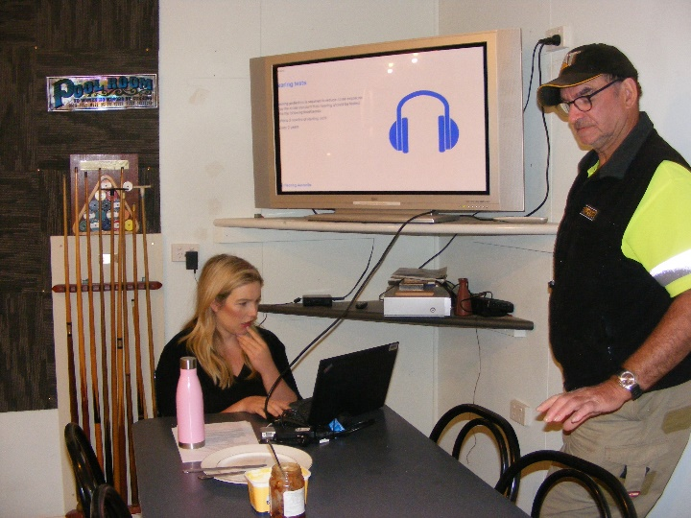

When you get a pretty lady in they all want to help. Here is Dave helping Angela set up for her demo.

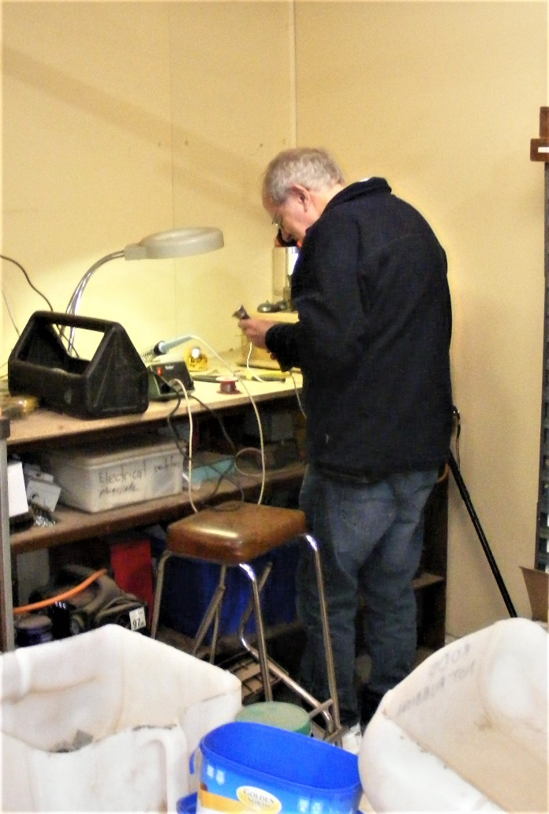

Dale soldering some wires on an old telephone.

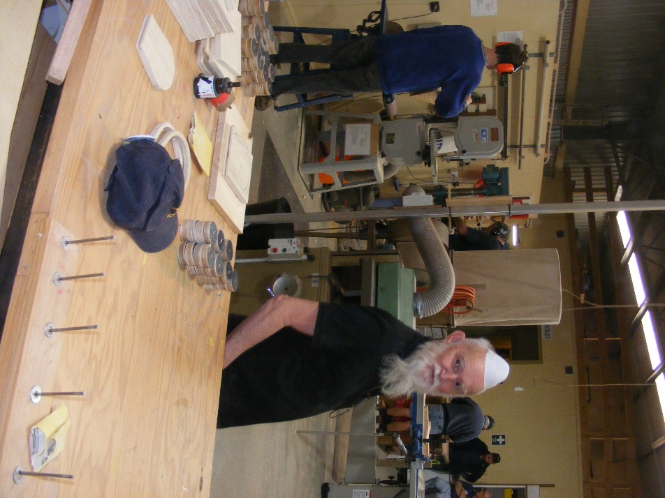

Glen can’t get his hair to grow so now he is going for the Jewish look.

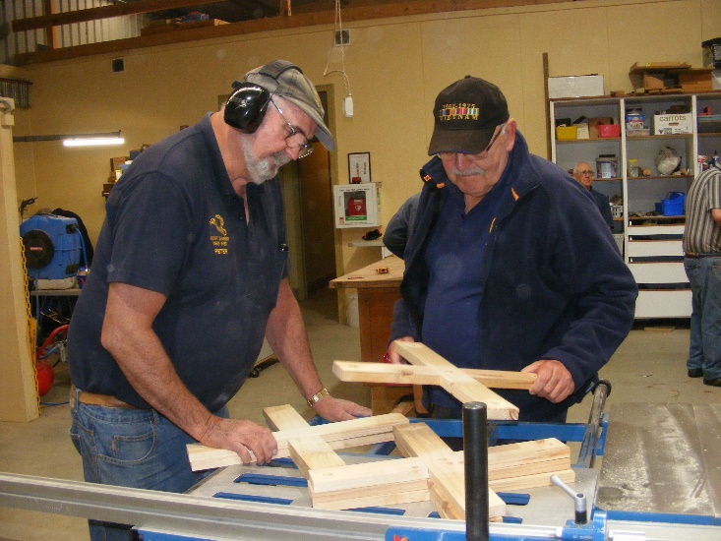

Ansi asking what or who are we hitting with this? Answer it is for kids to playquoits with.

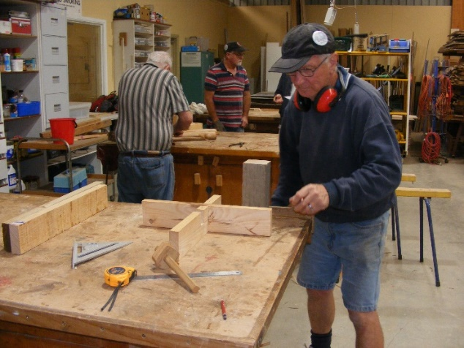

Geoff with the first part of a new table he is making.

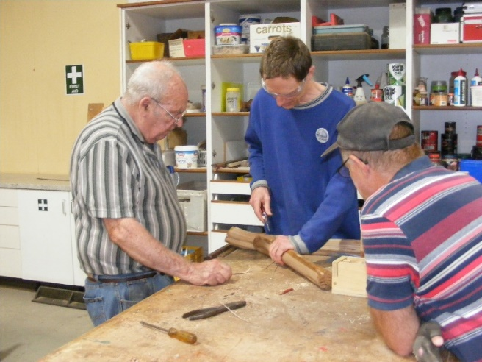

Jim and Garry learning from Richard how to debark a bit of branch with a pair of pliers.



HAPPY NEW YEAR

And welcome back