**EXECUTIVE MEMBERS FOR 2023**

**PRESIDENT**: Ian Bond 0420859540

**VICE PRESIDENT**: Grant Sullivan

**TREASURER**: John Plunkett

**SECRETARY**: Paul Edgeworth 0497386846

**PHONE**: 0478614027 (prefer Tuesday and Thursday am.)

**WE NOW HAVE A WEB SITE FOR THOSE WHO WISH TO LOOK. THIS WILL BE UPDATED FROM TIME TO TIME WITH NEW PHOTOS, NEWSLETTERS, RADIO REPORTS, CONTACTS AS WELL AS UPCOMING EVENTS AT THE SHED. Go to**

[**www.mgmensshed.com.au**](http://www.mgmensshed.com.au)

**FACEBOOK** Mens Shed Mount Gambier

[mgmensshed@gmail.com](mailto:mgmensshed@gmail.com)

**BIRTHDAYS**

Mark Woods 16/05

Wayne Earl 23/05

**2023 Calendar**

10th May Wednesday 6.30 Shedder and partners tea

11th May Thursday 10.30 Members Meeting

23rd May Tuesday 10.30 Management Meeting

8th June Thursday 10.30 Members Meeting

**Woodworking is all about the touch of the woodworker’s hands. There is no alternative to the tasks which are best done manually. Such tasks require specialized tools for performing each job. Hand tools make a lot of works easier for the woodworker. All it requires is to have the perfect tool for each job.** The woodworking requires some[**compulsory hand tools**](https://thetoolspick.com/types-of-hand-tools/) within reach for effortless woodworking. Some of the woodcraft tools will be mentioned in the next 11 newsletters. Let’s check them out. **4. Carpenter Square**

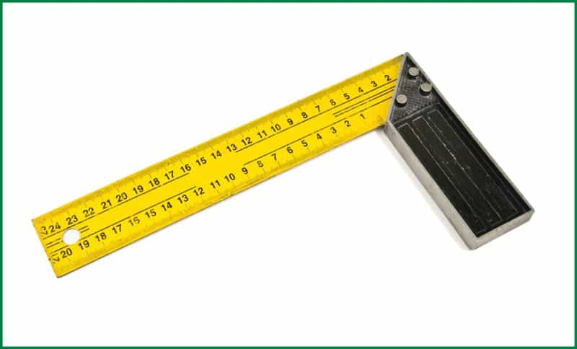

Carpenter’s square is basically a scale. This form of scale is the combination of 2 scales joint together at 90o angle. The 2 scales resemble two arms. One arm is wider which is named“ blade” and the other is narrower which is called “tongue”. The wider arm is about 2” wide, whereas the narrower one is 1.5” wide. Typically, such scales are made of steel and also called steel squares or framing squares. However, they are also made of aluminum and plastic. Such scales are lighter and resistant to rust. **Uses of Carpenter Square** Woodworking requires a lot of measurements to gain accuracy. A slight mismeasurement might lead to a huge crisis. That’s why the carpenter’s square always needs to be there on a woodworker’s workbench. It is used to measure the lines and angles to make the perfect cut.

**RECIEPE:-**

**CRUNCHY CHOCOLATE BARS**

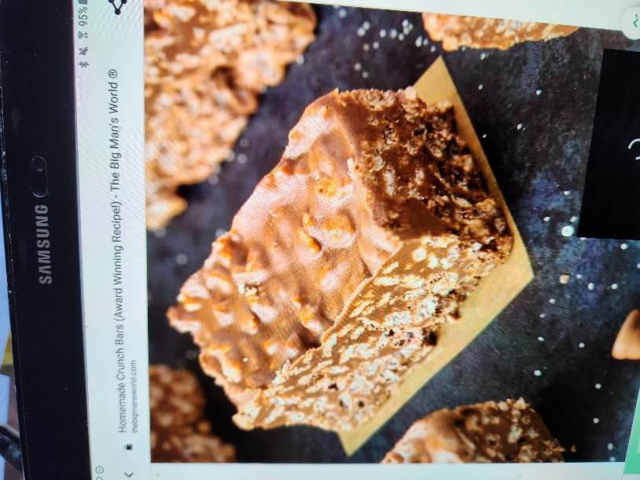

**Ingredients**

* 3 cups crispy rice cereal
* 1 ½ cups chocolate chips
* 1 cup of peanut butter (Can substitute any nut or seed butter)
* ½ cup maple syrup
* ¼ cup coconut oil (Can substitute for grass fed butter)

**Method**

* Line an 8 x 8 inch baking dish or deep baking tray of choice with parchment paper and set aside.
* Add crispy rice cereal into a large mixing bowl and set aside.
* In a microwave bowl or stove top, combine all the other ingredients and heat until melted. Remove and whisk until completely incorporated.
* Pour the chocolate/peanut butter over the crispy rice cereal and mix until combined.
* Pour into the lined baking dish and refrigerate until firm (at least an hour).
* Remove and cut into bars.
* Enjoy.

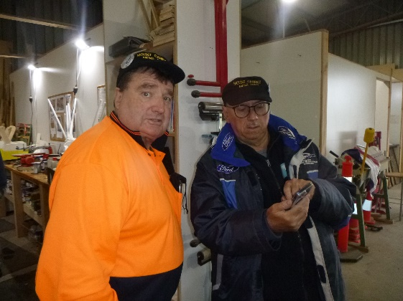

Stratty is trying to show Bill something but Bill just wants to look at the camera

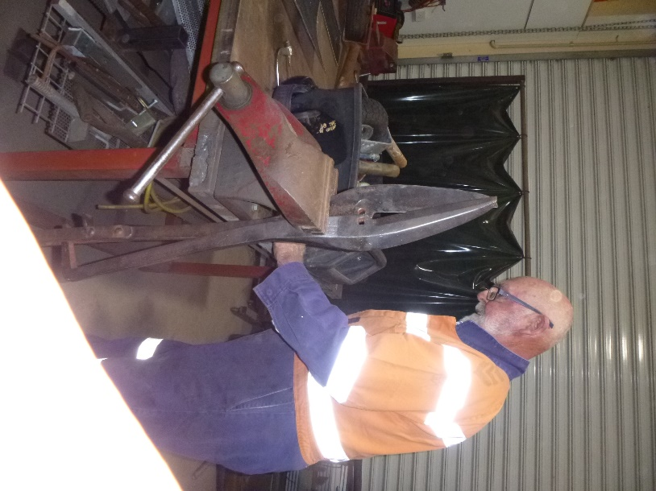

Bruce repairing a pair of tin snips. And if anyone can tell us what he would be cutting with them we are listening.

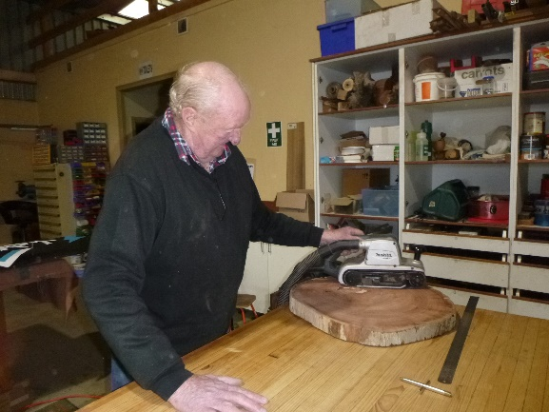

Not sure why Bruce is sanding this block of wood, but I am sure one day we will find out.

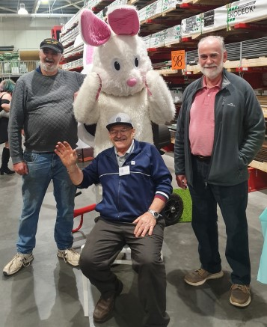

Easter time Peter, Ben and Rob were asked to help out at Bunnings for their Easter hunt and got a visit from Easter Bunny.

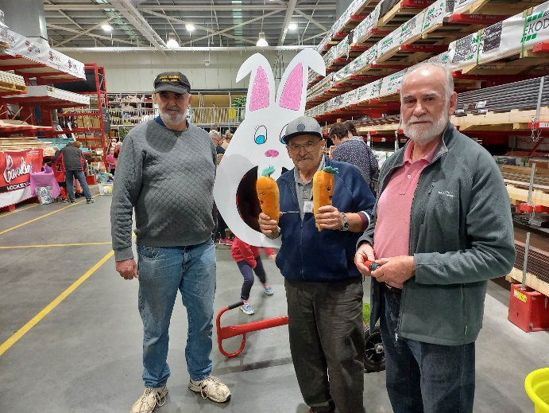

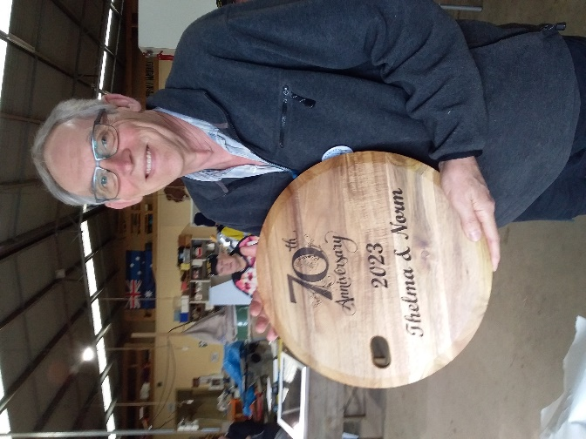

David with the engraving he did on the CNC laser.

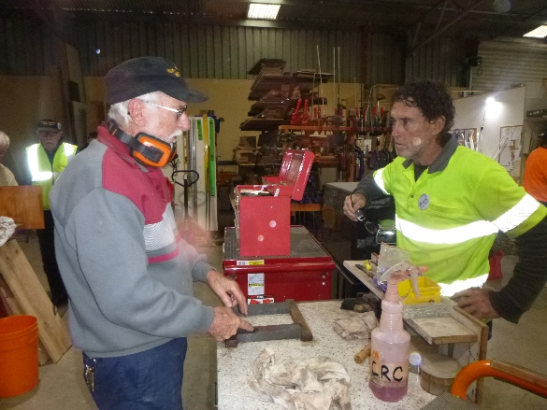

Don explaining to Ron how to sharpen a blade.

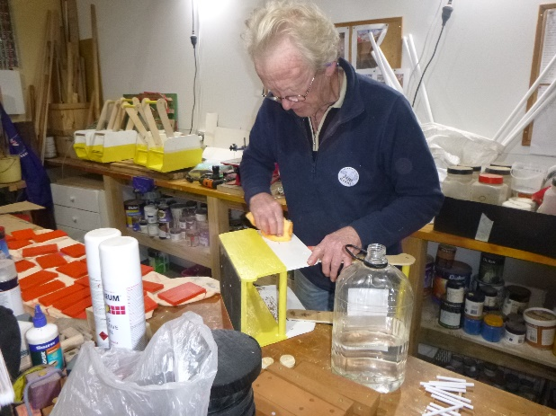

Jim sanding the side of a push-along bus.

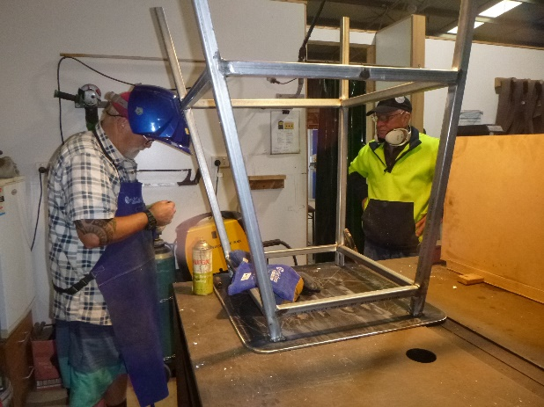

At the moment the welders are making some very large items. Here we have Ian and Geoff working on a large stool.

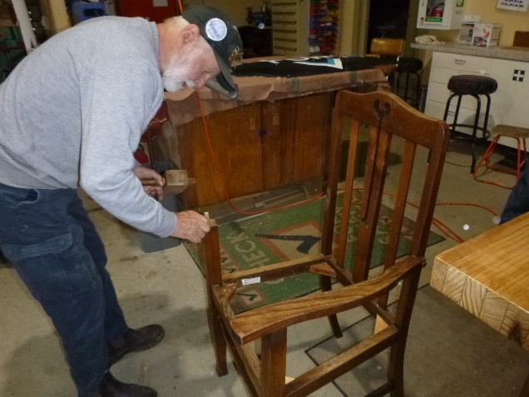

After months of building his coffin Herman has now turned his attention to repairing an old chair.

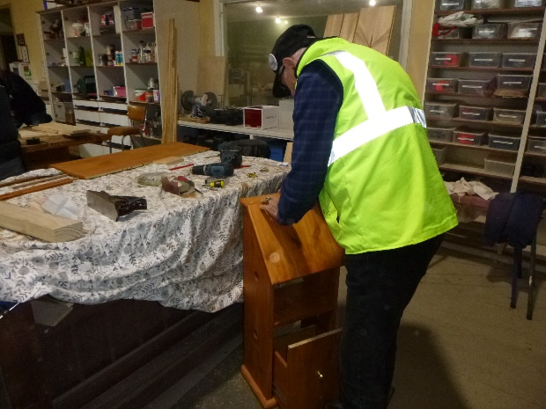

Ray fitting the hinges to Dicks vegetable tidy box.

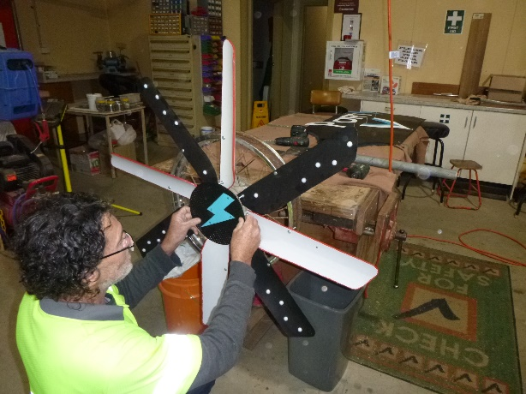

Ron and his windmill.

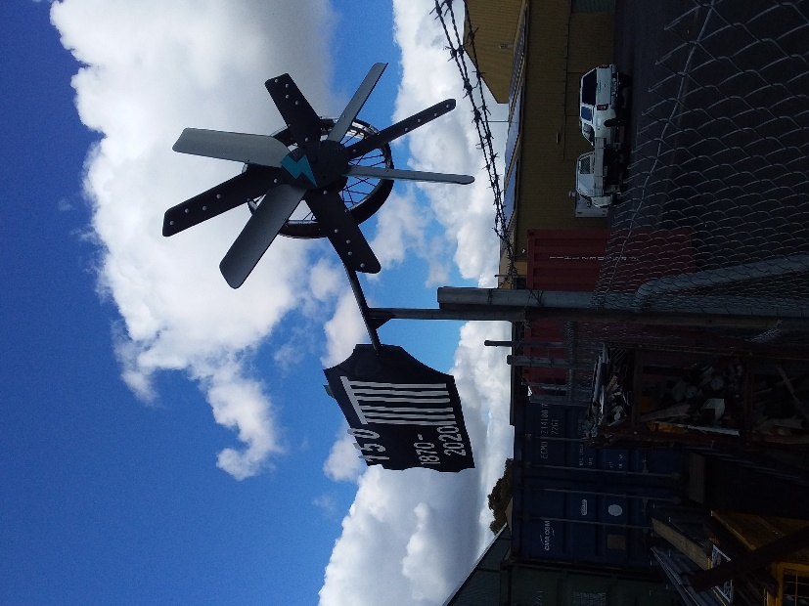

Ron’s Finished Windmill. We won’t hold it against him, but it is finished in Power colors.

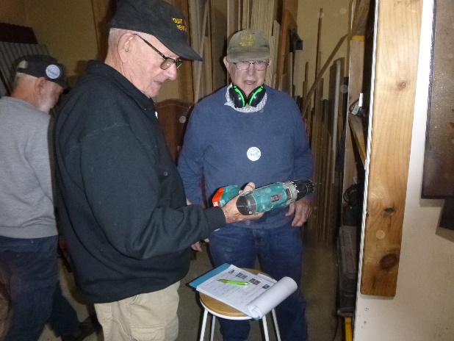

Rod and David checking out one of the new heavy duty drills.

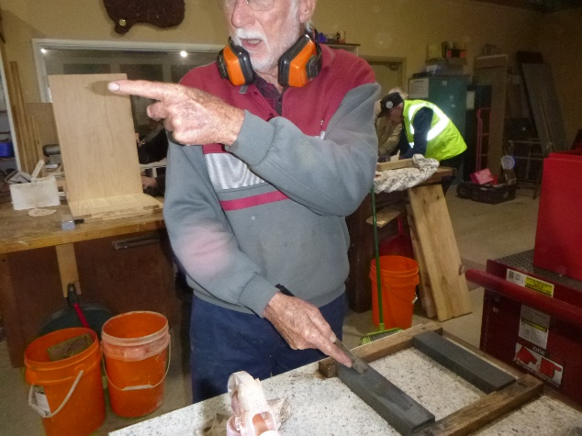

The face is nothing but watch that finger when Don points it he means business.

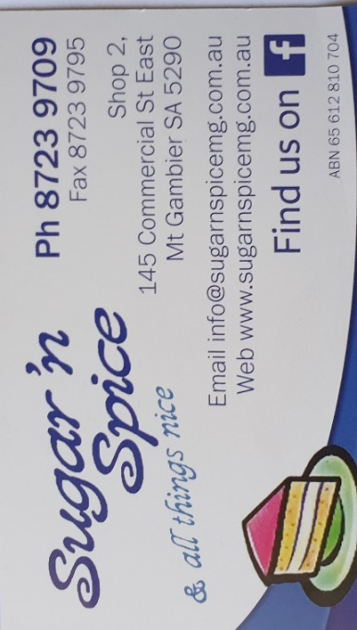

 





**Big supporters of Mount Gambier Mens Shed.**

**SUPPORT YOUR LOCAL BUSINESSES**

**THAT SUPPORT YOU.**