[mgmensshed@gmail.com](mailto:mgmensshed@gmail.com)

**EXECUTIVE MEMBERS FOR 2020**

**PRESIDENT**: Ansi Nitz 0439816074

**VICE PRESIDENT**: Ben Katris

**TREASURER**: John Plunket

**SECRETARY**: Paul Edgeworth 0887256385

**FACEBOOK**

Shed broadcasts are now available on Facebook

*[Image result for facebook logo](https://www.google.com.au/url?sa=i&rct=j&q=&esrc=s&source=images&cd=&cad=rja&uact=8&ved=2ahUKEwjO9cWTtajeAhUafisKHT6JAHoQjRx6BAgBEAU&url=http://www.seacliffeinn.com/spa-boutique/find-us-on-facebook-logo/&psig=AOvVaw0duNjpvsqixE3Pzu1qEwe2&ust=1540791326821108)* Mens Shed Mount Gambier

Thanks to all Shedders for phoning and emailing others during lockdowns as well as those in self or required isolation.

**We know that the Shed is an important part of the week for many of our members.** We know that there were lots of clusters of Shedders operating outside shed hours, so thanks to those while we were not operating.

**It is great to see every one back an d well.**

**BIRTHDAYS**

Stephen S. 11/07/1955

Keith R. 17/07/1938

Bill M . 17/07/1955

Chris N. 19/07/1945

Jim T 27/07/1949



**Remember Sugar ‘n Spice support the Men’s shed with Birthday cakes so support them where you can.**

 

**While mentioning our supporters always remember how much Bunnings help our shed, so support them as well when you need a product they can supply for you.**

**Safety: - Remember Safety begins at home.**





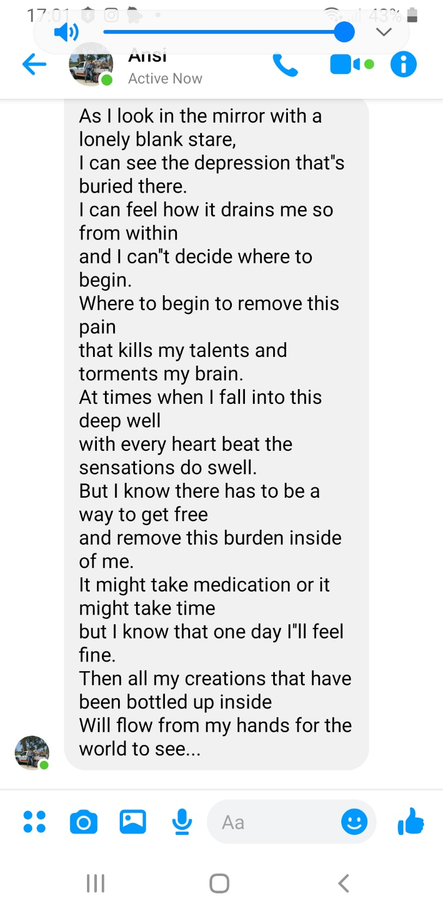

**JOKES**



**Confucius Did Not Say**

Man who wants pretty nurse must be patient. Passionate kiss, like spider web, leads to undoing of fly. Lady who goes camping with man must beware of evil intent. Squirrel who runs up woman's leg will not find nuts. Man who runs in front of car gets tired, but man who runs behind car gets exhausted. Man who eats many prunes get good run for money. War does not determine who is right; it determines who is left. Man who fights with wife all day get no piece at night. It takes many nails to build a crib, but only one screw to fill it. Man who drives like hell is bound to get there. Man who stands on toilet is high on pot. Wise man does not keep sledge hammer and slow computer in same room. Man who lives in glass house should change clothes in basement. And, Confucius Did Not Say. "A lion will not cheat on his wife, but a Tiger Wood!”



Our container has arrived and the crane is ready to go.



Off the truck now where do you want it.

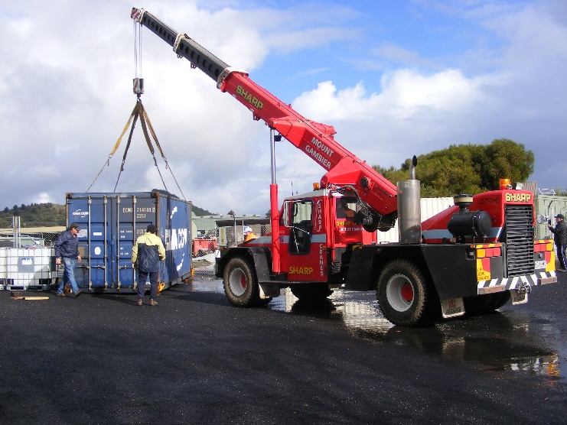

Hang on the boss is on hand to make sure it is in the right spot.

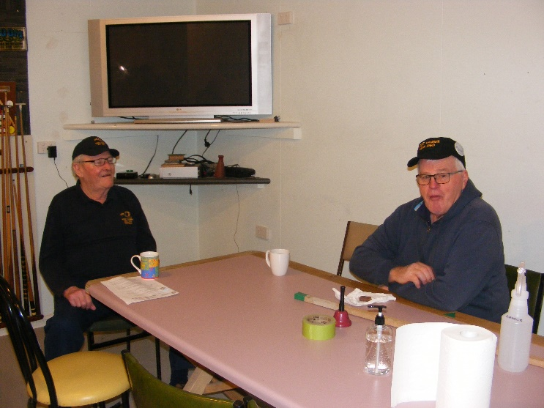

Norm C. and Grant S. in the smoko room practicing social distancing.

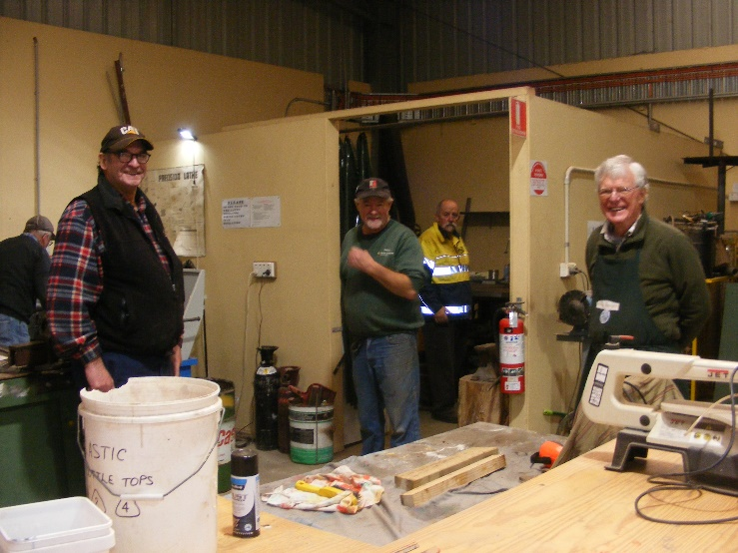

Trevor H., Dave L., Garry A., Ian A. and Jim T. showing social distancing while still working.

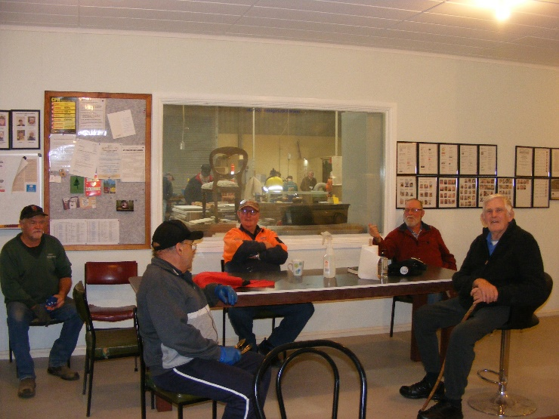

Gee it’s great to be back at the shed having a natter with all the boys even if we have to yell for the deaf ones to hear.

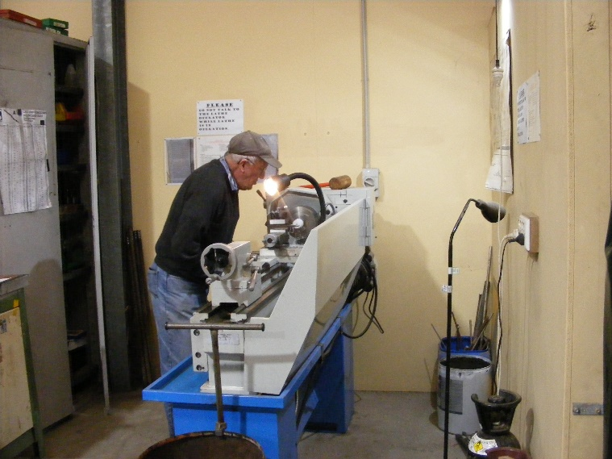

First day back and Trevor H is straight back into work mode.

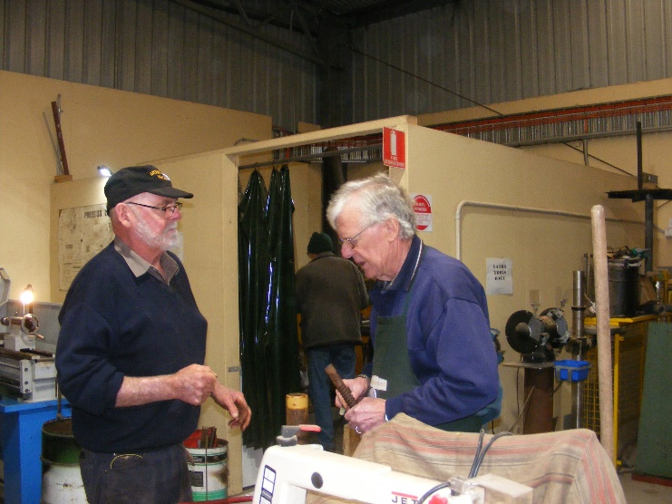

Bruce A. and Jim T. repairing a Jockey wheel.

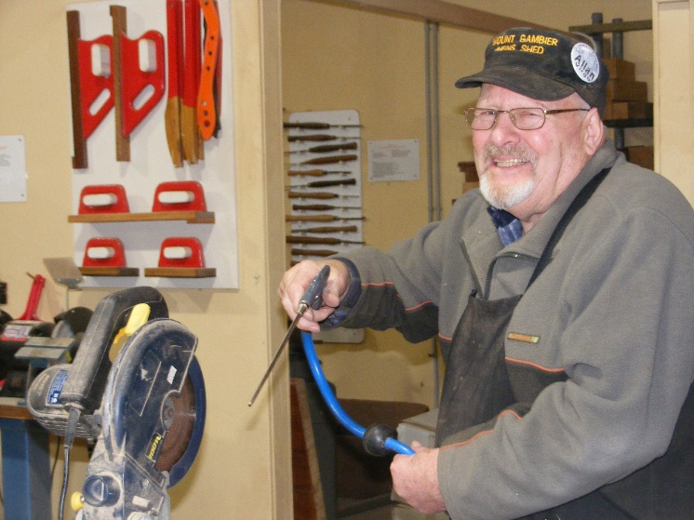

The smile on Allen V. says it all it’s great to be back.

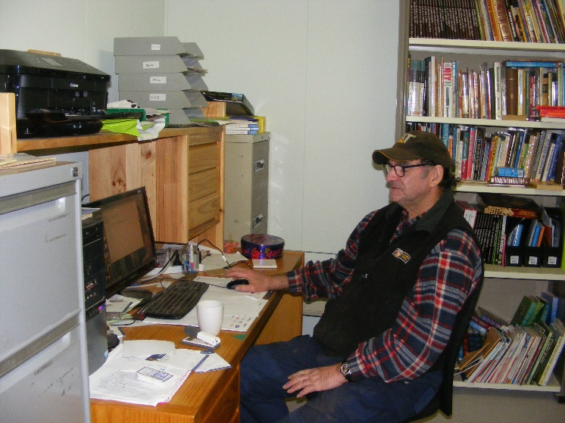

Dave L. really social distanced working on the computer.

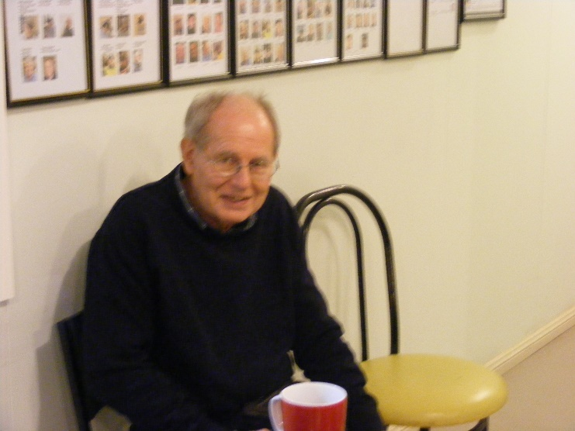

Dale A. enjoying a cuppa.

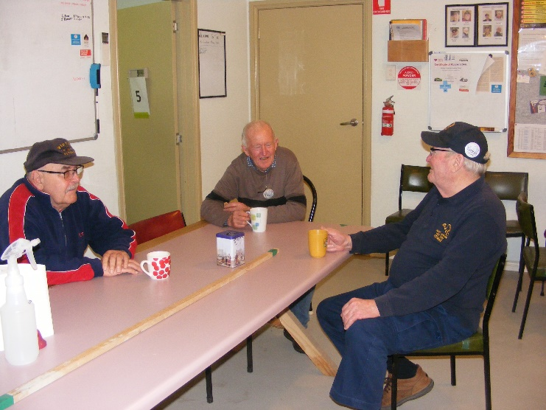

Ansi N., Trevor H. and Norm C. having a cuppa

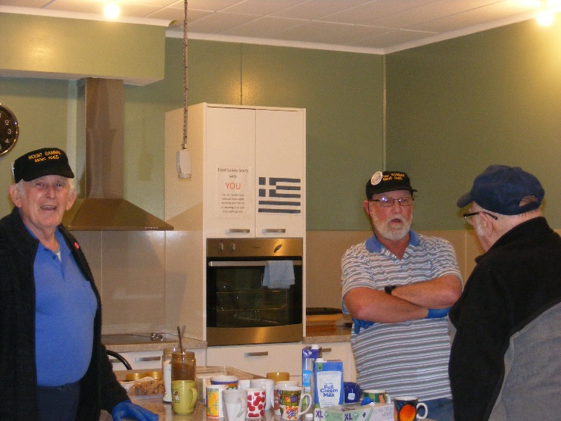

Peter Y., Kevin M. And Terry G. having a chin wag.

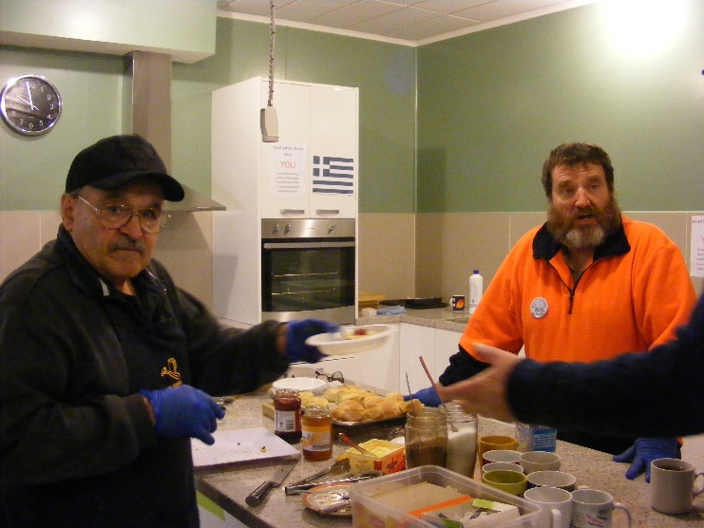

Bill Mc. and Ben K. may not be the “Flour Pot Men” but they have started to produce the traditional scones for morning tea post COVID 19. Well done boys.