**EXECUTIVE MEMBERS FOR 2023**

**PRESIDENT**: Ian Bond 0420859540

**VICE PRESIDENT**: Grant Sullivan

**TREASURER**: John Plunkett

**SECRETARY**: Paul Edgeworth 0497386846

**PHONE the Shed**: 0478614027 (prefer Tuesday and Thursday am.)

**WE NOW HAVE A WEB SITE FOR THOSE WHO WISH TO LOOK. THIS WILL BE UPDATED FROM TIME TO TIME WITH NEW PHOTOS, NEWSLETTERS, RADIO REPORTS, CONTACTS AS WELL AS UPCOMING EVENTS AT THE SHED. Go to**

[**www.mgmensshed.com.au**](http://www.mgmensshed.com.au)

**FACEBOOK** Mens Shed Mount Gambier

[mgmensshed@gmail.com](mailto:mgmensshed@gmail.com)

**BIRTHDAYS**

Glen B 05/06

Andrew K 05/06

Kevin M 15/06

Mat J 10/06

Allan C 14/06

David N 22/06

Dick P 29/06

**2023 Calendar**

8th June Thursday 10.30 Members Meeting

14th June Wednesday 6.30 - Shedders and Partners tea at Fasta Pasta Commercial St

**WOODWORKING is all about the touch of the woodworker’s hands. There is no alternative to the tasks which are best done manually. Such tasks require specialized tools for performing each job. Hand tools make a lot of works easier for the woodworker. All it requires is to have the perfect tool for each job.** The woodworking requires some[**compulsory hand tools**](https://thetoolspick.com/types-of-hand-tools/) within reach for effortless woodworking. Some of the woodcraft tools will be mentioned in the next 11 newsletters. Let’s check them out. **5. Level**

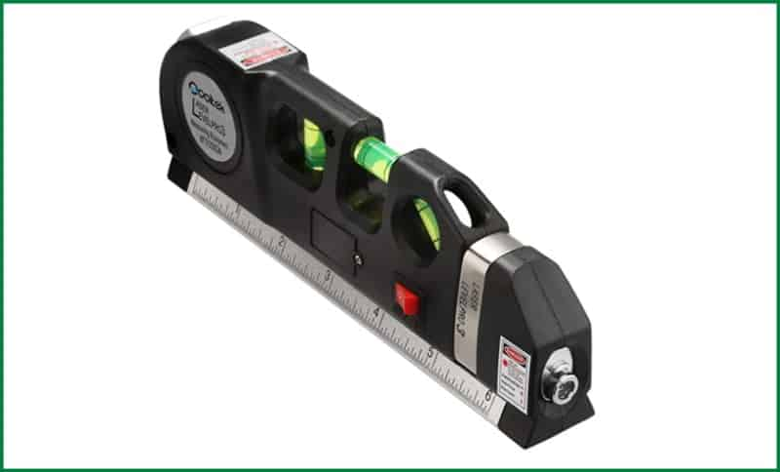

The level is an unusual type of measuring instrument. This measuring tool consists of a glass vial with liquid inside. It may have a glass barrel or a circular glass vial with curved glass. The liquid is moderately filled in the vial to leave a bubble in it.  As for the liquid, usually alcohol is used in it due to its low surface tension and viscosity. The Colouring agent is also added with it to increase visibility. The bubble moves within the vial when this scale is placed on a surface. The perfectly straight alignment will have the bubble in the centre of the vial. The bubble will shift from the centre to other directions with each degree of inaccuracy. **Uses of Level** The level is used in woodworking to examine the accuracy of the alignment of woods. Not only the wood pieces, the blade of the saw, the worktable and the designated wood piece all have to be aligned precisely for obtaining flawless cuts. The level is used for checking all those arrangements.

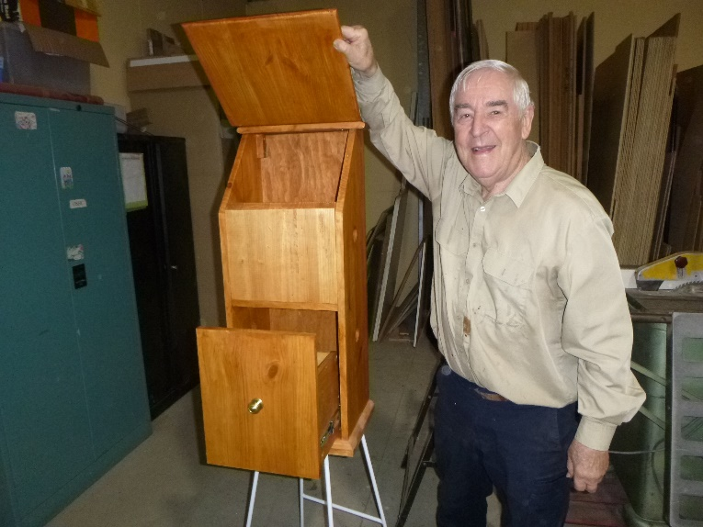

Dick P working on a vegetable tidy

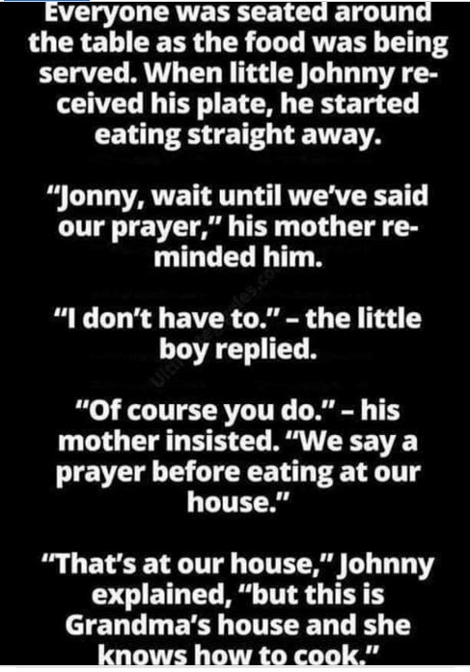

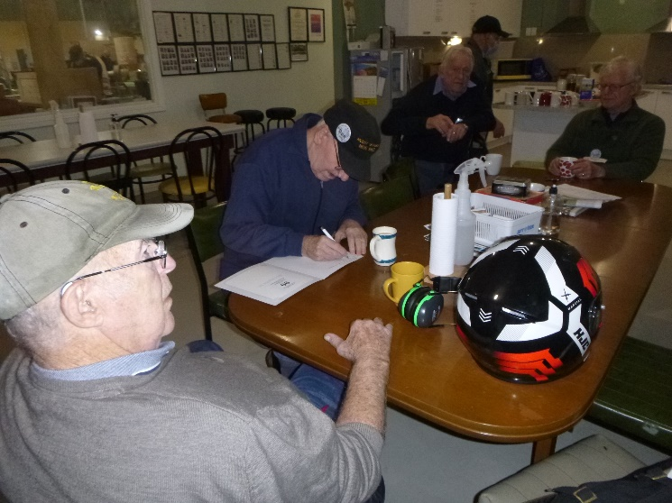

Rod L in deep thought about what

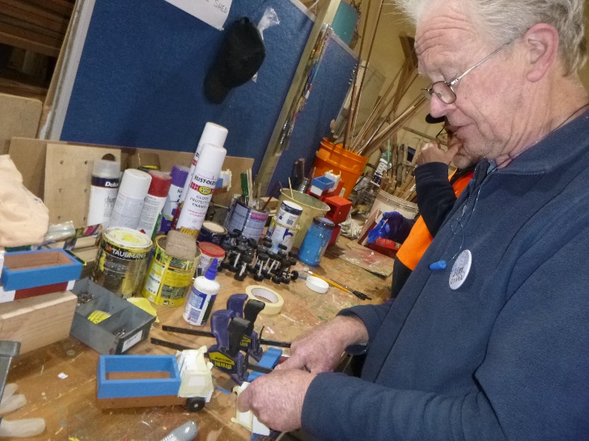

Jim G working on a toy truck

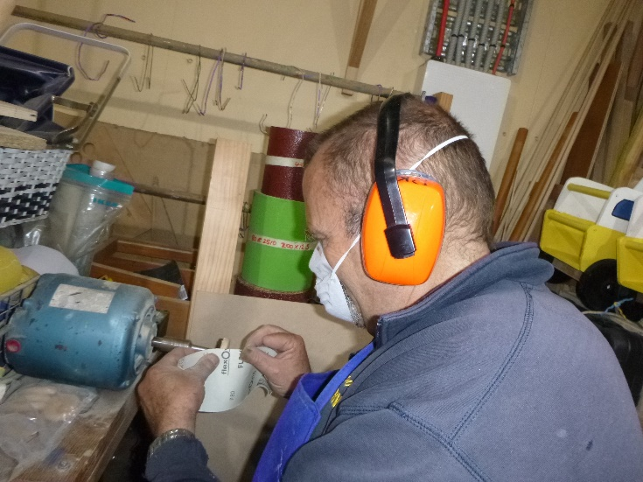

Peter K sanding some wheels



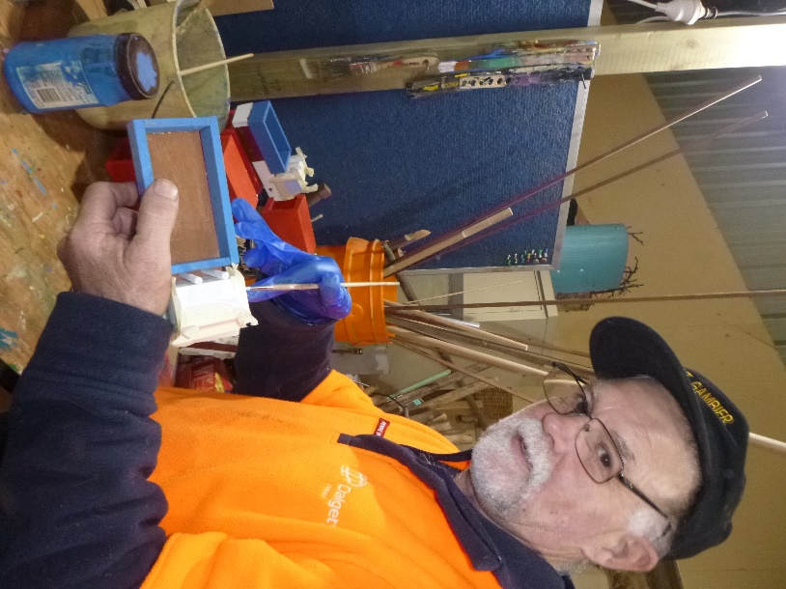

Gary A painting toy trucks

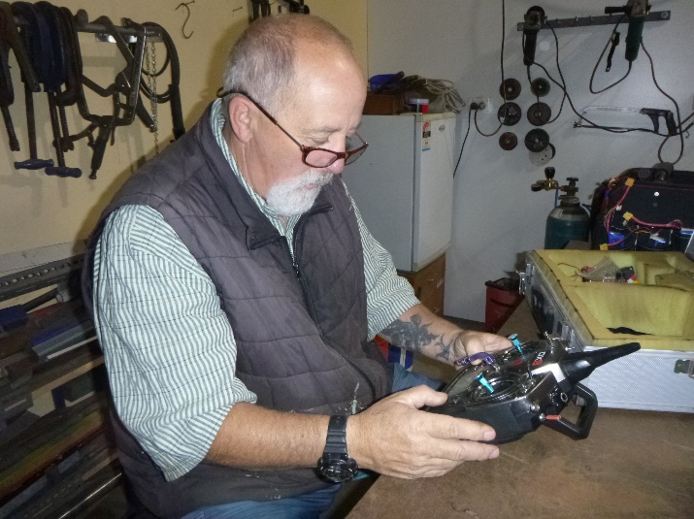

Ian A - now what does this thing do???





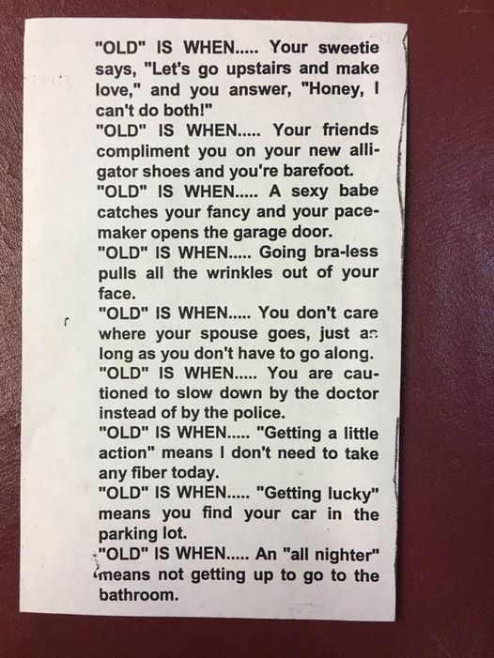



 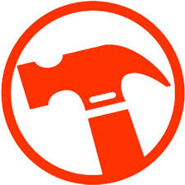





**Big supporters of Mount Gambier Mens Shed.**

**SUPPORT YOUR LOCAL BUSINESSES**

**THAT SUPPORT YOU.**