[mgmensshed@gmail.com](mailto:mgmensshed@gmail.com)

**EXECUTIVE MEMBERS FOR 2021**

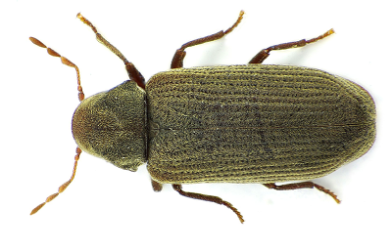**PRESIDENT**: Peter Halleday 0439500699

**VICE PRESIDENT**: Ian Bond

**TREASURER**: John Plunket

**SECRETARY**: Paul Edgeworth 0887256385

**PHONE**: 0478614027

**FACEBOOK** Mens Shed Mount Gambier

Shed broadcasts are now available on Facebook

**PHONE**: 0478614027

**FACEBOOK** Mens Shed Mount Gambier

*[Image result for facebook logo](https://www.google.com.au/url?sa=i&rct=j&q=&esrc=s&source=images&cd=&cad=rja&uact=8&ved=2ahUKEwjO9cWTtajeAhUafisKHT6JAHoQjRx6BAgBEAU&url=http://www.seacliffeinn.com/spa-boutique/find-us-on-facebook-logo/&psig=AOvVaw0duNjpvsqixE3Pzu1qEwe2&ust=1540791326821108)*

**Safety: - Remember Safety begins at home.**

**BIRTHDAYS**

Bob P 16/01

Lyndon M 21/01

[www.thesoutheastjunction.org.au](http://www.thesoutheastjunction.org.au)

Image result for facebook icon thesejunction

THE COMMON TYPES OF WOODWORM AND WOOD BORING INSECTS pART 3/12

So who are the ‘usual suspects’ when it comes to the types of wood boring insects snacking on the timber of your property?

**#2. Common Furniture Beetle**

Latin name: Anobium Punctatum

**Appearance**: On closer inspection, it looks like the classic beetle in terms of shape and size – but has light, green-brown coloring. A relatively small insect, it is still capable of causing structural damage to your property.

**Preferred timber**: The sapwood of both hard and softwood.

**Type of damage**: Bores extensively creating rounded tunnels, usually going with the grain of the wood - and will fly to find new wood sources.

**Telltale signs**: The droppings or frass of the Common Furniture Beetle are sandy, oblong pellets. The insect emerges from 2 mm diameter boreholes.

**Next Month - Death Watch Beetle**

**Joke**

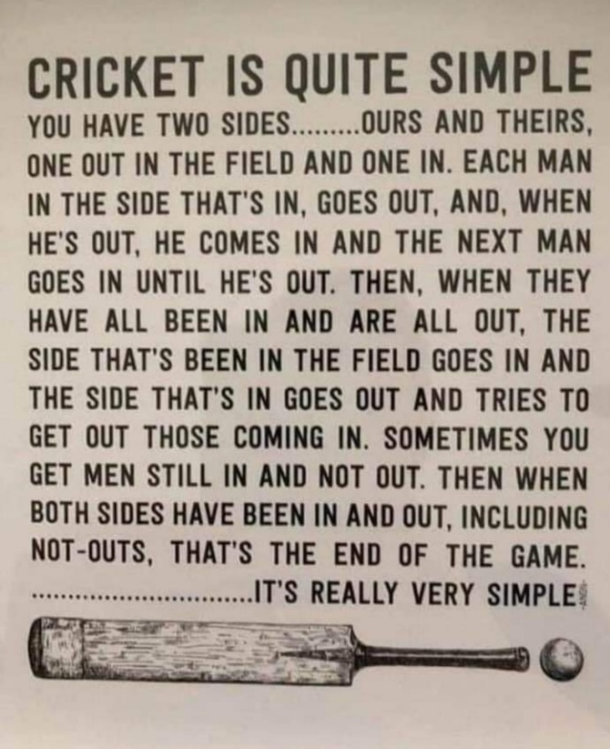

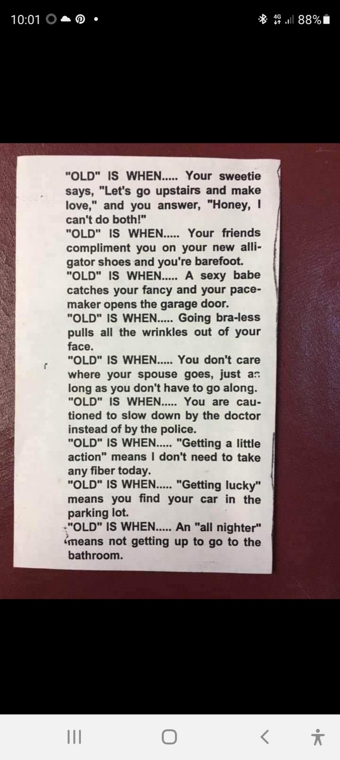

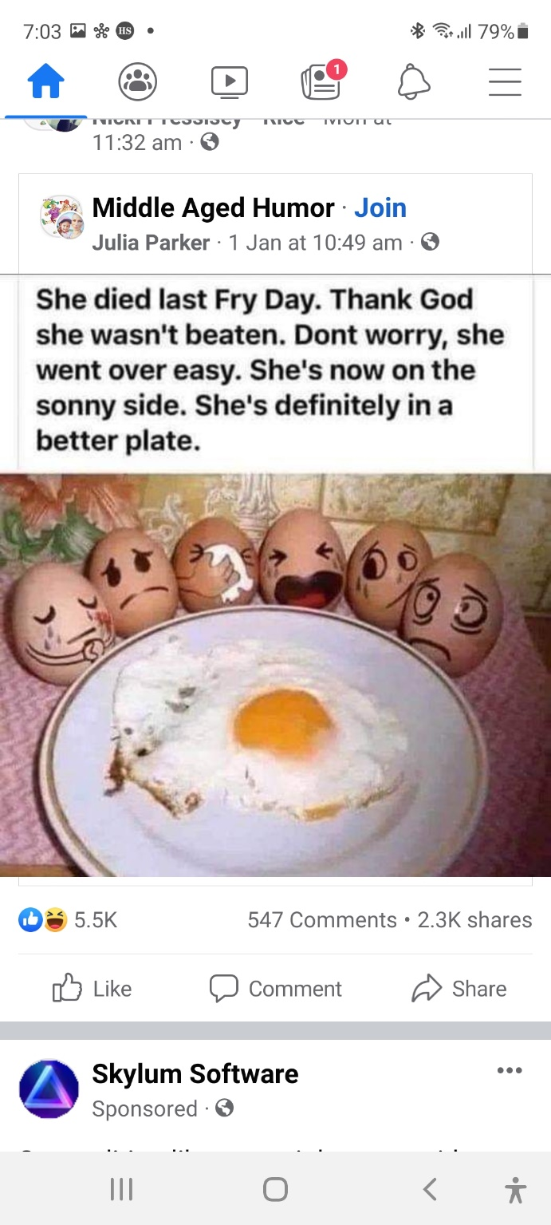

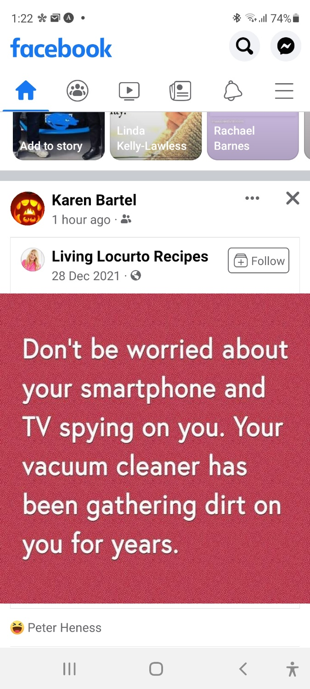

**President of the Men’s Shed Peter Halleday.**

Well it is a big Happy New Year to you all. Hope you have had a good break and look forward to another year at the shed enjoying each other’s company. COVID is everywhere so remember to stay safe cover up and if you have any symptoms please stay home and think of your mates so you do not pass it on.

**Member Profile:-**

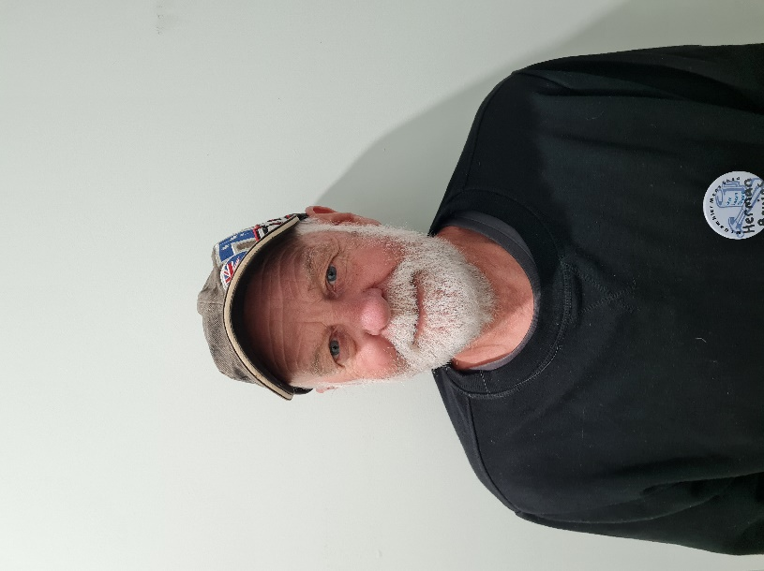

**Name:-**  Herman Bruins.

**Where have you worked:-** Woods and Forest for 25 years and safe Work S.A. 15 years.

**Something about you other may not know:-** Was a member of the Mongerls motor cycle club.

**What do you want to achieve at the shed:-** Comradery, new skills and a few personal projects

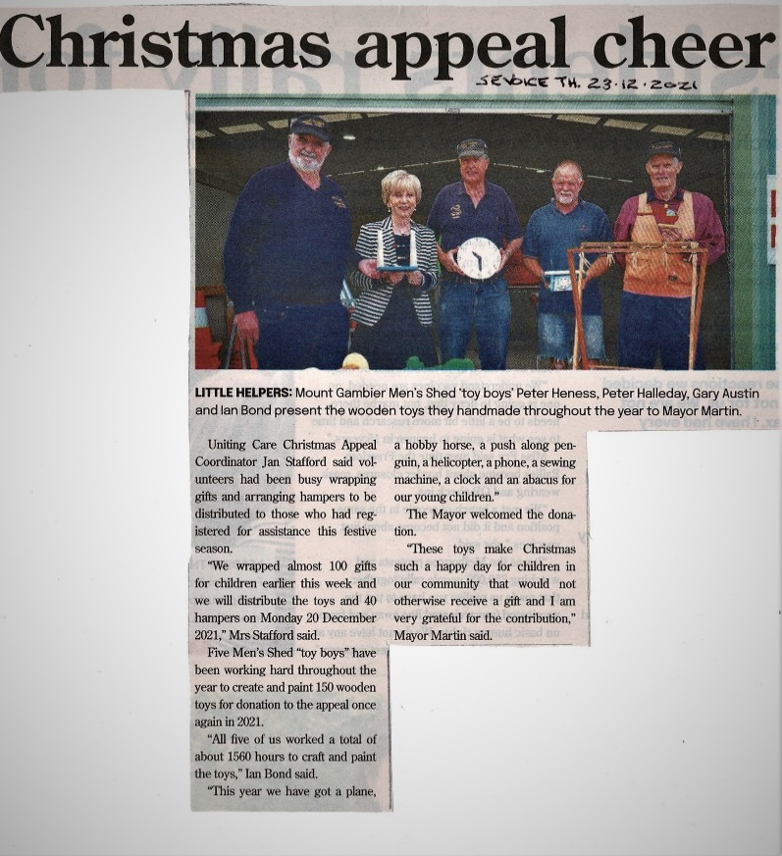

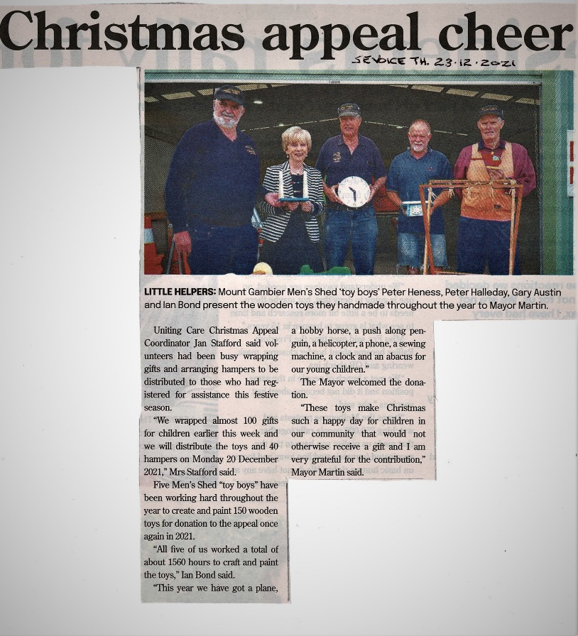

**LITTLE HELPERS**: Mount Gambier Men’s Shed ‘toy boys” Peter Heness, Peter Halleday, Gary Austin and Ian Bond present the wooden toys they made throughout the year to Mayor Martin.

Uniting Care Christmas Appeal Coordinator Jan Stafford said volunteers had been busy wrapping gifts and arranging hampers to be distributed to those who had registered for assistance this festive season.

“We wrapped almost 100 gifts for children earlier this week and we will distribute the toys and 40 hampers on Monday 20 December 2021,” Mrs Strafford said.

Five Men’s Shed “toy boys” have been working hard throughout the year to create and paint 150 wooden toys for donation to the appeal once again in 2021.

All five of us worked a total of about 1560 hours to craft and paint the toys,“ Ian Bond said.

“This year we have got a plane, a hobby horse, a push-along penguin, a helicopter, a phone, a sewing machine, a clock and an abacus for our young children.”

The Mayor welcomed the donation.

“These toys make Christmas such a happy day for children in our community that would not otherwise receive a gift and I am very grateful for the contribution,” Mayor Martin said.

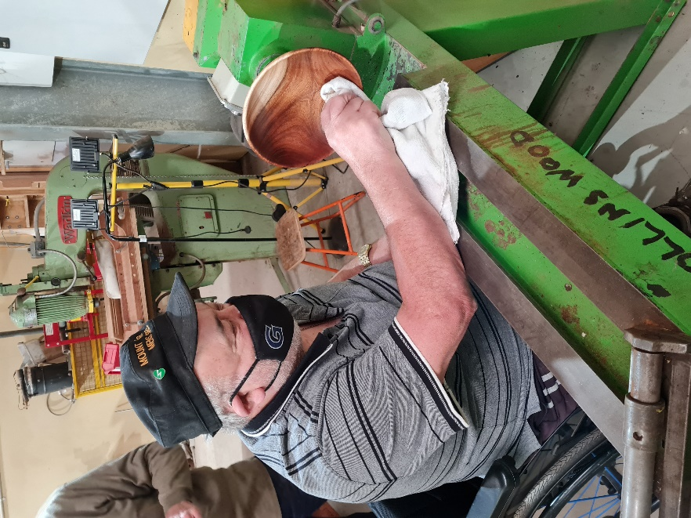

The Master Laurie finishing of the bowl he has been turning up.

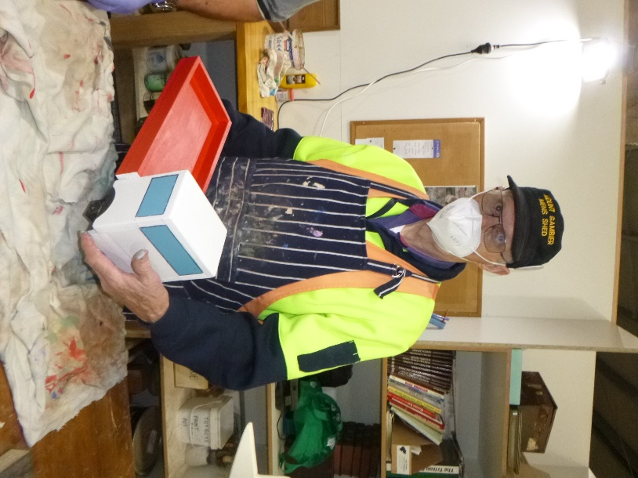

Ian with a toy truck he is working on.

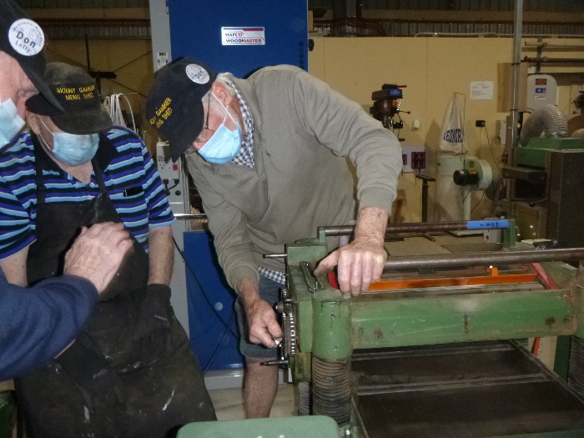

Don working on the new thicknesser

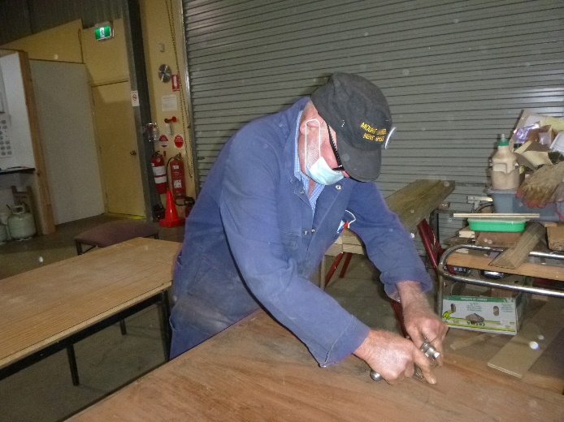

Bruce scraping his red cedar table top.

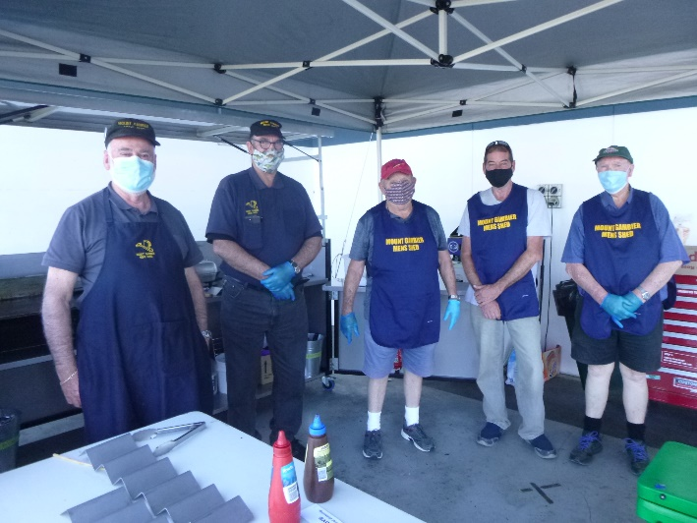

Bunnings afternoon crew

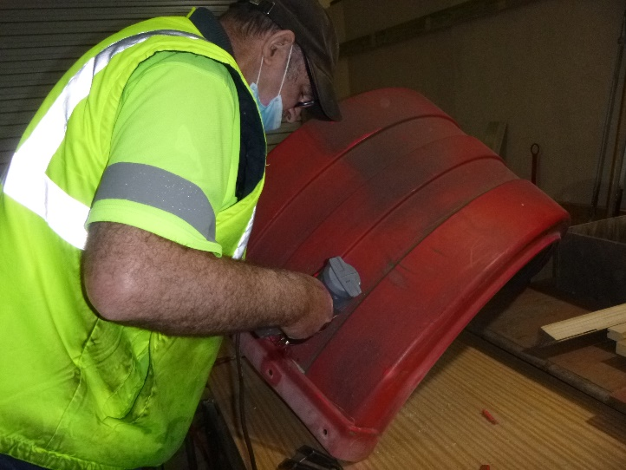Dave plastic welding a guard ready for a new garden bed.

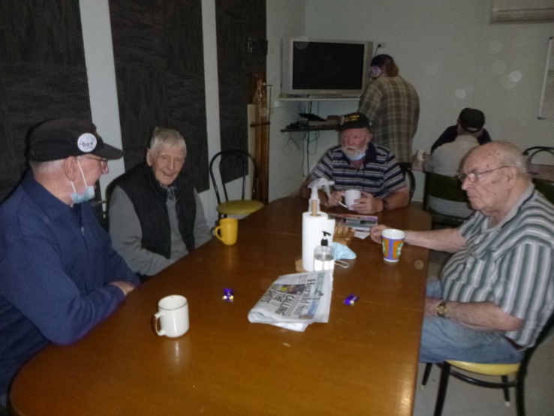

Don, Bernard, Kevin and Jim sharing a talk and a cuppa.

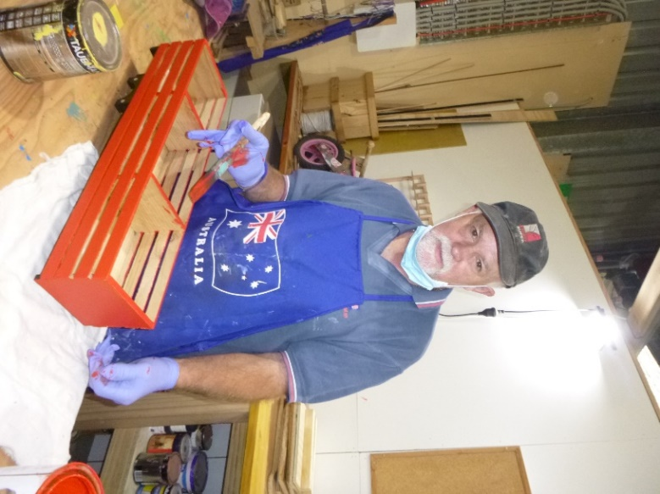

Garry with a stock crate being painted.

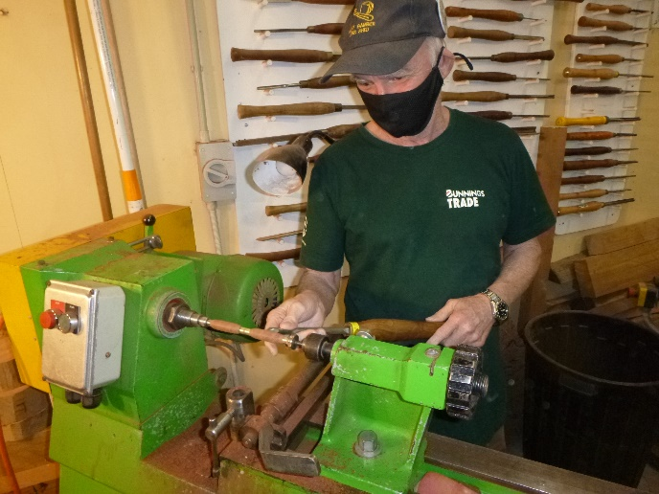

Glen showing us his pen making technique.

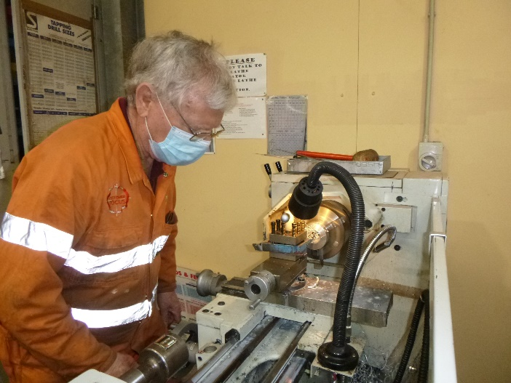

Jim is a picture of concentration on the metal tathe.

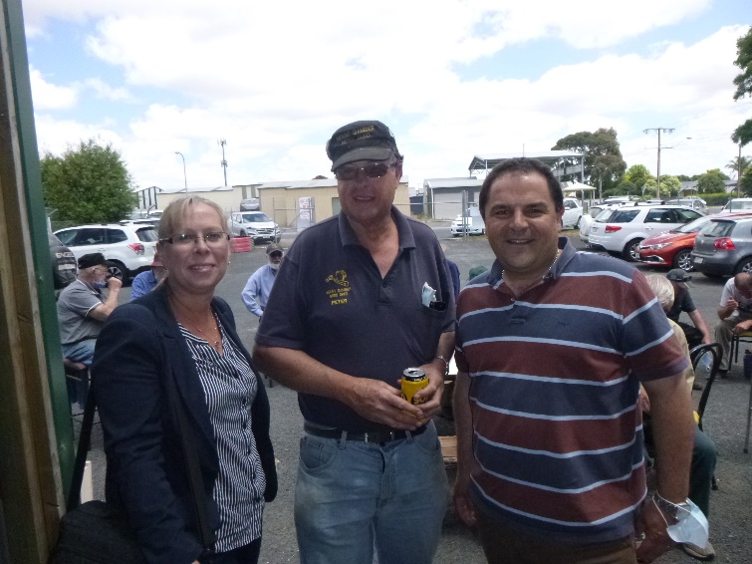

Tony Pasin managed to take time out of his busy schedule to visit our end of year BBQ.

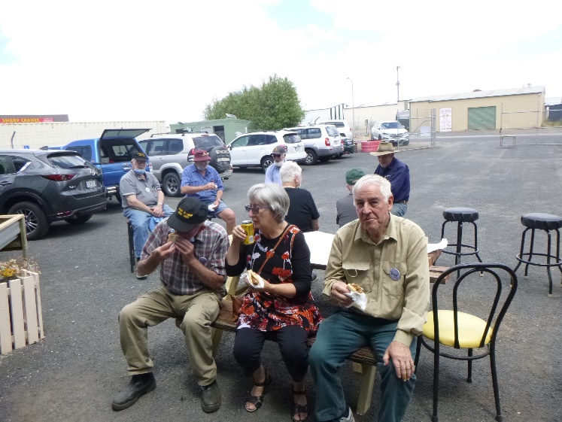

Next 3 photos are members and their wives at the end of year BBQ.

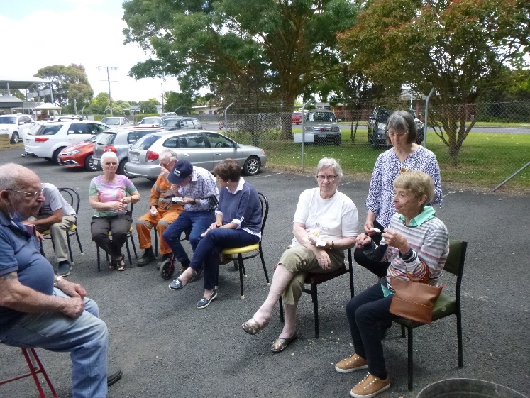

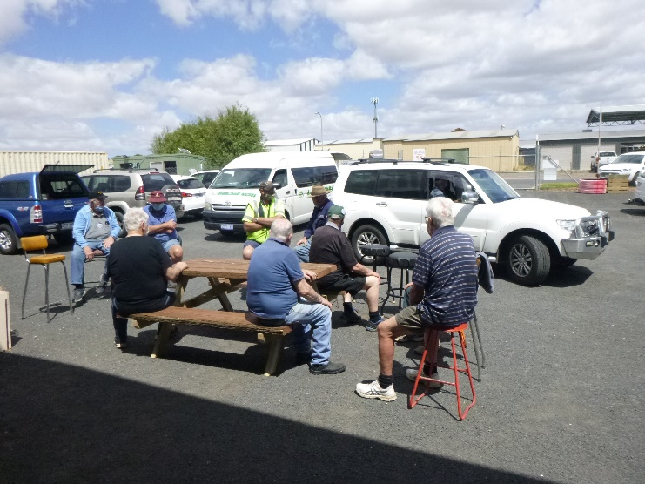

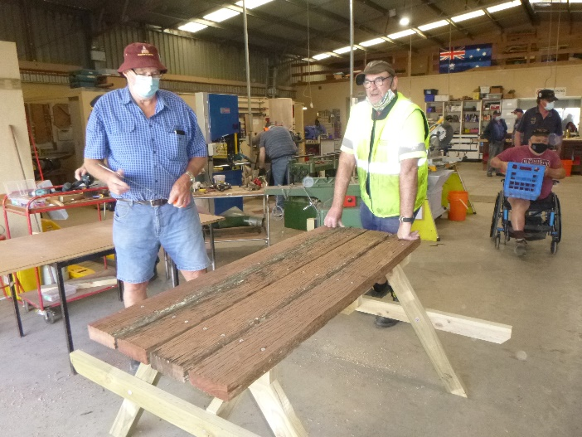

Dave and Jeff with a different way of doing a table using red gum for the top.



 





**Big supporters of Mount Gambier Mens Shed.**

**SUPPORT YOUR LOCAL BUSINESSES**

**THAT SUPPORT YOU.**