[mgmensshed@gmail.com](mailto:mgmensshed@gmail.com)

**EXECUTIVE MEMBERS FOR 2020**

**PRESIDENT**: Ansi Nitz 0439816074

**VICE PRESIDENT**: Ben Katris

**TREASURER**: John Plunket

**SECRETARY**: Paul Edgeworth 0887256385

**FACEBOOK**

Shed broadcasts are now available on Facebook

*[Image result for facebook logo](https://www.google.com.au/url?sa=i&rct=j&q=&esrc=s&source=images&cd=&cad=rja&uact=8&ved=2ahUKEwjO9cWTtajeAhUafisKHT6JAHoQjRx6BAgBEAU&url=http://www.seacliffeinn.com/spa-boutique/find-us-on-facebook-logo/&psig=AOvVaw0duNjpvsqixE3Pzu1qEwe2&ust=1540791326821108)* Mens Shed Mount Gambier

Thanks to all Shedders for phoning and emailing others during lockdowns as well as those in self or required isolation.

**We know that the Shed is an important part of the week for many of our members.** We know that there were lots of clusters of Shedders operating outside shed hours, so thanks to those while we were not operating.



**Remember Sugar ‘n Spice support the Men’s shed with Birthday cakes so support them where you can.**

 

**While mentioning our supporters always remember how much Bunnings help our shed, so support them as well when you need a product they can supply for you.**

**BIRTHDAYS**

Ian B. 06/09

Ray L. 08/09

Peter Hal. 18/09

Brian S. 26/09

Rod L. 28/09

**PUZZLE**

Answers to last month’s puzzles. How many did you get be honest and let me know. How many you can get.

1. 26 = LETTERS of the ALPHABET.
2. 7 = WONDERS of the WORLD.
3. 1001 = ARABIAN NIGHTS.
4. 12 = SIGNS of the ZODIAC.
5. 54 = CARDS in a DECK (with JOKERS).
6. 9 = PLANETS in the SOLAR SYSTEM.
7. 88 = PIANO KEYS.
8. 13 = STRIPES on the AMERICAN FLAG.
9. 32 = DEGREES FAHRENHEIT at which

WATER FREEZES.

1. 18 = HOLES on a GOLF COURSE.
2. 90 = DEGREES in a RIGHT ANGLE.
3. 200 = DOLLARS for PASSING GO in

MONOPOLY.

1. 8 = SIDES on a STOP SIGN.
2. 4 = QUARTS in a GALLON.
3. 24 = HOURS in a DAY.
4. 1 = WHEEL on a UNICYCLE.
5. 5 = DIGITS in a ZIP CODE.
6. 57 = HEINZ VARIETIES.
7. 11 = PLAYERS on an AMERICAN

FOOTBALL TEAM.

1. 1000 = WORDS that a PICTURE is WORTH.
2. 29 = DAYS in FEBRUARY in a LEAP

YEAR.

1. 64 = SQUARES on a CHESS BOARD.
2. 3 = BLIND MICE (SEE HOW THEY RUN).

**Safety: - Remember Safety begins at home.**

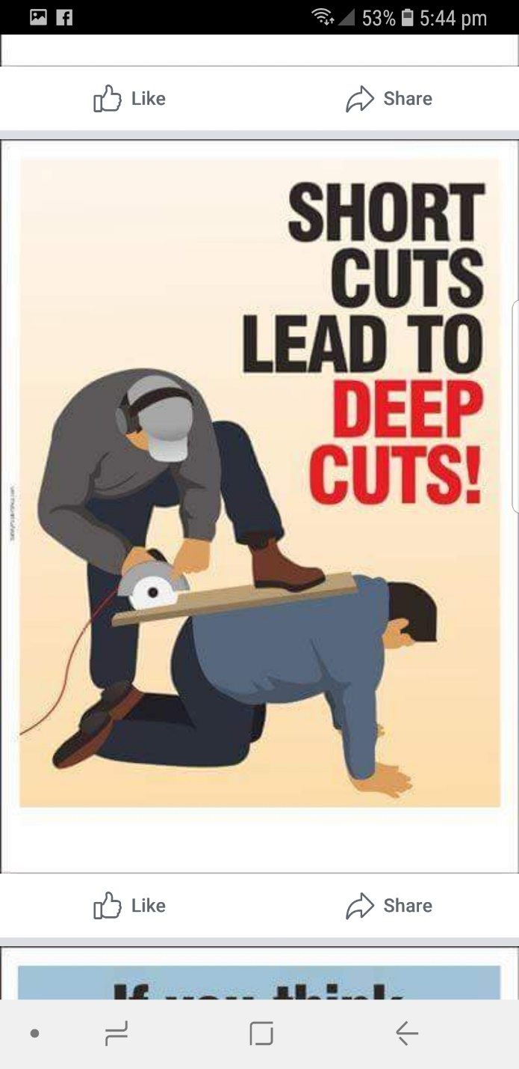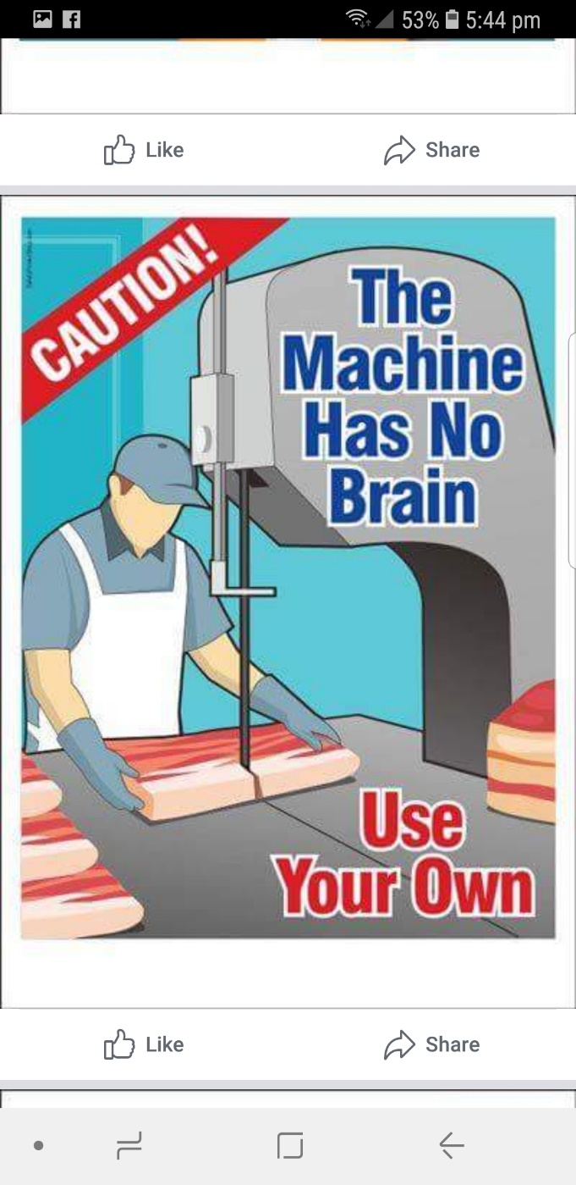

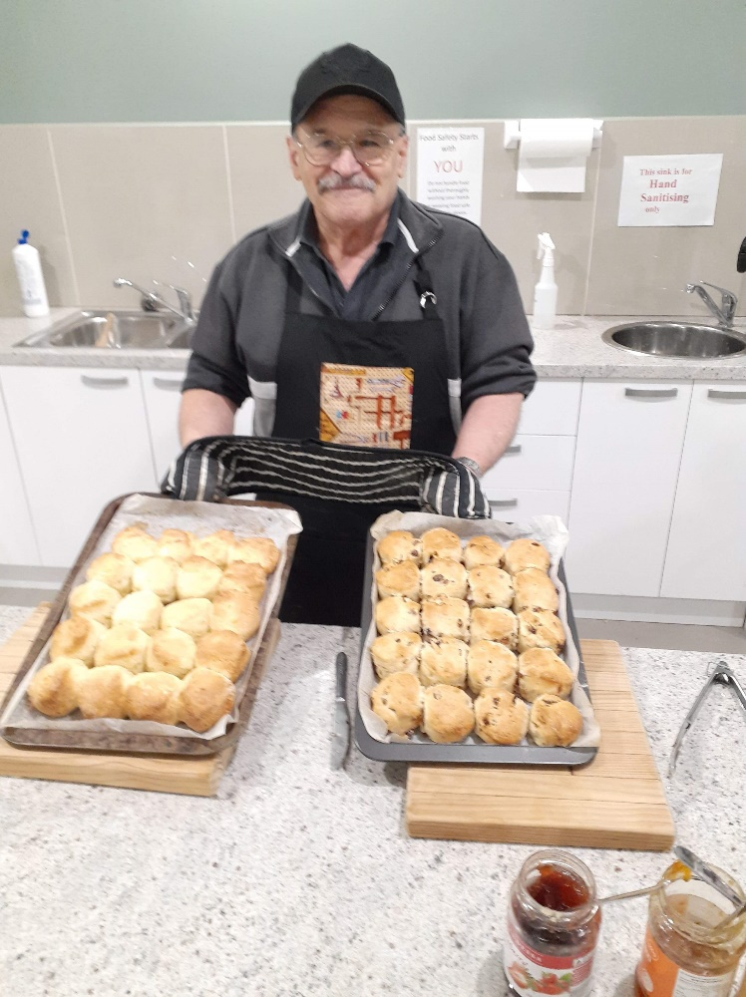

I think the boy is proud of his scones. Well done Ben.

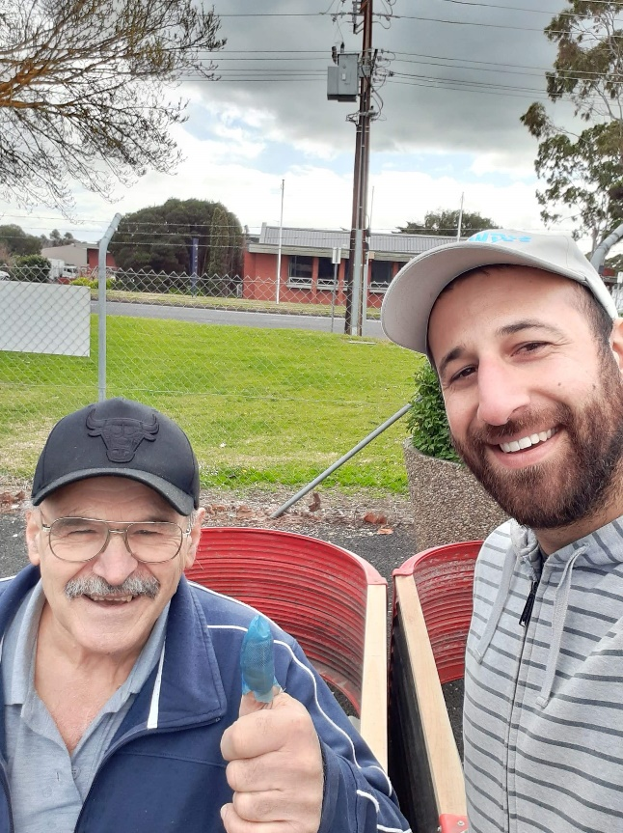

Gee Ben seems to be into everything now he has a little Greek boy Dimi at the shed to talk to. Here they are making raised garden beds.

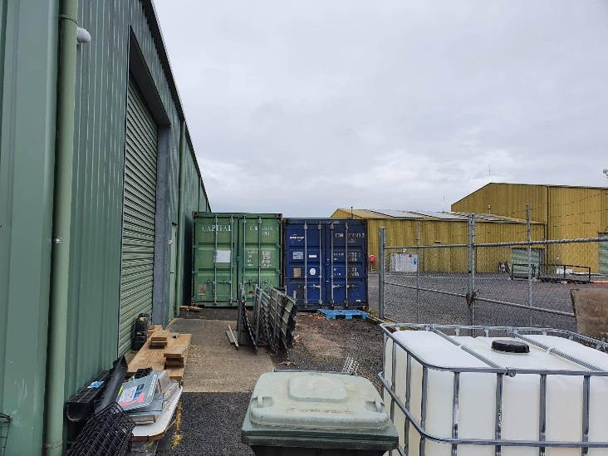

For those unaware the new container is now in place.

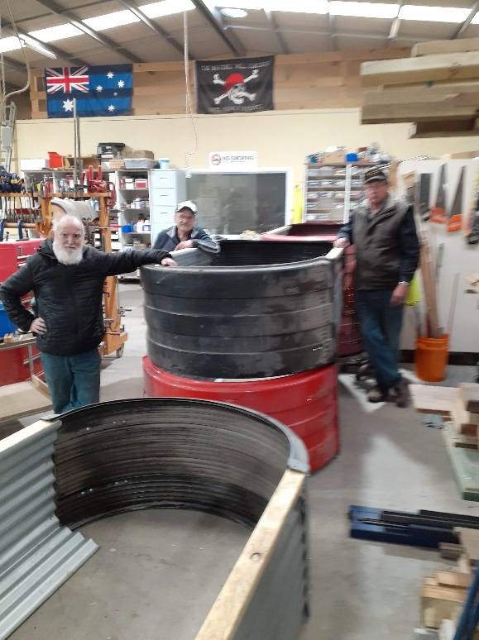

3 of the garden bed makers, Glen Ben and Peter admiring their handy work.

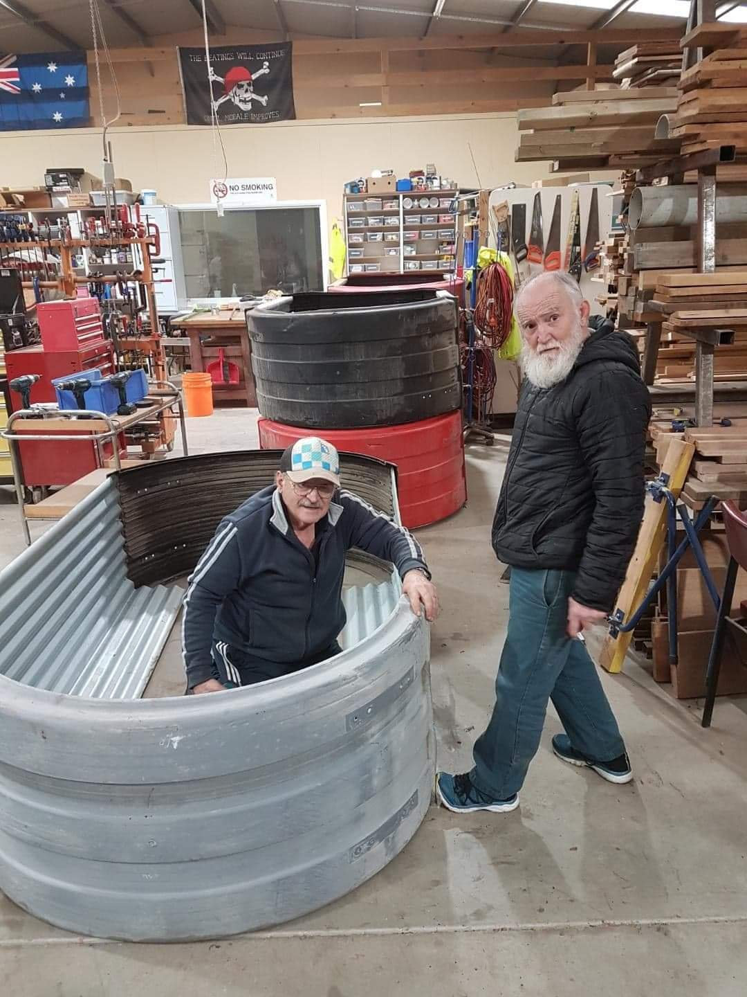

Looks like Santa has lost his hat or is this Santa’s Elf.

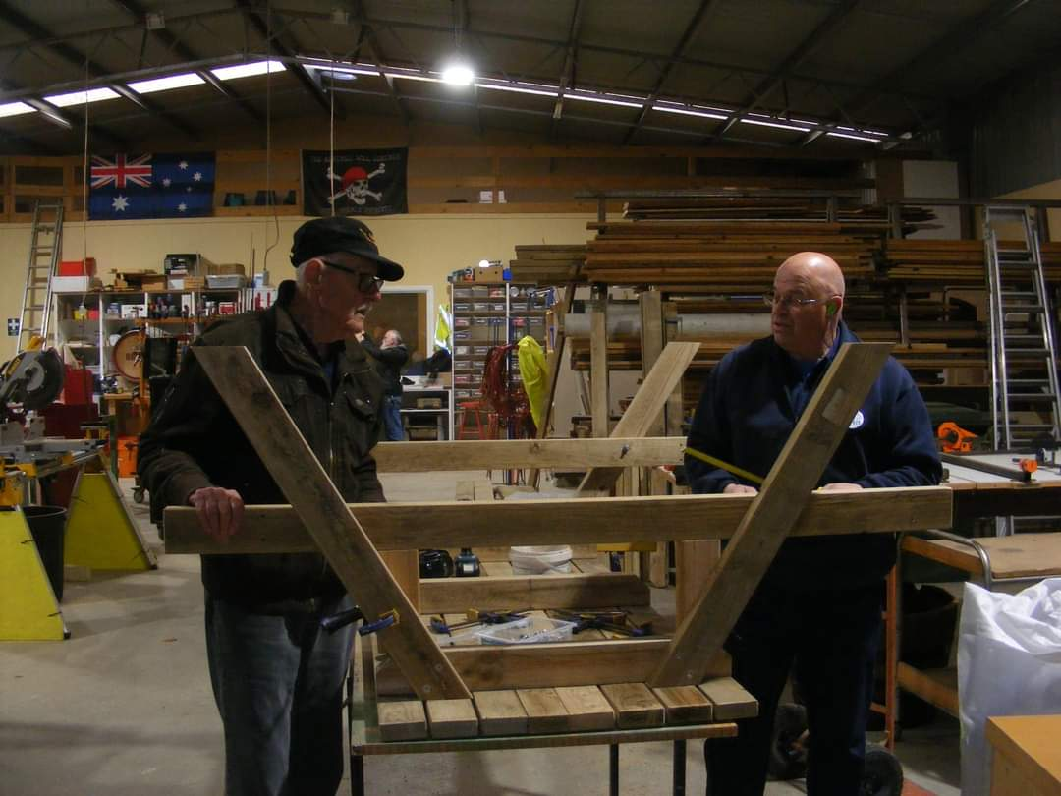

Ray and Robert working on one of the many park benches we have to make.

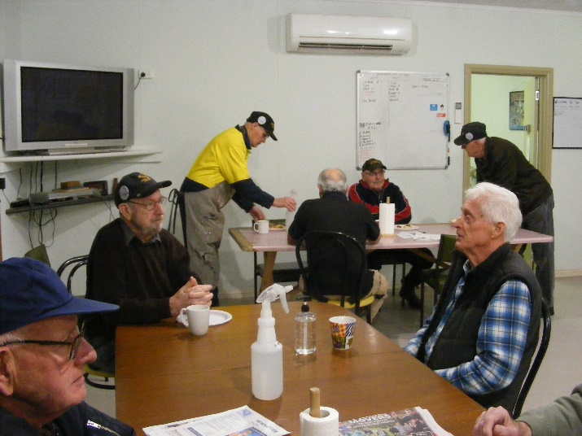

Smoko with social distancing.

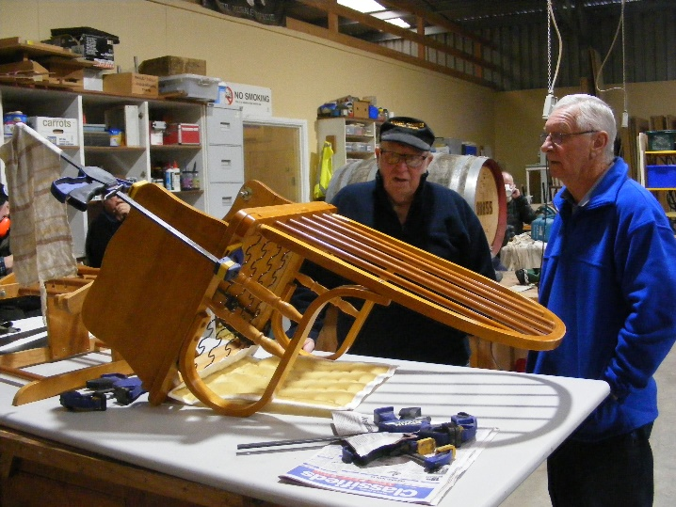

Terry and Geoff revamping a rocking chair ready for their old age.

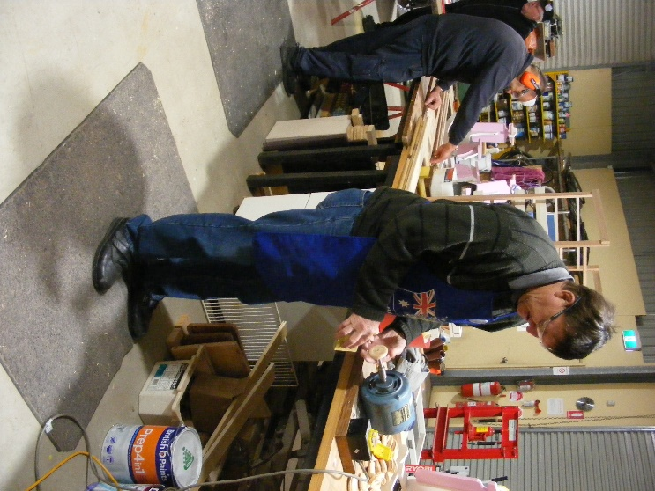

New member Andrew getting into the swing of things sanding up toy wheels.

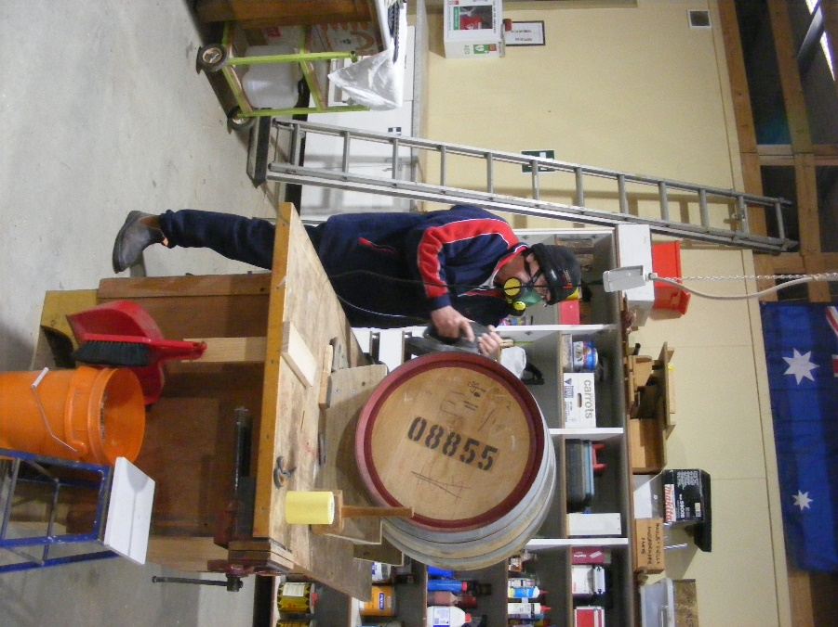

One of the many wine barrels Ansi and his group have been working on.

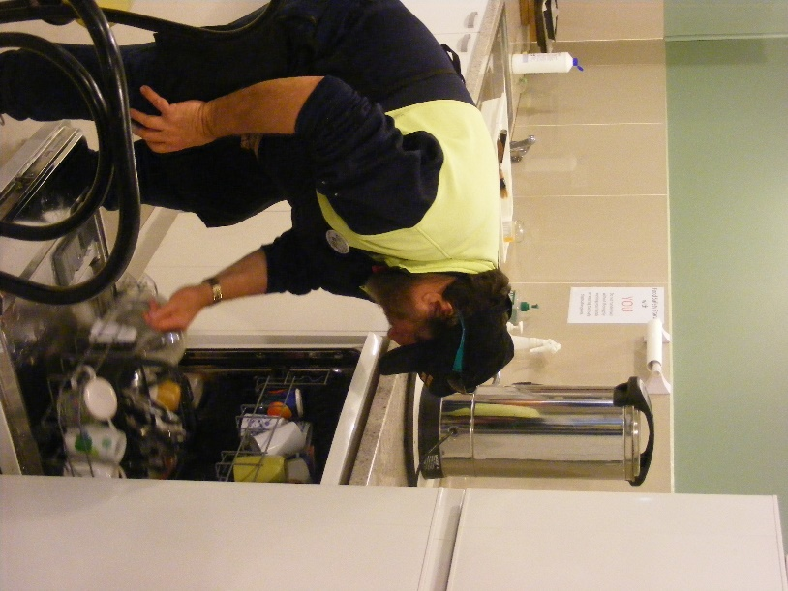

Someone has to do it and Bill is our man.

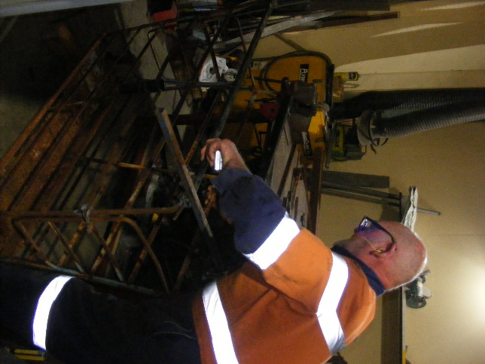

Bruce constructing a Judas crate.

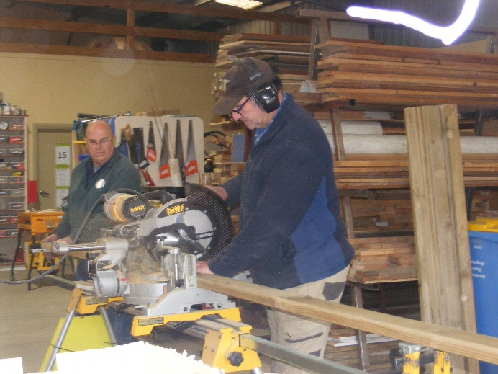

Dave and Robert preparing timber for another park bench.

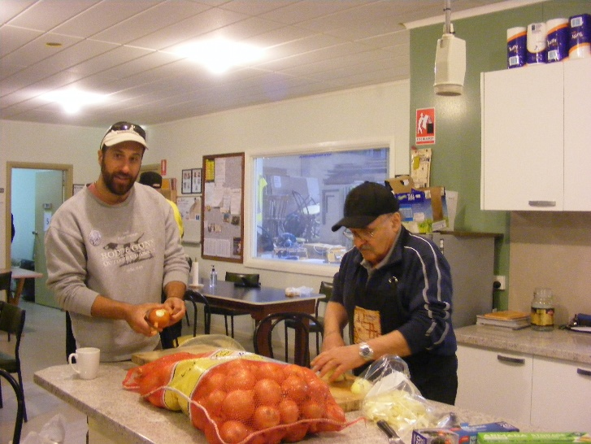

The Greek Adonis Dimi and the shed cook Ben preparing onions for the next Bunnings sausage sizzle.

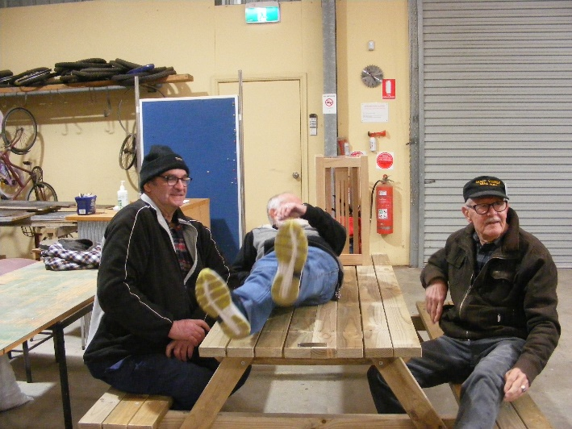

Dave, Ray and Glen checking that this table is strong enough to go out in the big world.or is Glen sleeping again.

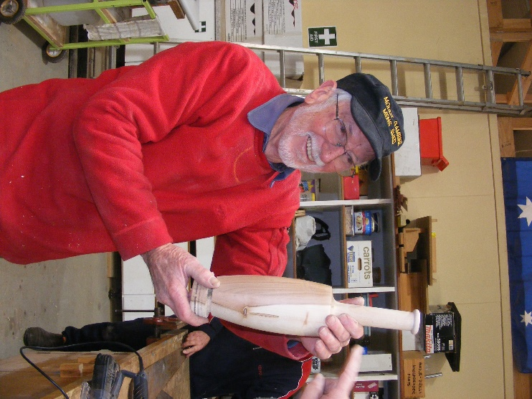

Don with his wooden wine bottle.

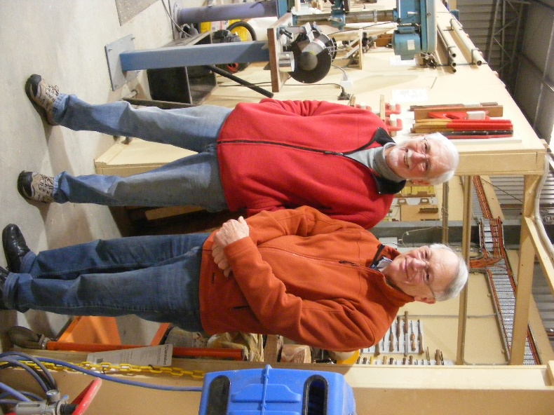

Don and brother Ray Happy 80th Birthday Don.

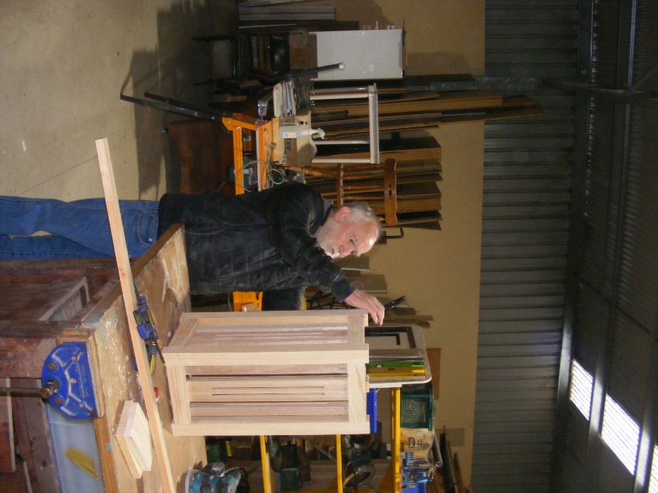

Glen has finally finished his umbrella stand just in time for summer, but sure he will get to use it next year.

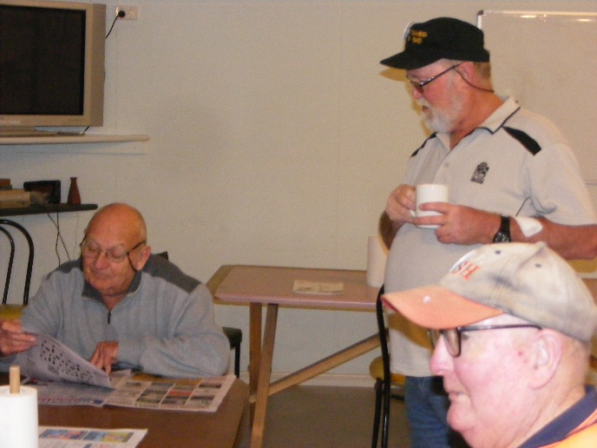

Not all work at the shed as Graham, Kevin and Allen are showing her having a cuppa and read of the local.

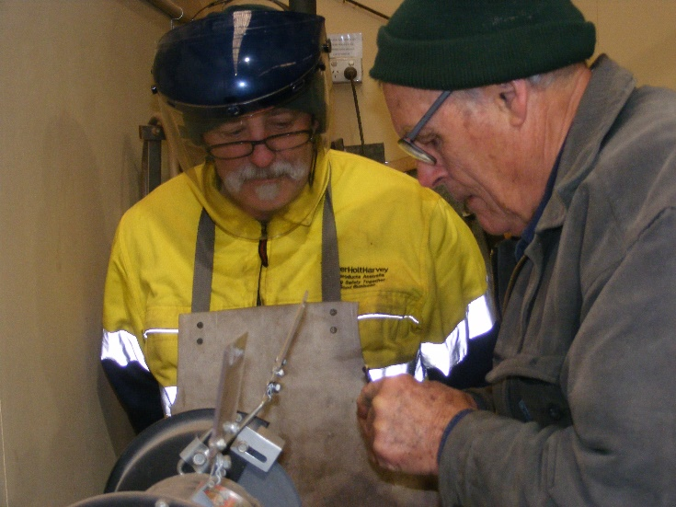

Ian and Trevor grinding small objects. Good to see Ian still remembers safety from his work days.

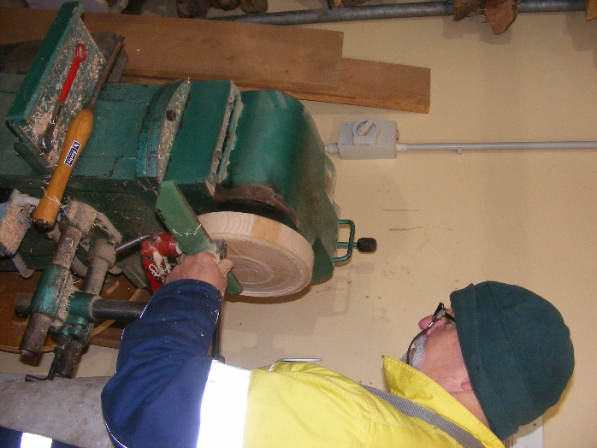

Ian moved from metal to now trying his hand at wood turning a bowl.

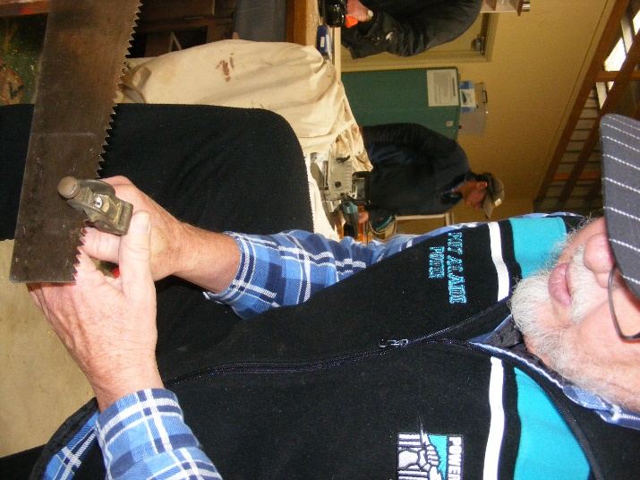

Matt showing how to set teeth on a saw.

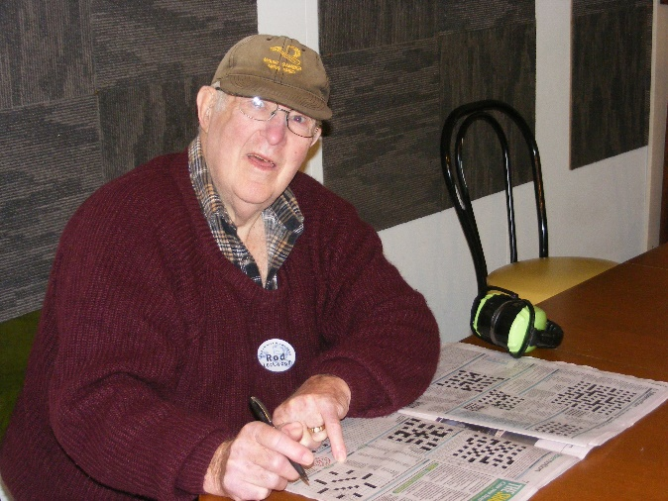

Rod doing the daily puzzles in the paper.

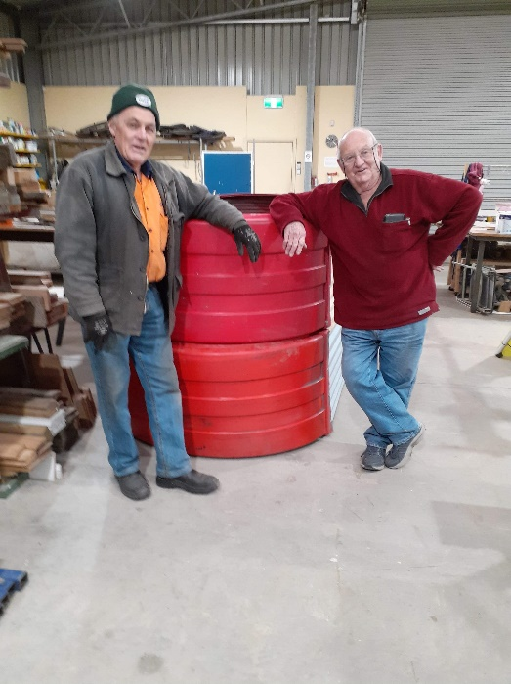

Someone else did all the work we just want to get in a photo, Trevor and Graham.

**QUIPS & JOKES**

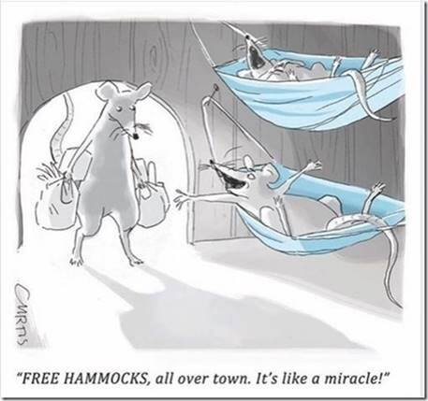

COVID appears to have some benefits.



