**EXECUTIVE MEMBERS FOR 2022**

**PRESIDENT**: Ian Bond 0420859540

**VICE PRESIDENT**: Grant Sullivan

**TREASURER**: John Plunkett

**SECRETARY**: Paul Edgeworth 0497386846

**PHONE**: 0478614027 ( prefer Tuesday and Thursday AM.)

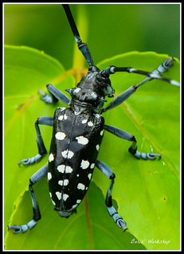**WE NOW HAVE A WEB SITE FOR THOSE WHO WISH TO LOOK. THIS WILL BE UPDATED FROM TIME TO TIME WITH NEW PHOTOS, NEWSLETTERS, RADIO REPORTS, CONTACTS AS WELL AS UPCOMING EVENTS AT THE SHED. Go to**

[**www.mgmensshed.com.au**](http://www.mgmensshed.com.au)

**FACEBOOK** Mens Shed Mount Gambier

[mgmensshed@gmail.com](mailto:mgmensshed@gmail.com)

**BIRTHDAYS**

David B 04/08

Don C 05/08

Paul E 07/08

Gary V 13/08

Don L 14/08

Rob B 23/08

Frank Mc A 23/08

**2022 Calendar**

10th August Wednesday 6.30 Tea with partners - Blue Lake Golf Bistro

11th August Thursday 10.15 Members Meeting

28th August Tuesday 10.15 Management Meeting

15th October Saturday 11.00 EST Heywood Mens Shed – Black Dog Institute

Scott St, Sand Shell

## THE COMMON TYPES OF WOODWORM AND WOOD BORING INSECTS pART 11/12

**#10 Asian Long-Horned Beetle**

Latin name: Anoplophora Glabripennis

**Appearance**: Also known as the Starry Sky or Sky Beetle because of its black colouring with white spots, this very large insect came over to the UK from China, Japan and Korea. Its hardy larvae are very difficult to kill.

**Preferred timber:** Loves hardwoods such as elm, poplar, willow and maple – and can fly some distance in search of new host trees.

**Type of damage:** Feasts extensively on the sappy bark of many different species of tree, causing damage so extensive that often the trees die. Has been found – albeit rarely – in construction bound timber at lumberyards.

**Telltale signs:** Leaving very large exit holes of 2 cm in diameter – with sawdust-like frass often oozing out in the sap – these wood boring insects are usually confined to woodland, however if they entered your home, they could cause extensive structural damage.

**Next Month - Wharf Borer**

This year the Shed decided to award Life Membership. Four more to be added to last month’s newsletter are, Graham C, and Don L. Bernard R. and Gary. V All these men have given great service to our Shed and are also held in high esteem by their fellow shedders.

Thank you for your many years of hard work.



Graham C

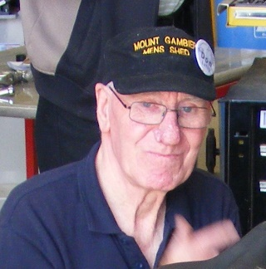

Don L

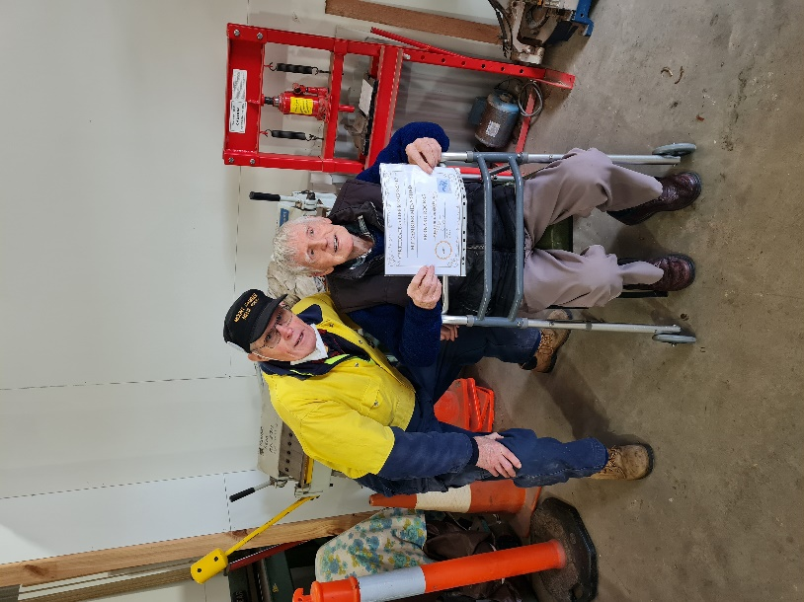

President Ian B. presenting Bernard R. with his life membership.

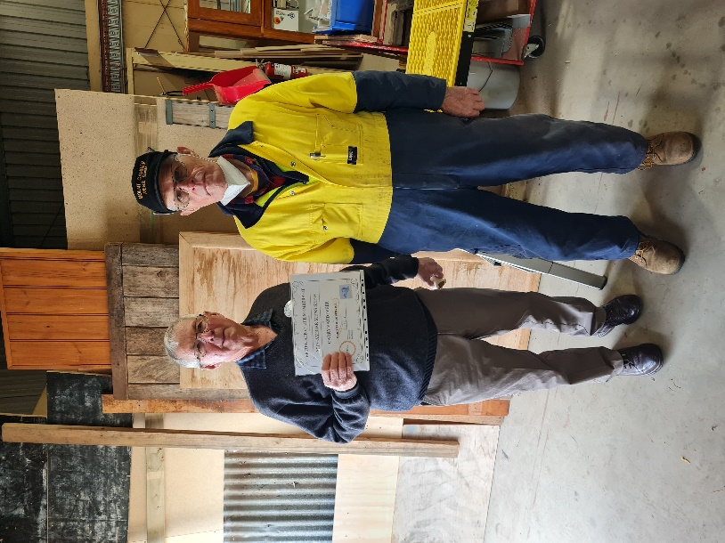

President Ian B. presenting Gary V. with his life membership

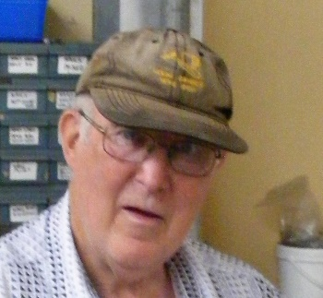

Rod L

One other person received their ten-year certificates this year. That is Rod Lockwood. Your fellow shedders congratulate you on reaching a decade of membership and great service to the Shed.

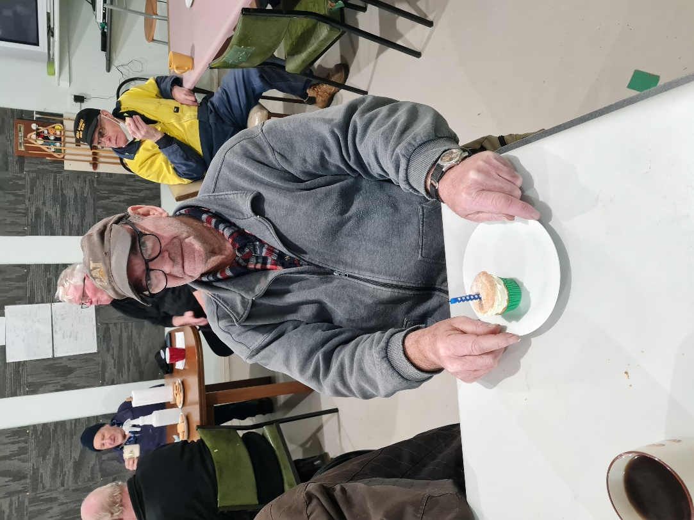

Above and below no matter how old you get you still like a Birthday cake on your Birthday.Congrats Dave and Stratty.

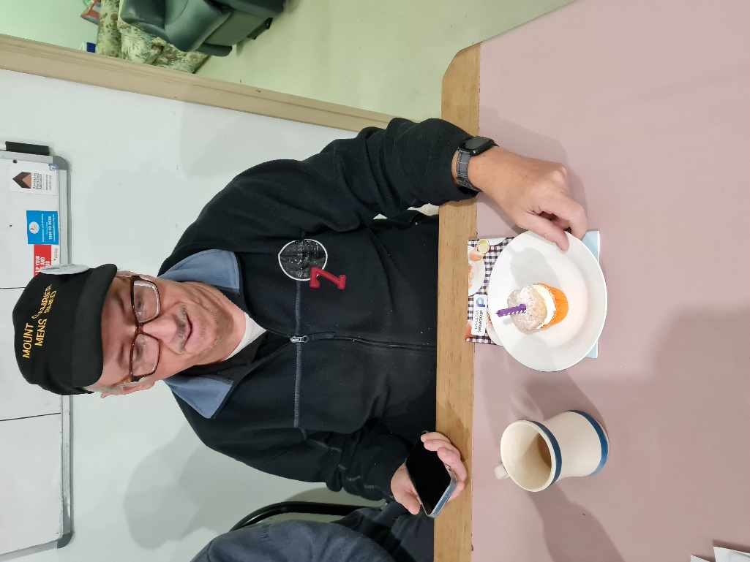

**Receipe:-**

**Raspberry Muffins**

Ingredients:-

1 ½ Cups Whole grain flour. 1 teaspoon Baking powder. ½ teaspoon Bi carb soda. ½ teaspoon salt. Mix these all together.

½ cup extra virgin olive oil. ½ cup of Honey or Maple syrup. 2 Eggs room temperature beaten. 1 Cup plain Greek yoghurt. 2 Teaspoons of Vanilla Essence. ½ teaspoon lemon zest. 1 ½ Cups frozen raspberries or Blueberries.

Mix these all together.

Combine wet and dry and mix well.

Makes about 18 muffins.

Sprinkle a little sugar on top of each.

Bake at 175 – 180 ⁰C for about 25 mins, until scewer comes out clean.

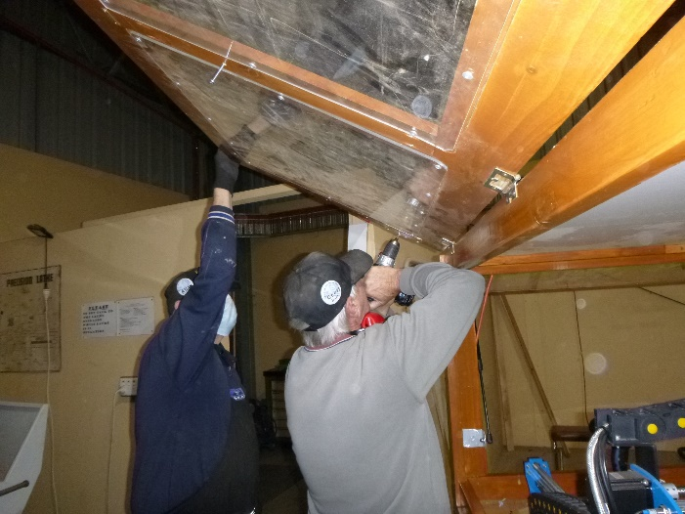

Alan V and Geoff H working on the CNC cabinet.

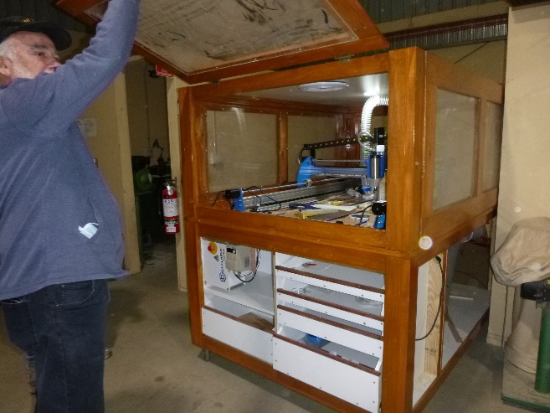

Rob B checking and holding up the cabinet door for the CNC before the gass struts go in.

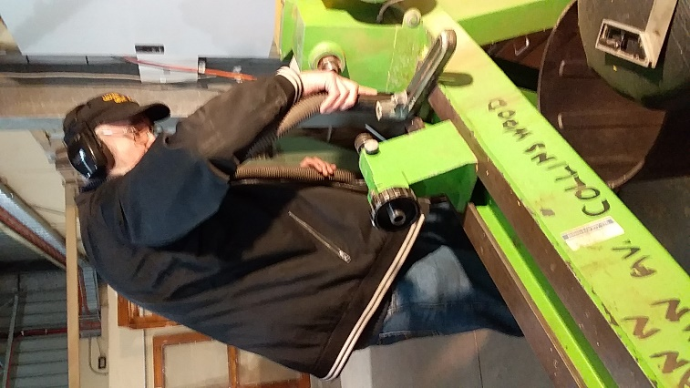

Peter He. doing a bit of gereral clean up on the wood lathe.

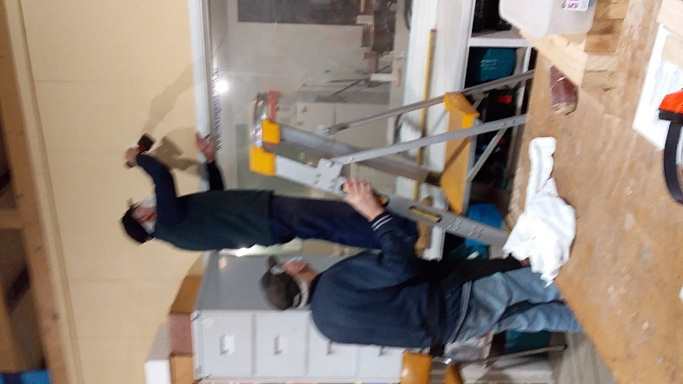Don C putting up the hanging point with Rob B assisting. Wait to see what will go up in the next newsletter

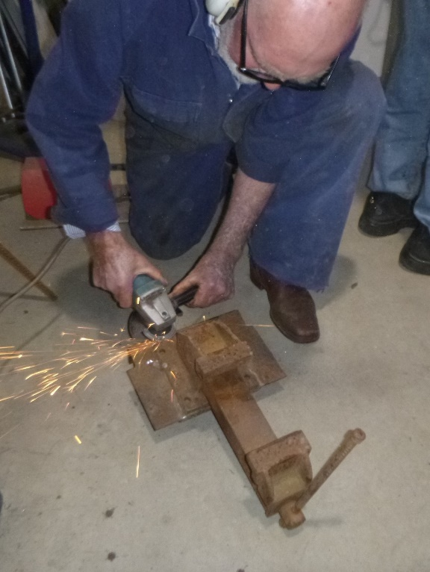

Bruce A repairing a vice.

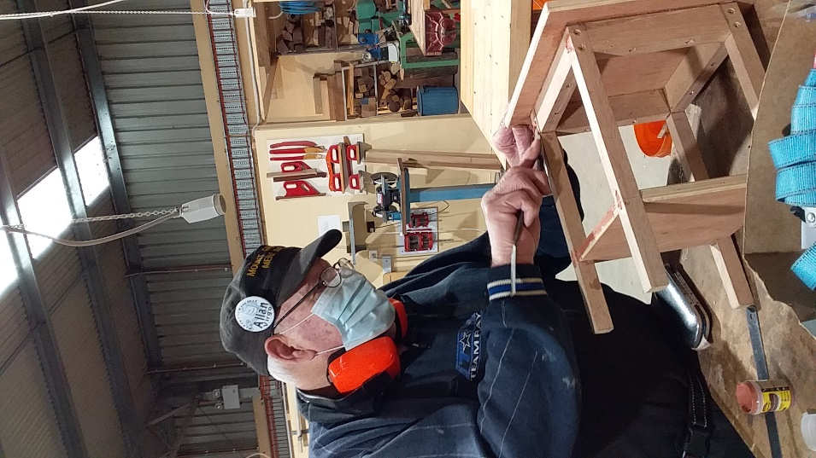

Alan V finishing a lamp table.

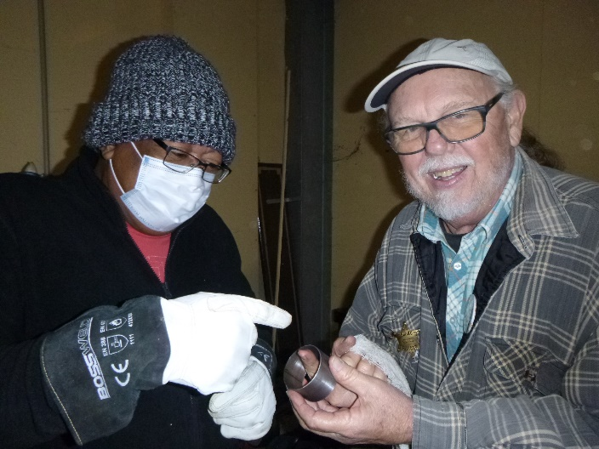

David N points out to Mat J another use for a scone cutter when making toad in the hole.

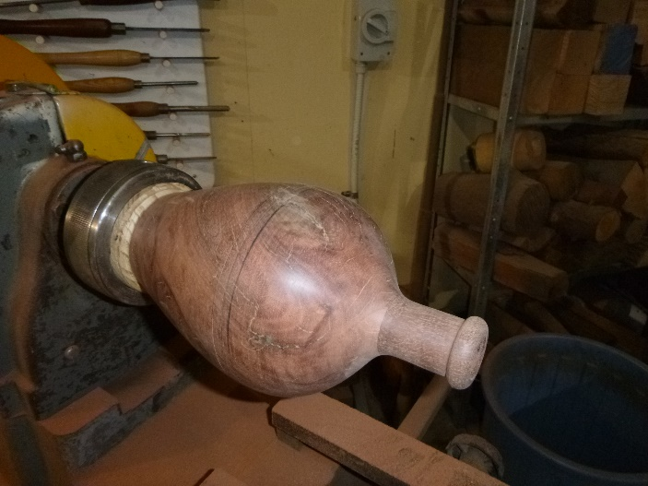

A red gum bottle geing made by Don C.

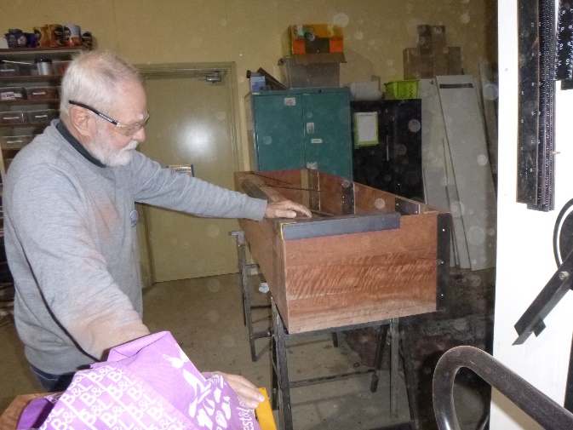

Herman B with his sence of humour says his coffin is available for hire before and after he uses it.

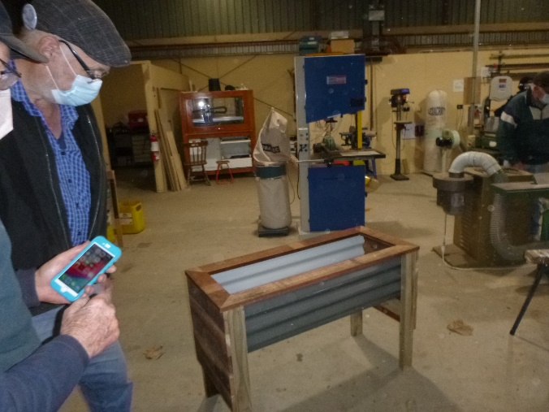

Jeff R with his new raised garden bed design.

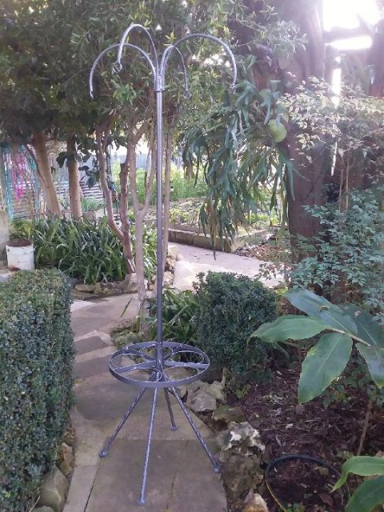

Trevor A made this plant stand.

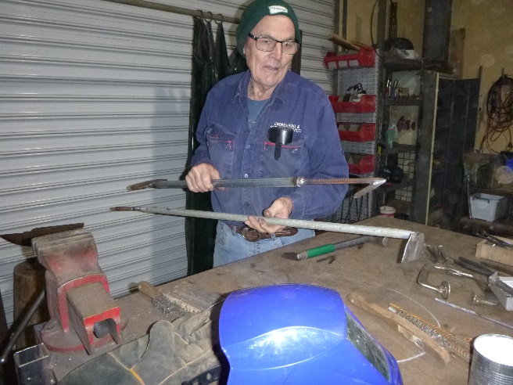

Trevor A with his Pizza oven scrapper and hook.

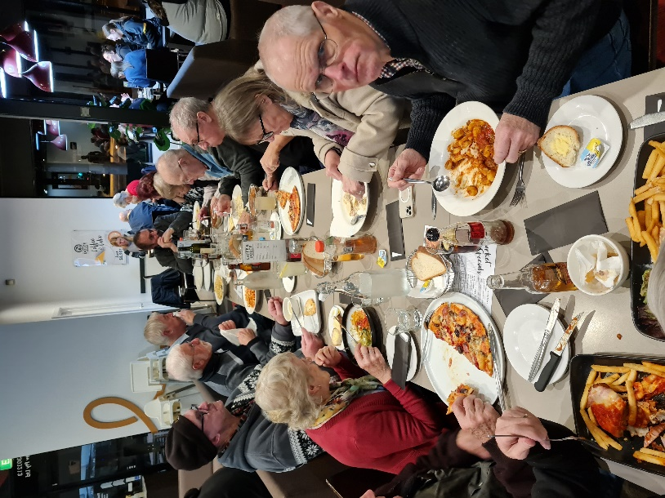

Above and below Shed members and wives/partners meal at Fasta Pasta.

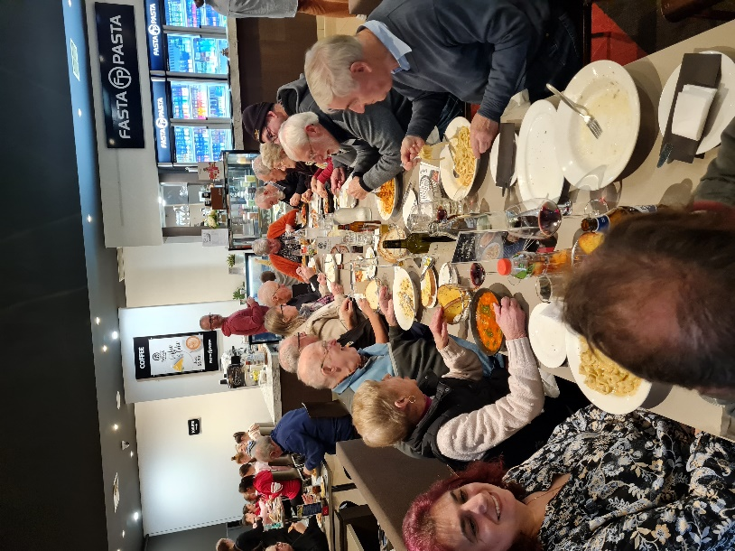

**Jokes**

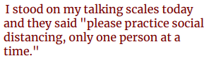





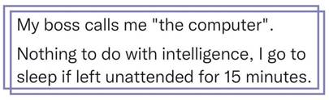



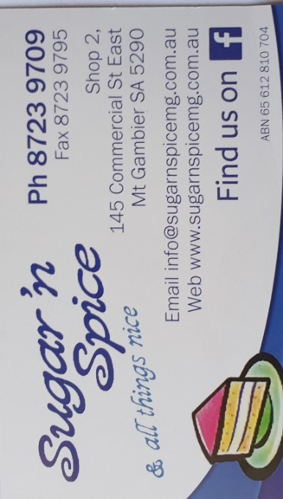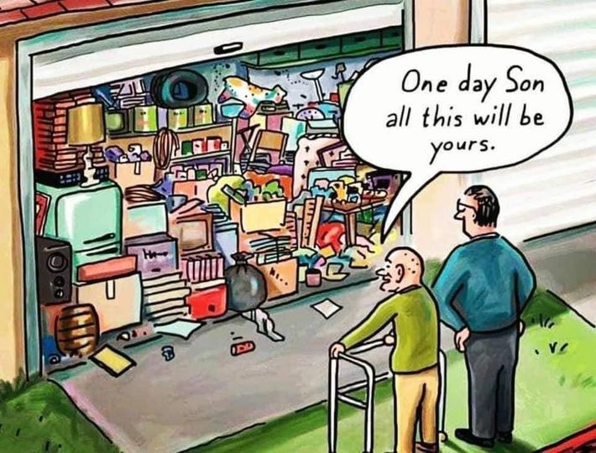

 





**Big supporters of Mount Gambier Mens Shed.**

**SUPPORT YOUR LOCAL BUSINESSES**

**THAT SUPPORT YOU.**