[mgmensshed@gmail.com](mailto:mgmensshed@gmail.com)

**EXECUTIVE MEMBERS FOR 2020**

**PRESIDENT**:

**VICE PRESIDENT**: Ben Katris

**TREASURER**: John Plunket

**SECRETARY**: Paul Edgeworth 0887256385

**FACEBOOK**

Shed broadcasts are now available on Facebook

*[Image result for facebook logo](https://www.google.com.au/url?sa=i&rct=j&q=&esrc=s&source=images&cd=&cad=rja&uact=8&ved=2ahUKEwjO9cWTtajeAhUafisKHT6JAHoQjRx6BAgBEAU&url=http://www.seacliffeinn.com/spa-boutique/find-us-on-facebook-logo/&psig=AOvVaw0duNjpvsqixE3Pzu1qEwe2&ust=1540791326821108)*

**Safety: - Remember Safety begins at home.**

Peter K 1/12

Chris B 6/12

Graham C 22/12

Paul C 26/12

Terry G 27/12

Trevor P 28/12

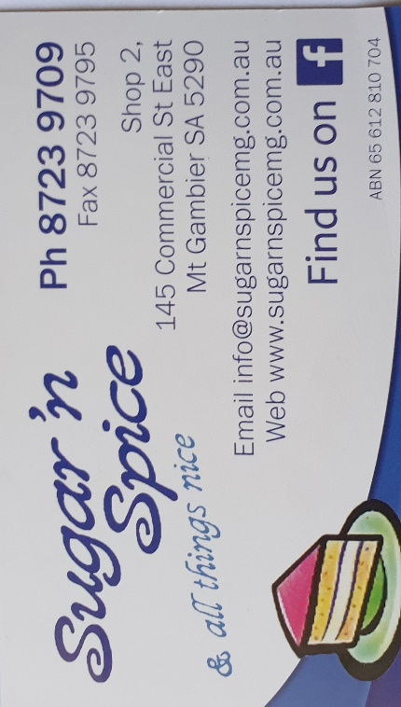

**Remember Sugar ‘n Spice support the Men’s shed with Birthday cakes so support them where you can.**

 

**While mentioning our supporters always remember how much Bunnings help our shed, so support them as well when you need a product they can supply for you.**



Thanks Sharp Cranes and Steeline for supporting our Mens Shed.

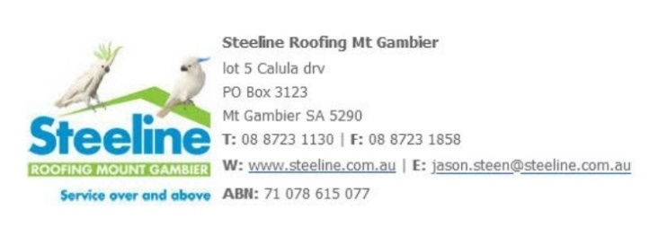

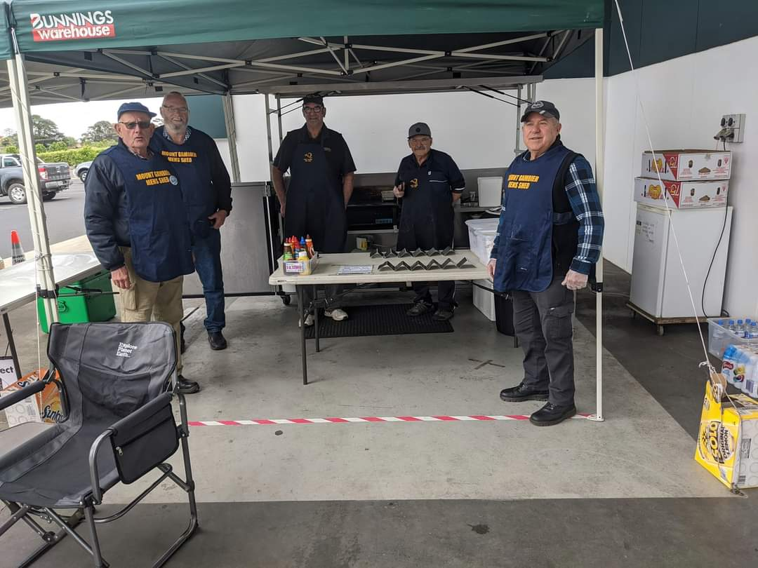

The month started off well with a sausage sizzle at Bunnings. Thanks to all who helped especially the new members who attended for the first time.

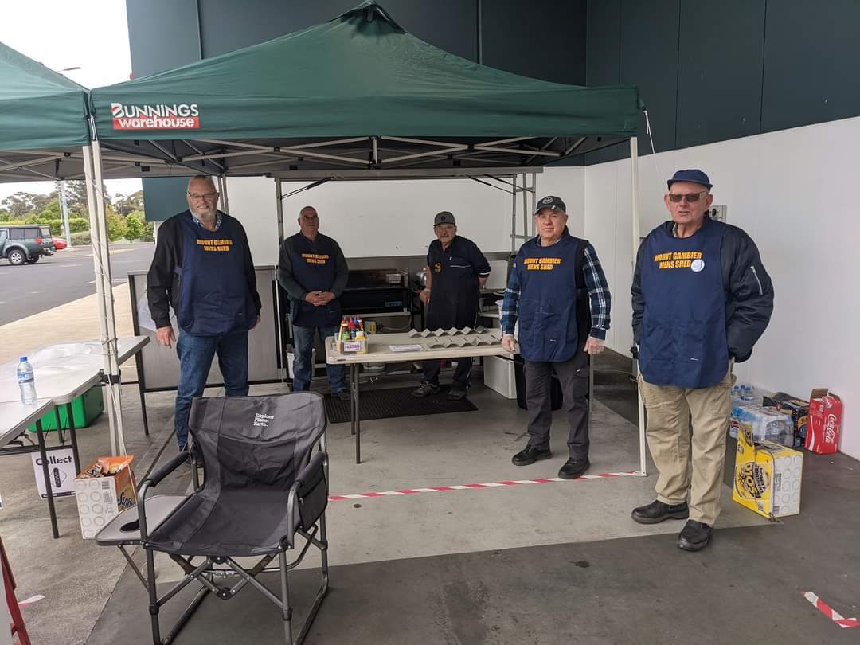

**REMINDERS:-**

Shed meal is next week at the Thai restraunt on Wednesday 9th December. Put names on the board.

Also the shed closes for Christmas on 17th of December and will not open again until the 12th of January.

A BBQ will be held in the shed on the 17th December as a thanks and Christmas break-up. Again put names on the board for Ben to organise food.

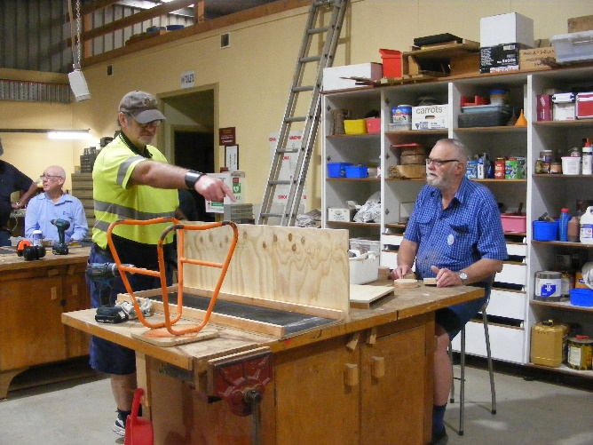

Coles asked the shed to make a truck for their grand opening on the 7th dec so the fellows stepped up to the plate and this is it.

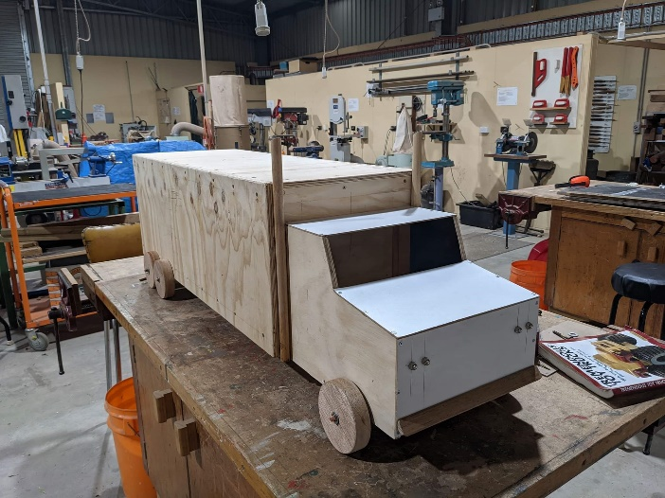

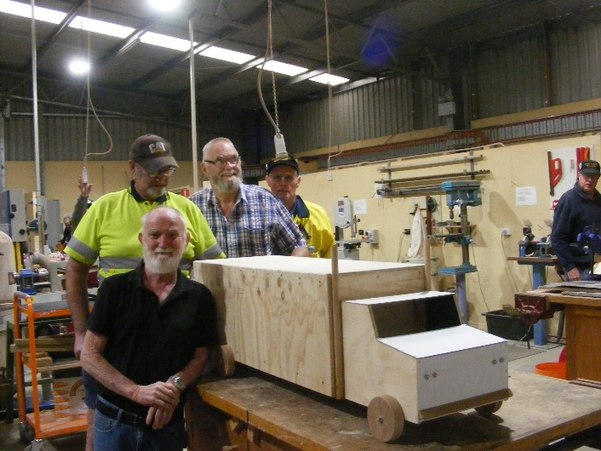

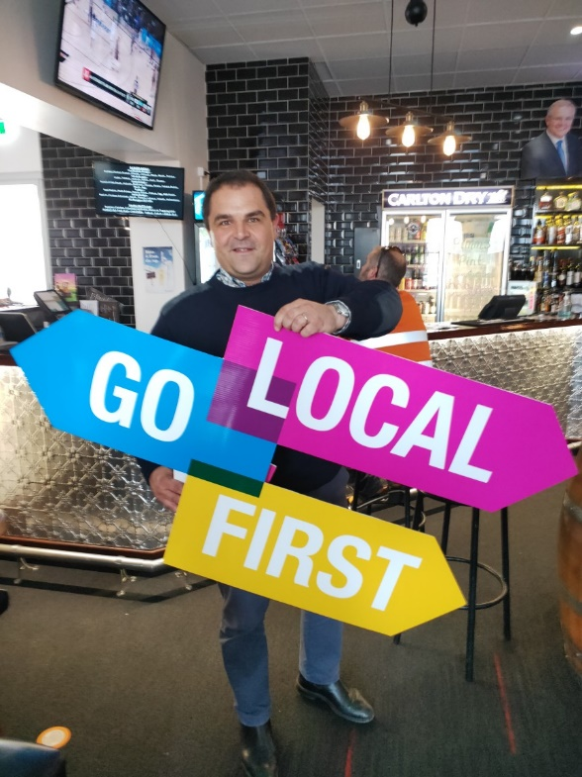

Local MP and men’s shed member Tony Pasin showing us what to do during the Pandemic.

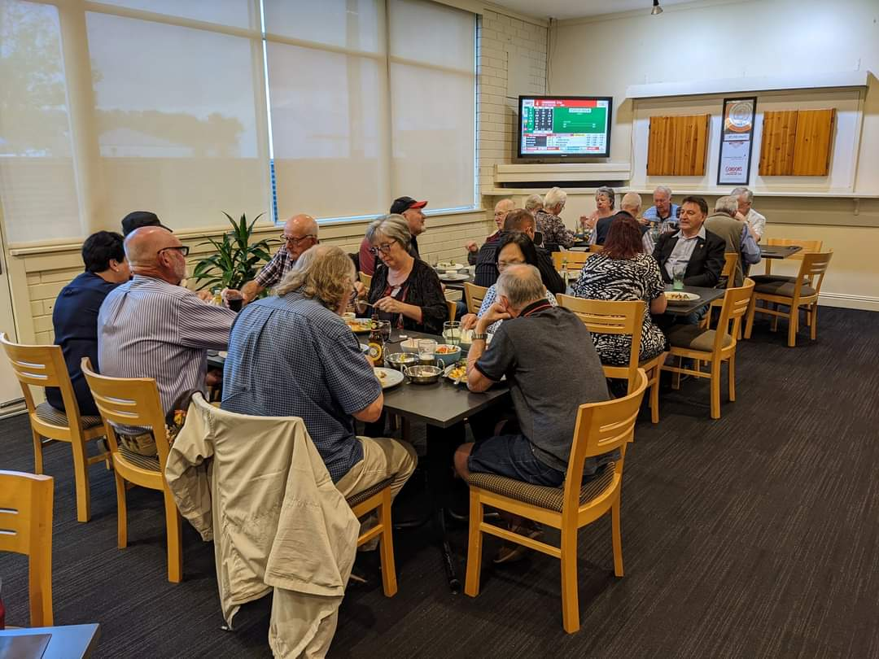

Shed members eating out on the 11th at Park Hotel.

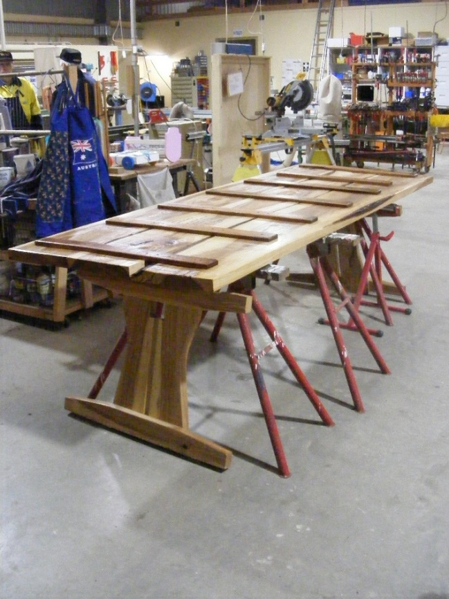

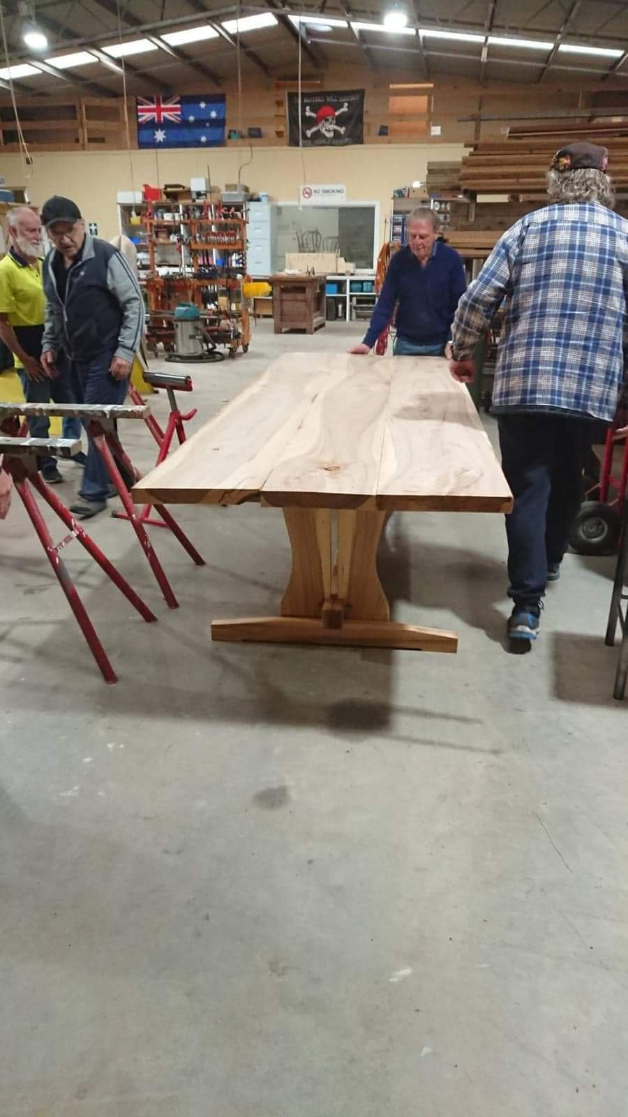

The huge table is slowly coming together after a lot

of work from Matt.

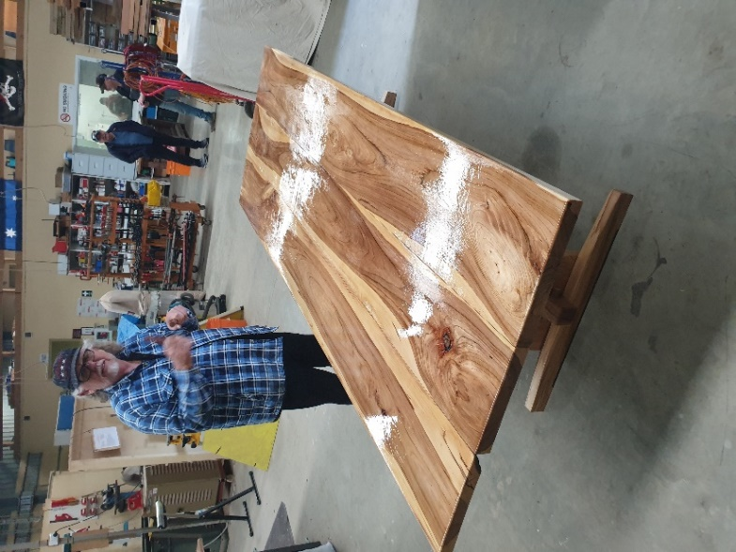

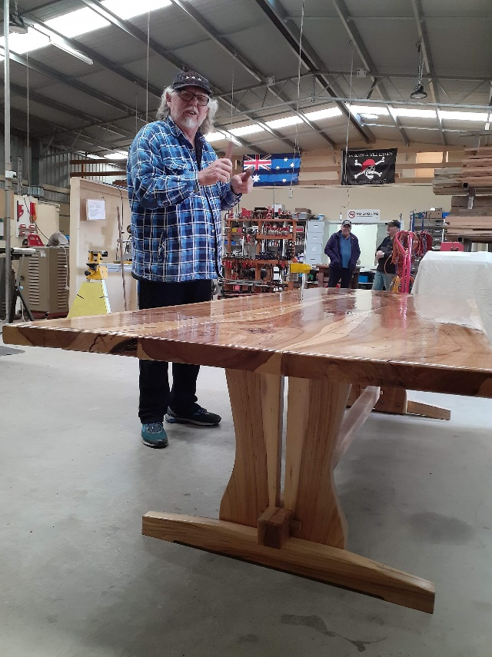

Just to show there are no nails used in the construction only pegs as per the old way.

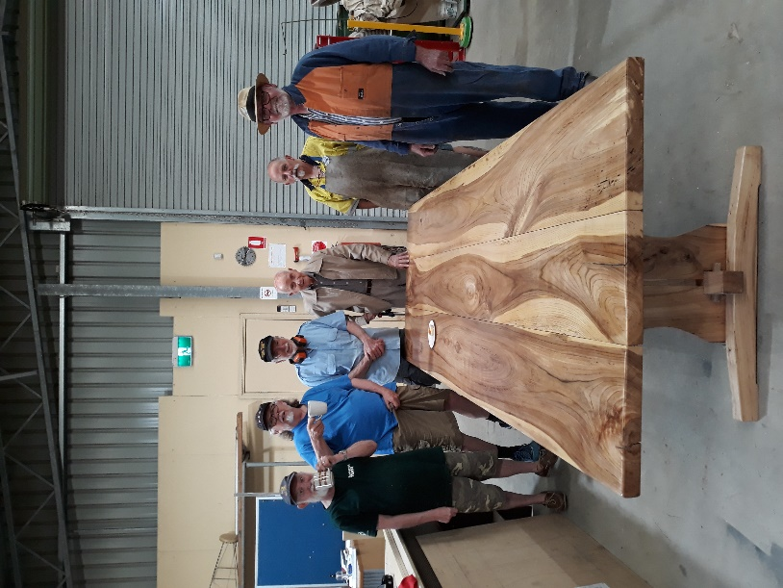

The team involved in building this table with the recipient Kelvin in the middle.

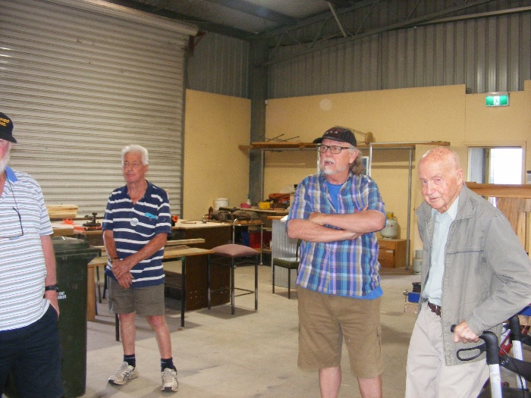

Social distancing for a shed meeting.

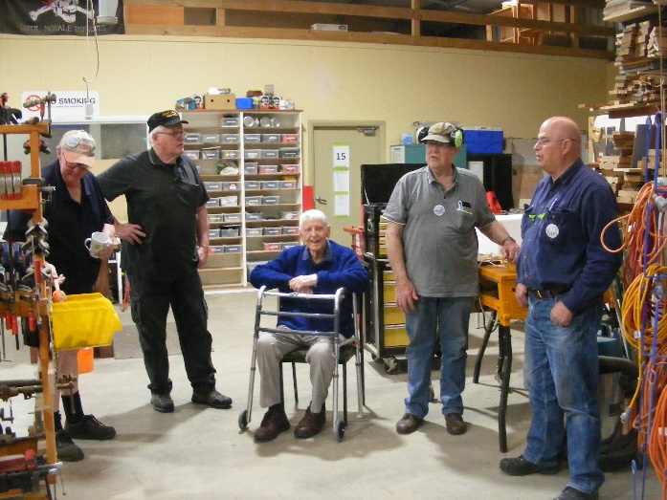

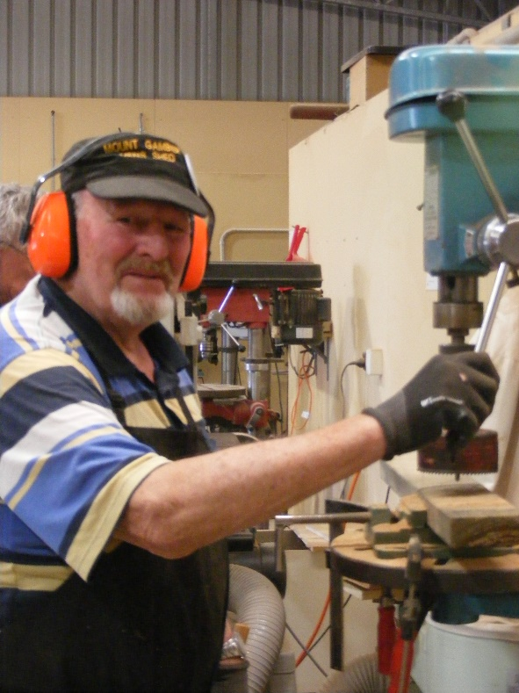

Alan cutting a wheel for a wheelbarrow.

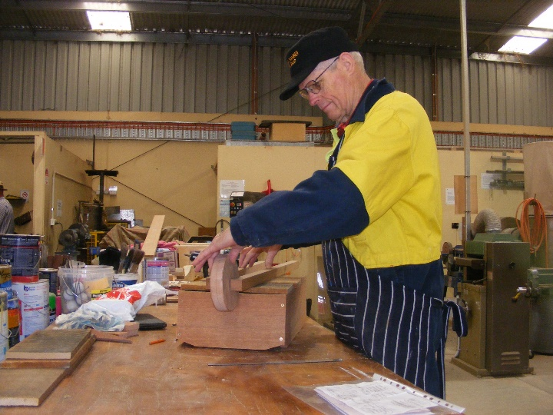

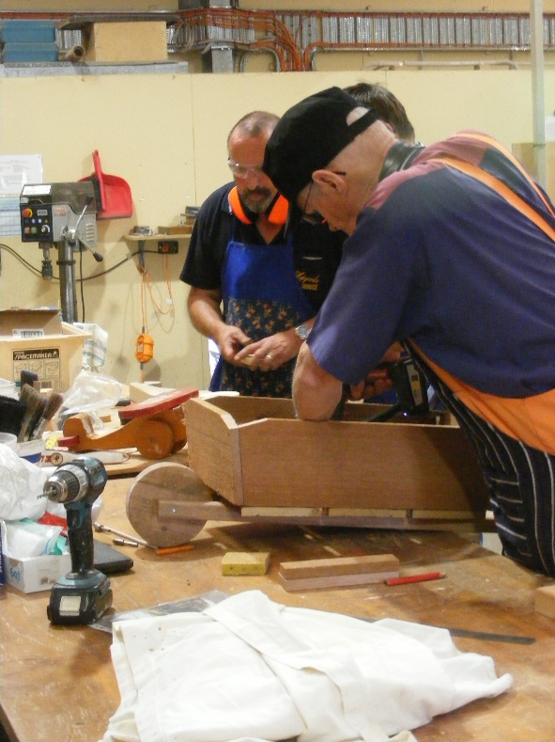

Wheelbarrow coming together.

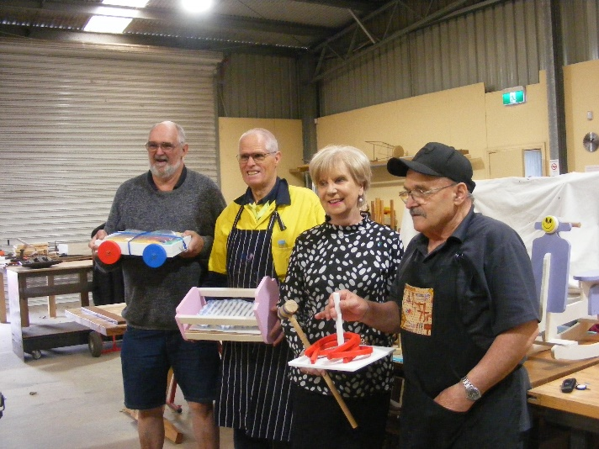

Getting ready for handover of this year’s toys to the Mayors Christmas appeal.

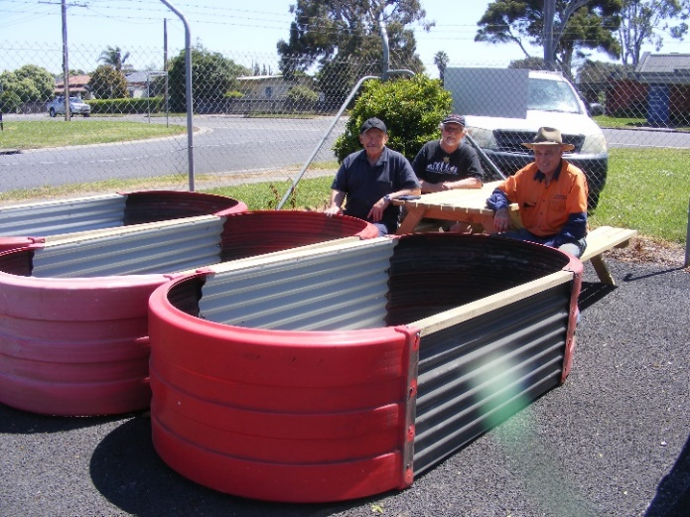

More of the best raised garden beds in the state.

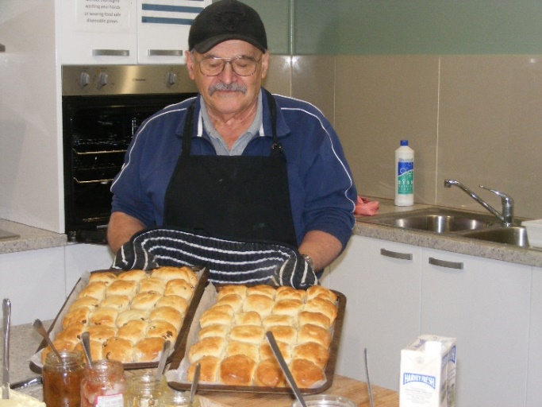

The master scone maker produces another batch of scones for morning tea.

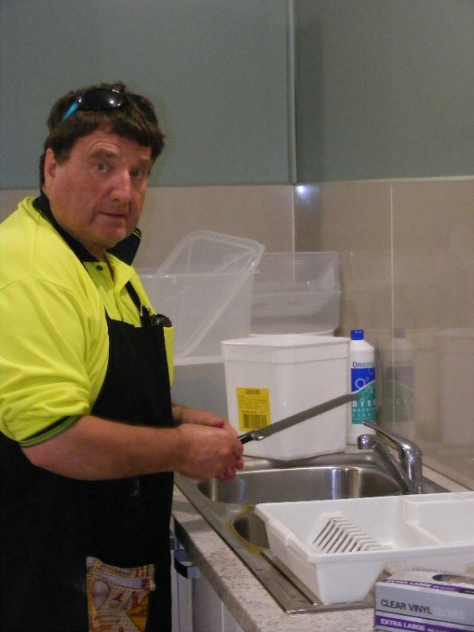

After the scones someone has to do the dishes and here’s our man.

**MEMBER PROFILE**

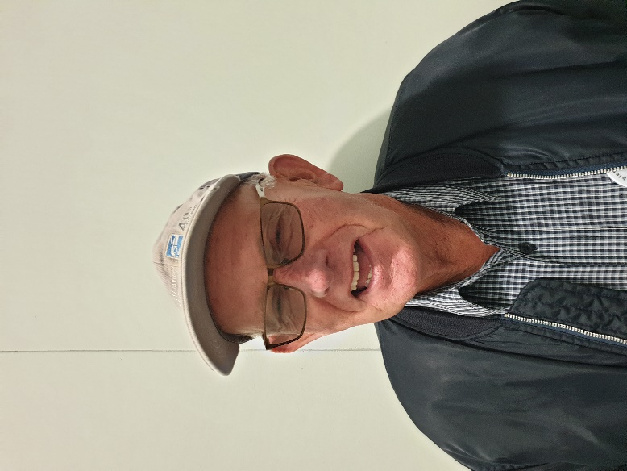

Name: - David Norton.

Where have you worked: - Ex farmer, truck driver and jack of all trades master of none.

Something about you people at the shed may not know: - Failed woodwork at school.

What do you wish to achieve at the shed: - Basically assist where possible and do anything to help others.

Could not make my mind up which one so you all got both Merry Christmas to all at our shed and to the many shed’s we send this newsletter to.

