[mgmensshed@gmail.com](mailto:mgmensshed@gmail.com)

**EXECUTIVE MEMBERS FOR 2021**

**PRESIDENT**:

**VICE PRESIDENT**: Ben Katris

**TREASURER**: John Plunket

**SECRETARY**: Paul Edgeworth 0887256385

**FACEBOOK**

Shed broadcasts are now available on Facebook

*[Image result for facebook logo](https://www.google.com.au/url?sa=i&rct=j&q=&esrc=s&source=images&cd=&cad=rja&uact=8&ved=2ahUKEwjO9cWTtajeAhUafisKHT6JAHoQjRx6BAgBEAU&url=http://www.seacliffeinn.com/spa-boutique/find-us-on-facebook-logo/&psig=AOvVaw0duNjpvsqixE3Pzu1qEwe2&ust=1540791326821108)*

**Safety: - Remember Safety begins at home.**

Bob P. 16/1

Timothy C. 17/1

Lyndon M. 21/1

Robert A. 28/1

Phillip V. 31/1



**Remember Sugar ‘n Spice support the Men’s shed with Birthday cakes so support them where you can.**

 

**While mentioning our supporters always remember how much Bunnings help our shed, so support them as well when you need a product they can supply for you.**



Thanks Sharp Cranes and Steeline for supporting our Mens Shed.

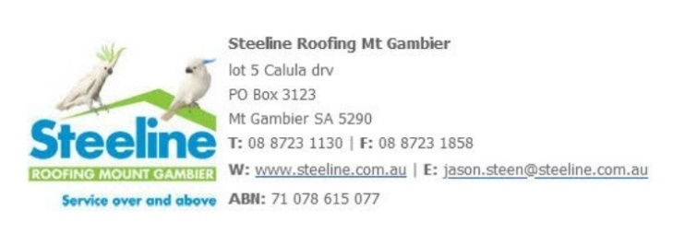



**Hope you all had a very Merry Christmas with loved ones and wishing you a Happy New Year.**

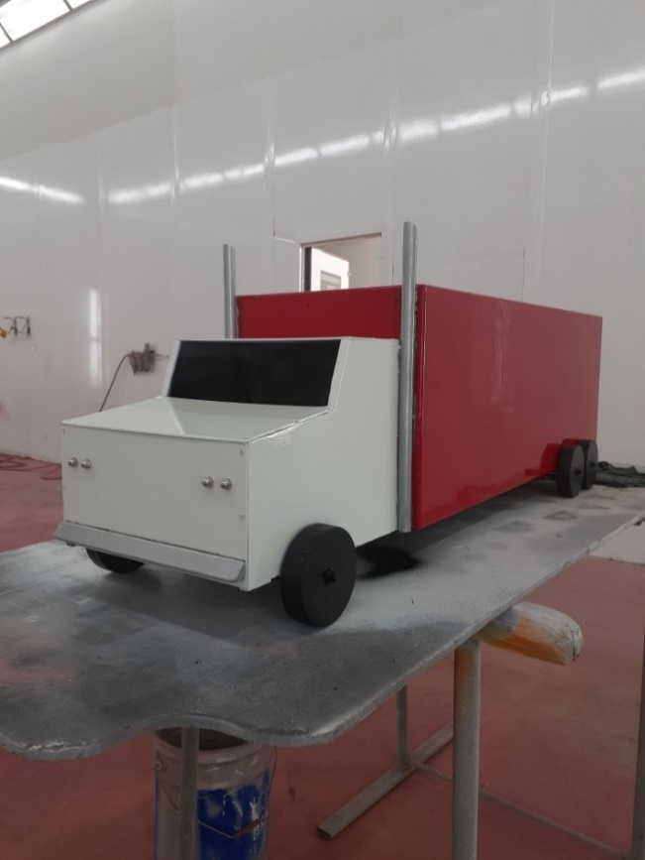

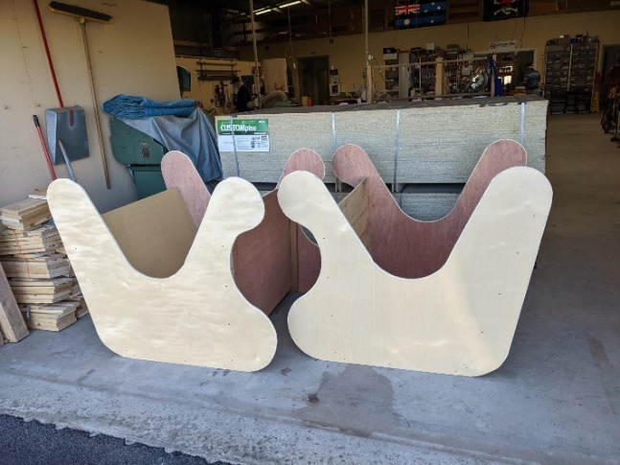 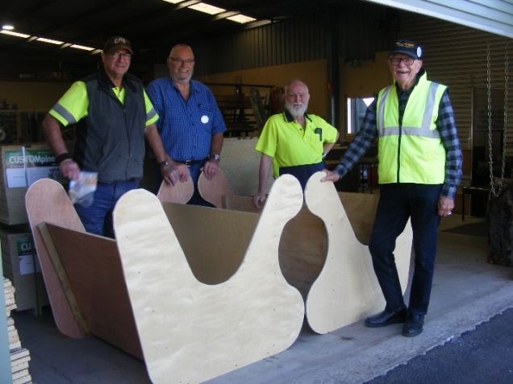

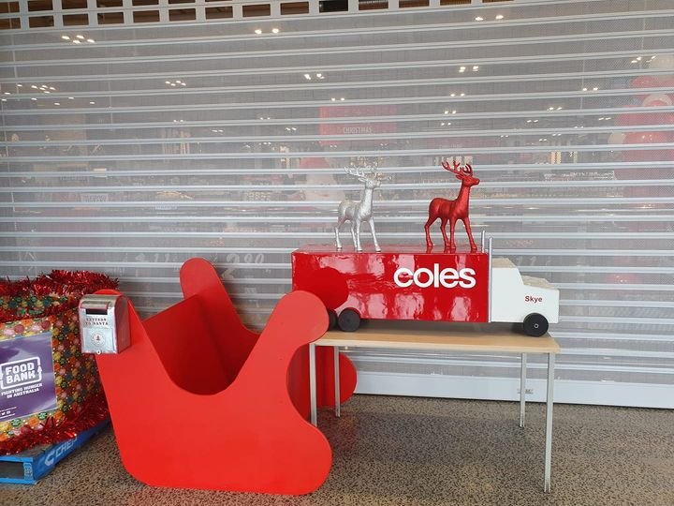

Dave Geoff Glen and Ray with the Semi and Sleigh made for the opening of the new Coles. Items were used for letters to Santa and donations. Painted by Coles.

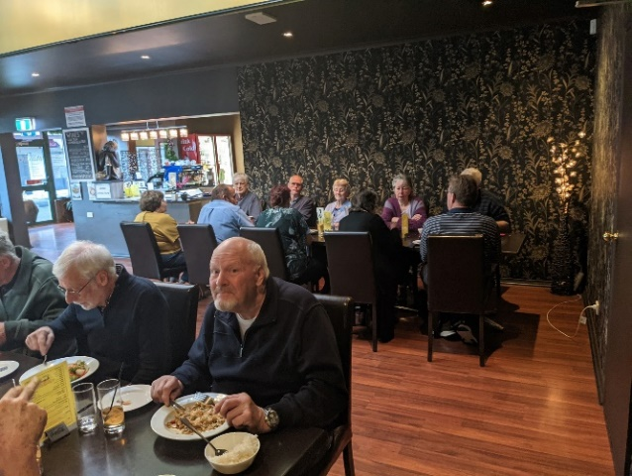

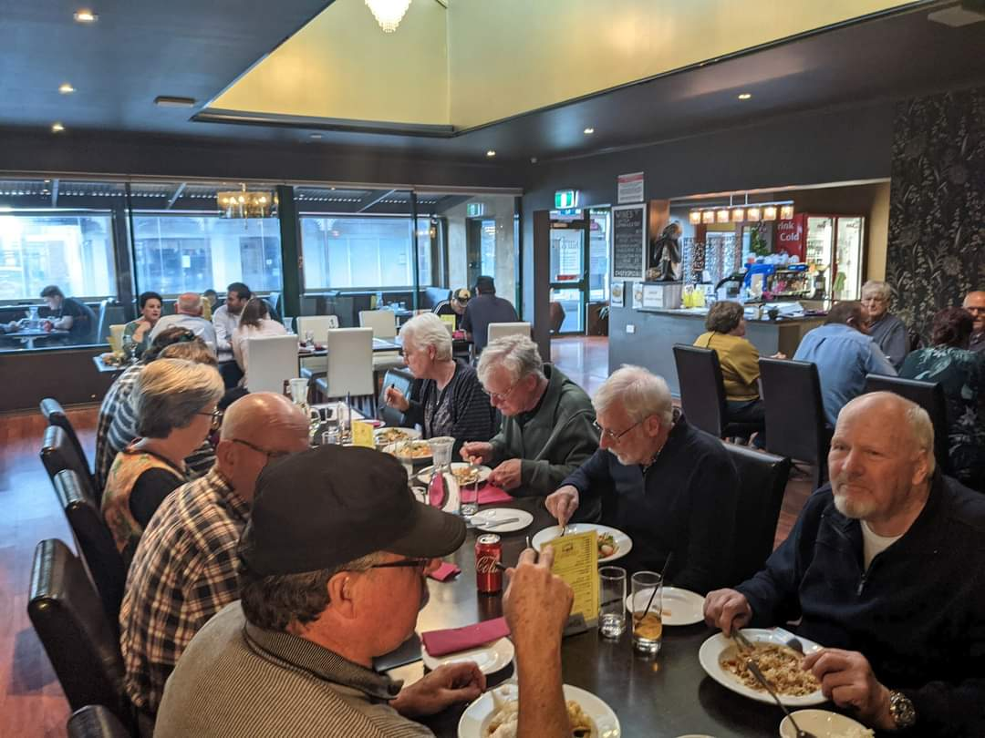

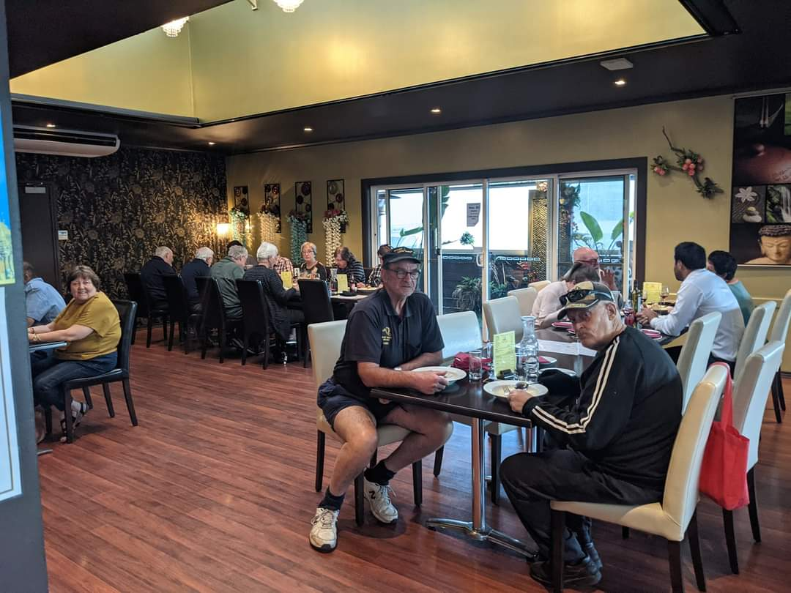

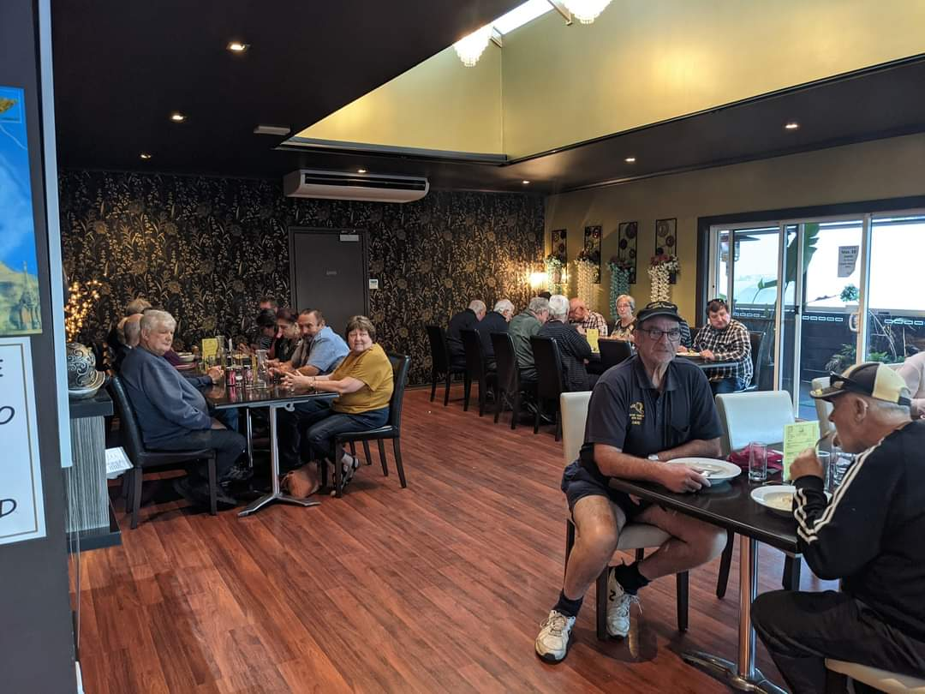

Tea at the Thai café before Christmas.

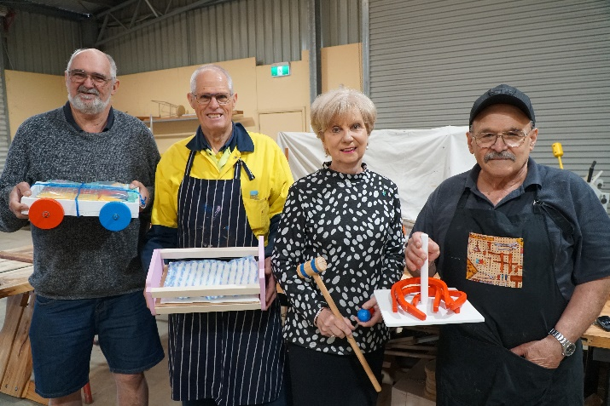

Mayor Lyn accepting toys for the Mayors Christmas appeal.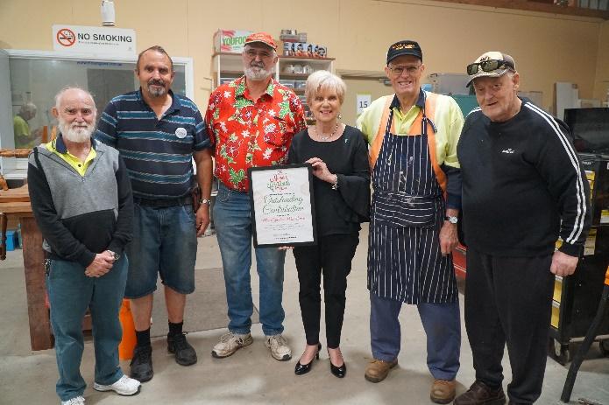

A certificate given by Mayor Lyn to the Mens Shed for toys donated to the Mayors Christmas appeal.

**In recent weeks, Mount Gambier community groups, businesses and individuals have contributed $7,250 and more than $5,000 in hand made wooden toys to the 2020 Mount Gambier Community Mayor’s Christmas Appeal.**

The annual appeal provides a united and direct local response to the needs of the community during the Christmas period each year. Uniting Care, A.C.Care, Lifeline SE, St Vincent de Paul and The Salvation Army jointly distribute all donations through the Christmas Cheer program.

“The COVID-19 pandemic has created a lot of uncertainty for many people within our community which means that local support agencies are expecting greater demand for assistance,” City of Mount Gambier Mayor Lynette Martin said. Local Timber Company NF McDonnell & Sons donated $5000 to the cause to assist people within the community who may have faced additional challenges this year.

“I think we can all recognise that 2020 has presented us with many new challenges, and as a result a number of people within our community may now be struggling. The Mount Gambier Community Mayor’s Christmas appeal continues to raise much needed funds to assist those in need. We felt that now, more than ever, additional support was needed and were pleased to be able to donate to the 2020 appeal," NF McDonnell & Sons CEO Craig Nisbet said.

Group Training Employment donates to the appeal each year and also decided to increase the organisation's contribution to $1,500 in 2020 as a result of the pandemic.

“It is important to ensure that goodwill within the community goes around. This is an opportunity to reflect on that and encourage others to do the same so that we build a better community,” Group Training Employment Chair Ray Herbert said.

“We hope that our donation encourages other people to share and give back for the benefit of the community,” Mr Herbert said.

Benevolent community member Julian Mattay donated $750.00 to the appeal to help others enjoy the festive season. “I am happy that I am personally able to give back to the community in this way,” Mr Mattay said.

The Mount Gambier Men’s Shed and its band of eight ‘toy boys’ continued to work throughout a four-month COVID shut down period in 2020 to create and paint 250 toys for local children, to be distributed to the appeal’s support agencies.

“Ian Bond and I put in 40-hour weeks during the shed’s closure period to make the toys in our own personal sheds. We then had the volunteer ‘toy boys’ come and collect the toys and paint them at their respective houses,” Men’s Shed member Peter Heness said.

“The kids need to have Christmas this year, more so than any other year, so COVID-19 wasn’t going to stop us from creating and delivering the toys,” he said.

The wooden toys are made using donated timber and paint and aimed at children from the age of one to five years old. The offering this year includes a cricket set, trolley of blocks, ironing boards, a clock, pull along cat and dog, knock through games, hand rattles, log trucks, rockers, cooking utensils and skipping ropes, Croquet sets and cradles.

“We like to know that there will be lots of smiles on Christmas morning,” Men’s Shed member Ian Bond said.

All funds raised as part of the appeal are distributed within the local area.

“A $50.00 donation will provide a food hamper for an entire family,” Mayor Martin said.

“Our community is very generous, and I am personally grateful for each and every contribution to the appeal.”

Thanks to Sharny McClean for writing this story for the council web site and allowing us to use it.

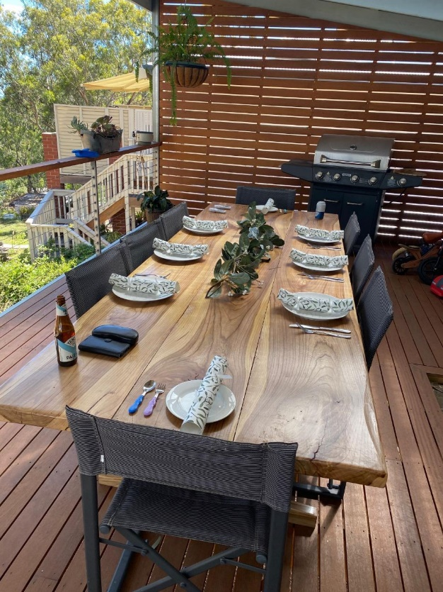

The table produced by Matt for Kelvin before Christmas delivered and in full use for Christmas dinner

Advantages of living after 70! Someone had to remind me, so I'm reminding you too. Don't laugh.....it is all true... 20 Perks of reaching 70! 01. Kidnappers are not very interested in you. 02. In a hostage situation you are likely to be released first. 03. No one expects you to run -- anywhere...... 04. People call at 9 PM and ask, “did I wake you?" 05. People no longer view you as a hypochondriac. 06. There is nothing left to learn the hard way. 07. Things you buy now won't wear out. 08. You can eat supper at 4 PM. 09. You can live without sex, but not your glasses. 10. You get into heated arguments about pension plans. 11. You no longer think of speed limits as a challenge. 12. You quit trying to hold your stomach in no matter who walks into the room. 13. You sing along with elevator music. 14. Your eyes won't get much worse. 15. Your investment in health insurance is finally beginning to pay off. 16. Your joints are more accurate than the Bureau of Meteorology. 17. Your secrets are safe with your friends because they can't remember them either. 18. Your supply of brain cells is finally down to manageable size. 19. You can't remember who sent you this list. 20.??????????

STEPPING UP LADDER SAFETY

A simple, but important reminder for all shedders, take extra care with ladders. Shedders and their families are being urged to put their safety first when using ladders for odd jobs, taking down Christmas decorations and DIY maintenance around the home, as part of an awareness campaign being launched today. Run annually, the Ladder Safety Matters campaign extends across social and digital, with the aim to reduce serious injury, hospitalisations and deaths from ladder falls. Ladders are associated with more deaths and injuries that any other household product, with older people most likely to suffer serious injuries from a ladder fall. In Victoria alone, there is around 1200 emergency department presentations due to ladder falls and around six Victorians die as a result of falling from a ladder at home each year. The latest data shows hospital admissions for ladder falls around the home have gone up by 22 per cent over the five years to 2018/19 – from 614 to 752. The number of men hospitalised increased by 16 per cent from 474 to 549 and concerningly the number of women jumped by 45 per cent – from 140 to 203. Sixty-one per cent of all hospital admissions were people aged 60 and over, and men aged from 40 to 79 made up more than half (55 per cent) of the people who presented to hospital emergency departments after falling off a ladder. People who are hospitalised after a ladder fall commonly suffer bone fractures, open wounds and head injuries, including concussion. Physical injury is often linked to long-term psychological trauma, loss of mobility and independence for older people. Most ladder injuries are preventable, which is why older People should be cautious and not take shortcuts. People should always maintain three points of contact, use two hands when climbing and when using a tool, make sure both feet and your other hand are secure on the ladder. It is important to work within your limits and make sure another person is at home while you are on a ladder, in case you need help. Having another person around can help hold the ladder to ensure it doesn’t slip, simple, but very important.

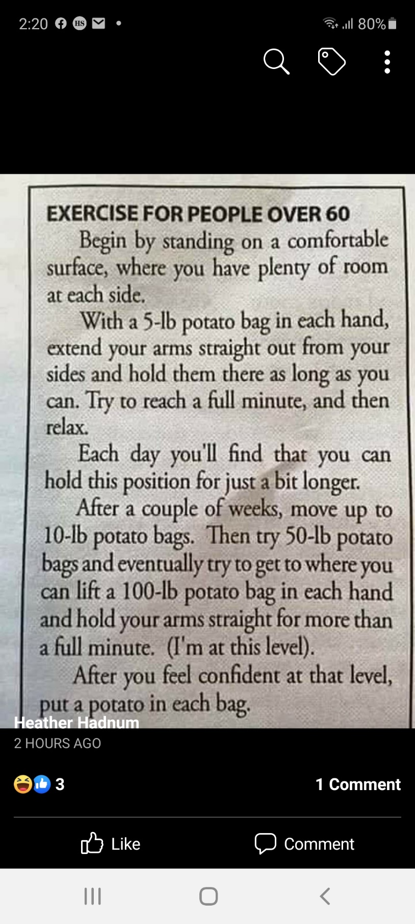

**How to get rid of blackspot on roses.**

