**EXECUTIVE MEMBERS FOR 2023**

**PRESIDENT**: Ian Bond 0420 859 540

**VICE PRESIDENT**: Grant Sullivan

**TREASURER**: John Plunkett

**SECRETARY**: Paul Edgeworth 0497 386 846

**PHONE**: 0478 614 027 (prefer Tuesday and Thursday am)

**Open Tuesday, Wednesday & Thursday** 9am– 12pm **1a McDonnell Drive**

Website [www.mgmensshed.com.au](http://www.mgmensshed.com.au)

FacebookMens Shed Mount Gambier

Email [mgmensshed@gmail.com](mailto:mgmensshed@gmail.com)

**BIRTHDAYS**

David H 02/08

David B 04/08

Don C 05/08

Peter B 06/08

Paul E 07/08

Gary V 13/08

Don L 14/08

Rob B 23/08

Kevin P 23/08

Frank Mc A 23/08

**CALENDAR - August**

Sunday 6th Bunnings BBQ

Wednesday 9th 6.30 Shedder & partners tea at Blue Lake Golf Bistro

Thursday 10th 10.30 Members Meeting

Thursday 17th Continence & Prostate Cancer-speaker

Thursday 22nd 10.30 Committee Meeting

Thursday 31st BBQ lunch

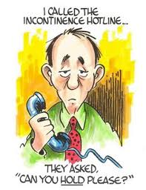

**********

If you would like to contribute information or an article to your newsletter, talk to Editor David N or email [mgmensshed@gmail.com](mailto:mgmensshed@gmail.com)

**7. Centre Punch**

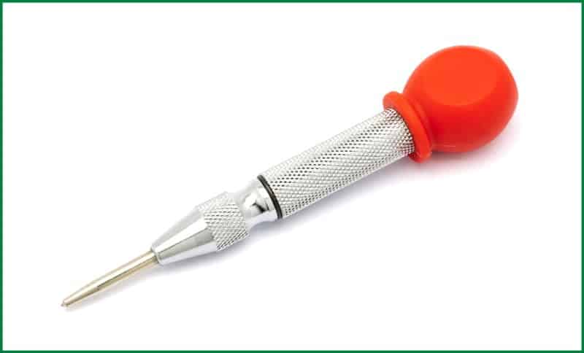

Punch is a tool made of metal with a pointed fine tip. The handle of the tool is usually broad and rounded to facilitate hammering. An iron hammer or wooden mallet is used to strike on the broad handle to insert the pointed edge on the targeted object.

This tool can be of varying types based on their purpose. Each of them has its specific structure and properties complementing its purpose. There are drift punch, centre punch, prick punch, decorative punch, transfer punch, letter punch and others.

**Uses of Centre Punch**

The punch tool is used by woodworkers to mark the centre to assist in drilling. It is also used for duplicating patterns of markings on different pieces. The letter punches are quite impressive in their work. They are used for engraving letters or numbers on wood pieces.

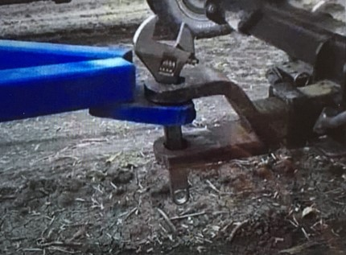

Tools have many uses, not all are recommended!

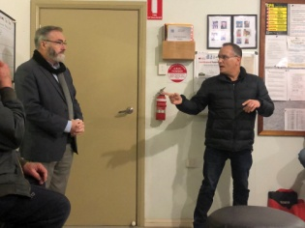Well, what a great session from David and Claude demonstrating their Tesla and BYD (Build Your Dreams) cars.

Those that thought they knew everything learnt something extra and those that knew a little bit were brought up to date and had their eyes opened to the amazing limitations and future possibilities.

Myths were politely quashed and the history, politics and future of the motor industry were expertly put into context.

Environmental benefits for the planet and general health improvement was laid out.

To finish our inspection of the features, the Tesla actually put on a party (lights flashing to music). Wow!! Dick P

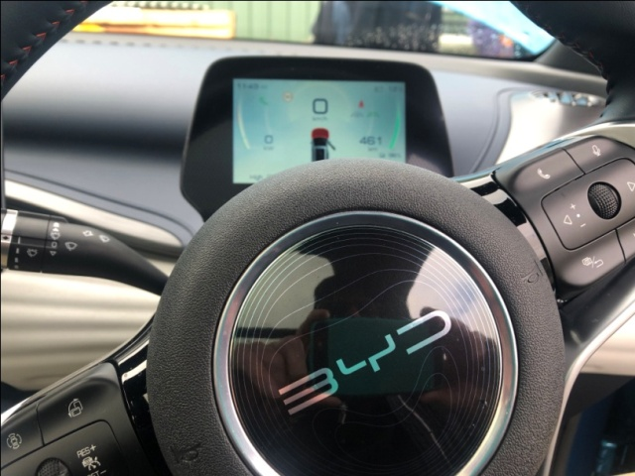

BYD dash

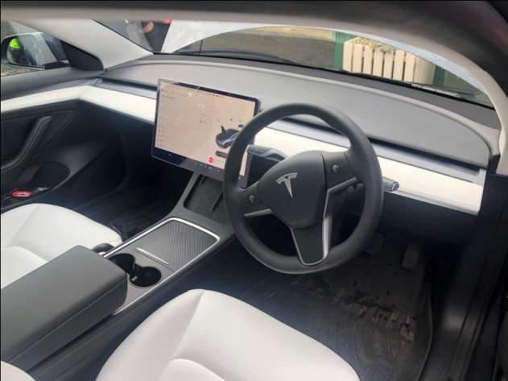

Tesla dash

HIRED A HANDY MAN AND GAVE HIM A LIST.

WHEN I GOT HOME, ONLY #1, 3 & 5 WERE DONE.

TURNS OUT, HE ONLY DOES ODD JOBS!

|  |  |  |  |  |
| --- | --- | --- | --- | --- |
| |  | | --- | | D:\August 2023\Engine bay Tesla.jpg | | Tesla – under bonnet | | D:\August 2023\Engine bay BYD 1.jpg | | BYD – under bonnet |   Jigsaw 1.jpeg  Finished floor jigsaw at Riddoch Art Gallery  As with all Mens Sheds, we have our share of men in the process of receiving treatment or recovering from sickness. Some men struggle with life , Mens Sheds provide a safe place to share and to know they are not alone.  On a happy note, one of the highlights of recent times was when the president’s bell was sabotaged and would not ring when he  tried to call the group to order for a meeting. Grant S |

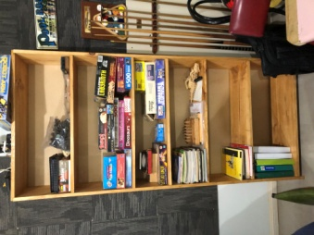 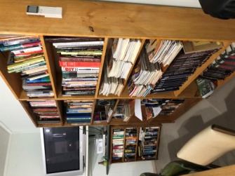

3 tall bookshelves made by Dick P & Ray L

have been put to good use in the smoko room

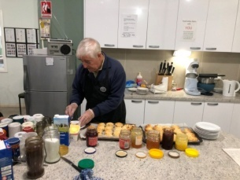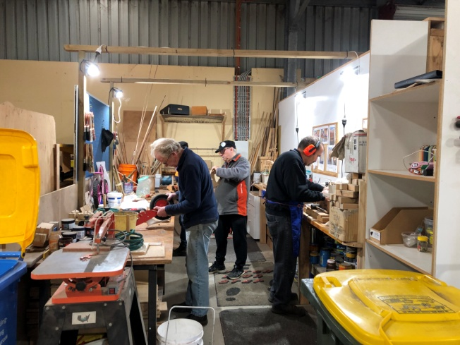

Toy Boys appreciate room to move without bumping into each other – much safer!

Below - Finished toys in storage container

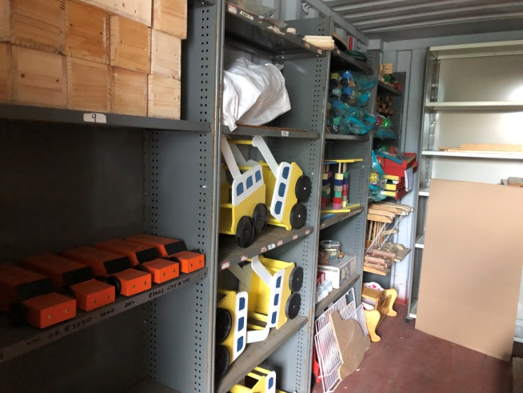

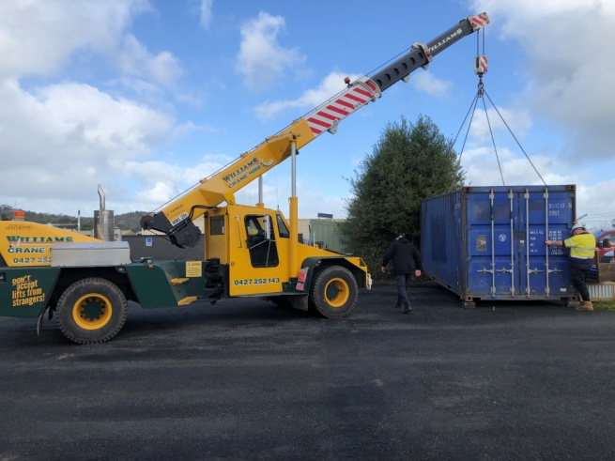

New storage container being placed at front fence

by Williams Cranes

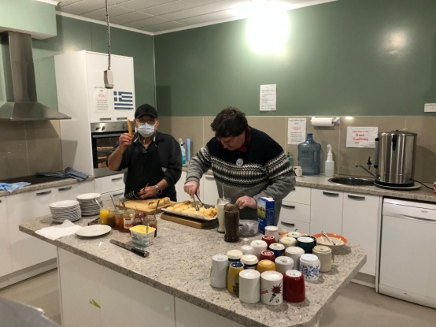

Ben K & Bill McG making scones

Below - Thanks to Dick P & Grant S - scone making apprentices in Ben’s absence

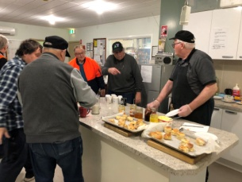

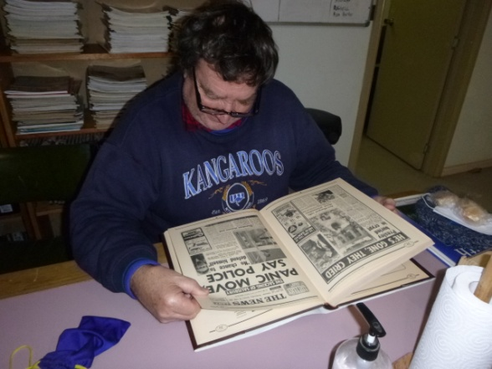

Bill McG catches up on some history reading

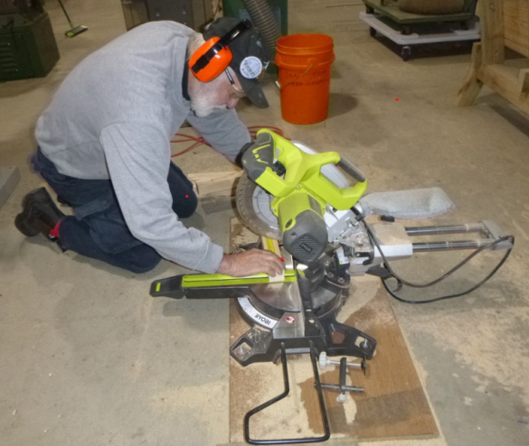

“How low does one have to get to cut a piece of timber” says Herman B

Visitor of the month – Ron Irwin from Wingham Mens Shed NSW

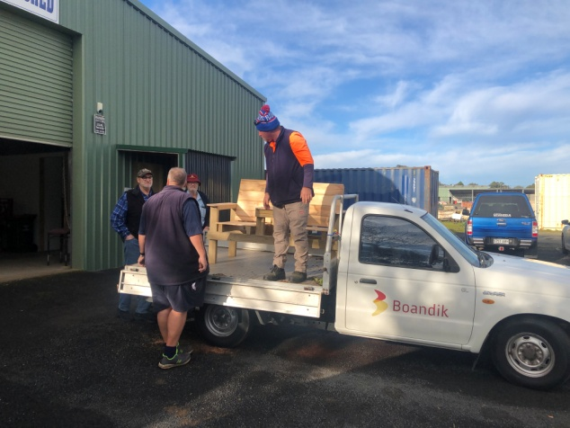

Boandik collecting Jack & Jill seat made by the team who make picnic tables & garden beds. Painted version below

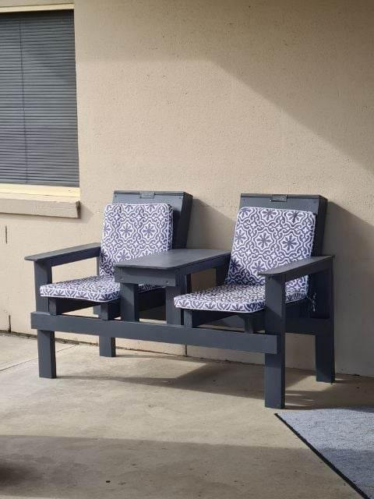

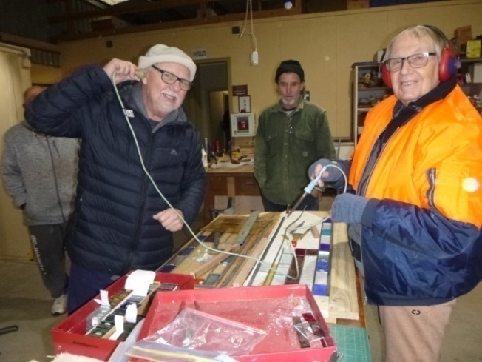

Mat J “tunes into” Graham T’s leadlighting soldering while Ron P watches on

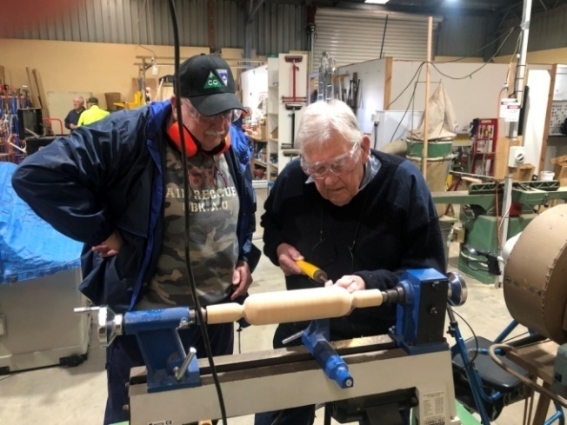

John S & Ian L turning a rolling pin

“the blind leading the blind” - under supervision

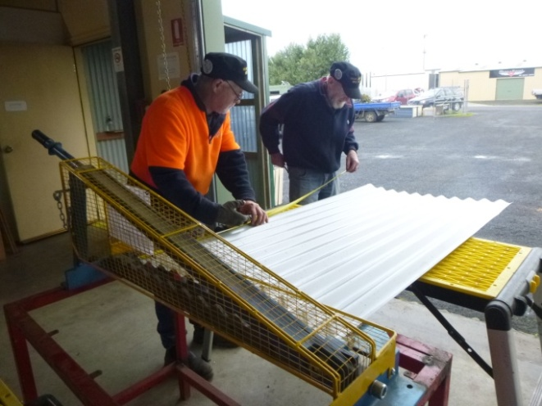

Gary A & Frank McA prepare garden bed iron

for guillotining

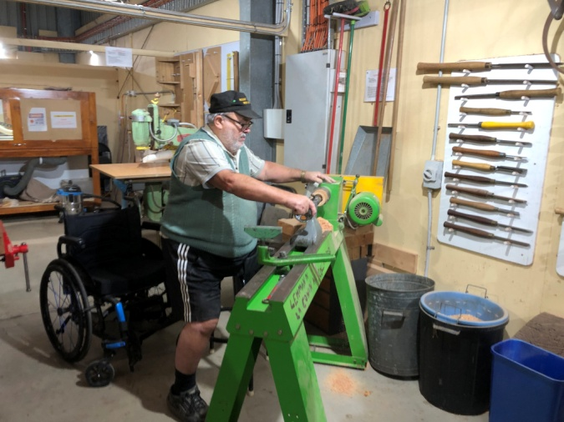

Laurie T at the wood lathe

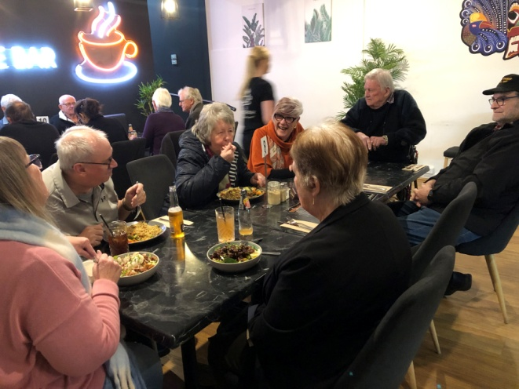

Above & below – Shedders tea at Foodie Bar

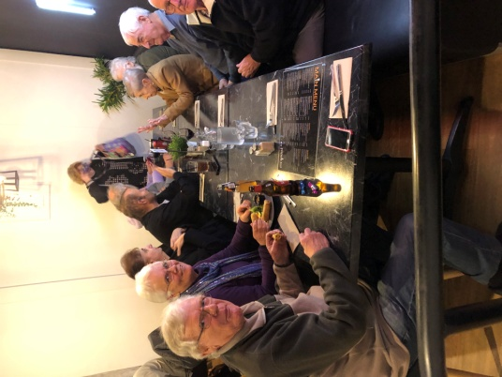

**HEYWOOD’S MENS SHED - MENS HEALTH**

On 27th July, Rod B, Ron P and Russell S went with Paul E to Heywood for a get together with about 40 other Men’s Shed people for talks on men’s health. There were several guest speakers on various topics of men’s health. Two of the speakers spoke on their dealings with BLACK DOG mental health. They spoke of how they handled it; they were told they would never work again and with determination and strong will they are now back in the work force. Another speaker spoke on NUTRITION and the benefits of the Mediterranean Diet, package labelling and what is really in packaged food. She suggested we should consume at least tablespoon of Virgin Olive Oil every day.

A balanced diet is very important.

Also an Ambulance Officer spoke on CPR and Defibrillators and demonstrated their use. He said every minute means success or not; just hop in and do your best.

The Heywood Shed provided their usual great hospitality and a lovely three course meal. Thanks to Paul for driving us over. Rod L

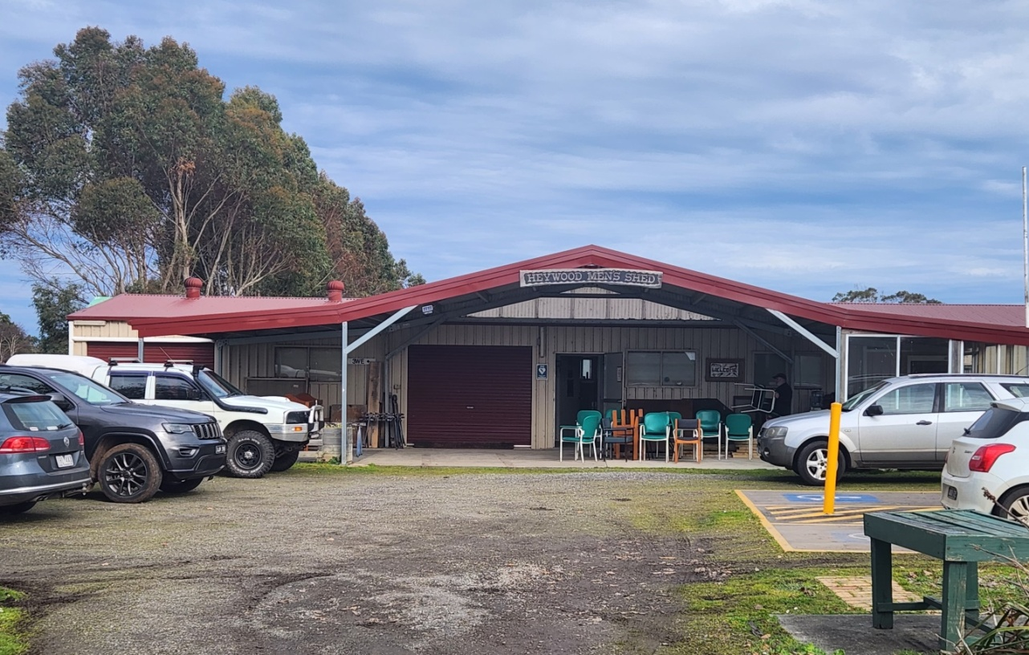

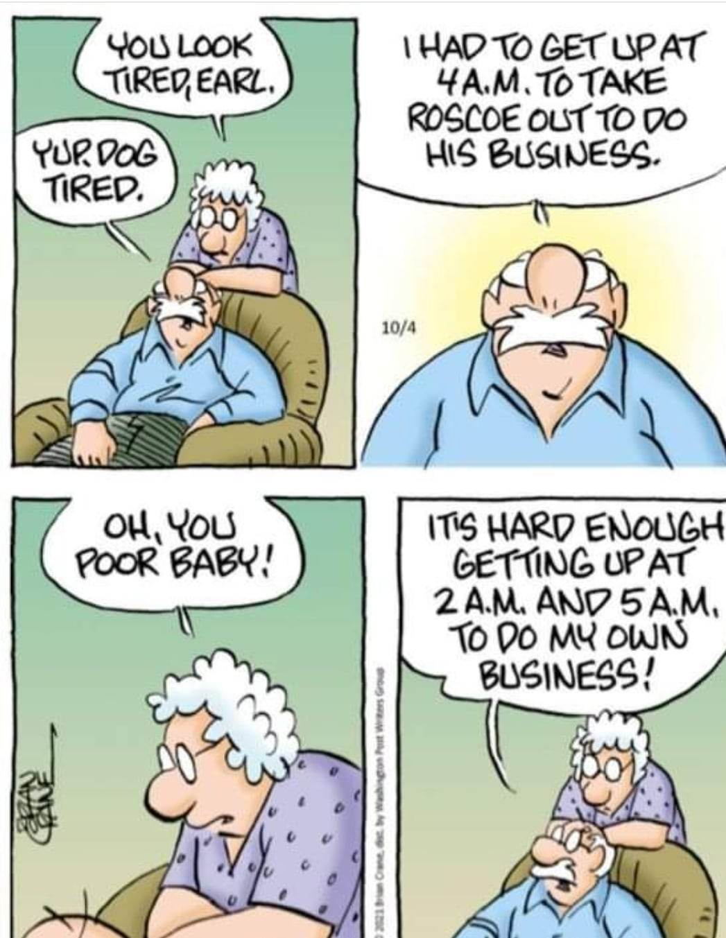

**SPONSORS**

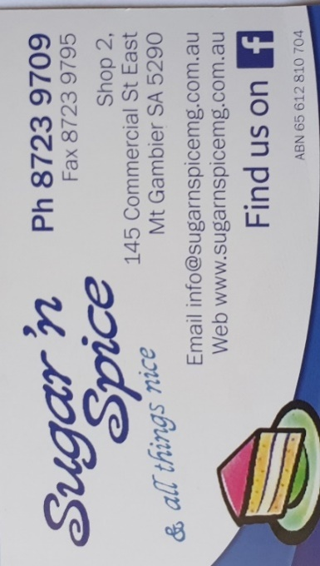







**Big supporters of Mount Gambier Mens Shed**

**SUPPORT OUR LOCAL BUSINESSES**

**THAT SUPPORT YOU**

Son: Dad, I want to marry

Dad: Say Sorry

Son: For what?

Dad: Say Sorry

Son: But for what?

Dad: You first say Sorry

Son: But what’s my fault?

Dad: You first say Sorry

Son: At least tell me the reason

Dad: First say sorry

Son: Ok Dad! I’m sorry

Dad: Now you are ready for marriage my son.

Your training is complete. You’ve learned to say sorry without any reason.