**EXECUTIVE MEMBERS FOR 2022**

**PRESIDENT**: Ian Bond 0420859540

**VICE PRESIDENT**: Grant Sullivan

**TREASURER**: John Plunkett

**SECRETARY**: Paul Edgeworth 0497386846

**PHONE**: 0478614027 (prefer Tuesday and Thursday AM.)

**WE NOW HAVE A WEB SITE FOR THOSE WHO WISH TO LOOK. THIS WILL BE UPDATED FROM TIME TO TIME WITH NEW PHOTOS, NEWSLETTERS, RADIO REPORTS, CONTACTS AS WELL AS UPCOMING EVENTS AT THE SHED. Go to**

[**www.mgmensshed.com.au**](http://www.mgmensshed.com.au)

**FACEBOOK** Mens Shed Mount Gambier

[mgmensshed@gmail.com](mailto:mgmensshed@gmail.com)

**BIRTHDAYS**

Angelo M 08/04

Tony P 13/04

Graham P 28/04

Michael R 29/04

**2023 Calendar**

13th April Thursday 10.30 Members Meeting

25th April Closed Anzac Day

27th April Thursday Shed BBQ

29th April Saturday 8.30 12-3.30 Bunnings BBQ

2nd May Tuesday 10.30 Management Meeting

11th May Thursday 10.30 Members Meeting

**Woodworking is all about the touch of the woodworker’s hands. There is no alternative to the tasks which are best done manually. Such tasks require specialized tools for performing each job. Hand tools make a lot of works easier for the woodworker. All it requires is to have the perfect tool for each job.** The woodworking requires some[**compulsory hand tools**](https://thetoolspick.com/types-of-hand-tools/) within reach for effortless woodworking. Some of the woodcraft tools will be mentioned in the next 11 newsletters. Let’s check them out. **3. Handsaw**

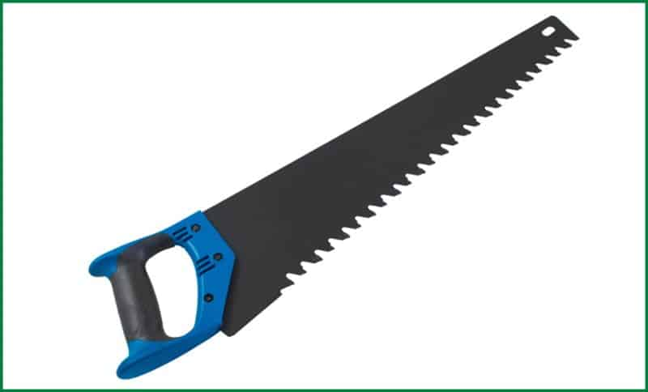

The saws which are used by hand manually to cut objects are handsaws. A typical handsaw includes a wooden handle and a sharp blade with numerous pointed teeth. Handsaws are of different types based on structure, shape and size. Handsaws are not limited to a handle and blade structure. It also comes in frame design. such handsaws have a robust frame to hold the blade in position with high tension to cut objects. **Uses of Handsaw** Handsaws are used in woodworking to cut through wood pieces or other materials as per the requirements. They can make small to large cuts. Different handsaws serve different purposes of cutting wood pieces. The user gets the maximum control over cut while working with a handsaw and can make precise desired cuts.

**RECIEPE:-**

**GREEN TOMATO CAKE.**

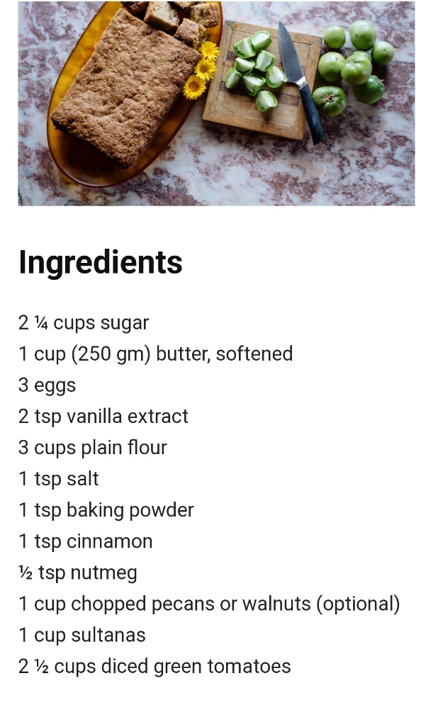

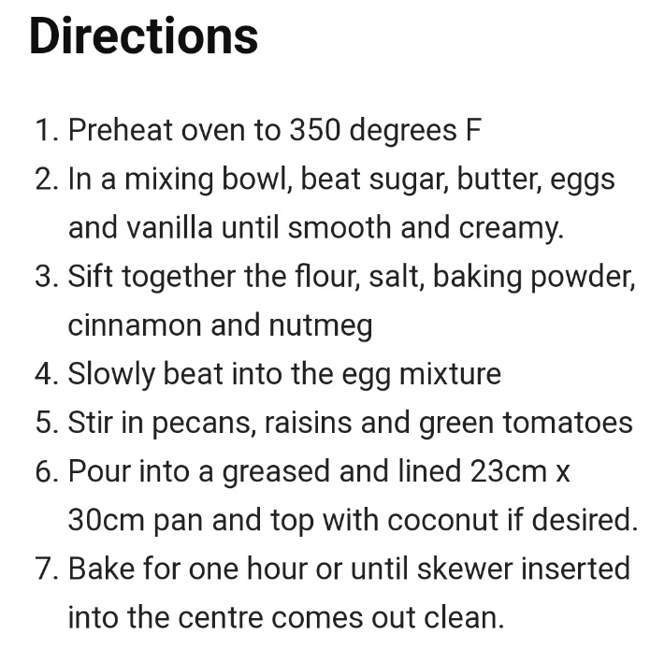

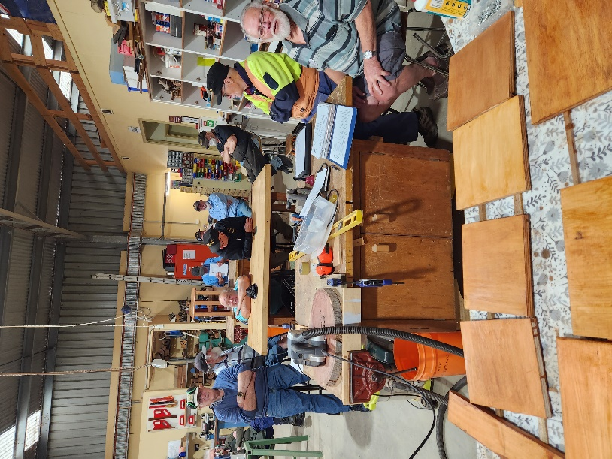

Top and below members at the AGM meeting.

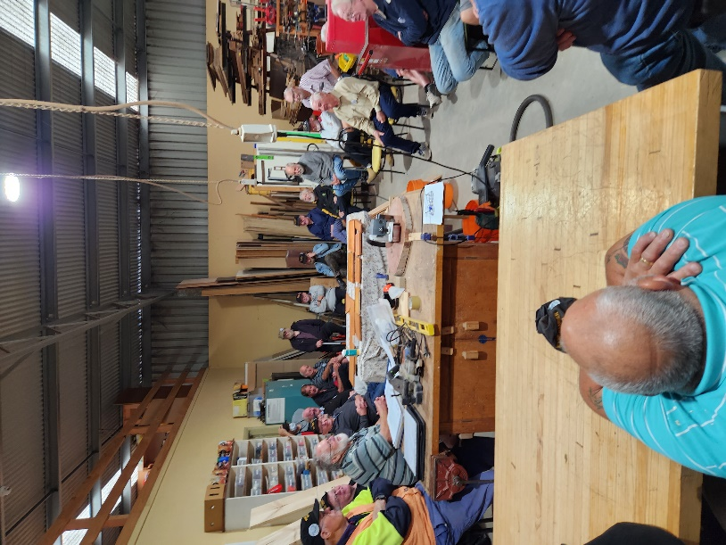

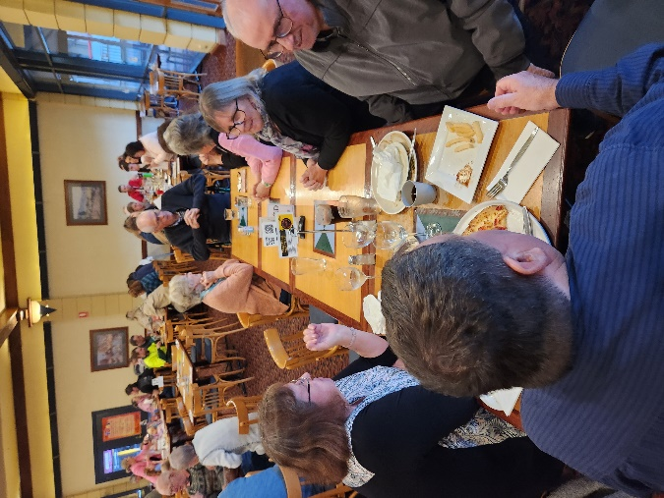

The last dinner meeting at South Eastern Hotel.

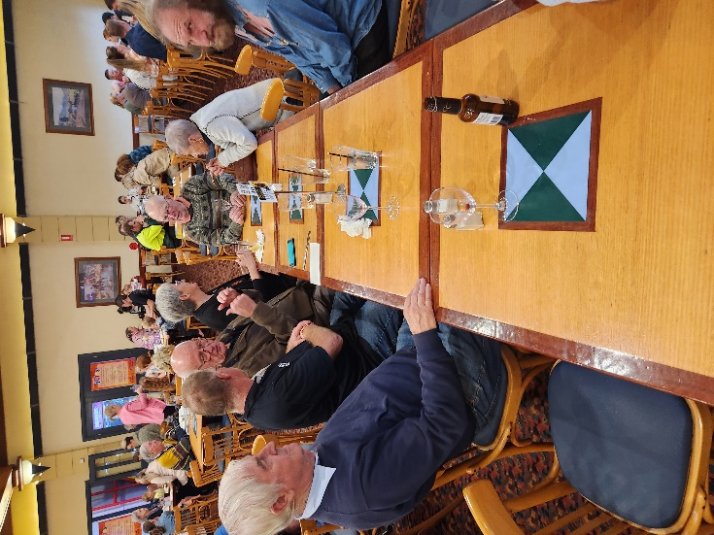

The last dinner meeting at South Eastern Hotel.

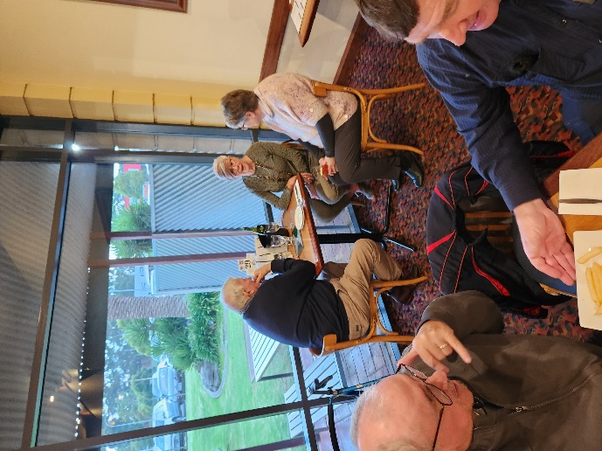

The last dinner meeting at South Eastern Hotel.

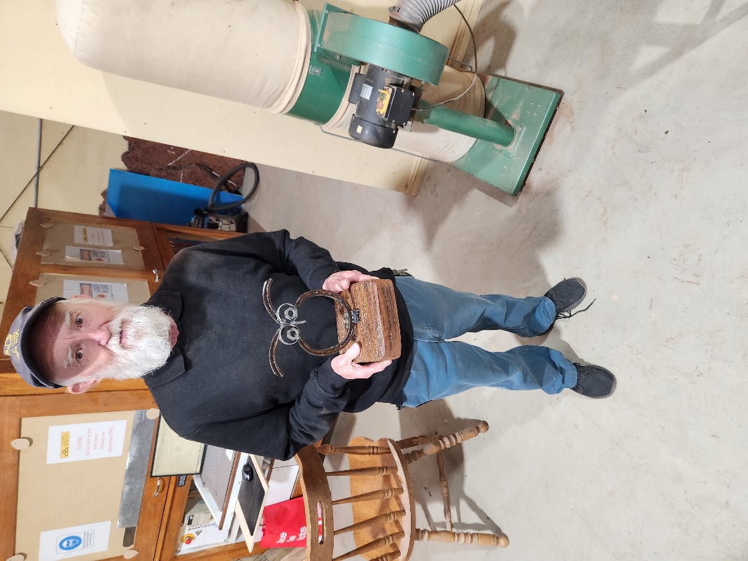

Glen with the owl ornament he has made.

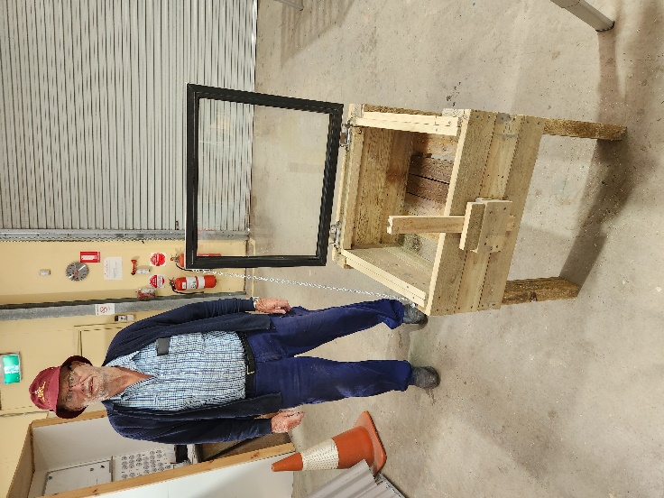

Jeff with his hot house made from a fridge door.

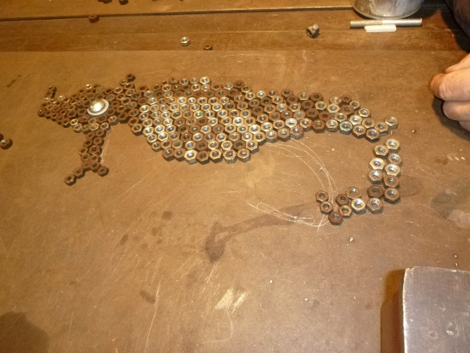

A leafy sea dragon about to be made by Ian.

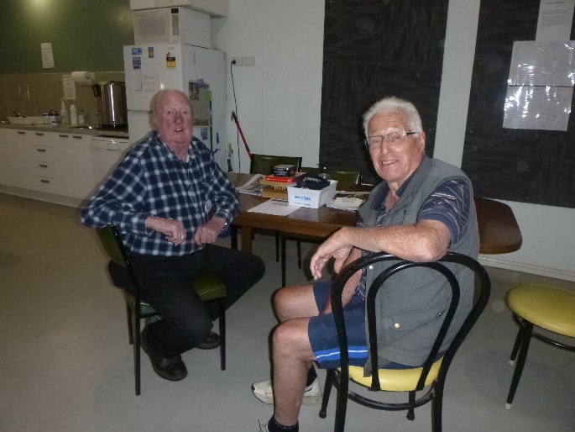

Some people have nothing to do except enjoy each others company.

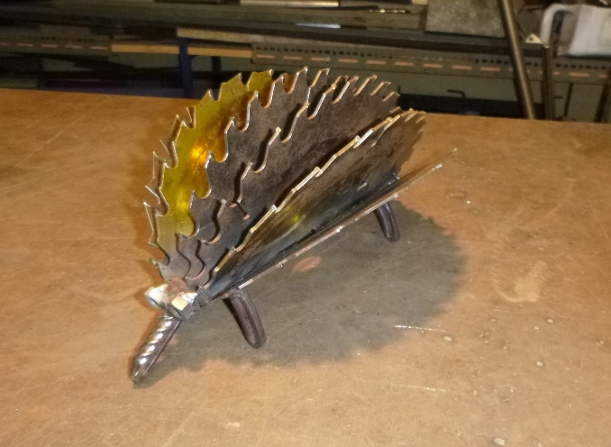

An Echidna made by Ian.

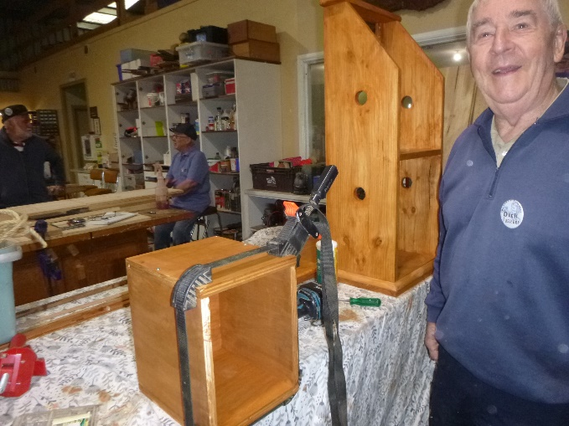

Dick continuing with his Vegetable tidy.

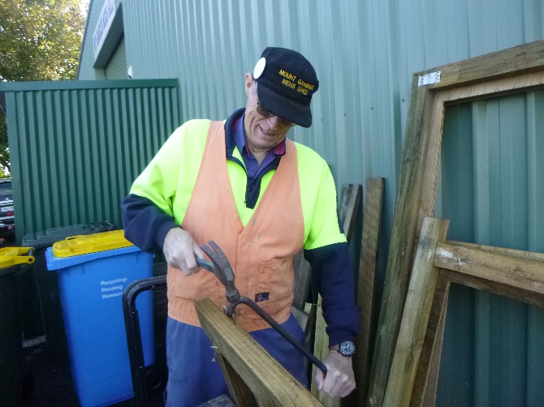

Look at that! President Ian actually doing some work dismanteling a pallet for reuse.

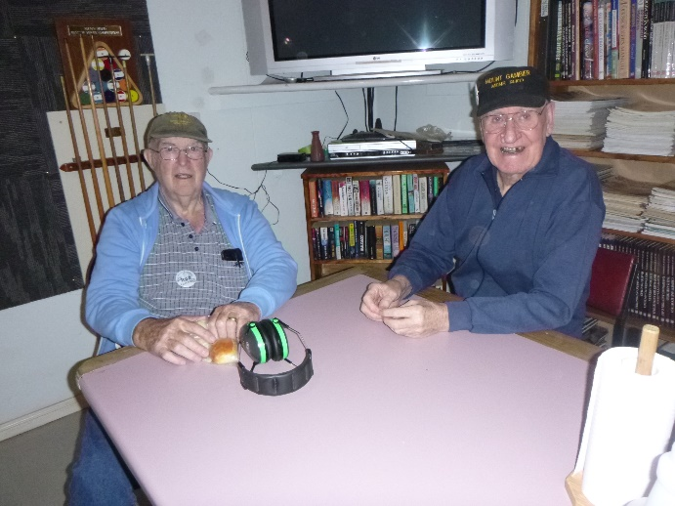

Rod and Don enjoying each others company.

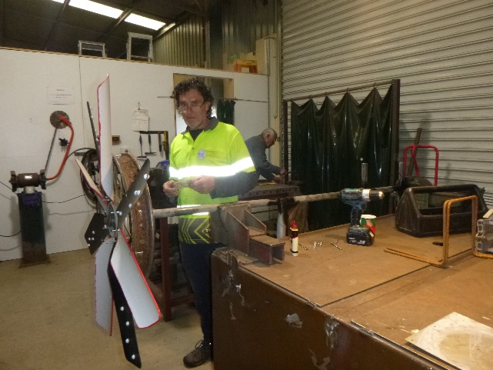

Ron with the Windmill he is making.













 





**Big supporters of Mount Gambier Mens Shed.**

**SUPPORT YOUR LOCAL BUSINESSES**

**THAT SUPPORT YOU.**