[mgmensshed@gmail.com](mailto:mgmensshed@gmail.com)

**EXECUTIVE MEMBERS FOR 2021**

**PRESIDENT**: Peter Halleday 0439500699

**VICE PRESIDENT**: Ian Bond

**TREASURER**: John Plunket

**SECRETARY**: Paul Edgeworth 0887256385

**FACEBOOK**

Shed broadcasts are now available on Facebook

*[Image result for facebook logo](https://www.google.com.au/url?sa=i&rct=j&q=&esrc=s&source=images&cd=&cad=rja&uact=8&ved=2ahUKEwjO9cWTtajeAhUafisKHT6JAHoQjRx6BAgBEAU&url=http://www.seacliffeinn.com/spa-boutique/find-us-on-facebook-logo/&psig=AOvVaw0duNjpvsqixE3Pzu1qEwe2&ust=1540791326821108)*

**Safety: - Remember Safety begins at home.**

**BIRTHDAY”S**

Tony P 13/4

Kelvin S 24/4

Graham P 28/4



**Remember Sugar ‘n Spice support our Men’s Shed with Birthday cakes, so support them where you can.**

 

**While mentioning our supporters always remember how much Bunnings help our shed, so support them, as well, when you need a product that they can supply for you.**



**Thanks to Sharp Cranes and Steeline for supporting our Mens Shed.**

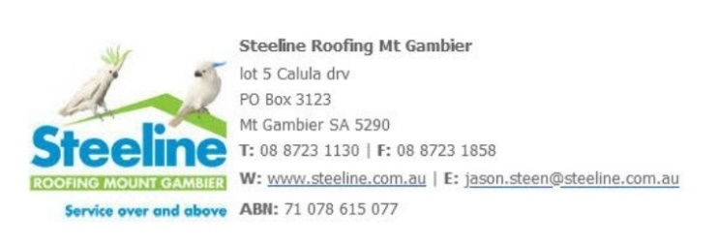



**A big supporter of Mount Gambier Mens Shed.**



**SUPPORT YOUR LOCAL BUSINESSES**

**THAT SUPPORT YOU.**

**DIARY DATES**: 2021

April 8th Thursday 10.15am

Members Meeting

April 14th Wednesday 6.30pm

Tea with partners at Fasta Pasta

April 22nd Thursday 10.15am

Management Committee Meeting.

Thursday 11.30am

BBQ Lunch – free.

Thursday Lunch

Tony Pasin MP visiting.

**WORKSHOP TIPS From the AMSA Men’s Shed Health & Safety Manual.**

* Do not operate machines whilst under the influence of drugs, alcohol or medication.
* Wear approved eye & ear protection & when necessary hair covers & dust mask.
* Do not wear ties, loose gloves or loose clothing.
* Never start a machine before clearing away nearby objects.
* Always use the safety guards and ensure they are correctly spaced from the cutter.
* Ensure there is enough space on the feed and exit sides for the work piece.
* Where applicable ensure the dust extractor is **On** and functioning.
* Before starting, warn anyone using tools to prevent reaction to sudden noise.
* When switching **On**, keep well clear of cutters.
* Let the machine get to full speed before contacting the work piece.
* Turn the machine **Off** when a job is jammed.
* When finished, turn machine **Off**. Wait for cutter/blade to stop before removing work piece.
* Always turn **Off** at the machine NOT at the power outlet switch, to prevent unexpected starts if someone else operates the wall switch.
* C lean up after yourself to keep the area safe.
* If a machine does not seem to be functioning correctly:

• STOP • Unplug the machine from power

• Put a ‘Warning’ notice on the machine

• Notify a Supervisor.

**MEMBERS PROFILE:-**

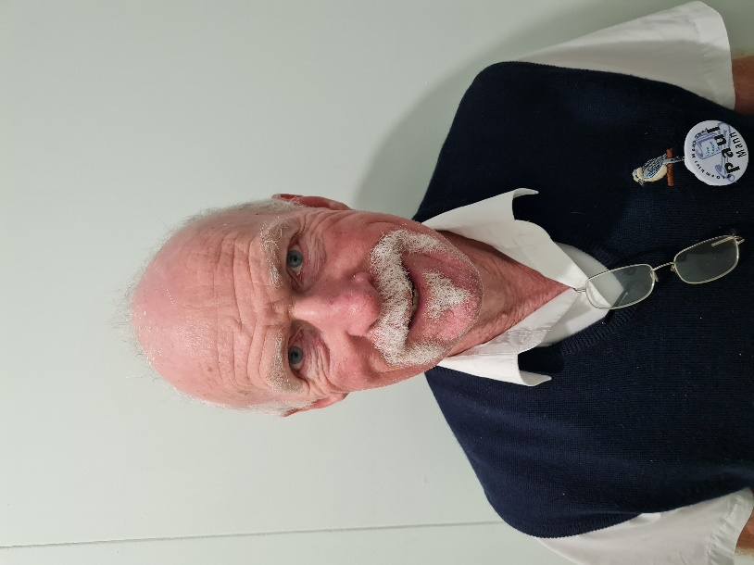

**NAME: -** Paul Mann.

**Where have you worked in your life: -** The last 30 years at the Mount Gambier Airport. Also worked at the East Gambier Football Club and the S.A. Bank of South Australia.

**Something about you that others at the shed don’t know: -** Live in the former CSIRO building next to the Airport.

**What do you wish to achieve at the shed: -** Learn to make things out of timber and utilise the machinery.

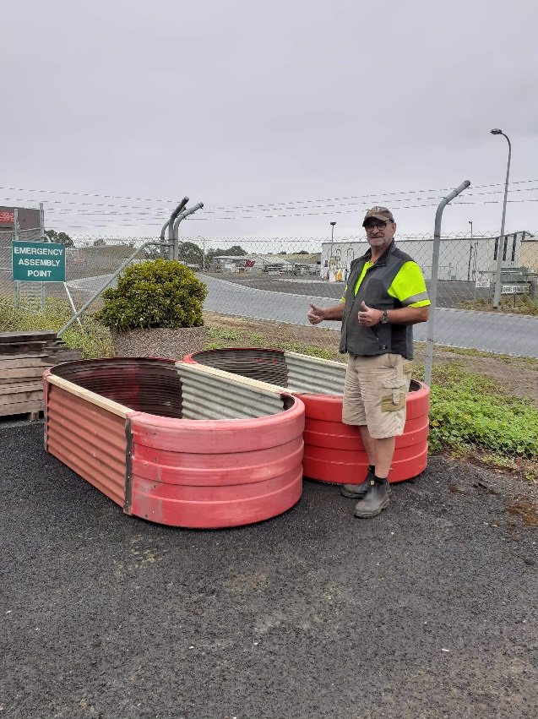

Not sure if David is giving us naughty signals or that he is happy with these 2 new garden beds. Think it is the later.

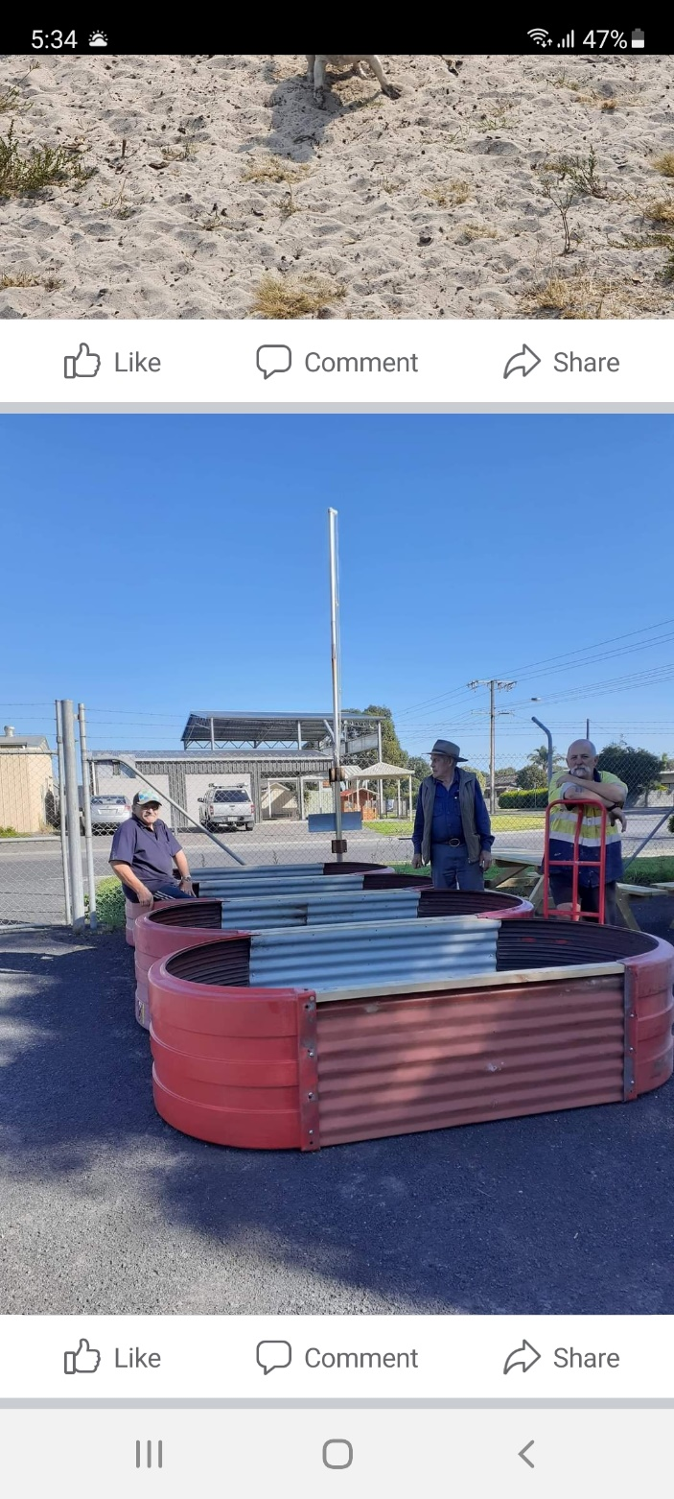

More Garden Beds. But why are they standing around? They must have more to make.

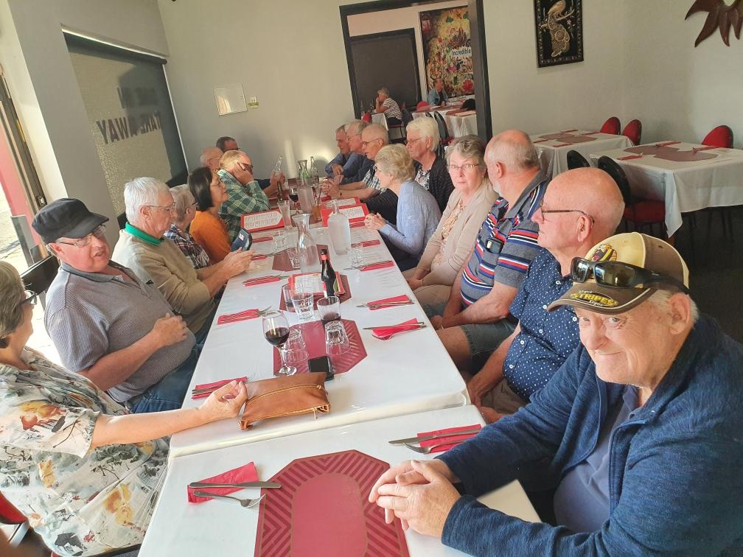

Members and wives about to enjoy their meals.

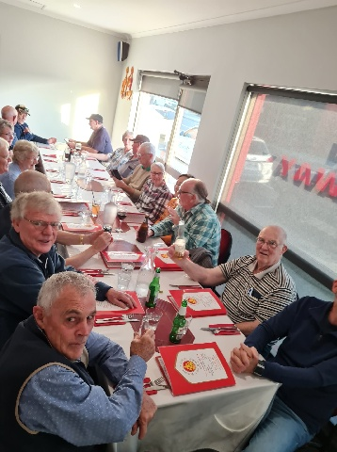

Meal with our wives at the Indian Gourmet Restaurant.

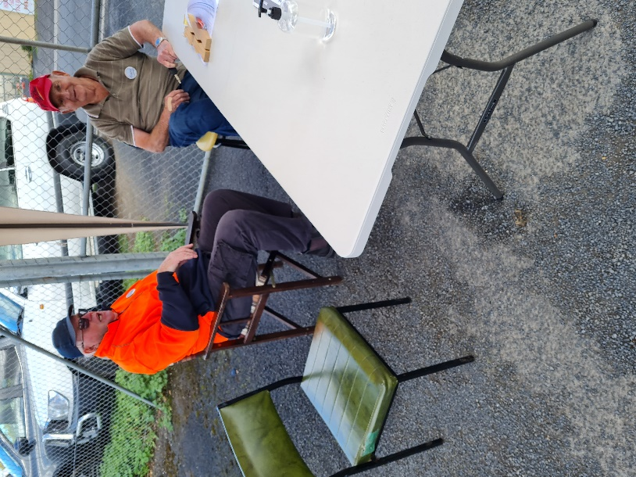

While some people worked at the garage sale some like Graham and Geoff like to sit and welcome customers.

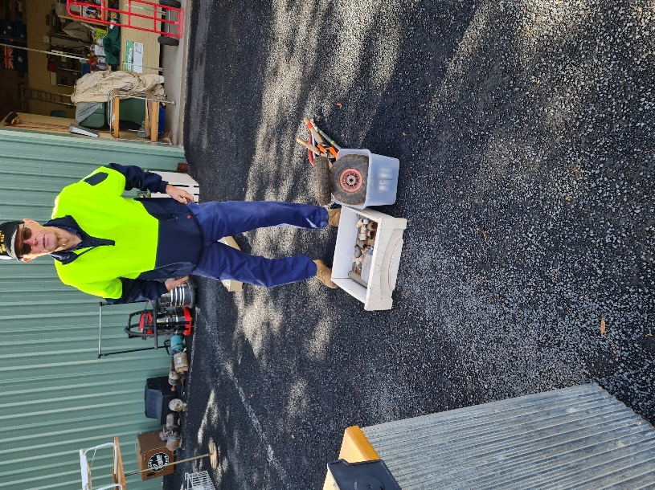

Ian checking out a box of goodies before anyone else gets in first.

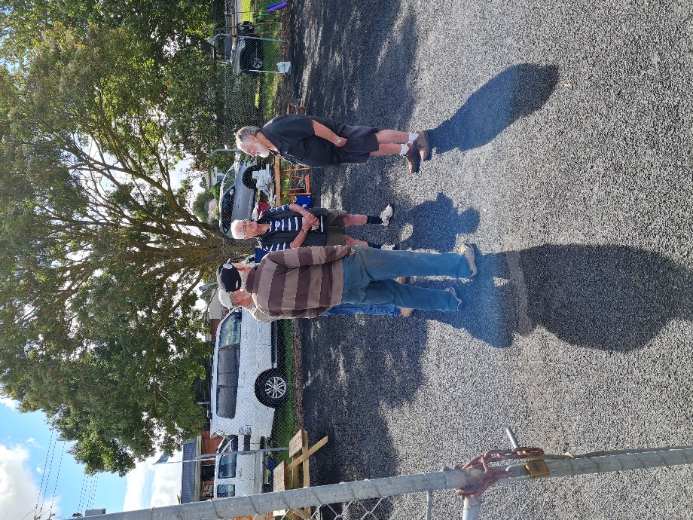

Bit of secret men’s business going on here.

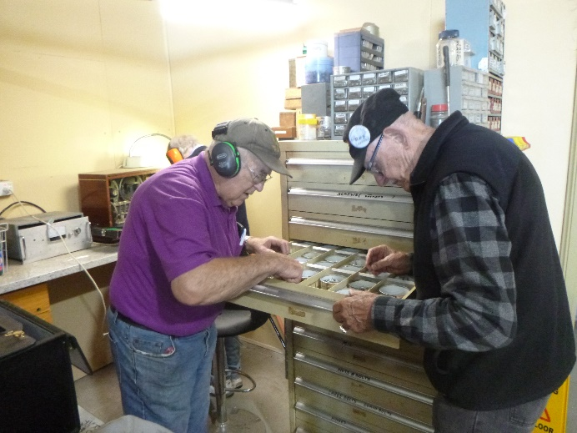

Rod telling Ray, “I know it is in here just not sure where”.

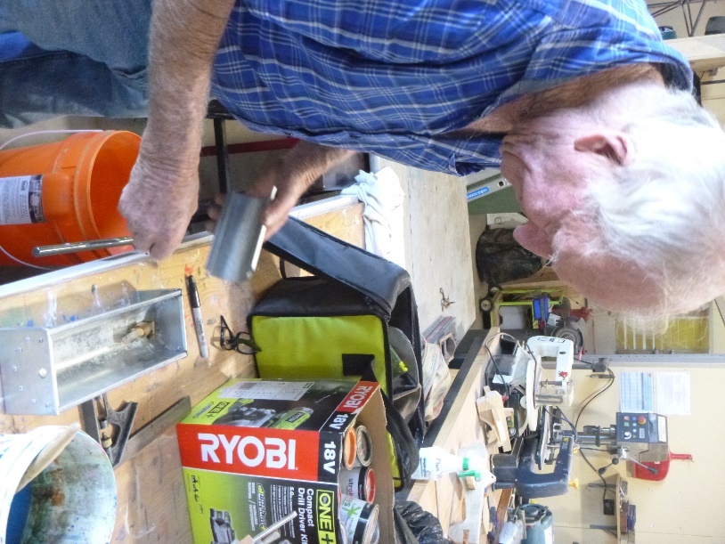

Trevor building a cover for his small water trough. The whole water system was made from scratch.

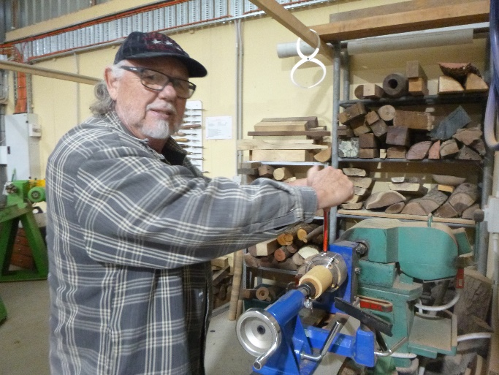

Matt using the small wood lathe.

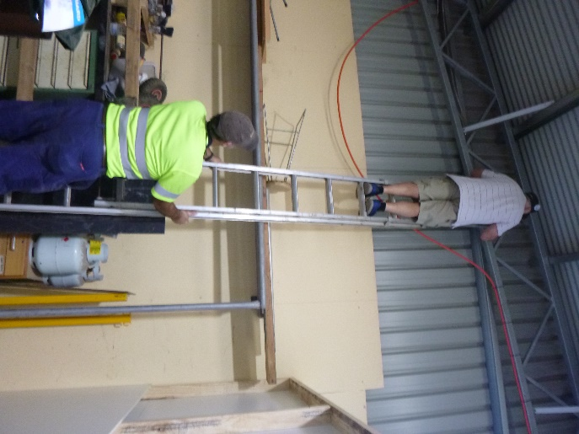

Rob up the ladder and Dave holding it while doing wire work for the new welding area.

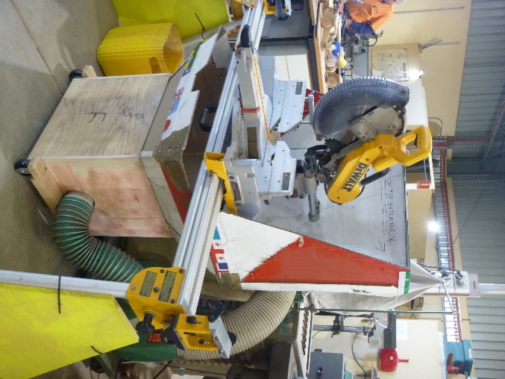

The trial dust extraction in position and working.

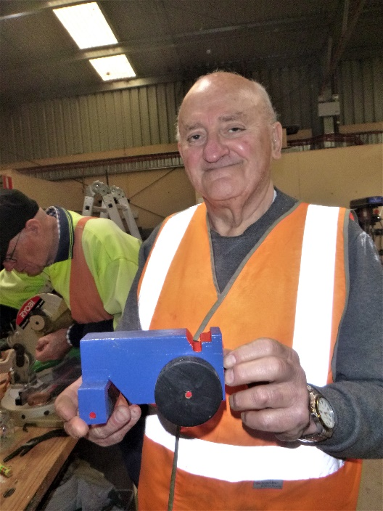

George with one of the toy steam rollers.

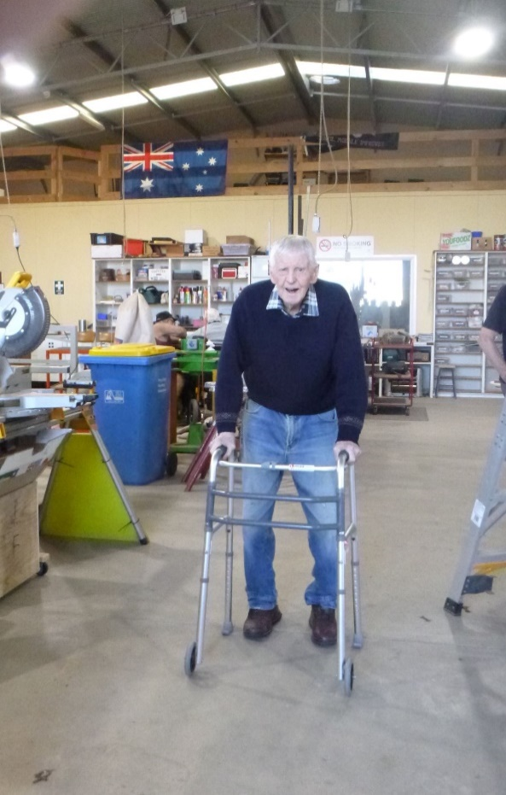

Welcome back to Bernard after his medical stint away from us.

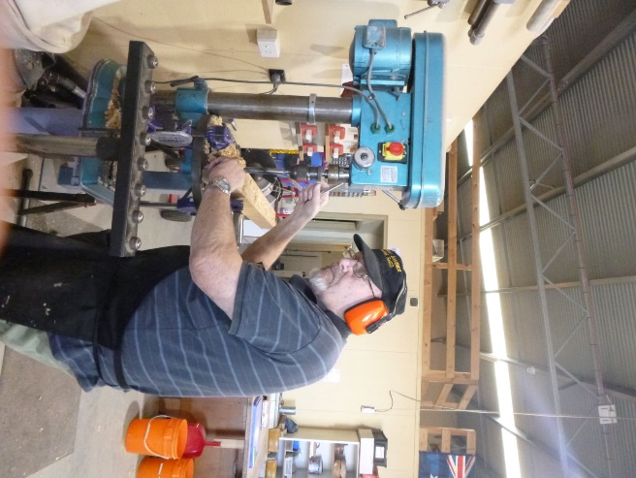

Allan making a template for the wood lathe tool rests.

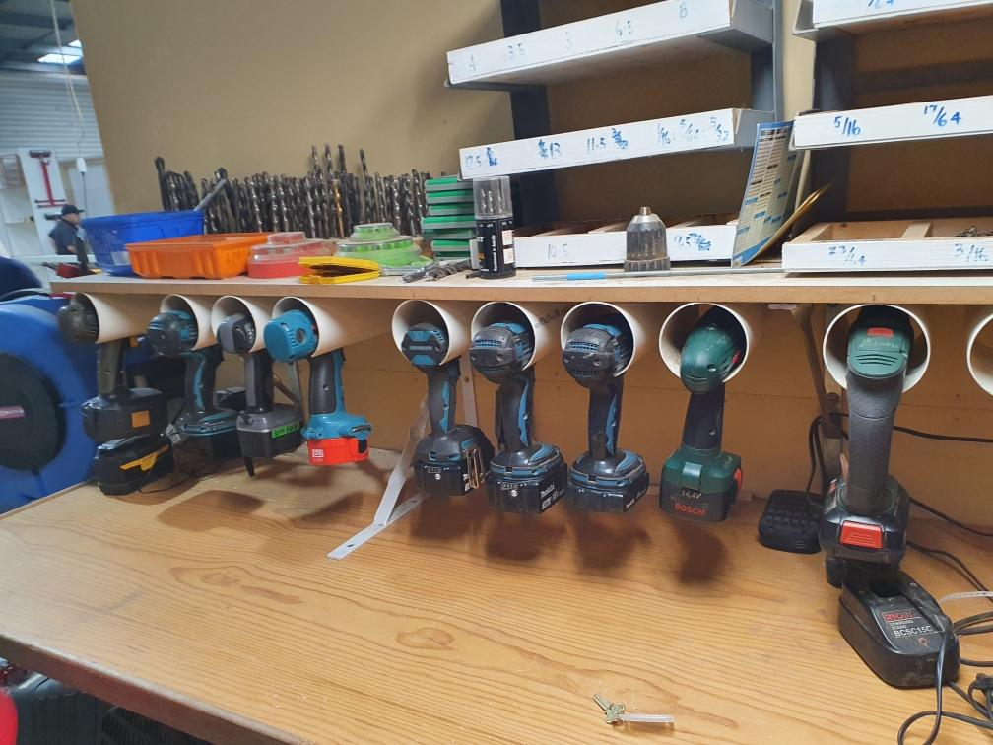

Thanks Ray for this effort. Much tidier.

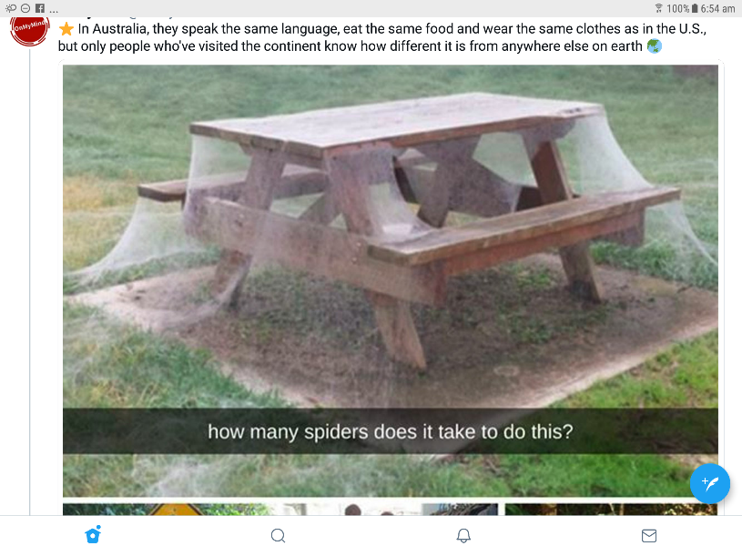

Dave I know you can be slow sometimes but we think you may have over done it this time, the spiders were too quick.





A professor gave a balloon to every student, who has to inflate it, write their name on it and throw it in the hallway. The professors then mixed all the balloons. The students were given 5 minutes to find their own balloon. Despite a hectic search, no one found their balloon. At that point, the professors told the students to take the first balloon that they found and hand it to the person whose name was written on it. Within 5 minutes everyone had their own balloon.

The professors said to the students: “These balloons are like happiness. We will never find it if everyone is looking for their own. But if we care about other people’s happiness …. We’ll find ours too.

~ Author unknown.

