**EXECUTIVE MEMBERS FOR 2022**

**PRESIDENT**: Ian Bond 0420859540

**VICE PRESIDENT**: Grant Sullivan

**TREASURER**: John Plunkett

**SECRETARY**: Paul Edgeworth 08 8725 6385

**PHONE**: 0478614027

**PHONE**: 0478614027

**WE NOW HAVE A WEB SITE FOR THOSE WHO WISH TO LOOK. THIS WILL BE UPDATED FROM TIME TO TIME WITH NEW PHOTOS, NEWSLETTERS, RADIO REPORTS, CONTACTS AS WELL AS UPCOMING EVENTS AT THE SHED. Go to**

[**www.mgmensshed.com.au**](http://www.mgmensshed.com.au)

**FACEBOOK** Mens Shed Mount Gambier

[mgmensshed@gmail.com](mailto:mgmensshed@gmail.com)

**BIRTHDAYS**

Tony P 13/04

Graham P 28/04

**A note from incoming President Ian Bond.**

On behalf of the Management Committee I will work for the interest of all members. This is our paramount wish for the upcoming year. These interest include our mental and physical health as well as helping each other with personal projects and transfer of skills.

**2022 Calendar**

13th April Wednesday 6.30pm Tea with partners – Belgiornos

14th April Thursday 10.15am Members Meeting

16th April Saturday 8.30am – 12.00noon Bunnings BBQ

12.00noon – 3.30/4pm

26th April Tuesday 10.15am Management Meeting

## fan bearing wood borerTHE COMMON TYPES OF WOODWORM AND WOOD BORING INSECTS pART 6/12

**#5. Fan-Bearing Wood-Borer**

Latin name: Ptilinus Pectinicornis

**Appearance:** A small, blackish-brown beetle with distinctive head fan antennae. Mainly stays in lumber yards and woodland settings and can cause significant damage to timber stocks.

**Preferred timber:** Tunnels extensively near the surface of hardwood, mainly focusing attention along the grain of the timber. It flies within its near environment to find wood sources.

**Type of damage**: Creates rounded tunnels filled with a flour-like frass – and is rarely found in domestic or business properties (which is good news considering the high level of damage it can cause).

**Telltale signs:** Exits through 2 mm diameter holes and stays near the surface of the timber. You can sometimes find this beetle by simply peeling back the bark on fresh or cut wood.

**Next Month - Powder Post Beetle**

**Profile:-**

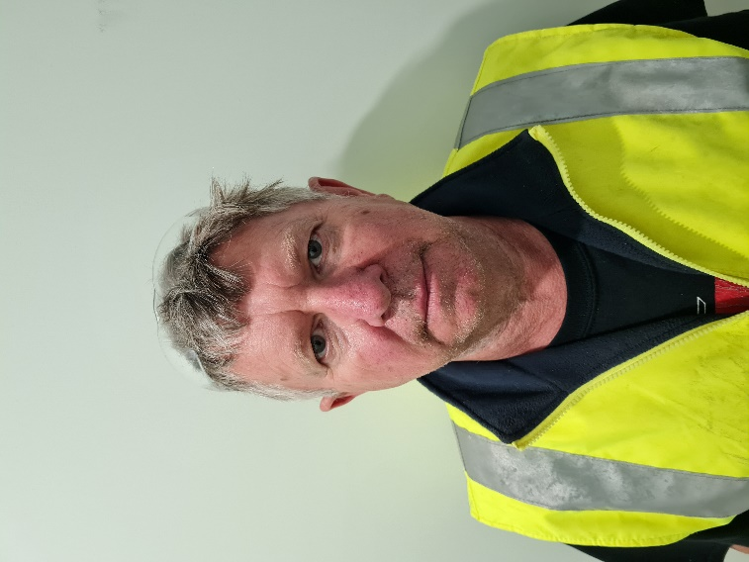

Name: - Daryl Vanderhaak. Where have you worked:-At the old Kraft cheese factory ( Mondelez) Pasteuriser operator for 23 years. Something about you people at the shed don’t know:- I like to restore old cars and motorbikes. What do you want to achieve at the shed:- Make friends, talk a lot and make new things.

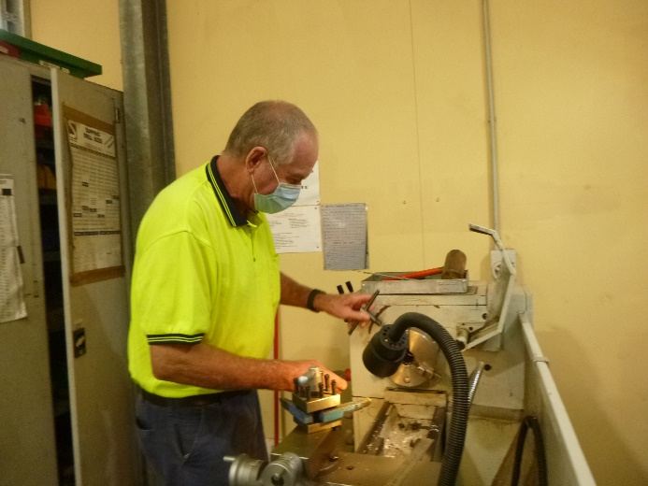

Alan R. looking and checking out the metal lathe.

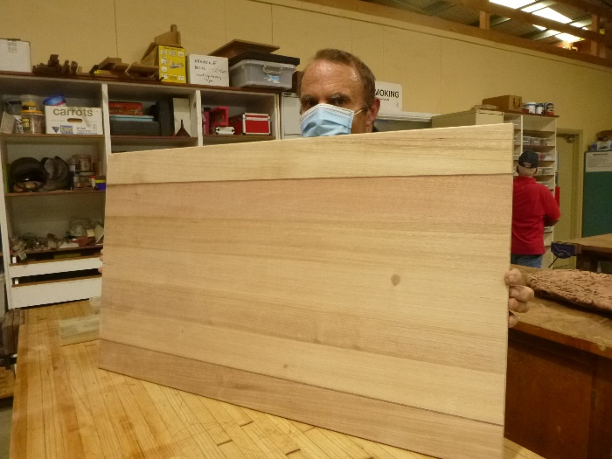

Peter K. Joining up pieces of timber to make a bench top for the kitchen.

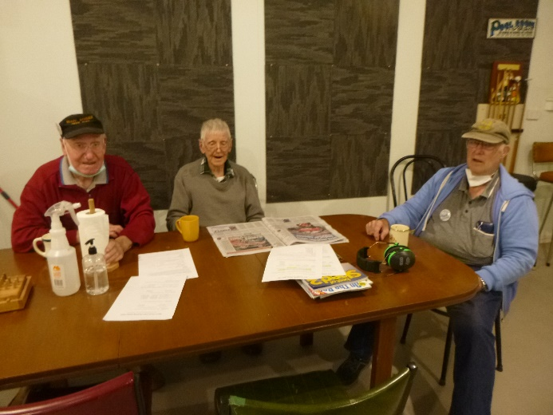

The 3 Amigo’s Don, Bernard and Rod not much to do so having a cupper and solving the world problems.

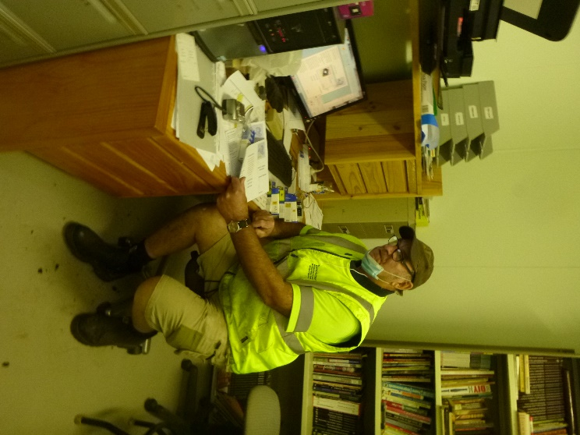

Dave sitting at his IT desk working on the web page.

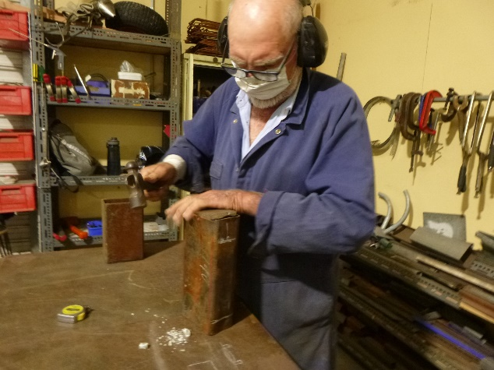

Bruce adjusting and strengthening his wood splitter.

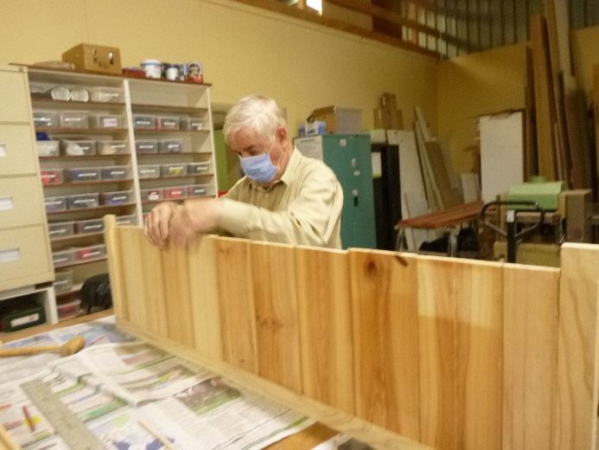

Believe it or not, this is not a wall, it is Dick making a boot box for one of his family members.

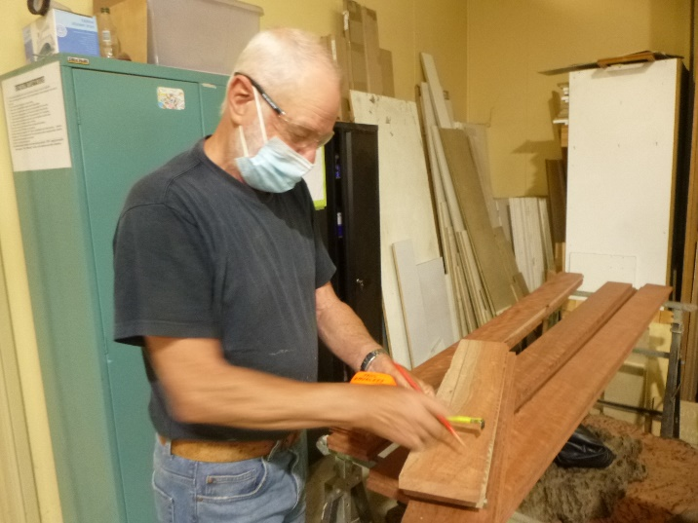

Herman measuring timber for his coffin he is making.

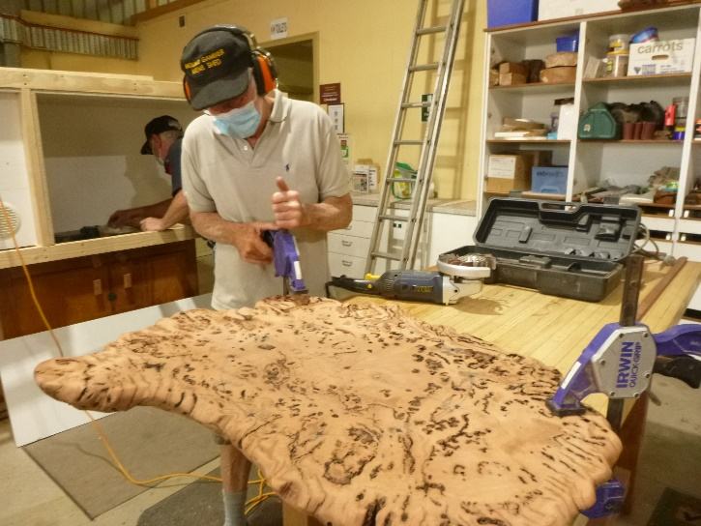

Don working on a burl for the shed clock face.

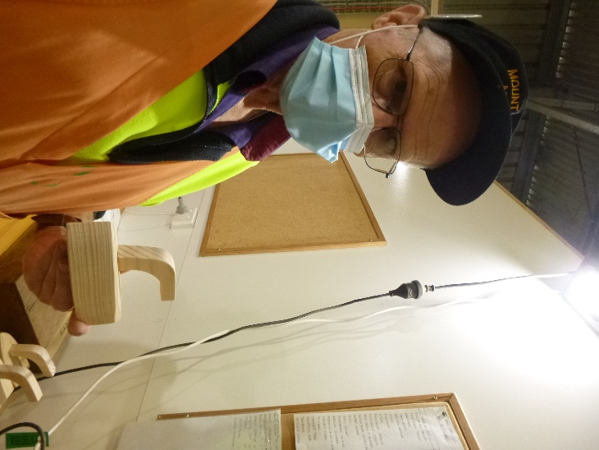

Ian B. inspecting his toy iron.

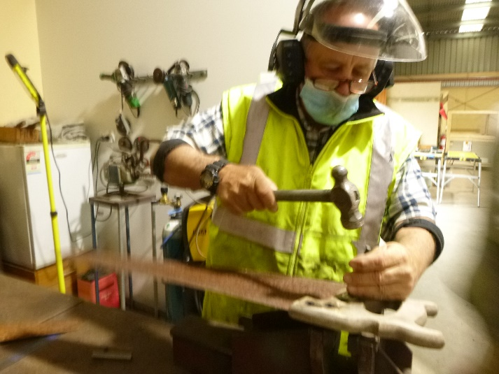

Ian A. refurbishing an old saw handle.

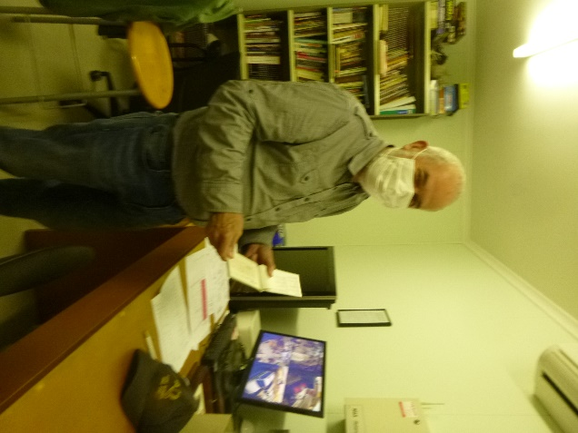

Secretary John going over tax invoices.

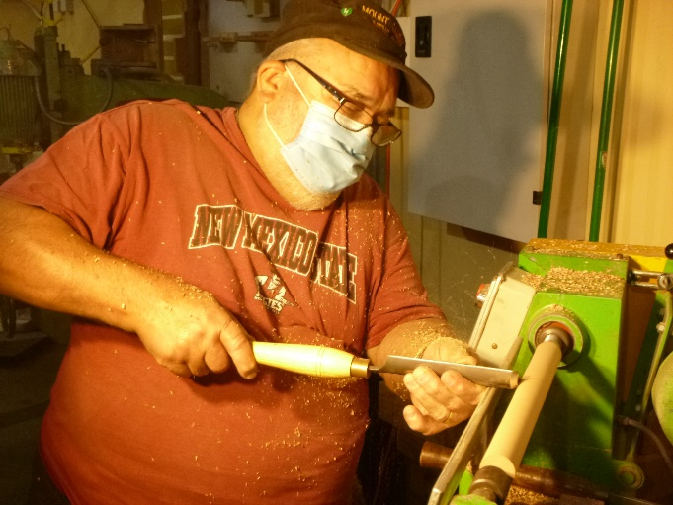

Laurie turning one of the many baseball bat trophies he is making.

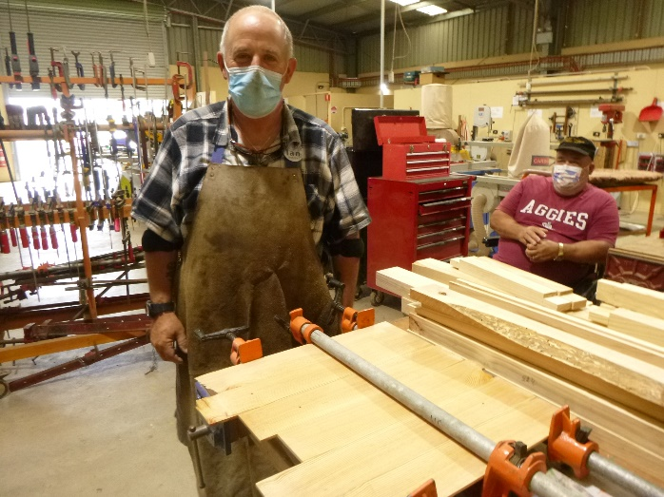

Ian A. joining timbers to make his three string guitar with Laurie in the background supervising something he knows nothing about.

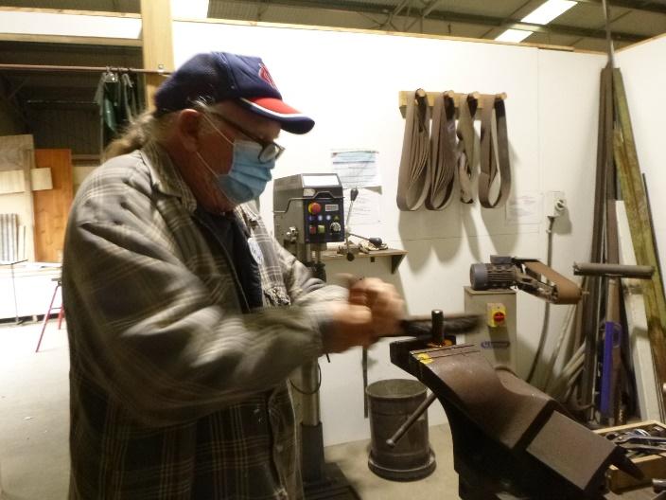

Matt brushing a tow-ball thread.

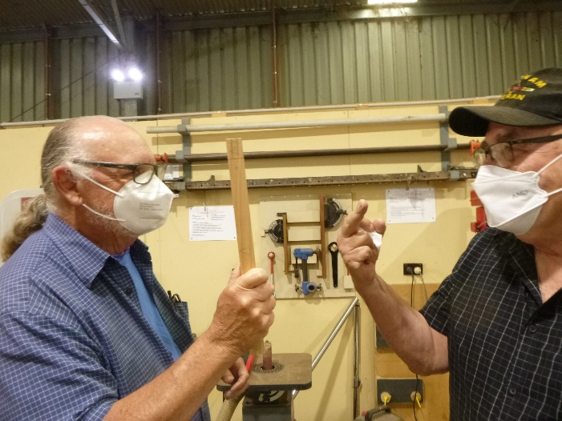

Matt and Ansi taking their friendly discussion/banter up a notch.

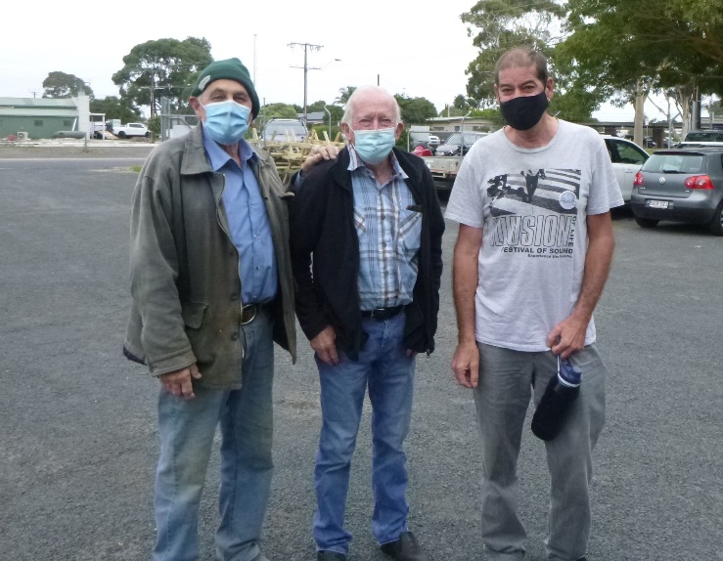

Not the three Tenors, but the three Trevor’s.

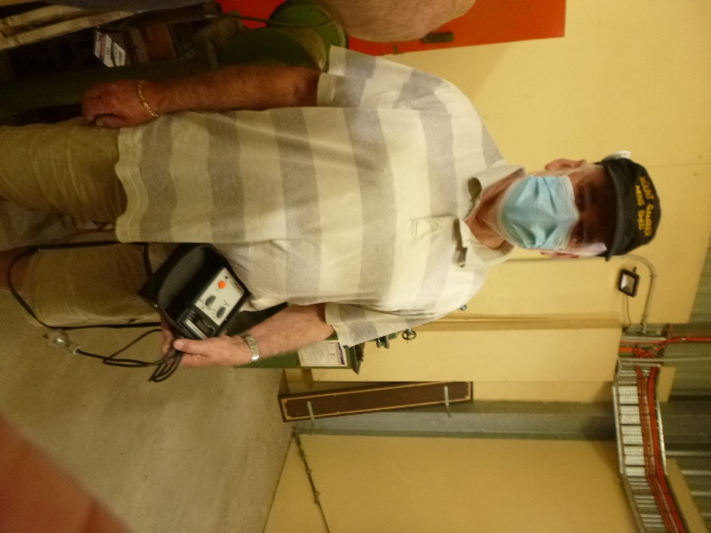

Rob with his electrical checking metre, keeping us all safe.

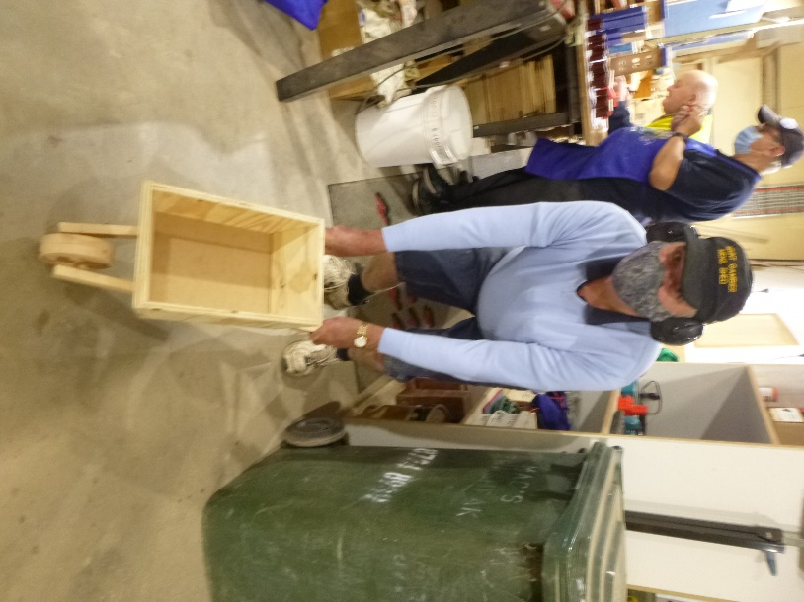

Peter with the new model wheelbarrow.

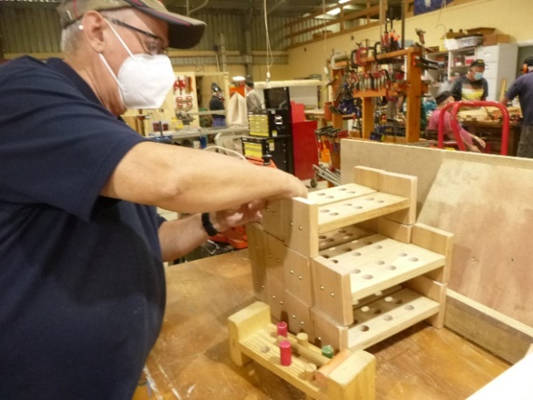

Shane constructing knock through toys.

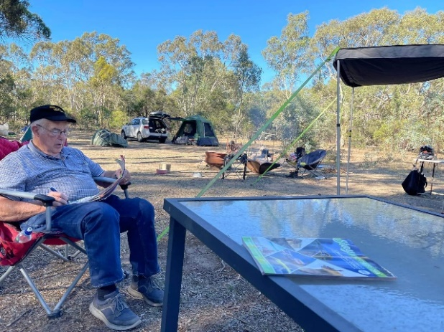

Not all good things happen at the shed as Rod, is showing on one of his camping trips to the Grampians.

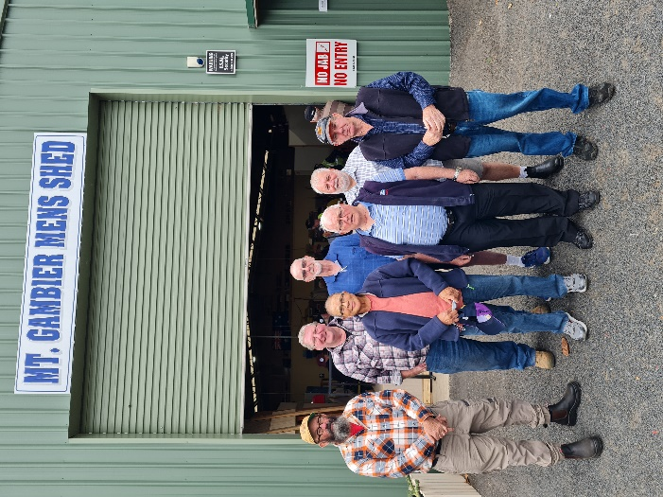

On the 31st March Mt Gambier Men’s Shed had the privilege of hosting the Casterton Men’s Shed for morning tea and BBQ lunch. I believe a good day was had by all.



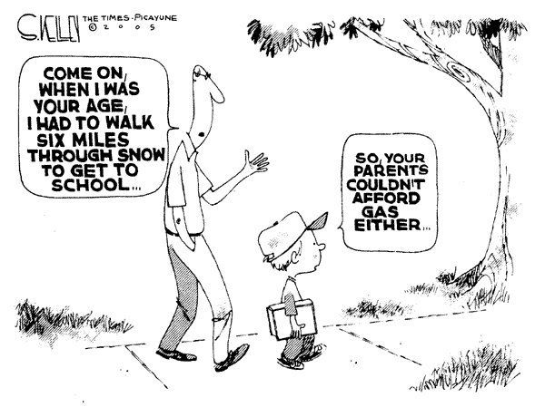





 





**Big supporters of Mount Gambier Mens Shed.**

**SUPPORT YOUR LOCAL BUSINESSES**

**THAT SUPPORT YOU.**