[mgmensshed@gmail.com](mailto:mgmensshed@gmail.com)

**EXECUTIVE MEMBERS FOR 2021**

**PRESIDENT**: Peter Halleday 0439500699

**VICE PRESIDENT**: Ian Bond

**TREASURER**: John Plunket

**SECRETARY**: Paul Edgeworth 0887256385

**FACEBOOK**

Shed broadcasts are now available on Facebook

*[Image result for facebook logo](https://www.google.com.au/url?sa=i&rct=j&q=&esrc=s&source=images&cd=&cad=rja&uact=8&ved=2ahUKEwjO9cWTtajeAhUafisKHT6JAHoQjRx6BAgBEAU&url=http://www.seacliffeinn.com/spa-boutique/find-us-on-facebook-logo/&psig=AOvVaw0duNjpvsqixE3Pzu1qEwe2&ust=1540791326821108)*

**Safety: - Remember Safety begins at home.**

**BIRTHDAYS**

David B 04/08

Don C 05/08

Paul E 07/08

Gary V 13/08

Don L 14/08

Rob B 23/08

Frank Mc A 23/08



**Remember Sugar ‘n Spice support our Men’s Shed with Birthday cakes, so support them where you can.**

 



**Thanks to Sharp Cranes and Steeline for supporting our Mens Shed.**





**Big supporters of Mount Gambier Mens Shed.**

**SUPPORT YOUR LOCAL BUSINESSES**

**THAT SUPPORT YOU.**

**DIARY DATES**: 2021

11th August Park Hotel dinner in dining room capacity of 25 only.

30th August – 5th September Men’s Health Week

21st September – 23rd September Spanner in the Works? Men's Health Checks, supported by Uncle Toby’s.

We are advised that Arthur Smith is no longer driving with his ongoing shoulder injuries.

Peter Halleday also advised the toilets could be cleaned only once a week, so it will be done on a Thursday.

**MEMBERS PROFILE:-**

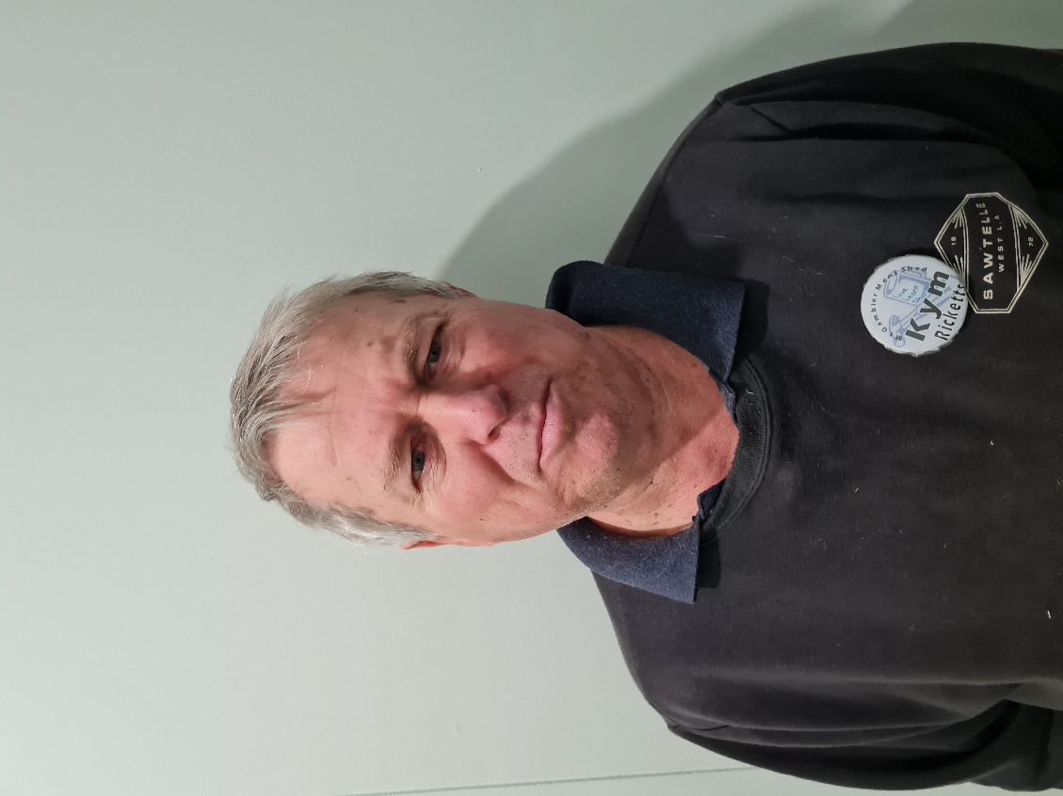

**NAME: -** Kim Rickets

**Where have you worked in your life: -** Navy, a Deli then 38yrs at Panel Board.

**Something about you that others at the shed don’t know: -** Does up old cars and makes wooden boats.

**What do you wish to achieve at the shed: -** Meet people as he is very shy.

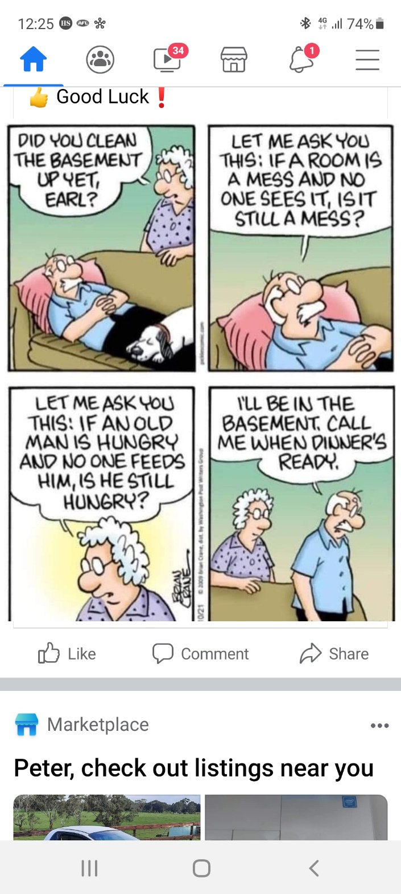



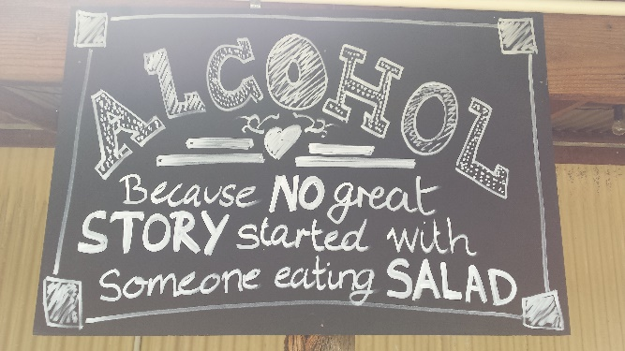



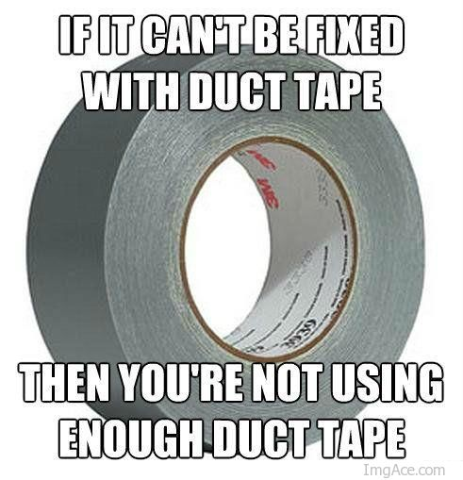

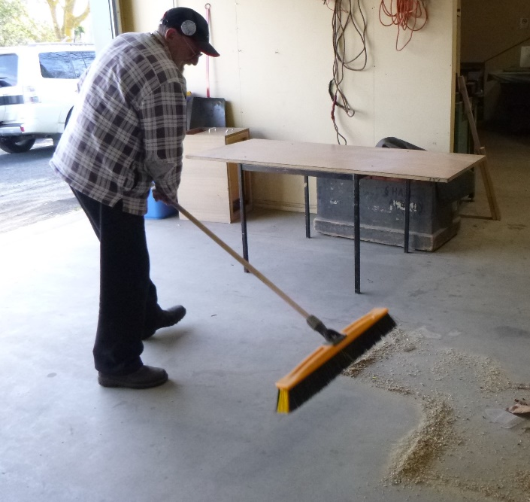

Frank McA one of this month’s birthday boys tidying up after a little job he was working on.

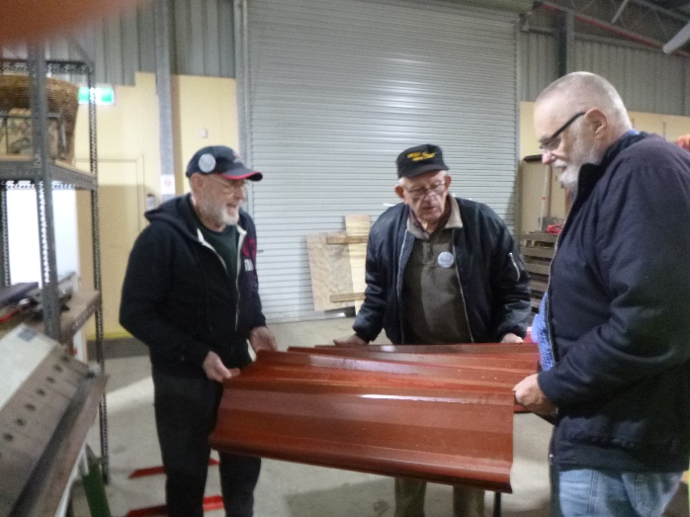

Frank, Dave N and Jeff working on one of the raised garden beds.

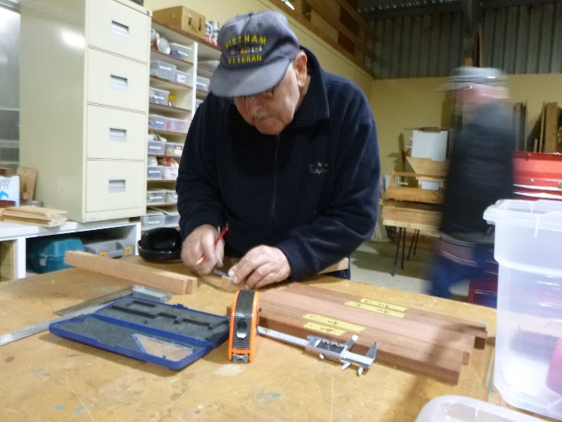

Ansi measuring timber pieces so he can make a bread board.

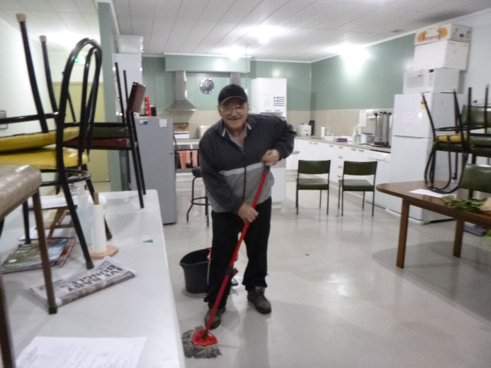

Ben after making the days scones decided to keep busy and mopped the floor, so versatile.

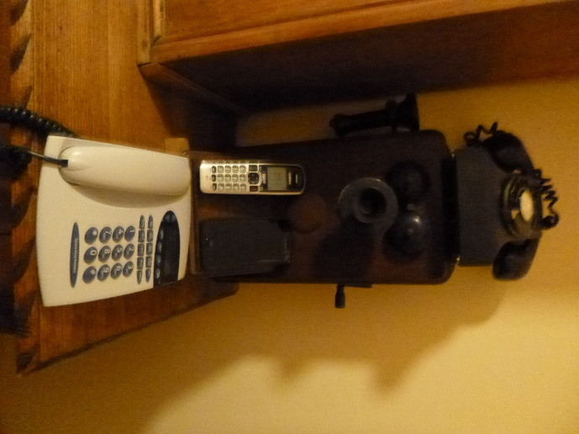

Keep the communications going during lockdown with whatever phone you now have

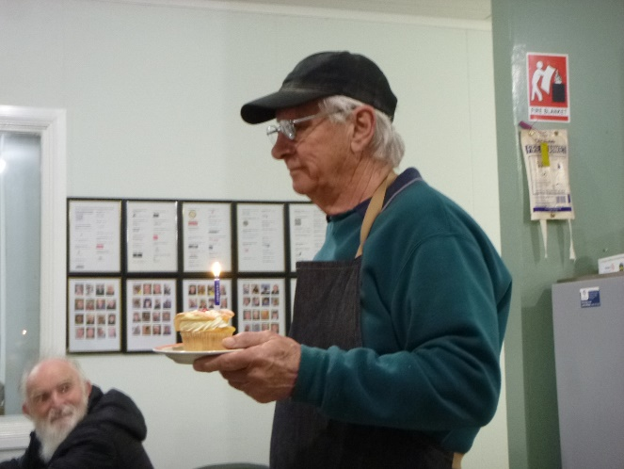

Geoff delivering one of the birthday cakes donated by *Sugar ‘n Spice* to the lucky birthday boy.

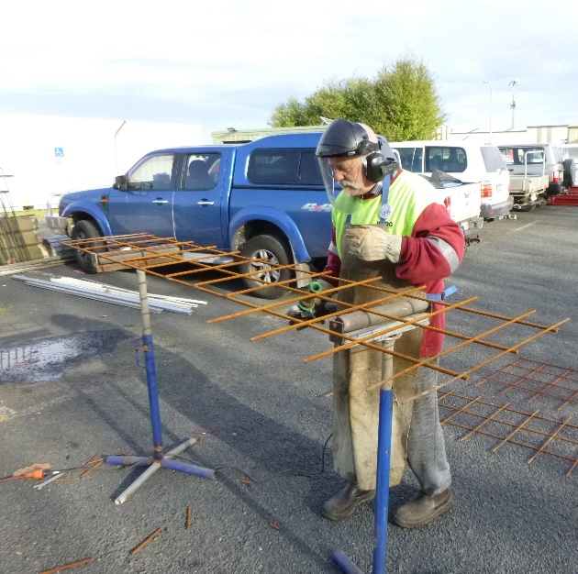

Ian decided cutting up this mesh was too noisy inside. Thanks for thinking of everyone else with the noise.

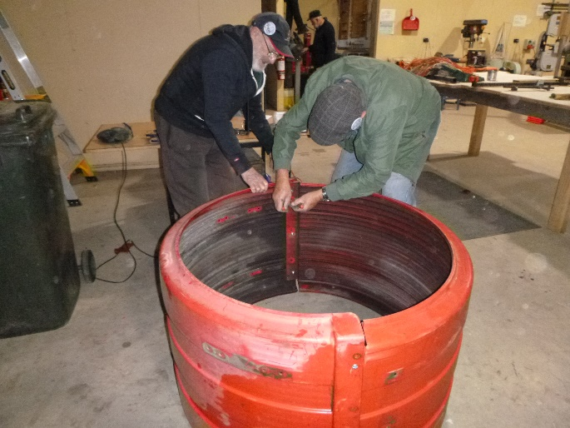

A different version of our raised garden beds being made.

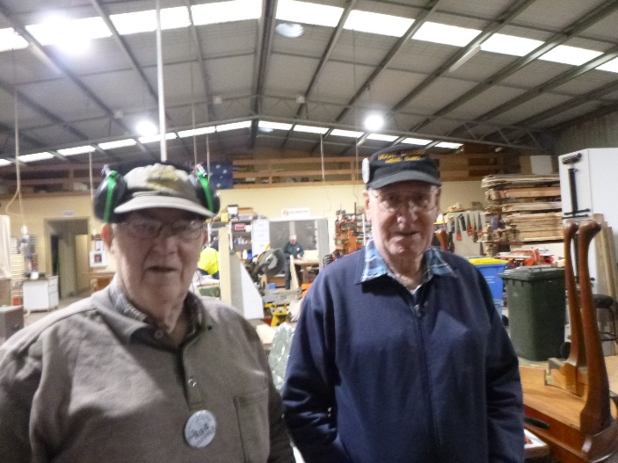

Couple of old mates Rod and Don catching up.

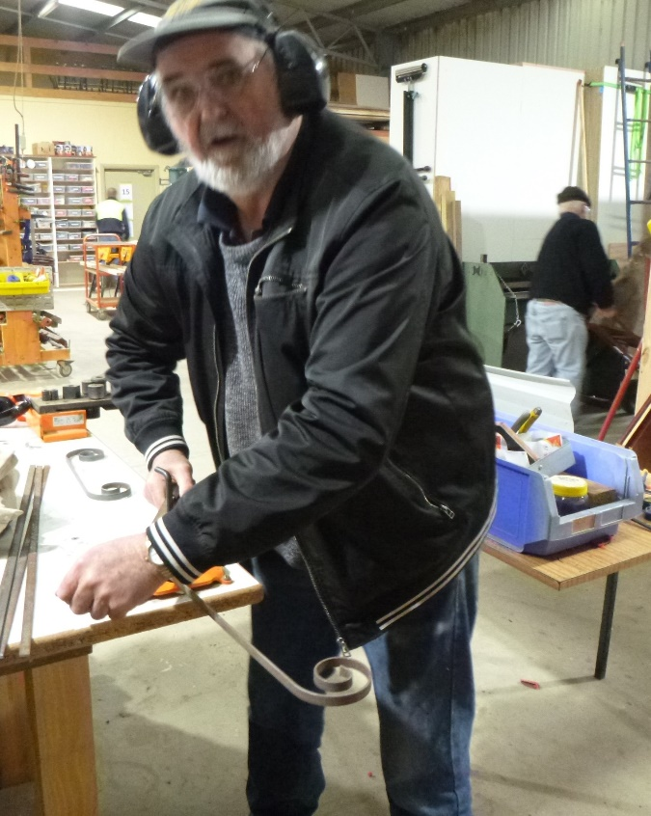

Oh Bugger! I (Peter) finally got caught doing some work on the metal bender.

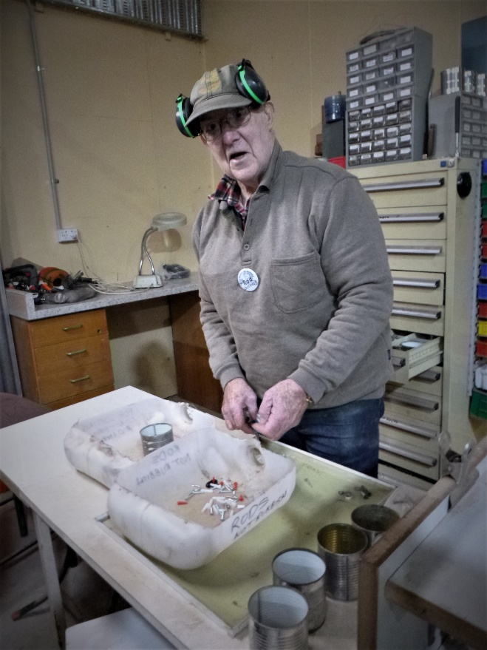

Rod sorting out our nuts and bolts we have had donated to us.

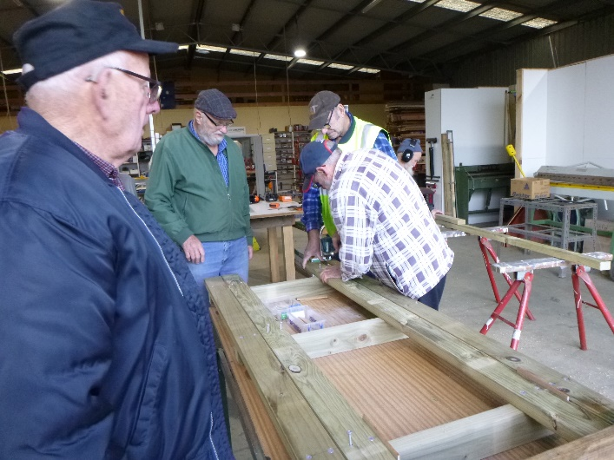

Dave, Jeff, Dave and Frank working on an outdoor picnic setting.

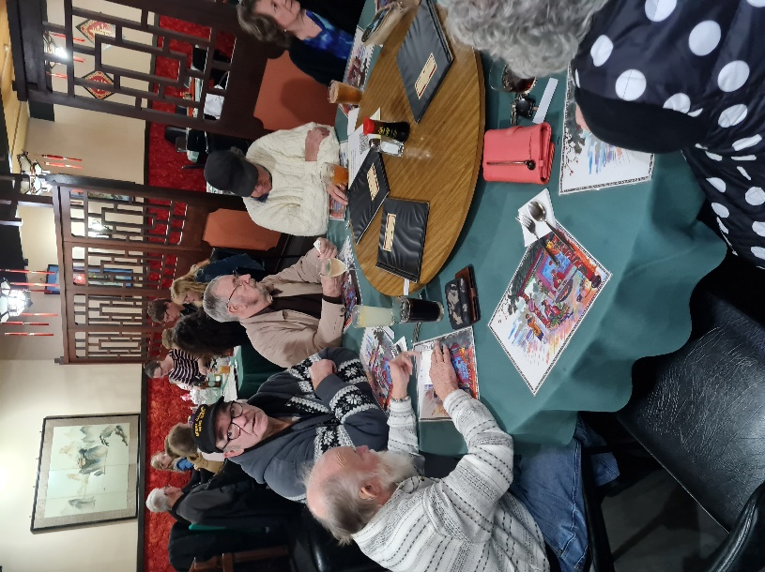

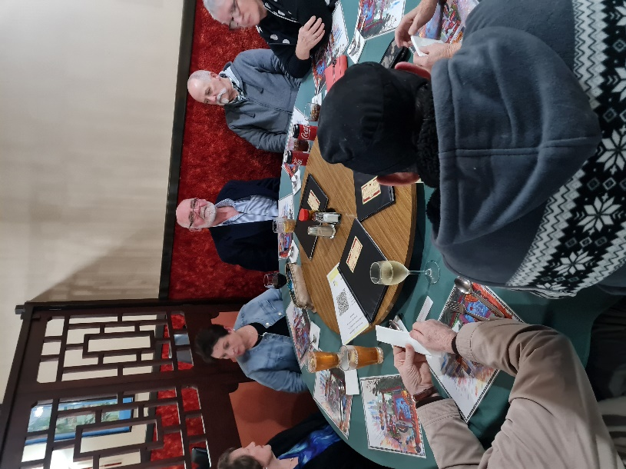

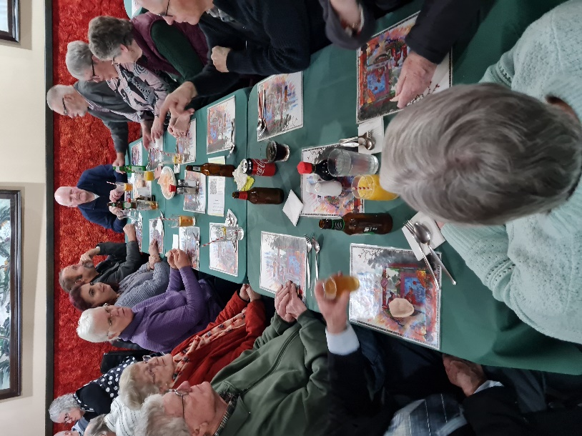

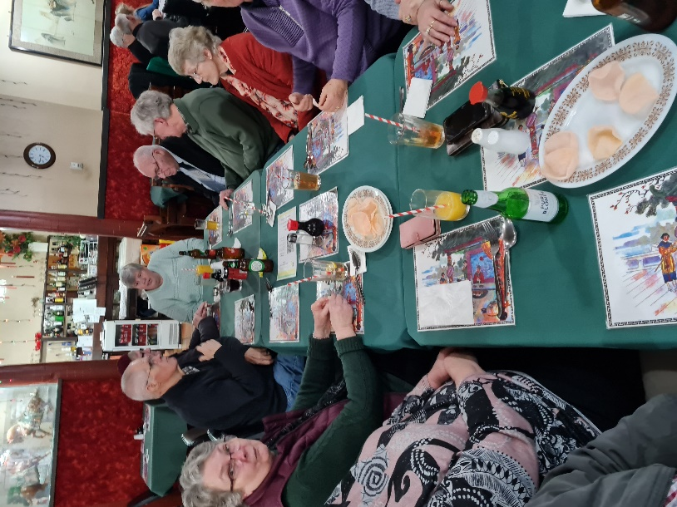

Last 4 pictures are showing the shed members and partners’ tea at the Golden Chopsticks - a Chinese dinner.

