**EXECUTIVE MEMBERS FOR 2023**

**PRESIDENT**: Ian Bond 0420859540

**VICE PRESIDENT**: Grant Sullivan

**TREASURER**: John Plunkett

**SECRETARY**: Paul Edgeworth 0497386846

**PHONE**: 0478614027 (prefer Tuesday and Thursday am)

**Open Tuesday, Wednesday & Thursday** 9am– 12pm **1a McDonnell Drive**

Website [www.mgmensshed.com.au](http://www.mgmensshed.com.au)

FacebookMens Shed Mount Gambier

Email [mgmensshed@gmail.com](mailto:mgmensshed@gmail.com)

**BIRTHDAYS**

Alan R 11/11

Grant S 17/11

Geoff H 19/11

Graham R 21/11

Dale A 24/11

Bert S 27/11

Graham T 28/11

**CALENDAR - November**

Wednesday 8th 6.30pm Shedder& partners tea

at Jens Hotel, 40 Commercial Street East

Thursday 9th 10.30am Members Meeting

Tuesday 28th 10.30am Committee Meeting

Thursday 30th  11.30am BBQ lunch with partners

for Barry Day

If you would like to contribute information or an article to your newsletter, talk to Editor David N or email [mgmensshed@gmail.com](mailto:mgmensshed@gmail.com)

Our thoughts are with Russell Smith on the death of his brother late last month.

**10. Block Plane**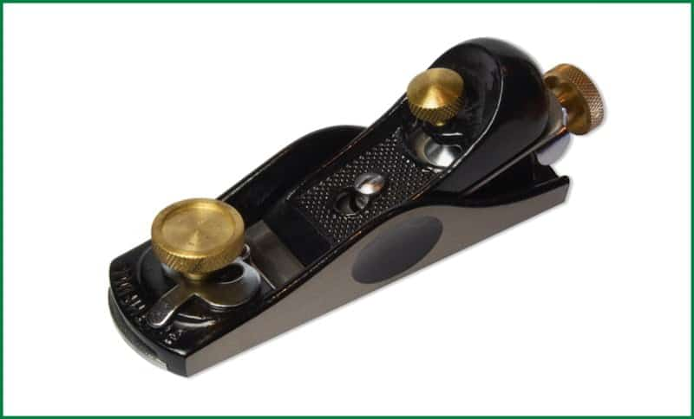

A block plane is a wooden device made for manual use. It has a blade embedded in the bottom of the wooden frame. The blade is like a chisel that consists of the bevel on one side and plane on the other. In a typical block plane, the bevel side remains up leaving the flat part on the down. The angles must be tuned properly to make necessary cuts. The ergonomic structure makes it very handy to use.

**Uses of Block Plane**

The block planes are used for giving a finishing touch to the completed work. It can cut end grains to give a smooth finish. With this tool, shallow cuts can be made having smaller angles.



Advance notice – planning so far

**MENS SHED CLUSTER**

**HEALTH and INFORMATION DAY**

**THURSDAY 16TH MAY 2024**

**10am to 3pm (SA time)**

**A SHED SHARING FORUM**

**SPEAKERS:**

**MATTIAS WICHMANN** (MD) **–- a light hearted and** informative session about **‘gut health and issues’**

**IAN LEWIS – the only cave diving, hydrogeologist in Australia**

Illustrated topics include–a fascinating expose on the unique geological formations in SW Victoria and the SE South Australia: fault lines, volcanoes, caves, sinkholes

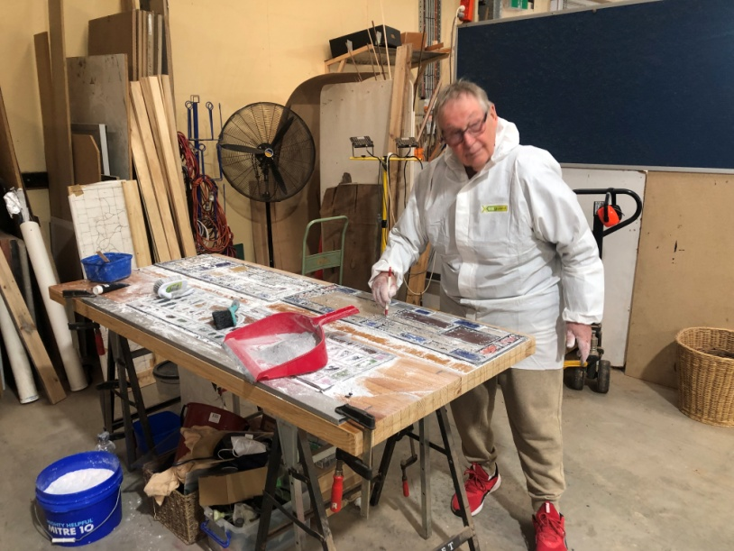

Graham preparing leadlight glass above

Finished project below

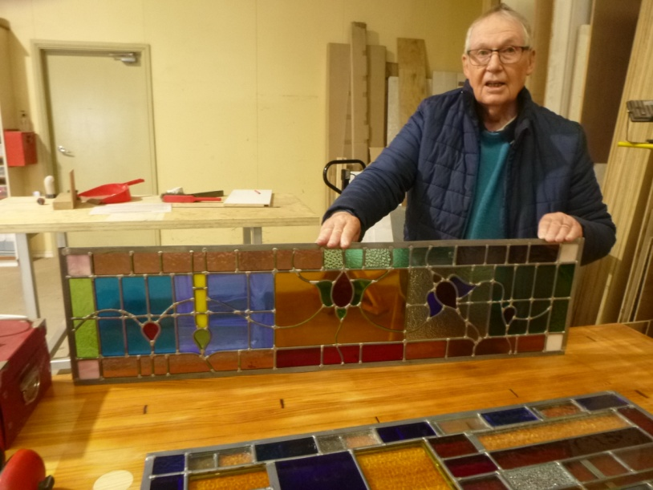

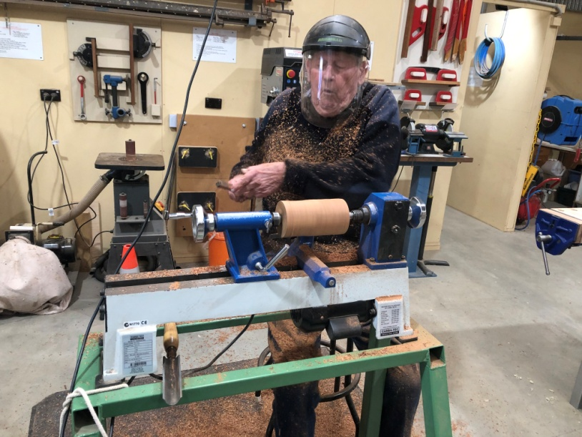

Ian covered in woodchips at the lathe

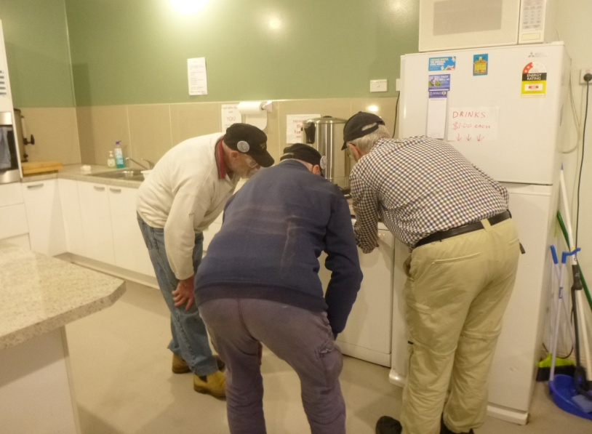

Frank, Don & Graham - How do you start a dishwasher?

Recently the Mount Gambier Men’s Shed donated $300 to the local South East Prostate Cancer Support Group as part of the Prostate Awareness week.

Vice President Grant Sullivan handed over the cheque to Southeast Prostate Support Group representatives Richard Harry and Brian Hueppauff. The Mount Gambier Shed decided to make this gesture as they support men’s health initiatives and this is one close to their hearts.

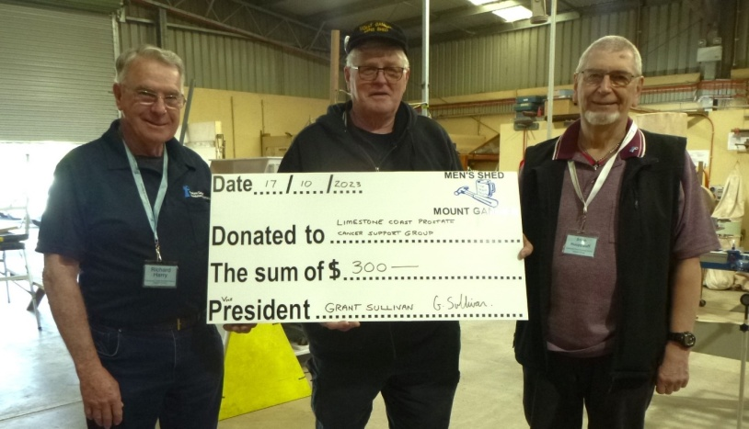

When life gives you lemons . . .

make an easy **Lemon Slice**

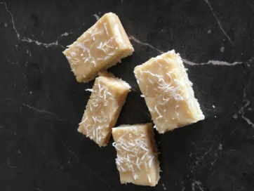

Grease and line an 18cm x 28cm rectangular slice pan.

Preheat oven to 160oC fan forced or 180oC

Mix together 340g packet vanilla cake mix, 1 cup coconut, 125g melted butter and zest of 1 lemon. Press over base of prepared pan. Bake for 10 minutes. Remove from oven and cool for 10 minutes. Stir 2/3 cup lemon juice into 395g can of condensed milk. Spread over base. Sprinkle with extra coconut. Bake 15 minutes or until filling has set. Cool, refrigerate for 3 hours.

Cut into rectangles. *Editor’s note - Delicious*

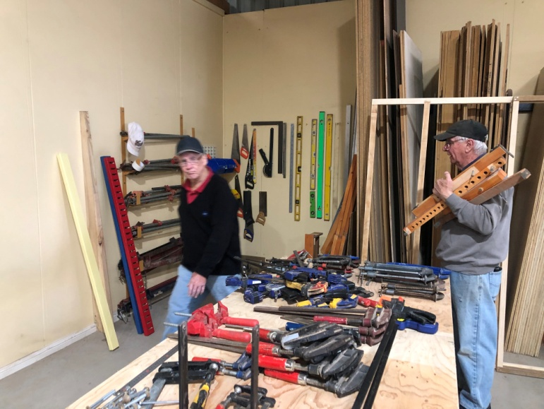

Tim & Geoff reorganising the clamps

If you’re ever worried that a woodworker might be going insane,  
just ask him if he has too many clamps.

If he says yes, get help immediately.

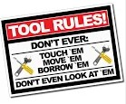

**The journey of a thousand miles . . . begins with a broken fan belt and a flat tyre.**

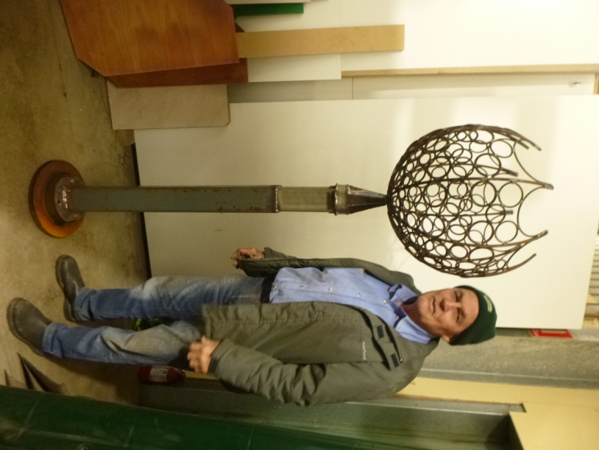

Trevor’s finished garden feature made from recycled metals

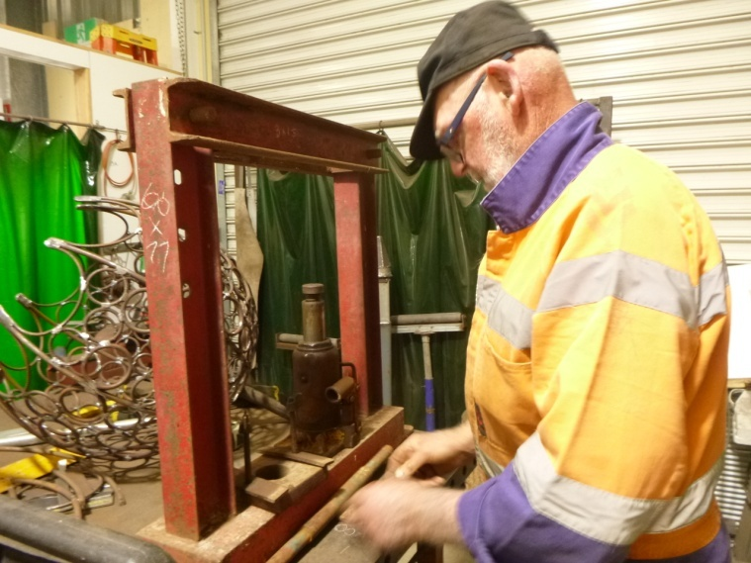

Bruce constructing a hydraulic press

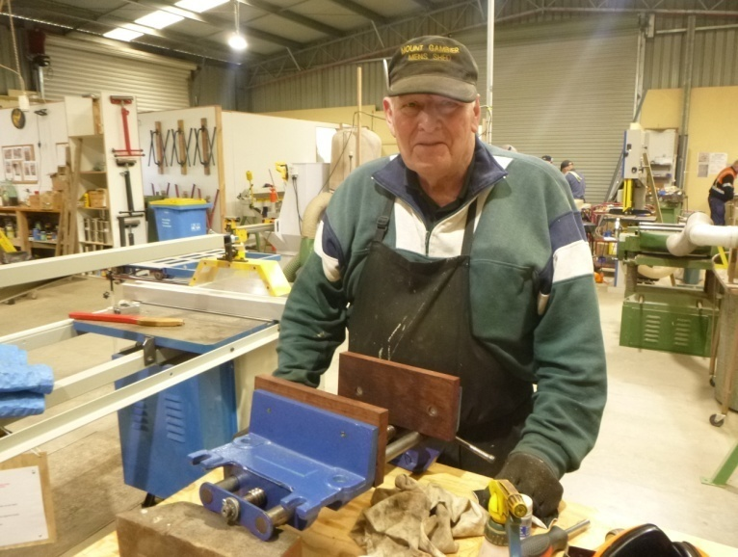

Alan fitting modified vices to new benches

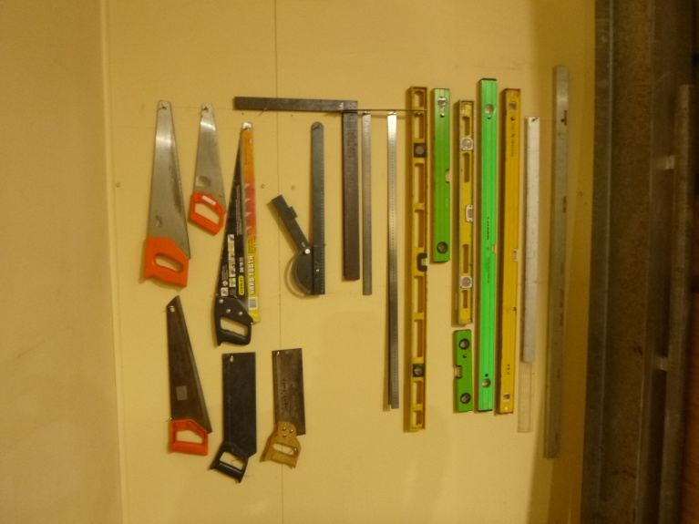

Utilising space better – a shadow board made by Geoff

Peter asked his granddaughter to pass him the newspaper.

“Oh, come on, Grandpa,” she said. “Nobody reads print anymore. Here, just use my laptop.”

He shrugged.

The fly on the workbench never saw it coming.

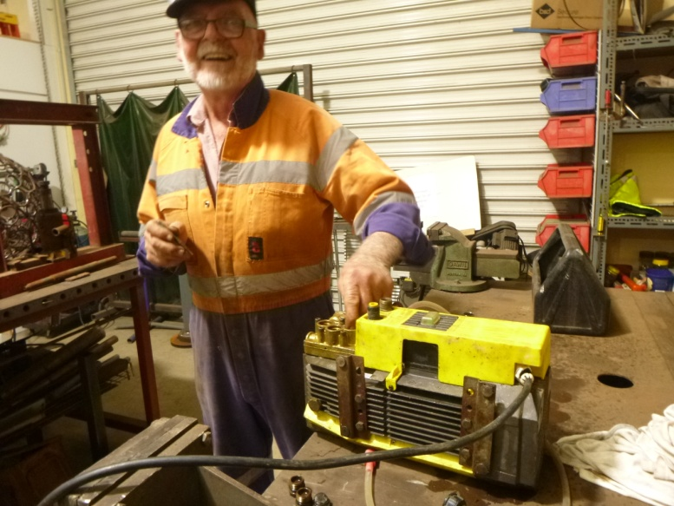

Bruce repairing an electric pump



**SPONSORS**











**Big supporters of Mount Gambier Mens Shed**

**SUPPORT OUR LOCAL BUSINESSES**

**THAT SUPPORT YOU**