**EXECUTIVE MEMBERS FOR 2023**

**PRESIDENT**: Ian Bond 0420859540

**VICE PRESIDENT**: Grant Sullivan

**TREASURER**: John Plunkett

**SECRETARY**: Paul Edgeworth 0497386846

**PHONE**: 0478614027 (prefer Tuesday and Thursday am.)

**WE NOW HAVE A WEB SITE FOR THOSE WHO WISH TO LOOK. THIS WILL BE UPDATED FROM TIME TO TIME WITH NEW PHOTOS, NEWSLETTERS, RADIO REPORTS,CONTACTS AS WELL AS UPCOMING EVENTS AT THE SHED. Go to**

[**www.mgmensshed.com.au**](http://www.mgmensshed.com.au)

**FACEBOOK**Mens Shed Mount Gambier

[mgmensshed@gmail.com](mailto:mgmensshed@gmail.com)

**BIRTHDAYS**

Bill McG 17/07

Jim T 27/07

David L 28/07

Shane S 28/07

**2023 Calendar**

Wednesday 6.30Shedder and partners tea

Thursday 10.30Members Meeting

Tuesday 10.30Management Meeting

Thursday 10.30Members Meeting

**6. Measuring Tape**

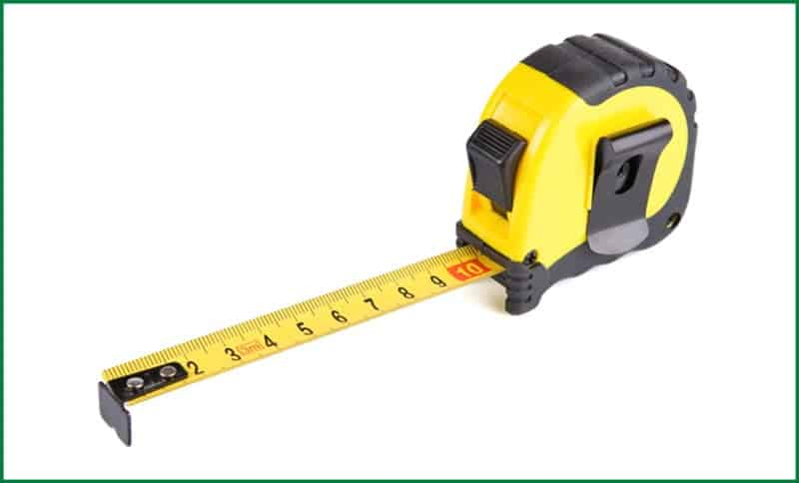

Measuring tape is a flexible scaling instrument. These might come in different forms, but all have the same purpose of measuring. There are measuring tapes of the metal strip, plastic, ribbon, polymer and others. All of them have a linear scaling mark in it.

Different measuring tapes have different scaling system. Some come in inches, some in meter or millimeter and some also have a combination of all. The length of the tape also makes a difference. The most famous tape among the woodworkers is the self-retracting spring mechanism metal tapes. They come in cases.

**Uses of Measuring Tape**

The measuring tape is the most common measuring tool used for measuring the length of the woods and cuts in woodworking. It is used in everyday work for delivering precise measurements.**RECIEPE:-**

**CRUNCHY CHOCOLATE BARS**





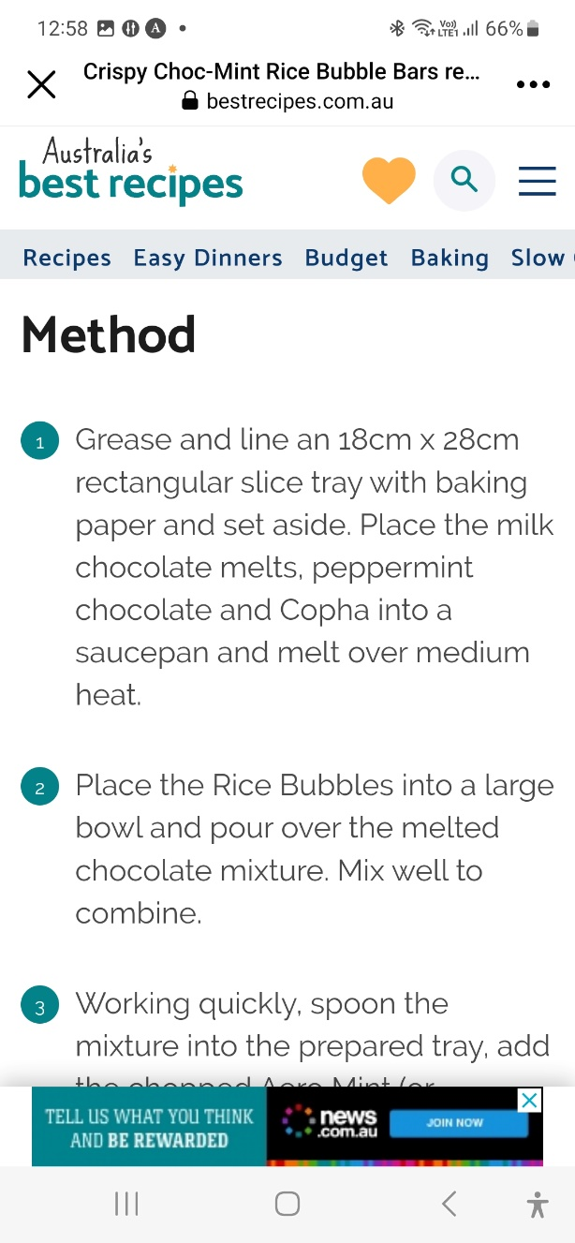

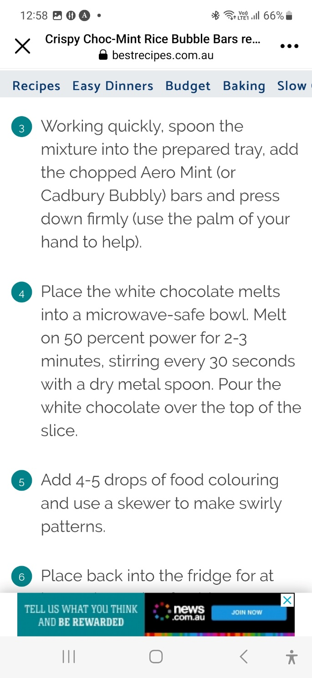



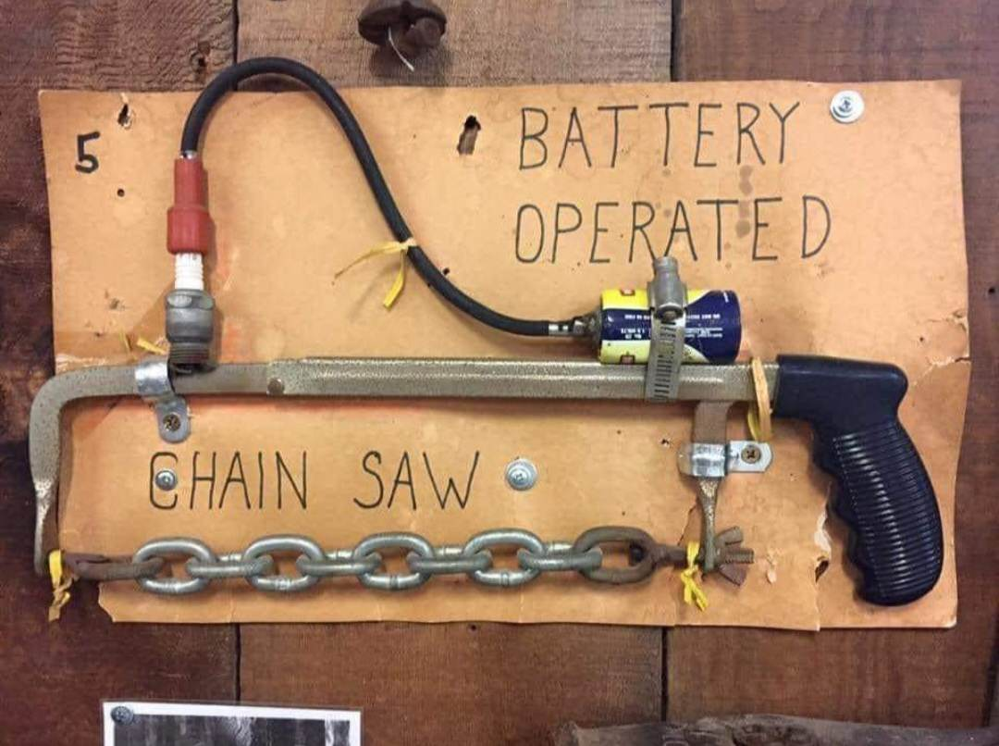

**PROFILE**



**Name** John Ditcham

**Where have you worked**  maintenance carpenter for S  Government and as a carpenter handyman for himself also as a driving instructor.

**Something about you no one at the shed knows**. Taught first aid all over the southeast, does a lot of volunteer work around Mt gambie and spent 1 month recently in Antarctica.

**What do you wish to achieve at the shed**. Come down and talk and help anyone where possible.

**PROFILE**



**Name** Graham Thomas

**Where have you worked**  Graphic designenvelope manufacturing company for 35 yrs.

**Something about you no one at the shed knows**. Lead light design and work.

**What do you wish to achieve at the shed**. Wood lathe making thigs and painting.

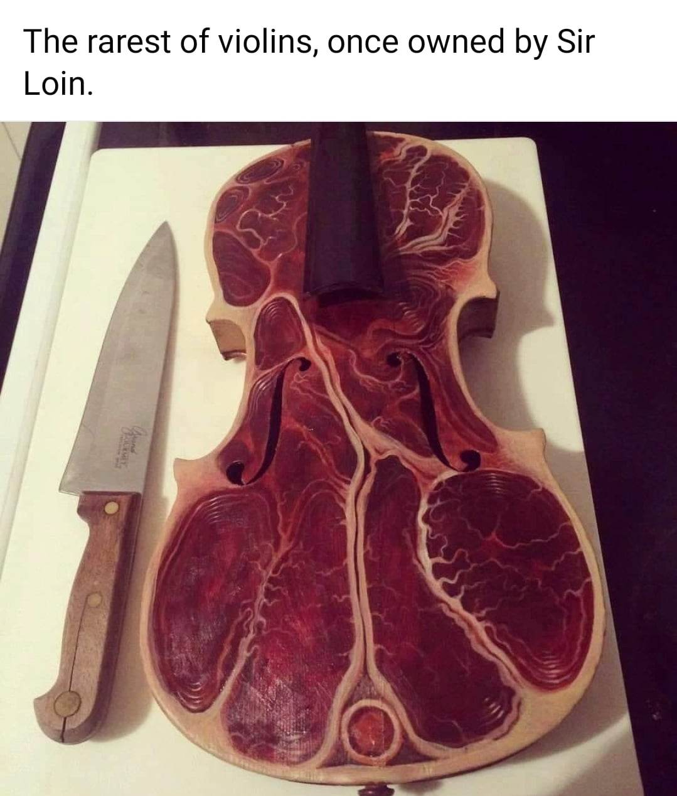

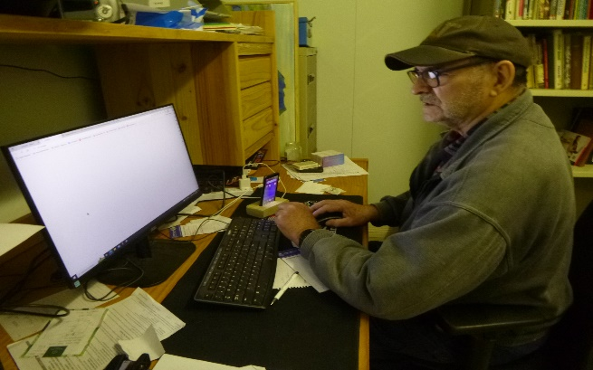

David L.working in the office.

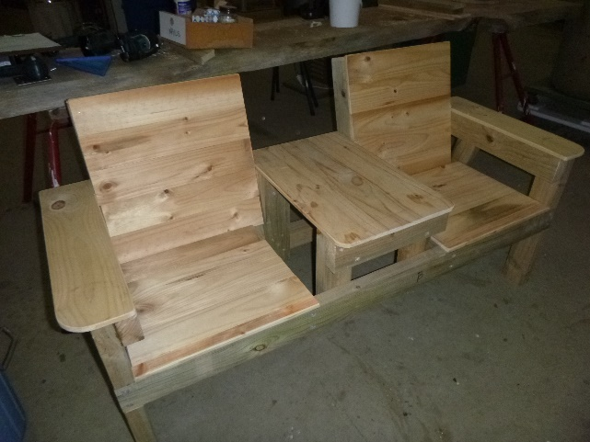

New seating design developed by Jeff and his team.

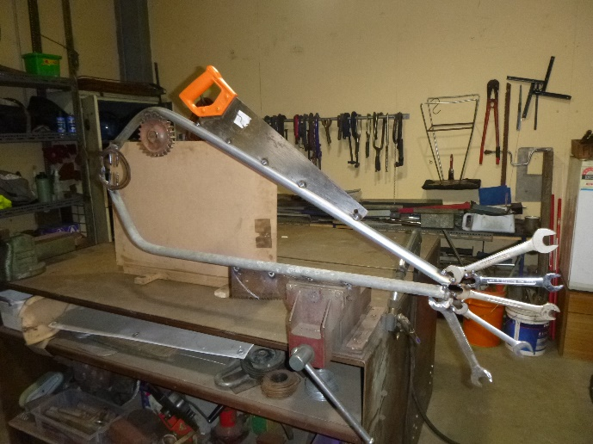

A swordfish made by Ian out of bits and pieces.

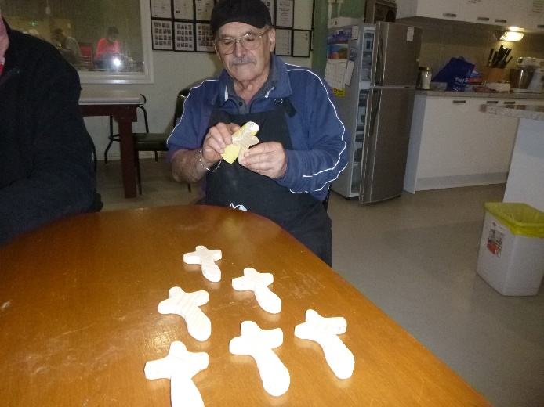

Ben sanding Crosses for Pallative care.

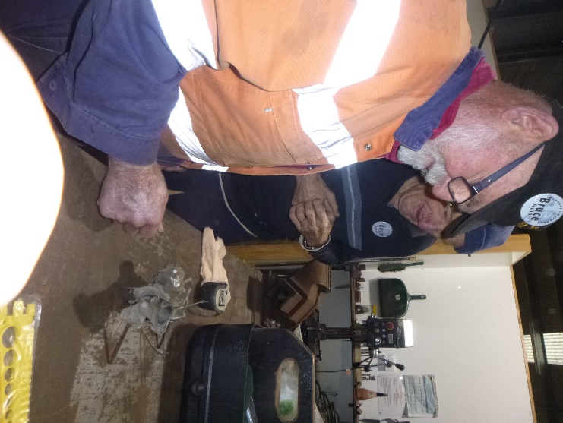

Bruce working on a Carbi while Kevin watches on.

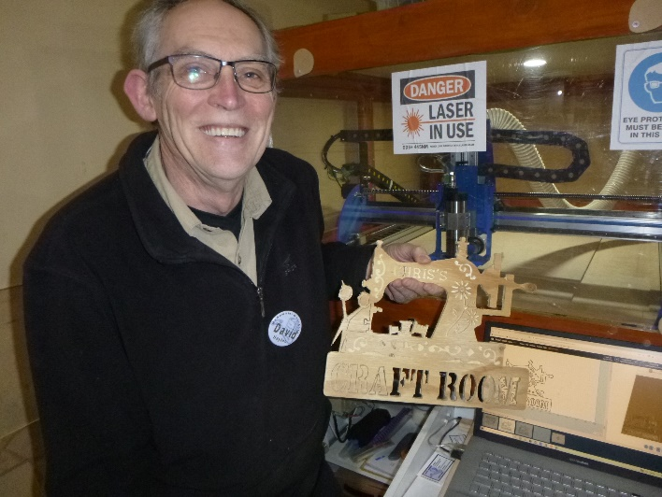

David.H. showing what can be don with the CNC machine.

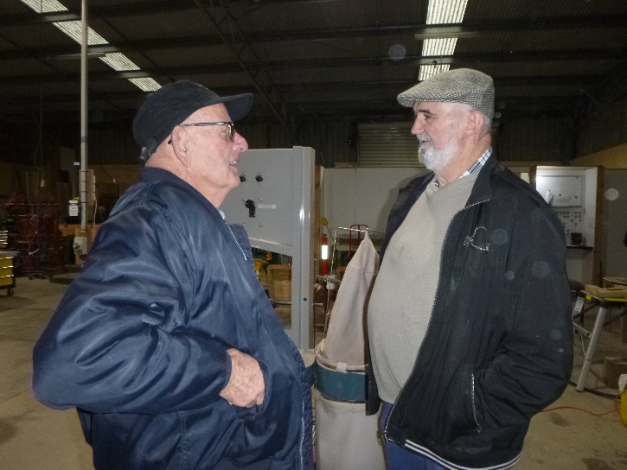

The old and the new. Editors talking shop.

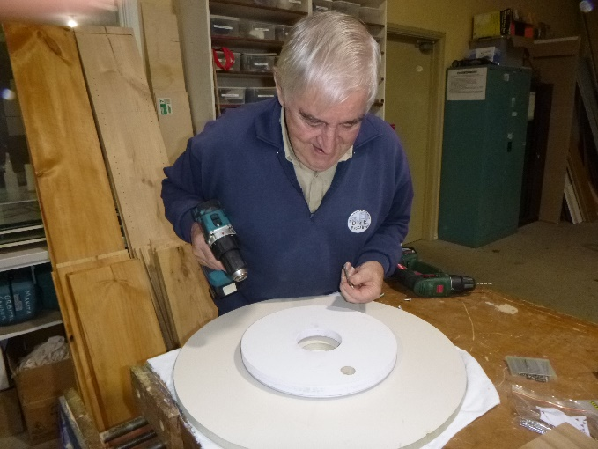

Dick making a lazy suzan. Don’t know who suzan it but must have been very lazy.

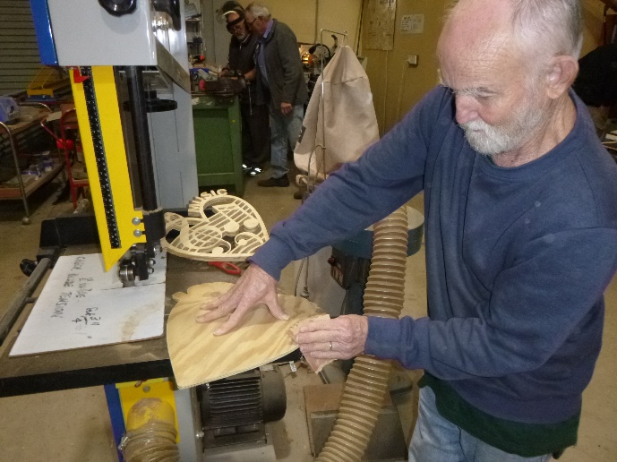

Glen sanding up the backing for his Music design cut on the CNC.

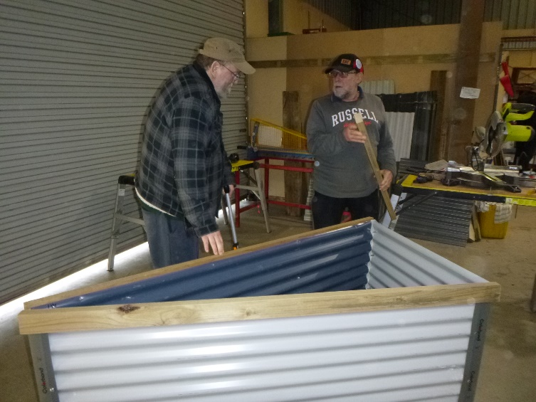

Showing rectangle garden beds are not always the norm this one is triangle.

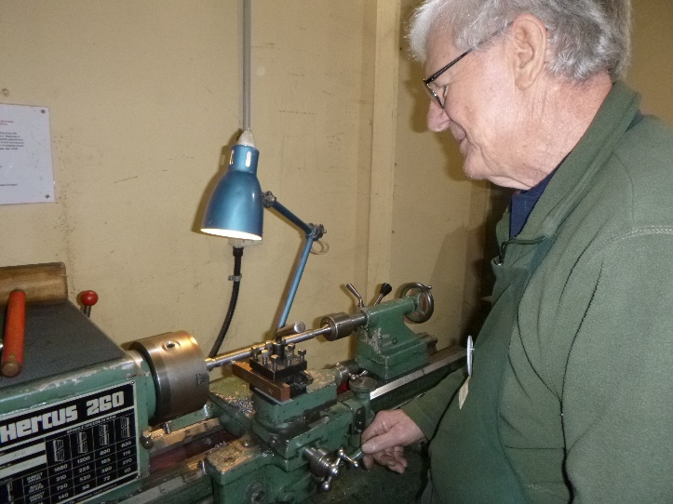

Jim making something on the metal lathe.

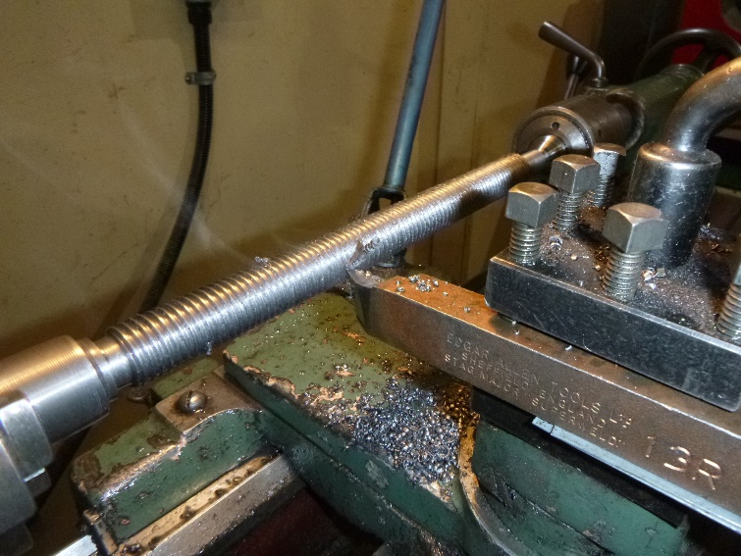

The end result of Jims work.

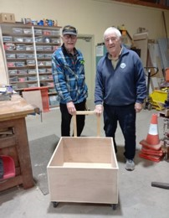

Ray and Dick showing the trolley for Ridoch Gallery’s floor jigsaw.

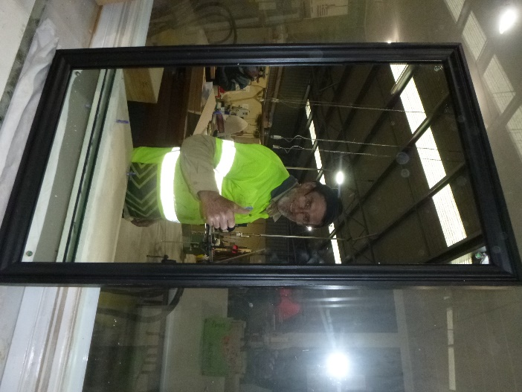

Ron the preety boy looking at his picture again in the mirror he has mnade.

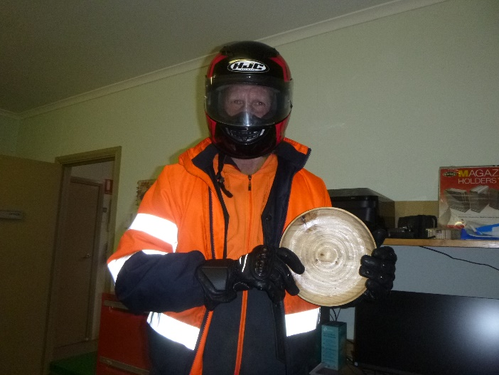

Russell is hiding under his PPE after making his wooden bowl.

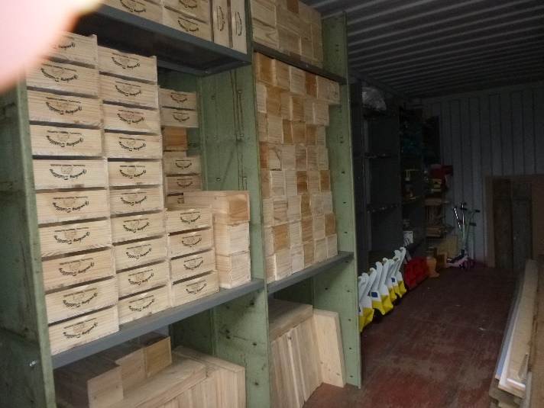

Some of the timber products donated from Bedford Industries.









**Big supporters of Mount Gambier Mens Shed.**

**SUPPORT YOUR LOCAL BUSINESSES**

**THAT SUPPORT YOU.**