[mgmensshed@gmail.com](mailto:mgmensshed@gmail.com)

**EXECUTIVE MEMBERS FOR 2021**

**PRESIDENT**: Peter Halleday 0439500699

**VICE PRESIDENT**: Ian Bond

**TREASURER**: John Plunket

**SECRETARY**: Paul Edgeworth 0887256385

**FACEBOOK**

Shed broadcasts are now available on Facebook

*[Image result for facebook logo](https://www.google.com.au/url?sa=i&rct=j&q=&esrc=s&source=images&cd=&cad=rja&uact=8&ved=2ahUKEwjO9cWTtajeAhUafisKHT6JAHoQjRx6BAgBEAU&url=http://www.seacliffeinn.com/spa-boutique/find-us-on-facebook-logo/&psig=AOvVaw0duNjpvsqixE3Pzu1qEwe2&ust=1540791326821108)*

**Safety: - Remember Safety begins at home.**

**BIRTHDAY”S**

Glen Bowmer 05/06

Andrew King 05/06

Mat James 10/06

Allan Compton 14/06

David Norton 22/06

Graham Portis 27/06

Dick Passauer 29/06

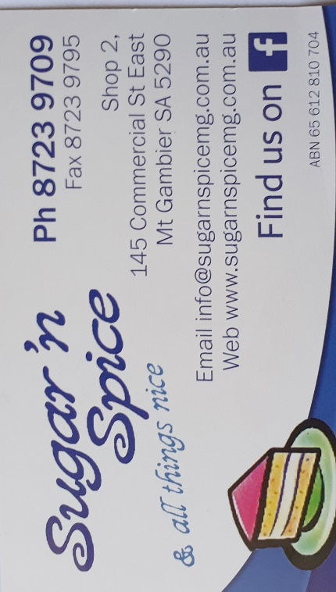

**Remember Sugar ‘n Spice support our Men’s Shed with Birthday cakes, so support them where you can.**

 

**While mentioning our supporters always remember how much Bunnings help our shed, so support them, as well, when you need a product that they can supply for you.**



**Thanks to Sharp Cranes and Steeline for supporting our Mens Shed.**

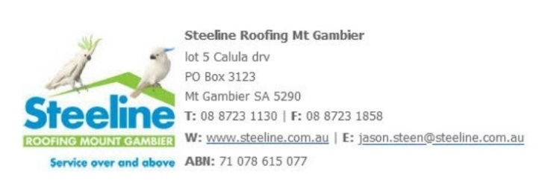



**A big supporter of Mount Gambier Mens Shed.**



**SUPPORT YOUR LOCAL BUSINESSES**

**THAT SUPPORT YOU.**

**DIARY DATES**: 2021

9th June Wednesday 6.30 Tea with partners – Commercial Hotel

10th June Thursday 10.15 Members Meeting

24th June Thursday 10.15 Management Committee meeting

**MEMBERS PROFILE:-**

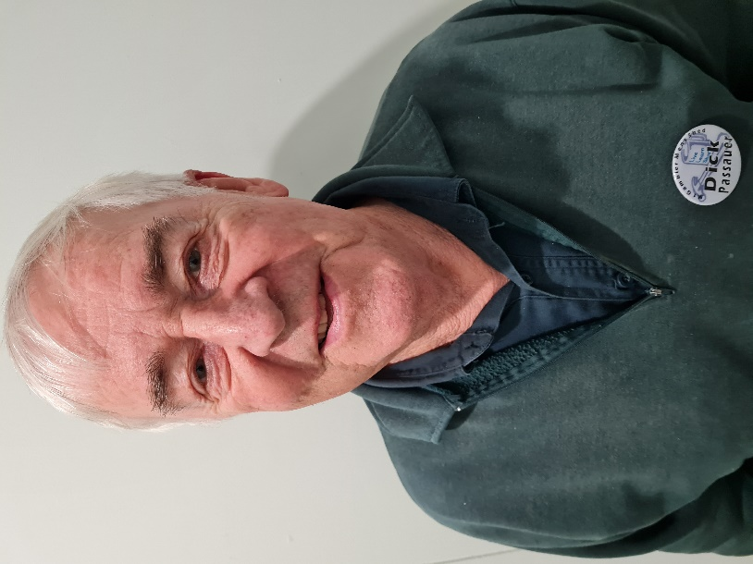

**NAME: -** Dick Passauer

**Where have you worked in your life: -** Forestry and Timber all over Australia.

**Something about you that others at the shed don’t know: -** Born not far from London during the Blitz. Plays bridge 3 times a week.

**What do you wish to achieve at the shed: -** Learn skills in timber and social interaction.

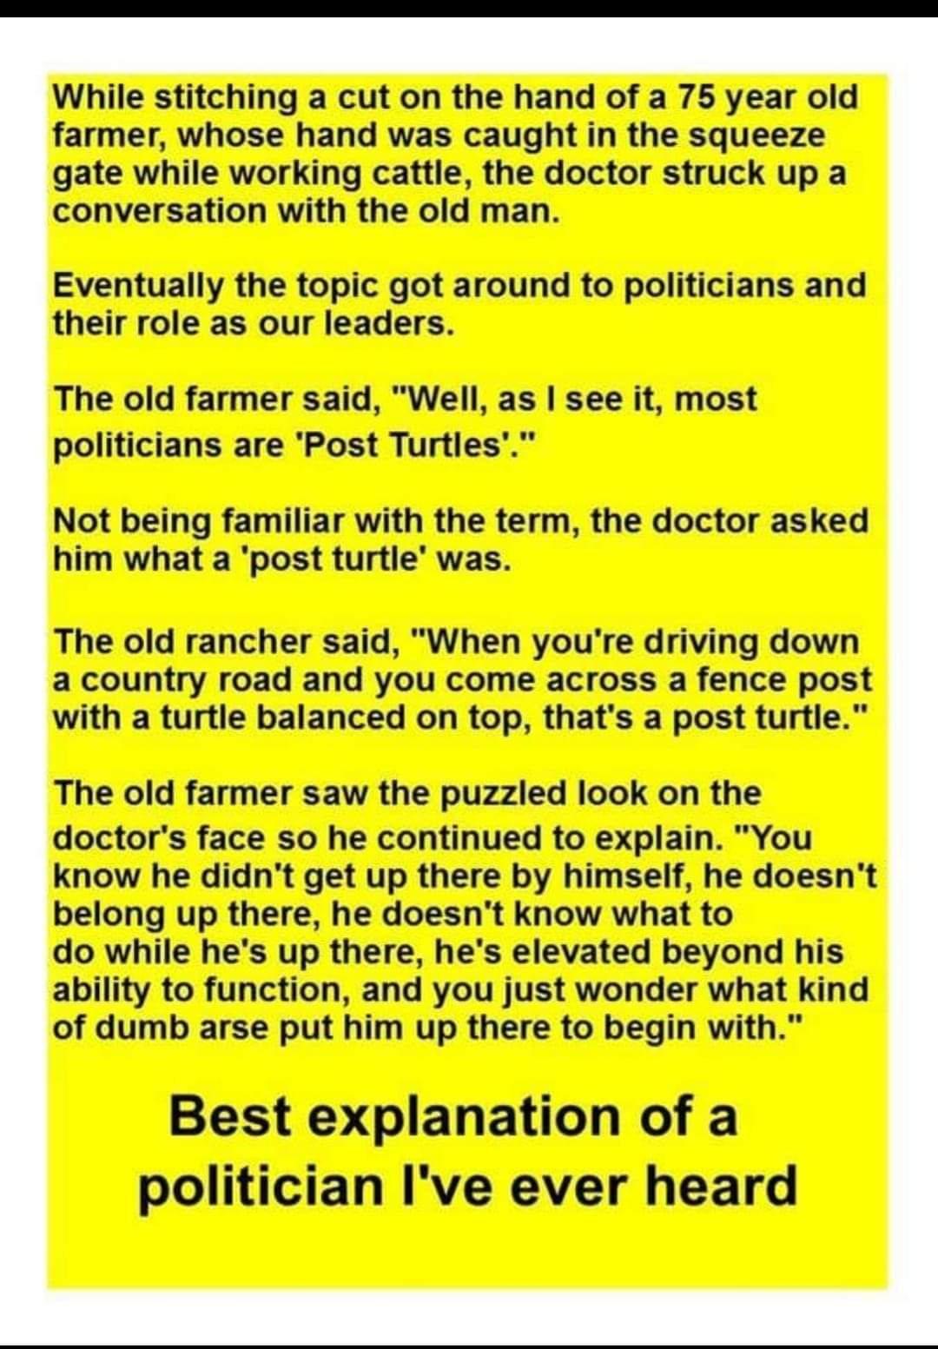

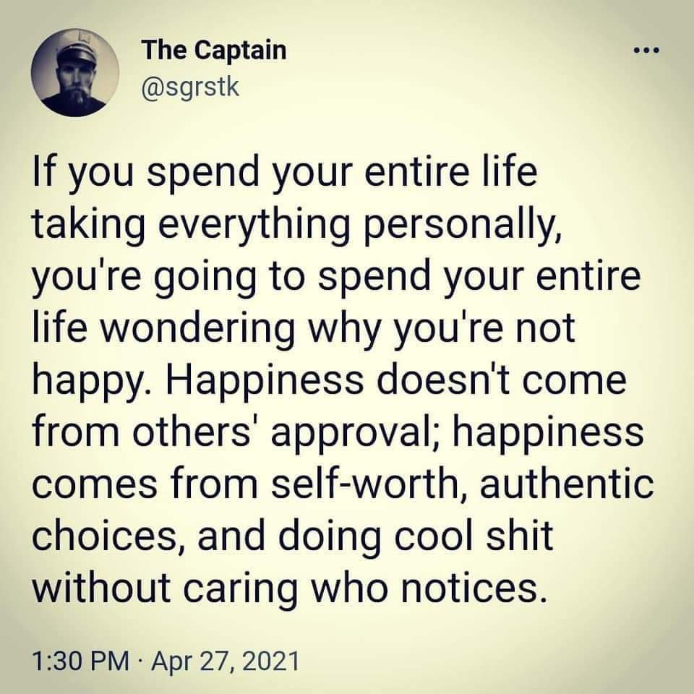

Great GROANERS! & Dad Jokes

* Venison for dinner again? Oh, deer!
* How does Moses make tea? Hebrews it.
* UK has no kidney bank, but it does have Liverpool.
* I tried to catch some fog, but I mist.
* They told me I had type-A blood, but it was a Typo.
* I changed my iPod's name to Titanic. It's syncing now.
* I stayed up all night looking where the sun went, and then it dawned on me from behind!
* This girl said she knew me from the vegetarian club, but I'd never met herbivore.
* I'm reading a book about anti-gravity and just can't put it down.
* I did a theatrical performance about puns; a play on words.
* The Indians were here first because they had reservations.
* I didn't like my beard at first. Then it grew on me.
* Did you hear about the cross-eyed teacher who couldn't control her pupils?
* Broken pencils are pointless.
* What do you call a dinosaur with an extensive vocabulary? A thesaurus.

1. Dad, are we pyromaniacs? Yes, we arson.
2. What do you call a pig with laryngitis? Disgruntled.
3. Writing my name in cursive is my signature move.
4. Why do bees stay in their hives during winter? Swarm.
5. If you’re bad at haggling, you’ll end up paying the price.
6. Just so everyone’s clear, I’m going to put my glasses on.
7. A commander walks into a bar and orders everyone around.
8. I lost my job as a stage designer. I left without making a scene.
9. Never buy flowers from a monk. Only you can prevent florist friars.
10. How much did the pirate pay to get his ears pierced? A buccaneer.
11. I once worked at a cheap pizza shop to get by. I kneaded the dough.
12. My friends and I have named our band ‘Duvet’. It’s a cover band.
13. I lost my girlfriend’s audiobook, and now I’ll never hear the end of it.
14. Why is ‘dark’ spelled with a k and not c? Because you can’t see in the dark.
15. Why is it unwise to share your secrets with a clock? Well, time will tell.
16. When I told my contractor I didn’t want carpeted steps, they gave me a blank stare.
17. A. Bono and The Edge walk into a Dublin bar and the bartender says, “Oh no, not U2 again.”

17. B. Two men walked into a bar. You’d think that the second one would have ducked.

1. Prison is just one word to you, but for some people, it’s a whole sentence.
2. Scientists got together to study the effects of alcohol on a person’s walk, and the result was staggering.
3. I’m trying to organize a hide and seek tournament, but good players are really hard to find.
4. I got over my addiction to chocolate, marshmallows, and nuts. I won’t lie, it was a rocky road.
5. What do you say to comfort a friend who’s struggling with grammar? There, their, they’re.
6. I went to the toy store and asked the assistant where the Schwarznegger dolls are and he replied, “Aisle B, back.”
7. What did the surgeon say to the patient who insisted on closing up their own incision? Suture self.
8. I’ve started telling everyone about the benefits of eating dried grapes. It’s all about raisin awareness.

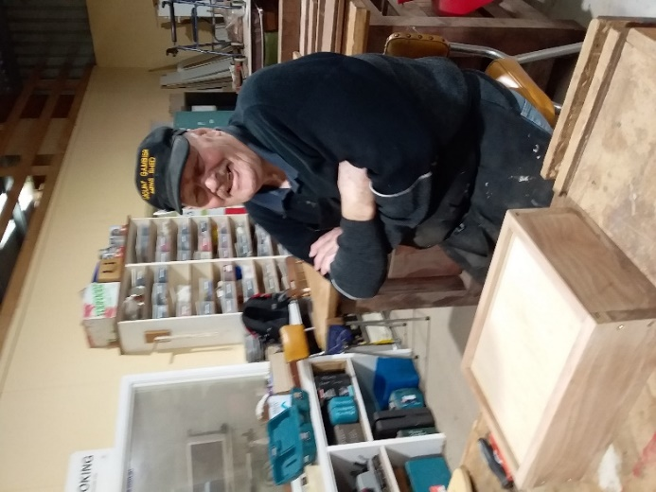

Allan looking very happy with the box he has created.

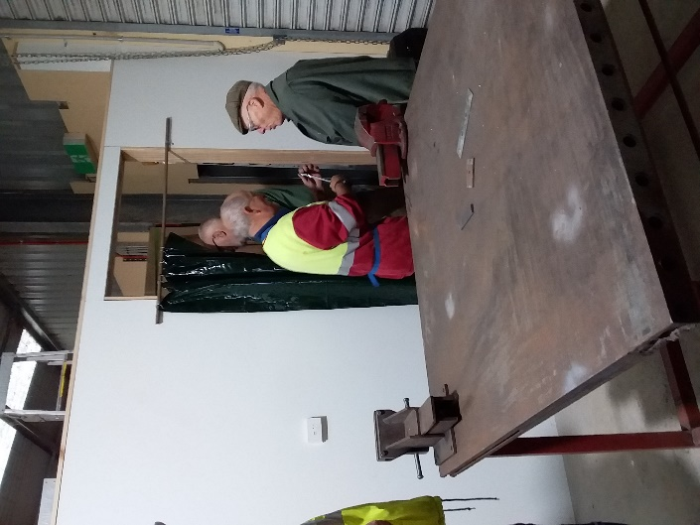

Looks like some secret men’s business going on here.

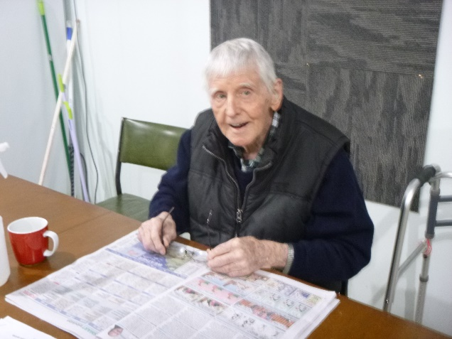

Great to see Bernard has been able to come back and be with us again.

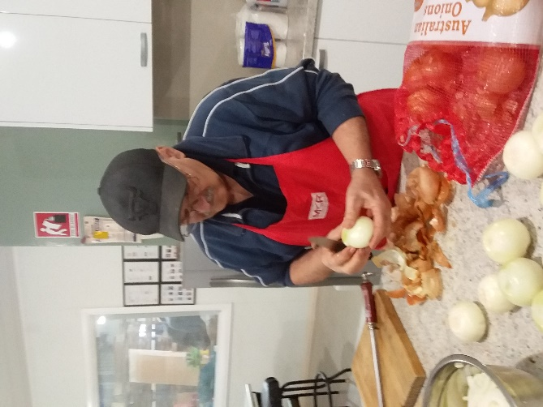

Don’t cry Ben, only 25kg to go.

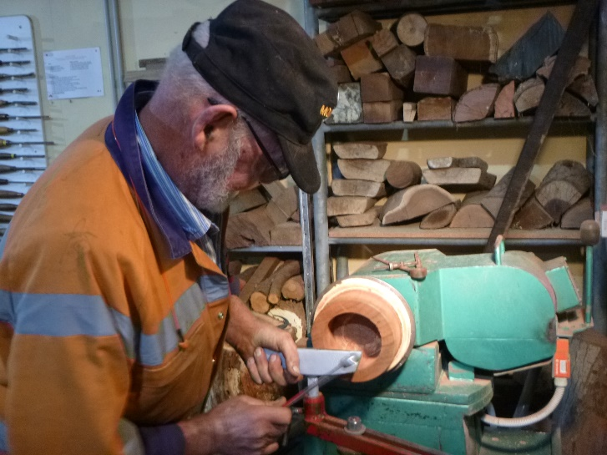

Bruce making a wooden bearing.

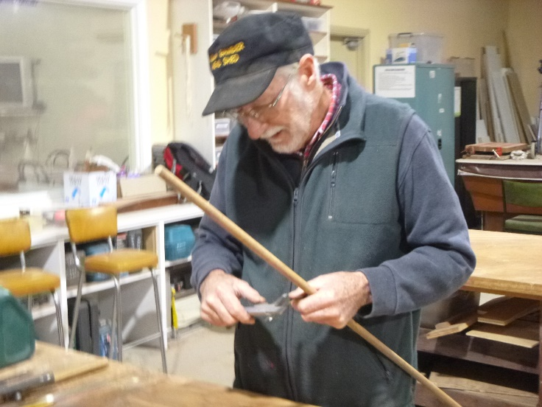

Don doing what Don does, measuring something no one else has thought of.

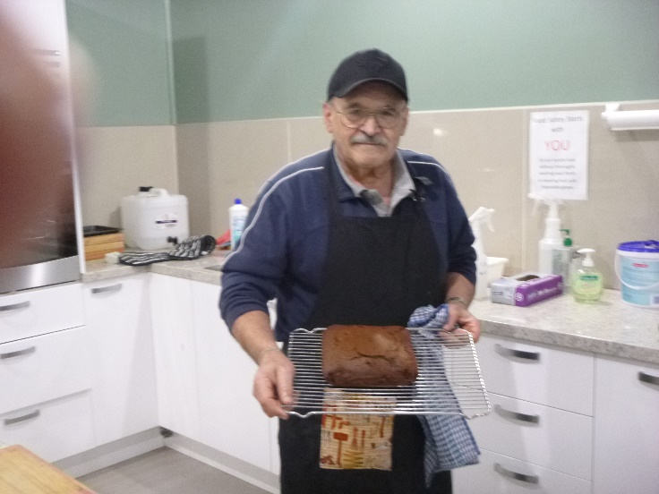

Ben not just our scone maker he is now putting his hand to making a chocolate cake.

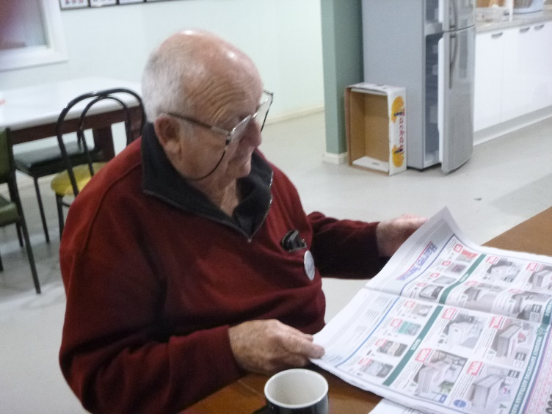

It looks like Graham is reading but unbeknown to everyone else he is only looking at the pictures. He can’t chose what he wants to buy!

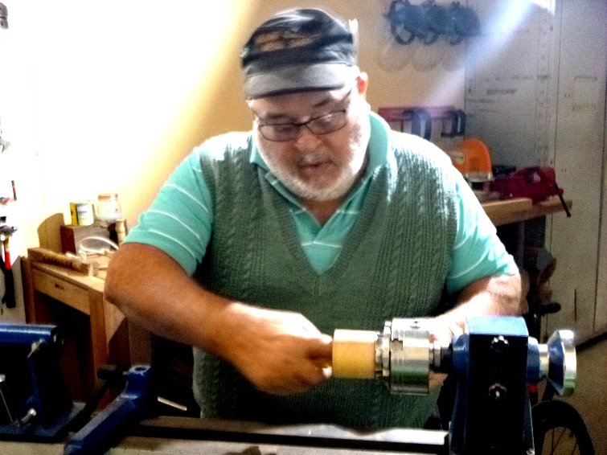

Laurie making a small bowl with the small lathe.

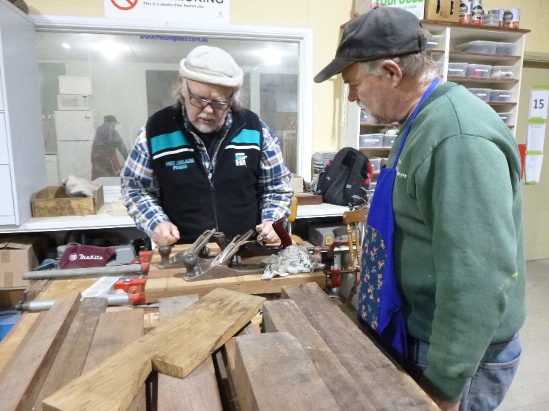

Matt showing Garry how different planes work.

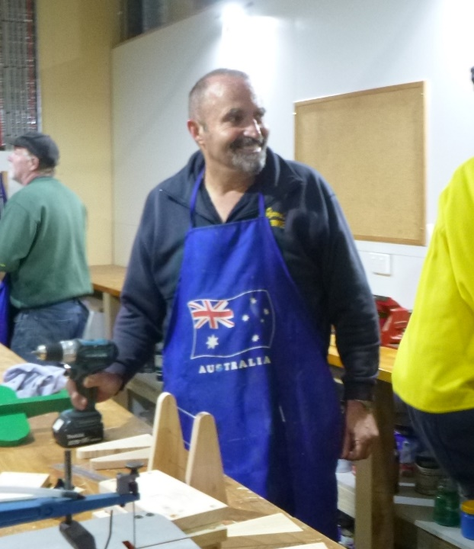

Peter sharing a joke instead of building the abacus.

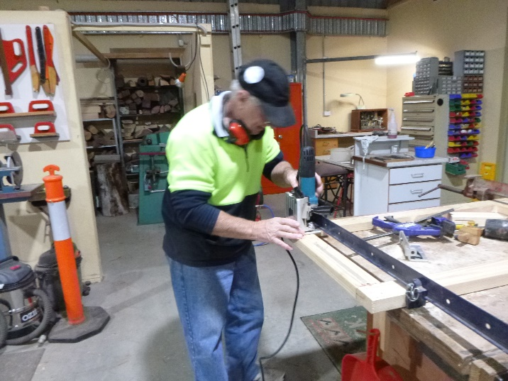

Geoff working with the biscuit cutter.

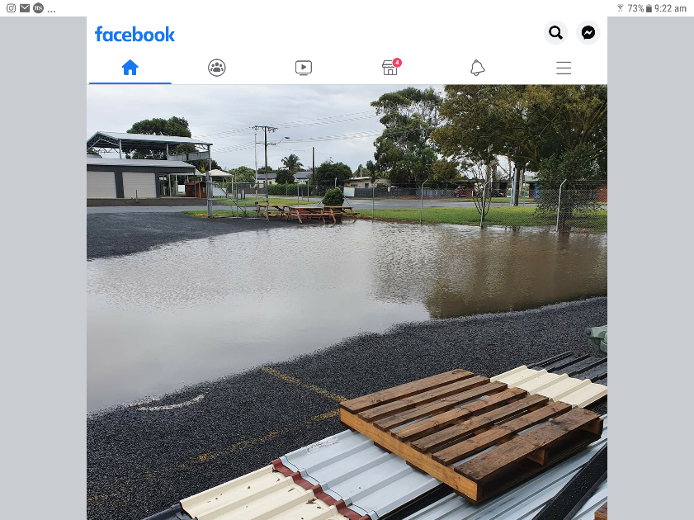

Hope you can all swim because when the drains block it is the only way into the shed.