**EXECUTIVE MEMBERS FOR 2022**

**PRESIDENT**: Ian Bond 0420859540

**VICE PRESIDENT**: Grant Sullivan

**TREASURER**: John Plunkett

**SECRETARY**: Paul Edgeworth 0497386846

**PHONE**: 0478614027 (prefer Tuesday and Thursday AM.)

**WE NOW HAVE A WEB SITE FOR THOSE WHO WISH TO LOOK. THIS WILL BE UPDATED FROM TIME TO TIME WITH NEW PHOTOS, NEWSLETTERS, RADIO REPORTS, CONTACTS AS WELL AS UPCOMING EVENTS AT THE SHED. Go to**

[**www.mgmensshed.com.au**](http://www.mgmensshed.com.au)

**FACEBOOK** Mens Shed Mount Gambier

[mgmensshed@gmail.com](mailto:mgmensshed@gmail.com)

**BIRTHDAYS**

Russell S 07/03

Kevin M 13/03

Jeff R 14/03

Thomas M 17/03

Stan B 26/03

**2023 Calendar**

March Garage Sale

16th March Thursday 10.30 AGM

16th March Thursday following AGM Members Meeting

28th March Tuesday 10.30 Management meeting

30th March Thursday 11.30 Monthly BBQ

**Woodworking is all about the touch of the woodworker’s hands. There is no alternative to the tasks which are best done manually. Such tasks require specialized tools for performing each job. Hand tools make a lot of works easier for the woodworker. All it requires is to have the perfect tool for each job.** The woodworking requires some[**compulsory hand tools**](https://thetoolspick.com/types-of-hand-tools/) within reach for effortless woodworking. Some of the woodcraft tools will be mentioned in the next 11 newsletters. Let’s check them out. **2. Clamps**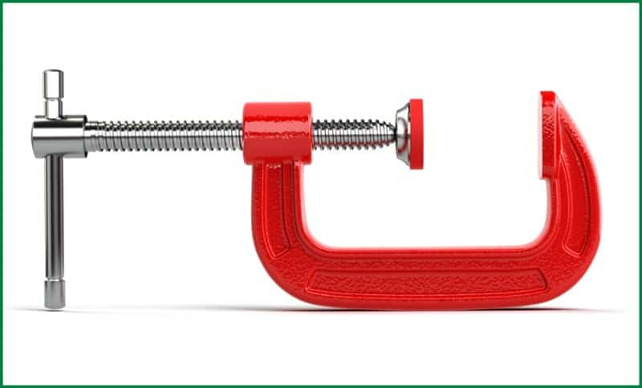

A clamp is a very useful tool in any workshop. It is a fastening tool. It holds an object in a place to work without drifting. Clamps are of various types based on their usability and structure. But all of them have the same purpose of preventing movement by applying inward pressure. Typically, a clamp includes jaws to hold the object and fasteners to tighten the space between the jaws. Some examples of clamps are hand screw clamp, bar clamp, parallel clamp, toggle clamp, T-track clap, bench clamp, edge clamp, and so on. **Uses of Clamps** Clamps are used in almost every field of construction such as metalworking, welding, carpentry, and so on. In woodworking its importance is immense. It holds wood pieces in a place to make a cut. The clamps hold the wood piece tightly in a place to avoid drifting while applying force on the wood to make a cut.

**Profile:-**

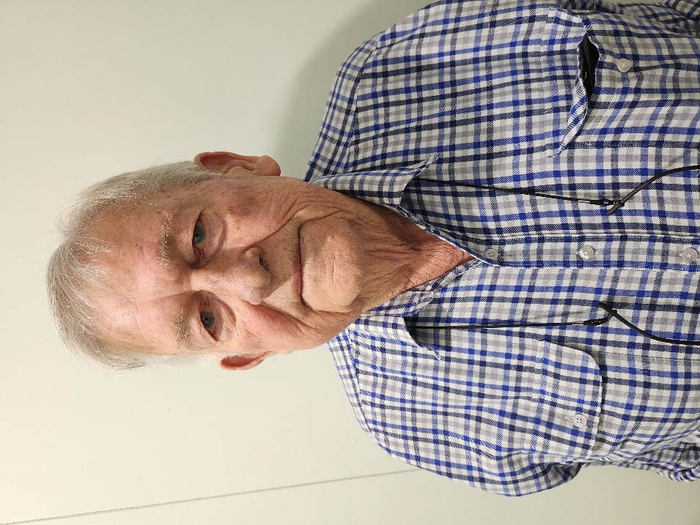

Name: -Ian Lambert Where have you worked:-Gun smith and gun shop owned irrigation business. Something about you people at the shed don’t know:-Spent time in the Middle East and South Africa and loves game shooting. What do you want to achieve at the shed:-At this point in time I am not sure so will assess as time goes on.

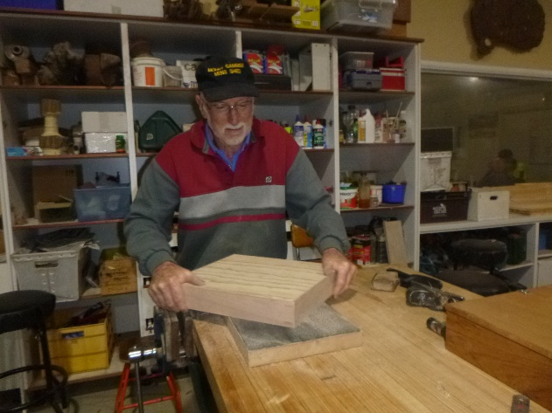

Don showing how to sand a large object.

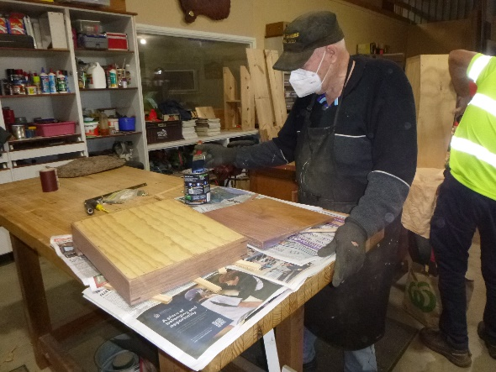

Alan painting the cash draw for Rotary.

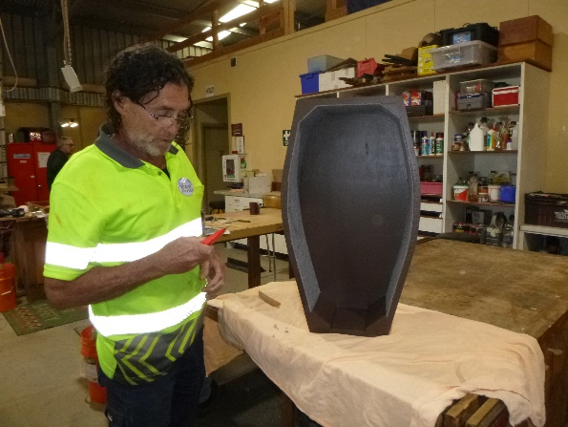

Ron says “now I have this thing what am I going to do with it?”

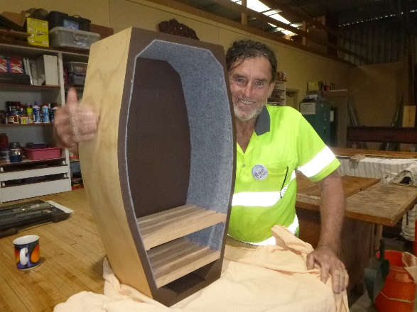

And this is the result, a book shelf shaped like a coffin.

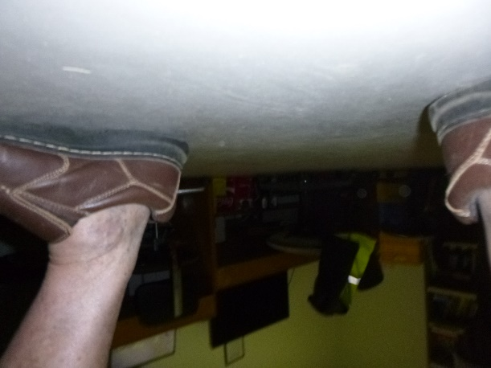

We must have a magnetic ceiling at the shed now or this is someone wanting to show off their very sexy ankles.

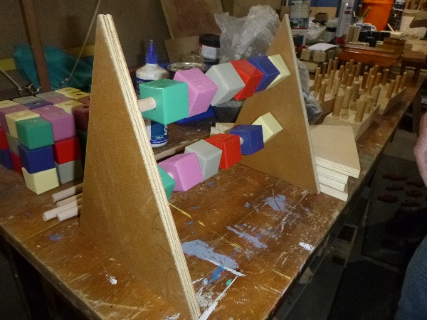

Sometime even when a mistake is made the results can be used as a new toy.

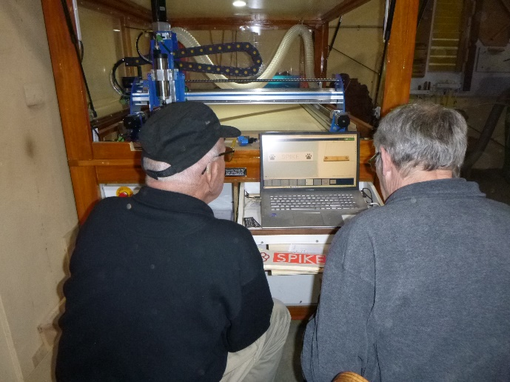

Dave teaching Dave how to use the CNC machine.

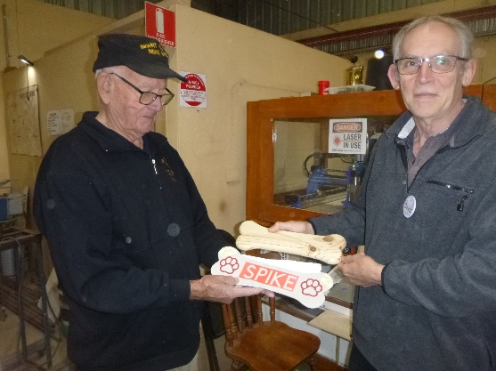

Dave and Dave show the results of how it works.

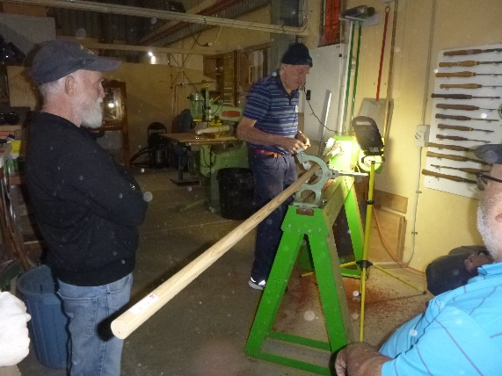

Glen watching on as Kevin shows how to turn up a Gaff for fishing.

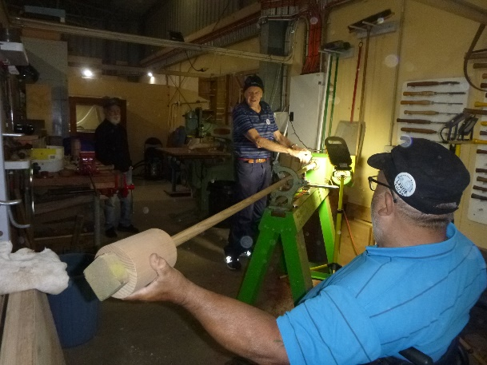

Laurie holding the end while Kevin is turning the fishing Gaff.

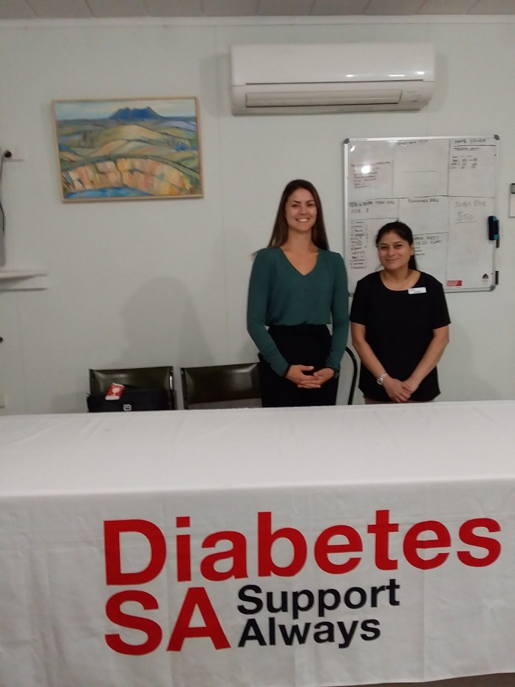

Pamela and Resma held a Diabetes session at the shed recently.

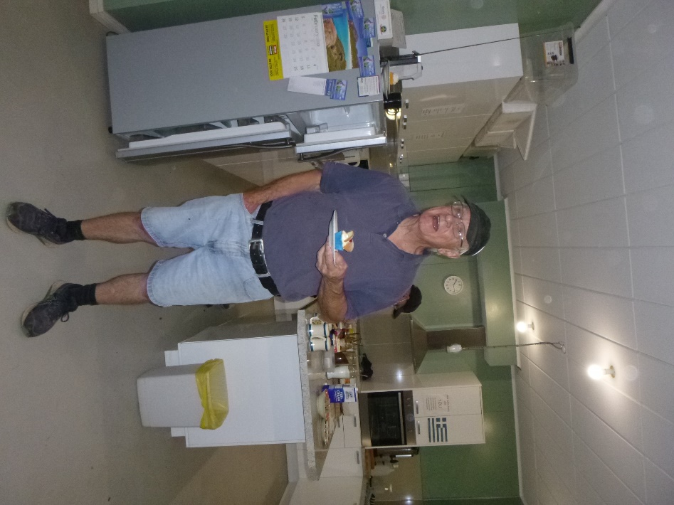

Geoff doing another Birthday cake presentation provided by Sugar & Spice.

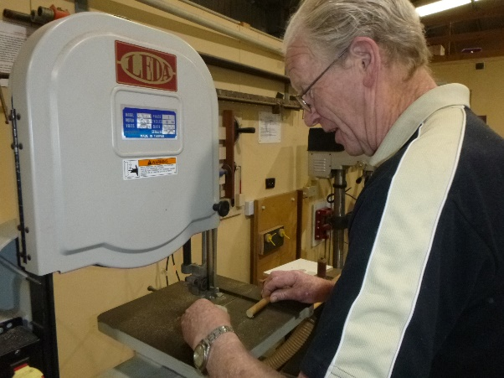

New member Jim working on one of the toys.

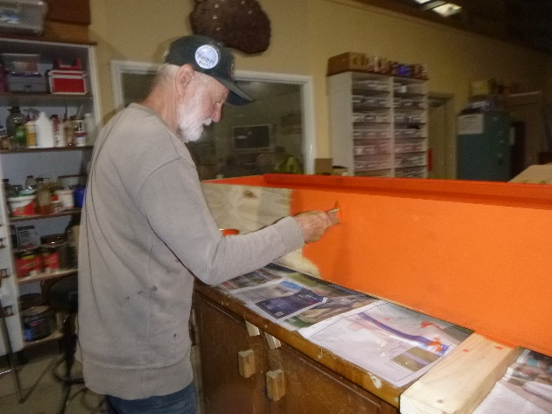

Herman doing the finishing touches to the inner lining of his coffin.

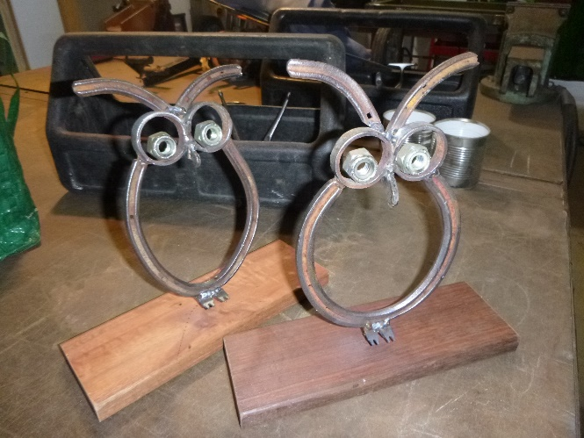

2 owls made by Ian.

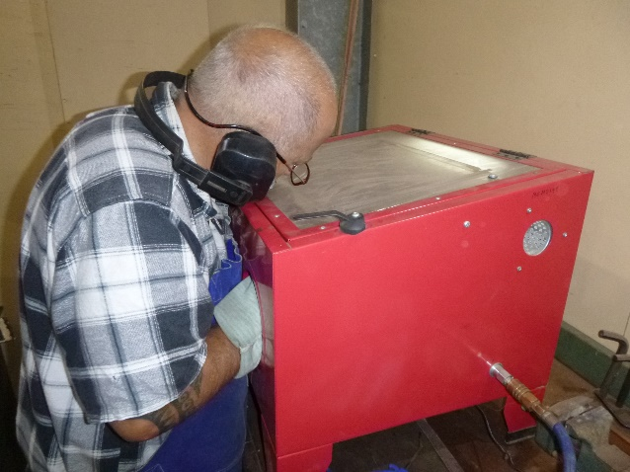

Ian showing how to use the sand blaster.

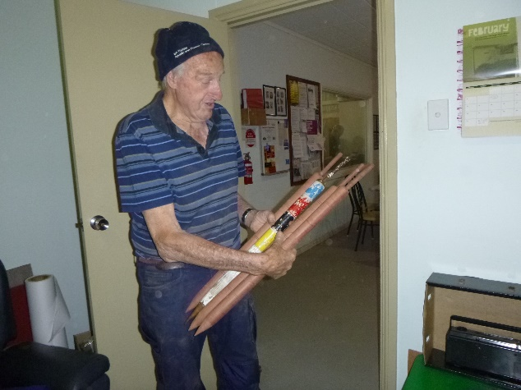

3 Croquet poles made for the local club.

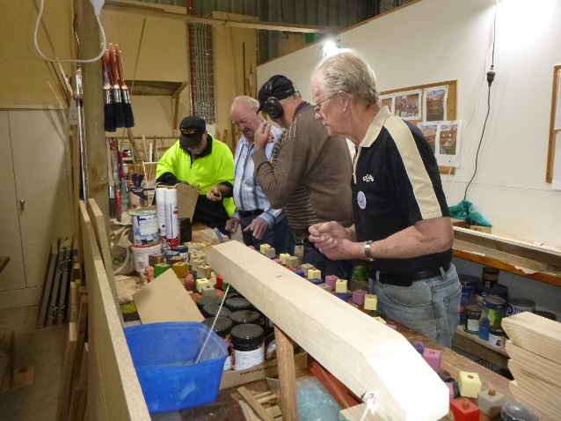

Some of the toy making crew hard at work.

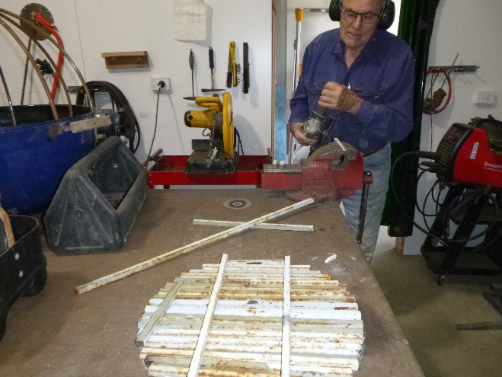

Trevor making a circular gate.

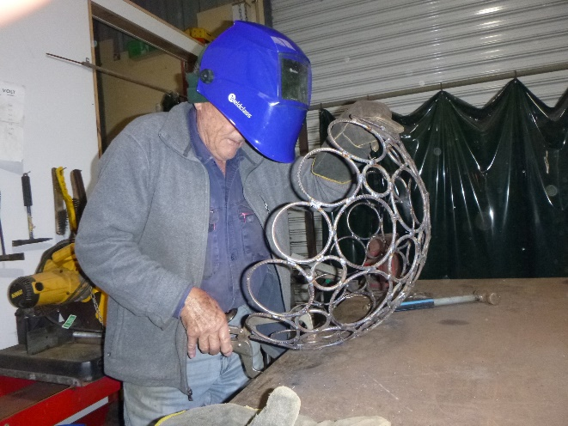

Now Trevor is making a hanging basket. A very clever man is our Trevor.

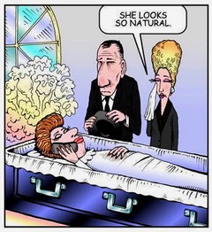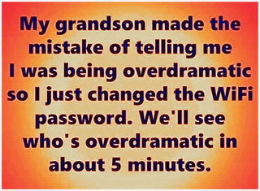

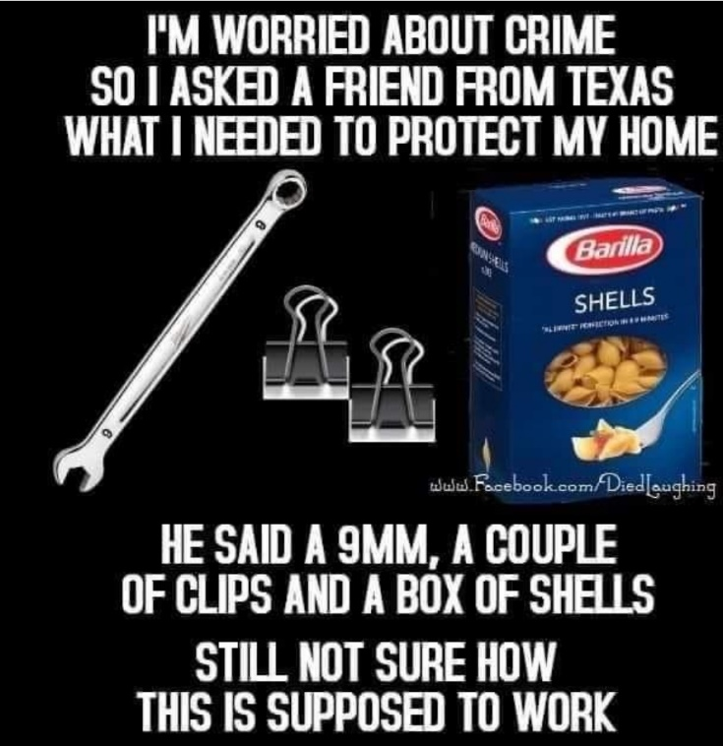

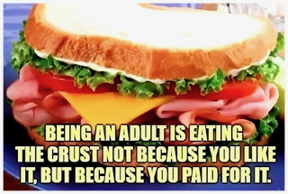

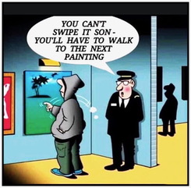

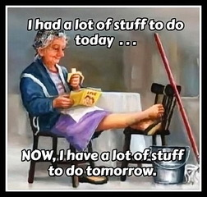

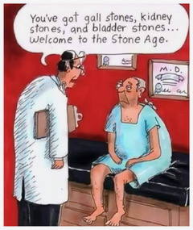

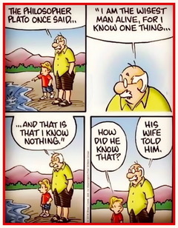

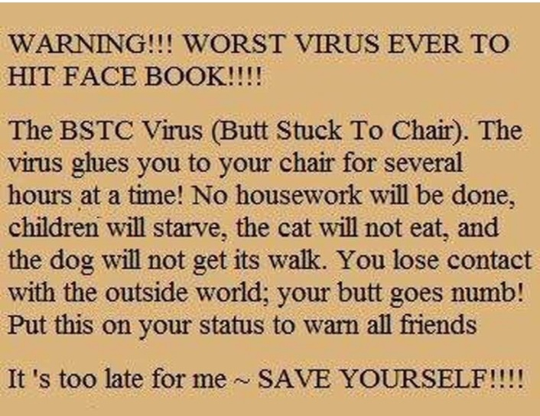

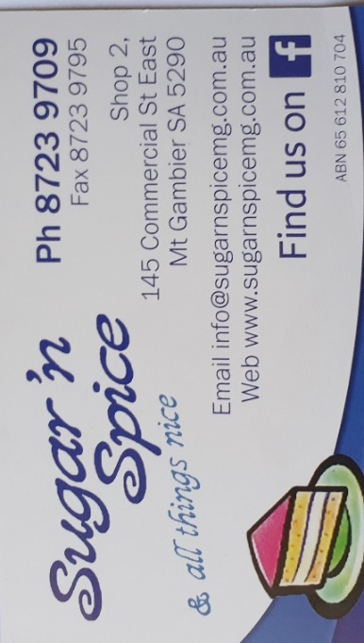

 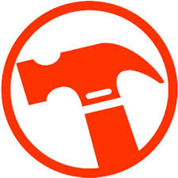

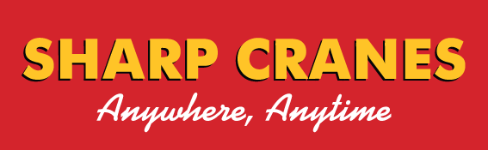



**Big supporters of Mount Gambier Mens Shed.**

**SUPPORT YOUR LOCAL BUSINESSES**

**THAT SUPPORT YOU.**