**EXECUTIVE MEMBERS FOR 2022**

**PRESIDENT**: Ian Bond 0420859540

**VICE PRESIDENT**: Grant Sullivan

**TREASURER**: John Plunkett

**SECRETARY**: Paul Edgeworth 0497386846

**MENS SHED PHONE**: 0478614027

**WE NOW HAVE A WEB SITE FOR THOSE WHO WISH TO LOOK. THIS WILL BE UPDATED FROM TIME TO TIME WITH NEW PHOTOS, NEWSLETTERS, RADIO REPORTS, CONTACTS AS WELL AS UPCOMING EVENTS AT THE SHED. Go to**

[**www.mgmensshed.com.au**](http://www.mgmensshed.com.au)

**FACEBOOK** Mens Shed Mount Gambier

[mgmensshed@gmail.com](mailto:mgmensshed@gmail.com)

**BIRTHDAYS**

Kevin M 13/03

Jeff R 14/03

After our AGM the incoming Executive and Management Committee are:-

**PRESIDENT** – Ian Bond.

**VICE-PRESIDENT –** Grant Sullivan.

**TREASURER** – John Plunket.

**SECRETARY** – Paul Edgeworth.

The outgoing Management Committee has invited the Past President Peter Halleday onto the new Committee as a full member (allowable under the Constitution).

**MANAGEMENT COMMITTEE MEMBERS**

Jeff Redwood, Graeme Richards, Ben Katris, Rob Burford and Dave Lawson.

**A note from incoming President Ian Bond.**

On behalf of the Management Committee I will work for the interest of all members. This is our paramount wish for the upcoming year. These interest include our mental and physical health as well as helping each other with personal projects and transfer of skills.

**2022 Calendar**

22nd March Tuesday 10.15am Management Meeting

1st April All day - Race Gates, Glenburnie – Gold Cup

13th April Wednesday 6.30pm Tea with partners – FACTS

14th April Thursday 10.15am Members Meeting

16th April Saturday 8.30am – 12.00noon Bunnings BBQ

12.00noon – 3.30/4pm

26th April Tuesday 10.15am Management Meeting

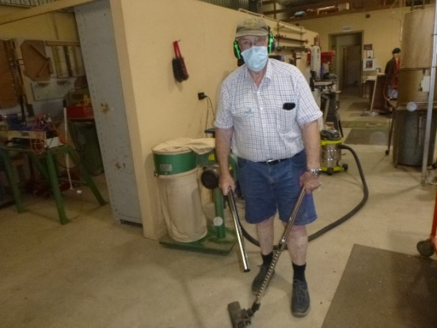

Cleaner extraordinaire Rod armed and ready to clean up in the shed. 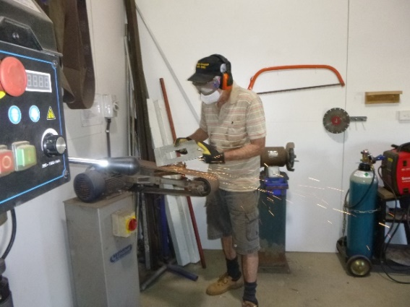

Don making adjustments on the dust extracter he is making.

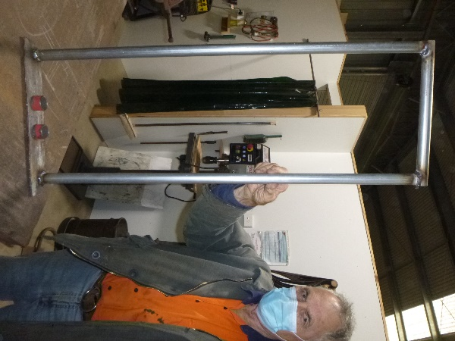

Trevor with the handle for a cart on rollers he is making.

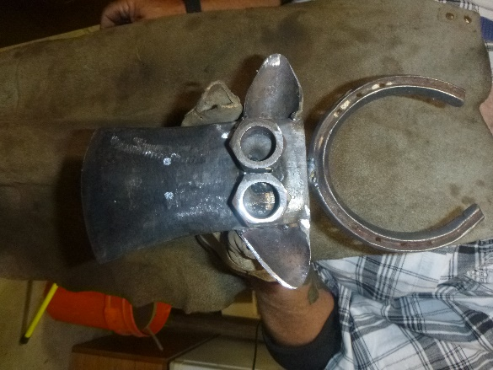

A cow sculpture Ian is making.

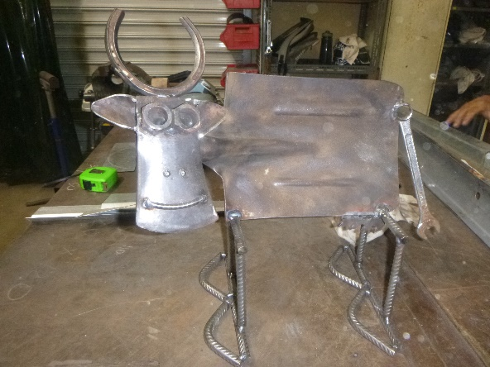

The finished Cow sculpture.

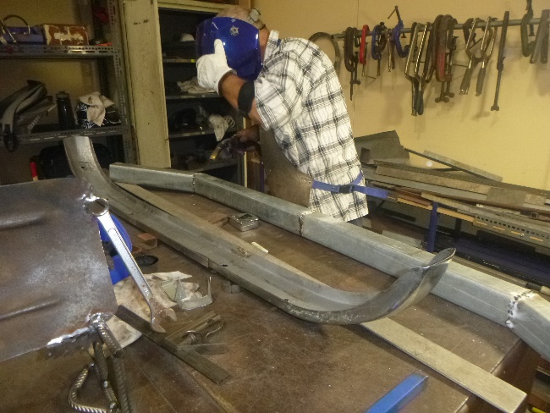

Ian making a temporary bumper bar for Paul’s Armstrong Siddeley.

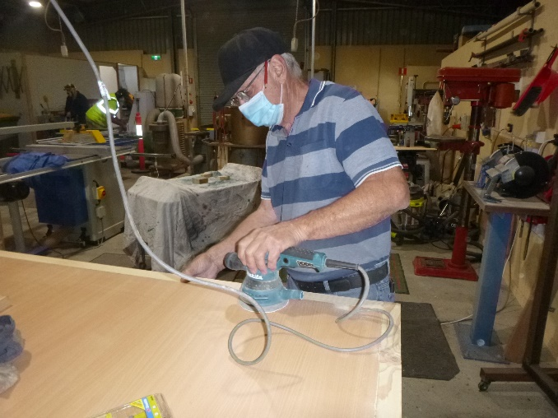

Geoff doing finishing touches for the CNC cabinet.

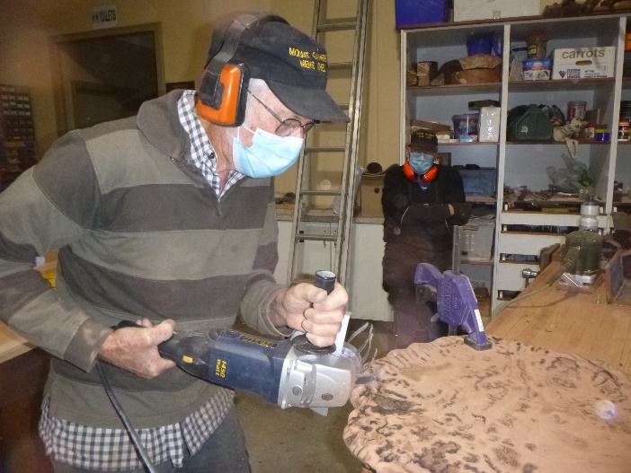

Don grinding a burl that will be made into a clock.

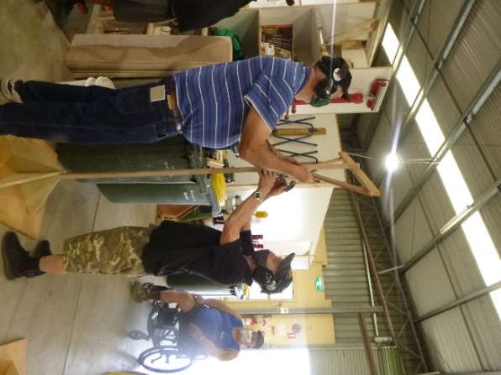

Peter and Shane putting the finishing touches on the medieval flag frames.

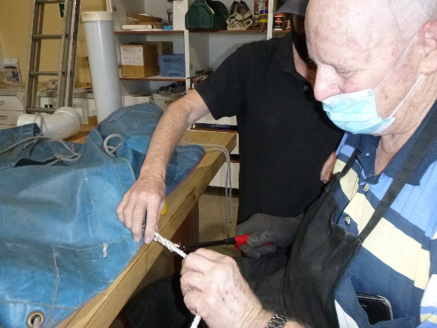

Alan burning off the end of rope he has spliced.

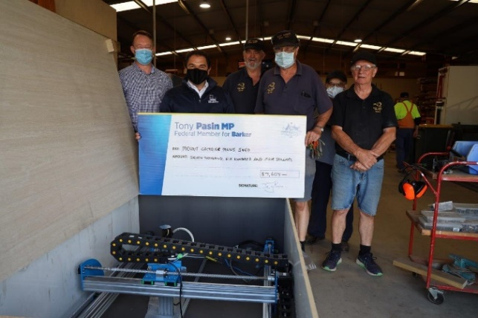

A visit from local Federal MP Tony Pasin and local state candidate Ben Hood to present a Stronger Communities Grant Cheque for the new CNC machine.

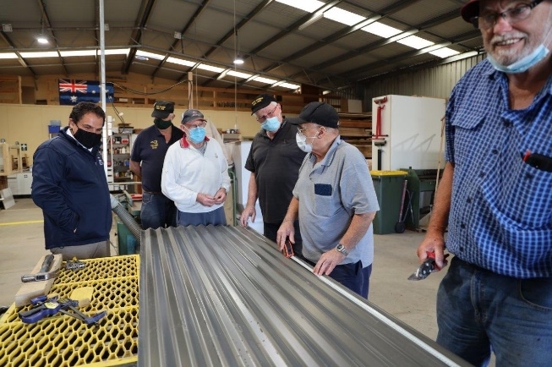

While at the shed Tony Pasin and Ben Hood had morning tea and inspected how the raised garden beds are made by the members. Above and Below.

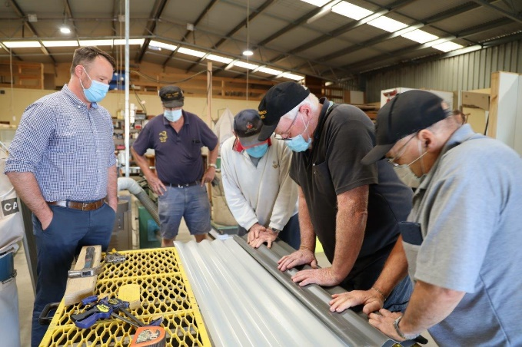

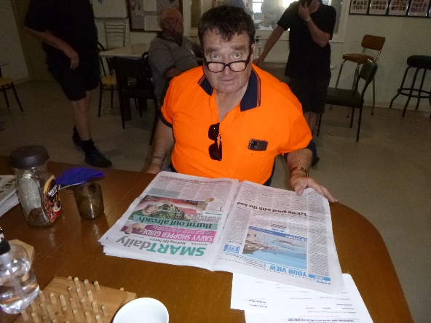

After a hard day making Scones it’s time for Bill to read the paper.

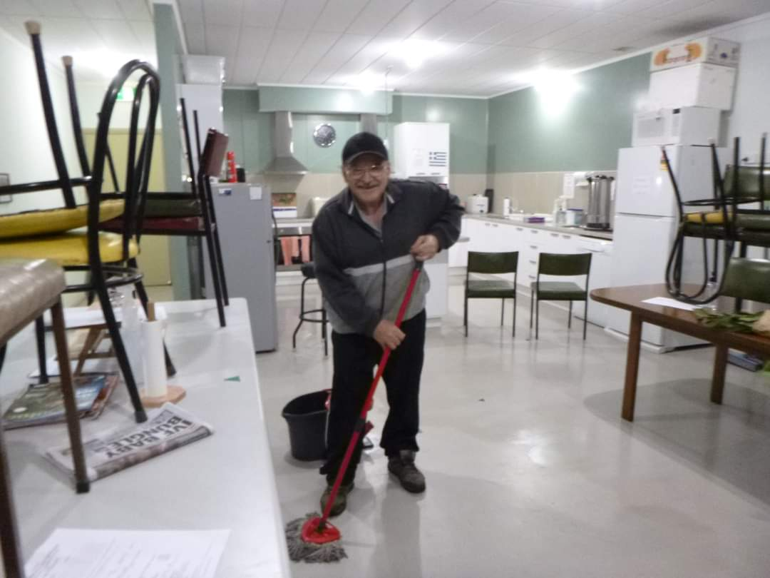

Not just a pretty face and a scone maker Ben cleans up his and our mess as well.

**Recipe:-**

**Seed crackers.**

1 Cup Oats.

1 cup Sunflower seed

1 cup Linseed.

1 cup Pumpkin seed

(Or use any seeds you like).

3 ½ cups plain flour

2 tsp salt

1 tsp baking powder

Mix together. Add 1 cup oil and 2 cups water.

Mix together and roll out between 2 sheets of baking paper cut into squares or shapes of your choice.

Put onto trays with paper underneath, bake for 18mins at 190 ⁰ C and cool on a rack.

THE COMMON TYPES OF WOODWORM AND WOOD BORING INSECTS

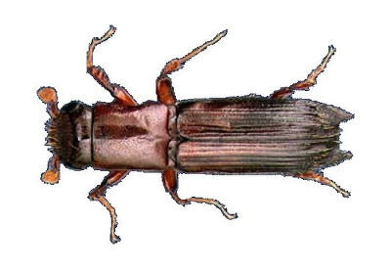**#4. Ambrosia Beetle**

Latin name: Platypus spp

**Appearance:** A relatively long, narrow beetle, with shiny dark-brown coloring and tucked back wings. Usually found in woodland but can enter the home given the right conditions.

**Preferred timber:** Loves both hard and softwoods of all types, and can often be found in newly fallen trees or fresh logs.

**Type of damage:** This forest living beetle flies between wood sources and creates rounded-edged blue-lined tunnels that run counter to the grain. Can cause extensive damage in construction-ready timber if left unchecked.

**Telltale signs:** Doesn’t create a lot of frasses – certainly not visible to the naked eye anyway – and exits timber through holes varying in size but often quite large compared to other types of beetles.

**Next Month - Fan-Bearing Wood-Borer**

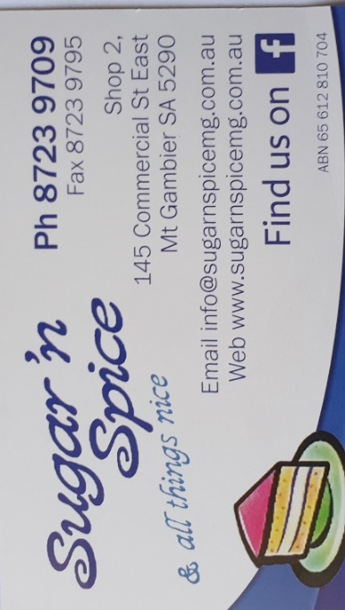

 





**Big supporters of Mount Gambier Mens Shed.**

**SUPPORT YOUR LOCAL BUSINESSES**

**THAT SUPPORT YOU.**