**EXECUTIVE MEMBERS FOR 2022**

**PRESIDENT**: Ian Bond 0420859540

**VICE PRESIDENT**: Grant Sullivan

**TREASURER**: John Plunkett

**SECRETARY**: Paul Edgeworth 0497386846

**PHONE**: 0478614027 ( prefer Tuesday and Thursday AM.)

**WE NOW HAVE A WEB SITE FOR THOSE WHO WISH TO LOOK. THIS WILL BE UPDATED FROM TIME TO TIME WITH NEW PHOTOS, NEWSLETTERS, RADIO REPORTS, CONTACTS AS WELL AS UPCOMING EVENTS AT THE SHED. Go to**

[**www.mgmensshed.com.au**](http://www.mgmensshed.com.au)

**FACEBOOK** Mens Shed Mount Gambier

[mgmensshed@gmail.com](mailto:mgmensshed@gmail.com)

**BIRTHDAYS**

Glen B. 05/06

Andrew K. 05/06

Mat J. 10/06

Allan C. 14/06

David N. 22/06

Graham P. 27/06

Dick P. 29/06

**2022 Calendar**

8th June Wednesday 6.30 Tea with partners - Southern Thai

19th June Sunday Glenburnie Racing gates

## THE COMMON TYPES OF WOODWORM AND WOOD BORING INSECTS pART 9/12

**#8. Wood Boring Weevil**

Latin name: Pentarthrum Huttoni

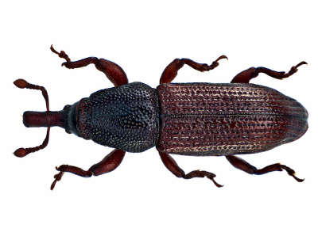 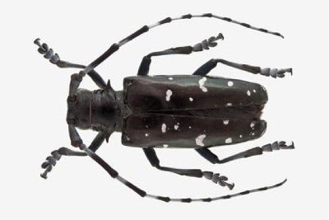

**Appearance**: Reddish brown in color, this European beetle is a small insect found predominantly in buildings – where it can cause extensive damage.

**Preferred timber:** The Wood Boring Beetle chooses very rotten timber of either the hard or softwood variety, and thrives in very damp conditions – often flying to and settling in buildings with damp problems.

**Type of damage**: Creates rough oval shaped tunnels, which are just underneath the wood and often break the surface. For this reason, they can cause visibly high levels of destruction to both furniture and wooden support beams.

**Telltale signs**: Flight holes left by this tiny insect are very small, only measuring around 1 cm in diameter. The frass left behind in its extensive surface tunnelling look like small oval pellets.

**Next Month - House Longhorn**

**How to recognise Stroke.**

I will continue to forward this every time it comes around! STROKE: Remember the 1st Three Letters....S.T.R. I received this via Whyalla Men’s Shed and it encouraged me to post it and spread the word. If everyone can remember something this simple, we could save some folks. Please read: STROKE IDENTIFICATION: During a BBQ, a friend stumbled and took a little fall - she assured everyone that she was fine (they offered to call paramedics) she said she had just tripped over a brick because of her new shoes. They got her cleaned up and got her a new plate of food. While she appeared a bit shaken up, Ingrid went about enjoying herself the rest of the evening Ingrid's husband called later telling everyone that his wife had been taken to the hospital - (at 6:00 pm Ingrid passed away.) She had suffered a stroke at the BBQ. Had they known how to identify the signs of a stroke, perhaps Ingrid would be with us today. Some don't die. They end up in a helpless, hopeless condition instead. It only takes a minute to read this... A neurologist says that if he can get to a stroke victim within 3 hours he can totally reverse the effects of a stroke...totally. He said the trick was getting a stroke recognized, diagnosed, and then getting the patient medically cared for within 3 hours, which is tough. **RECOGNIZING A STROKE** Thank God for the sense to remember the '3' steps, STR. Read and Learn! Sometimes symptoms of a stroke are difficult to identify. Unfortunately, the lack of awareness spells disaster. The stroke victim may suffer severe brain damage when people nearby fail to recognize the symptoms of a stroke. Now doctors say a bystander can recognize a stroke by asking three simple questions: S \***Ask the individual to SMILE.** T **\*Ask the person to TALK and SPEAK A SIMPLE SENTENCE** (Coherently) (i.e. It is sunny out today) R \***Ask him or her to RAISE BOTH ARMS**. If he or she has trouble with ANY ONE of these tasks, call emergency number immediately and describe the symptoms to the dispatcher. New Sign of a Stroke -------- **Stick out Your Tongue** NOTE: Another 'sign' of a stroke is this: Ask the person to 'stick' out his tongue.. If the tongue is 'crooked', if it goes to one side or the other, that is also an indication of a stroke. A cardiologist says if everyone who gets this e-mail sends it to 10 people; you can bet that at least one life will be saved. I have done my part. Have you?

**Profile:-**



Name: - David Angle. Where have you worked:-Worked in south Africa in the Navy and built GT40 cars out of the first stainless steel chassis in the world. Something about you people at the shed don’t know:- I am a Free Mason. What do you want to achieve at the shed:-Friendship and a couple of projects for myself like repairing a butchers block.

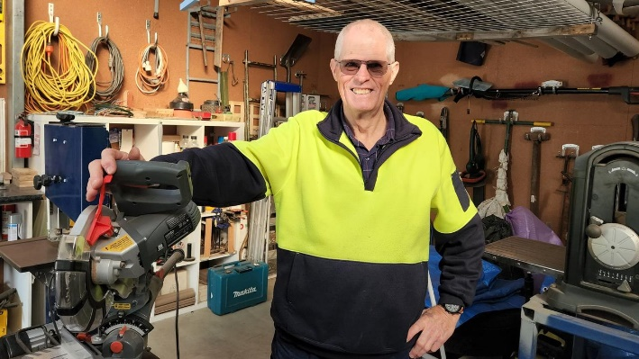

Ian Bond from the Mount Gambier Men's Shed. Picture: Arj Ganesan

After moving to Mount Gambier in 2017 to be closer to family, Ian Bond joined the local Men’s Shed.

Mr Bond said the Men’s Shed was a great way to serve the community and provide a place to promote men’s mental health.

“Last Wednesday, six of us got together and went to the Church of Christ Church on Jubilee Highway and rebuilt and assembled a storage shed for their op shop,” Mr Bond said.

“They’ve been waiting probably two years for this facility to be done and we fixed it for them.”

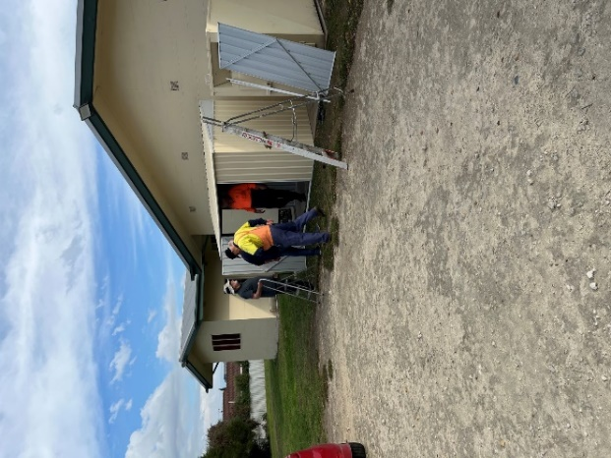

Start of the Church shed build.

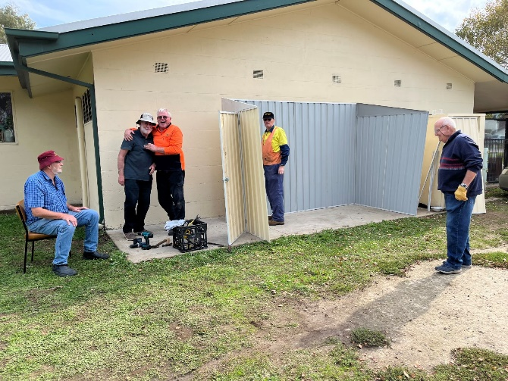

The crew involved with the build.

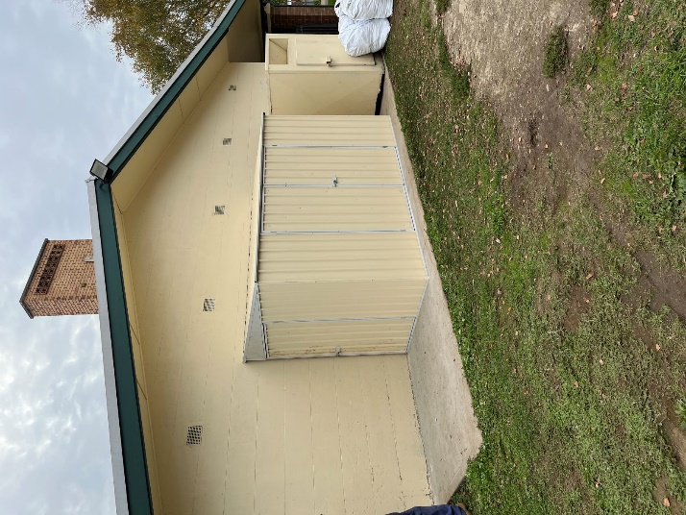

The finished product. Well done fellows.

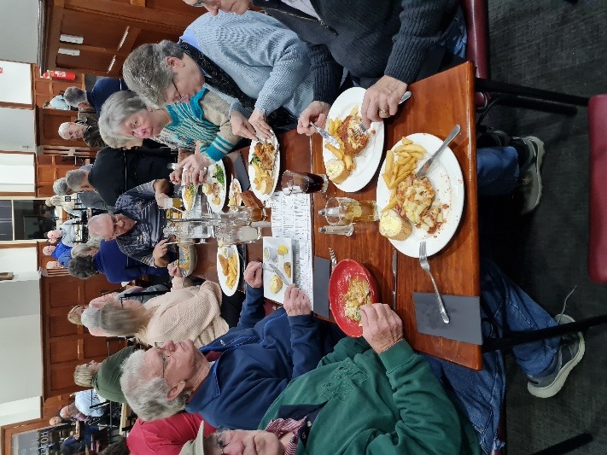

Jen’s Dinner with the ladies.

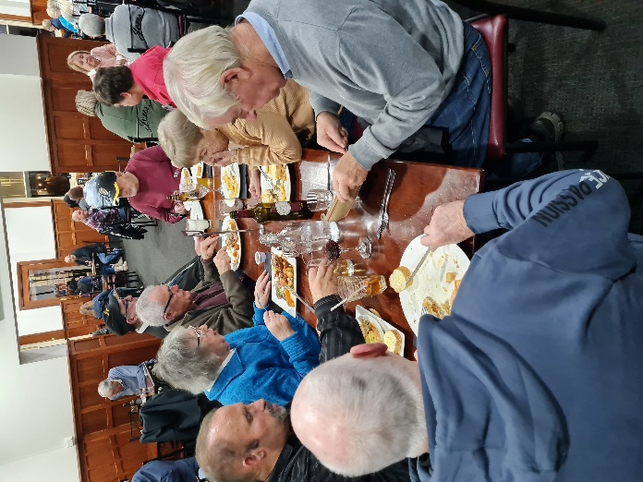

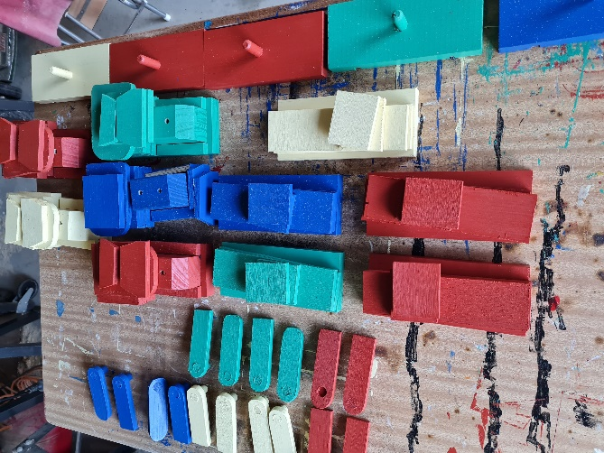

Start and finish of toy trains by Peter.

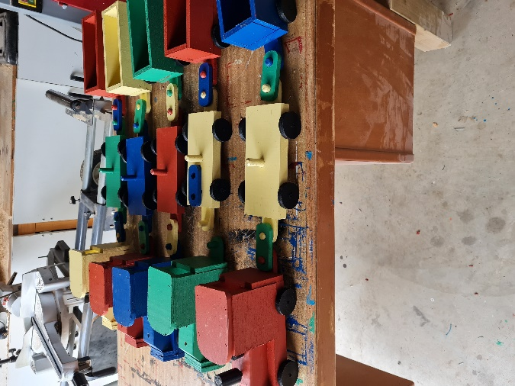

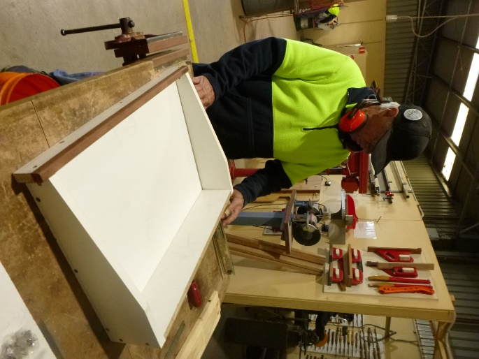

Geoff making the drawers for the new CNC machine.

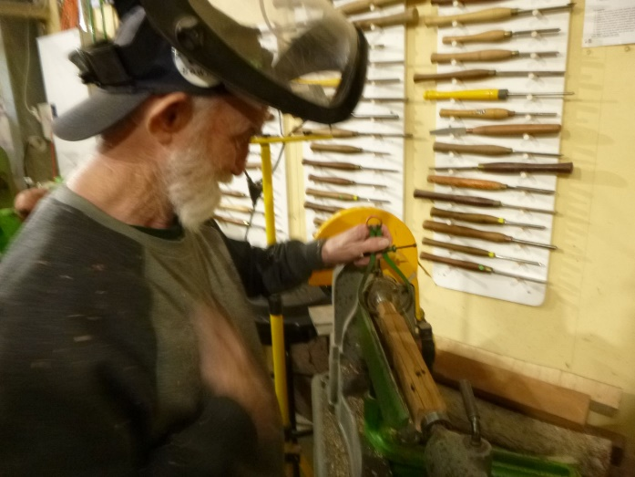

Glen working on the lathe.

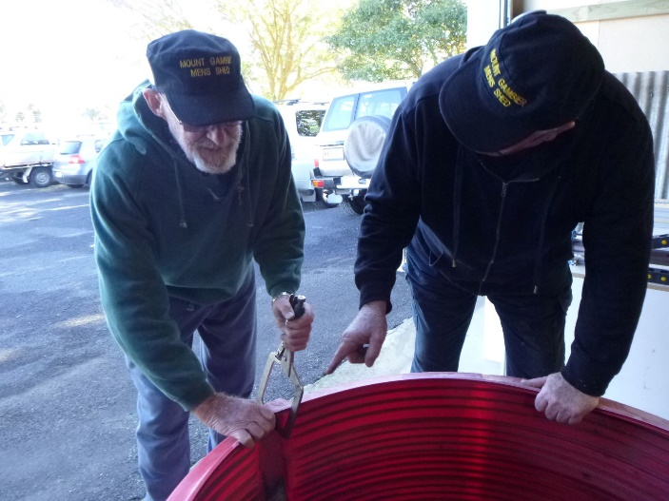

Grant showing Frank where the clamp goes.

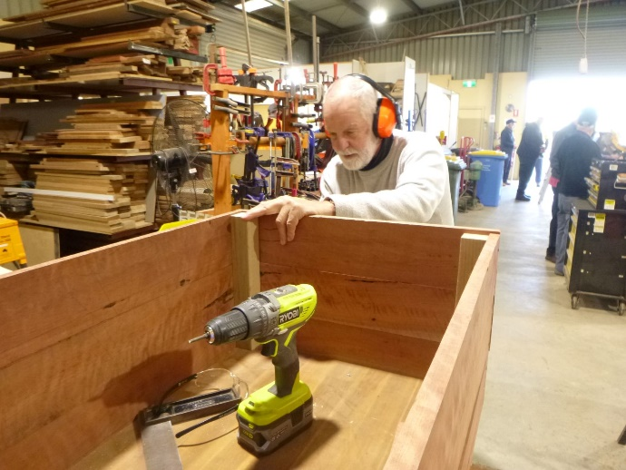

Herman building his coffin.

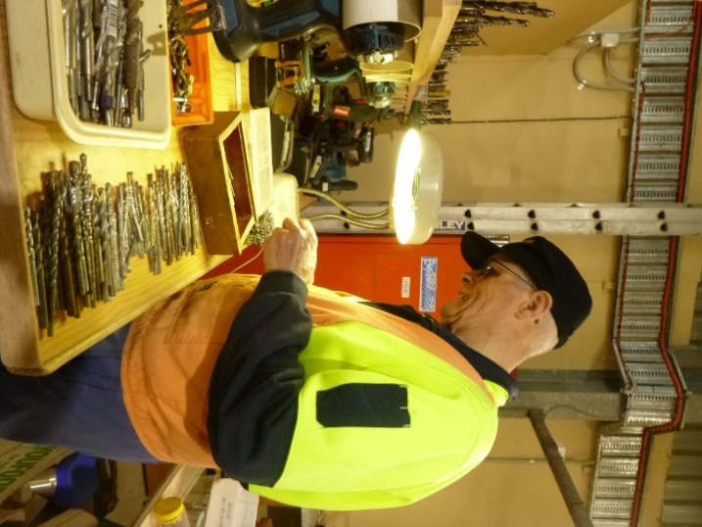

President Ian looking for the right drill. Must be here somewhere.

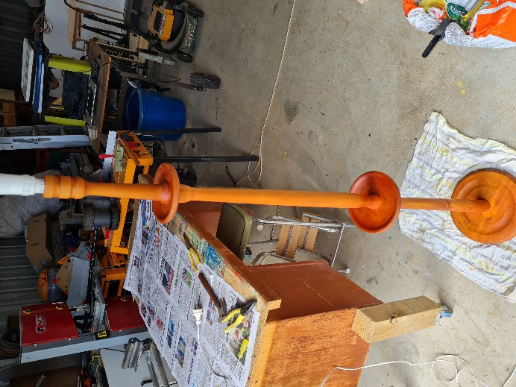

Lamp stand repaired for a customer by Peter H.

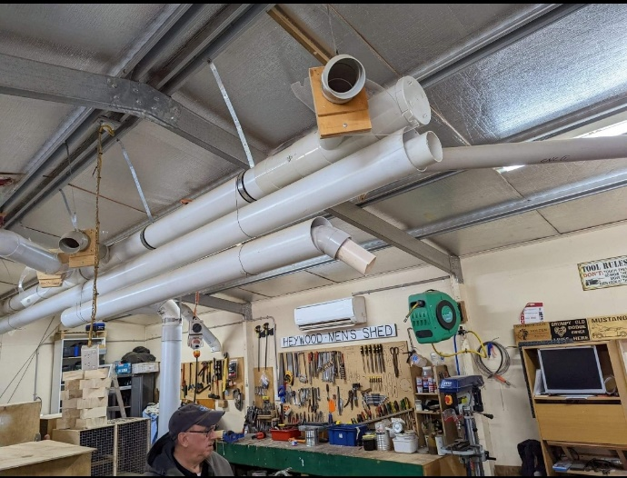

Visit to Heywood Men’s shed.

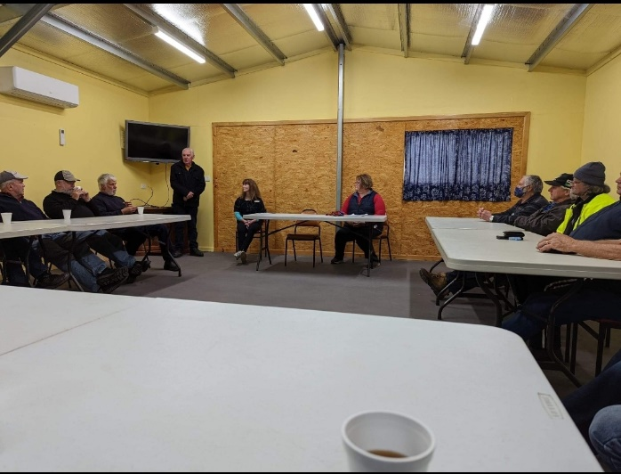

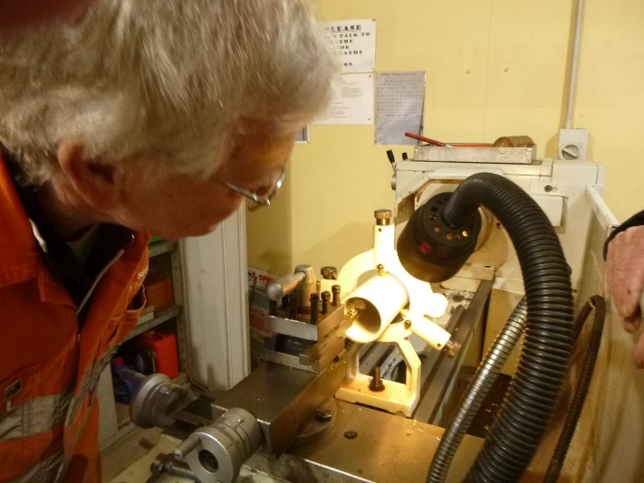

Jim hard at work at making a plastic Piece for the CNC machine.

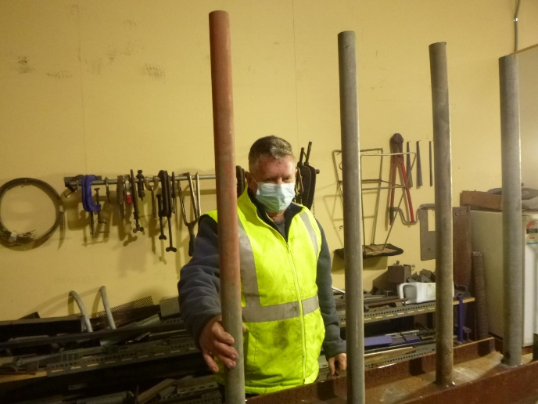

Darryl inspecting the metal storage rack.

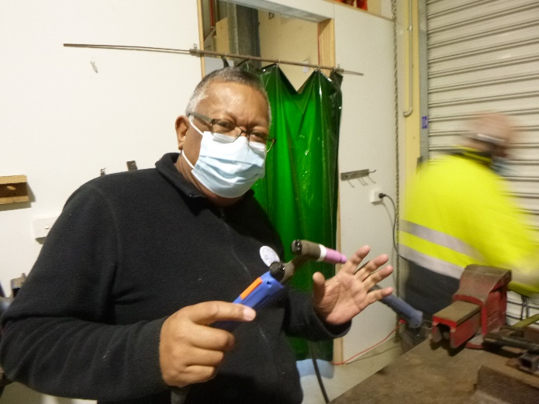

Nigel demonstrating the wielding equipment he has donated to the shed.

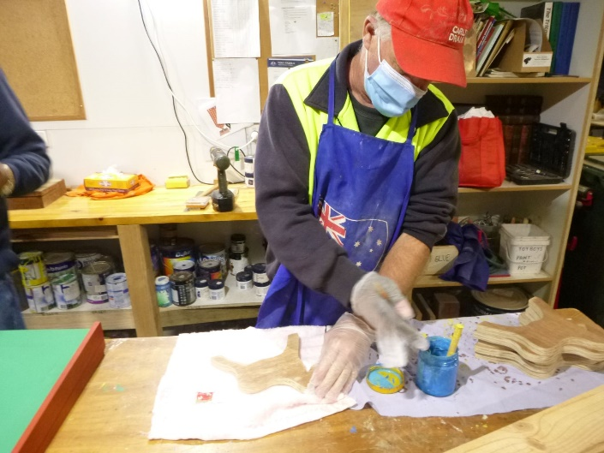

Gary painting the wooden horse Pull- A-Long toy.

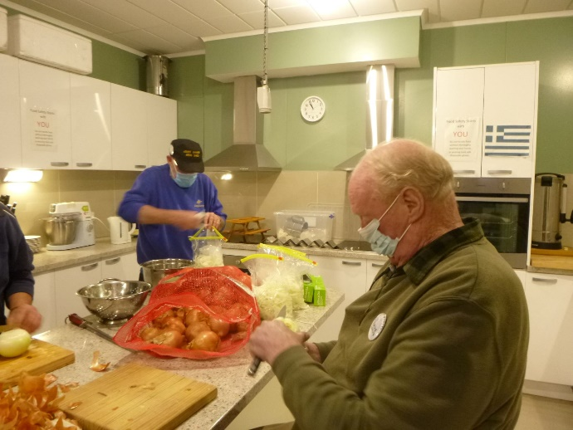

Frank and Bruce cutting up a batch of onions ready for the next BBQ.

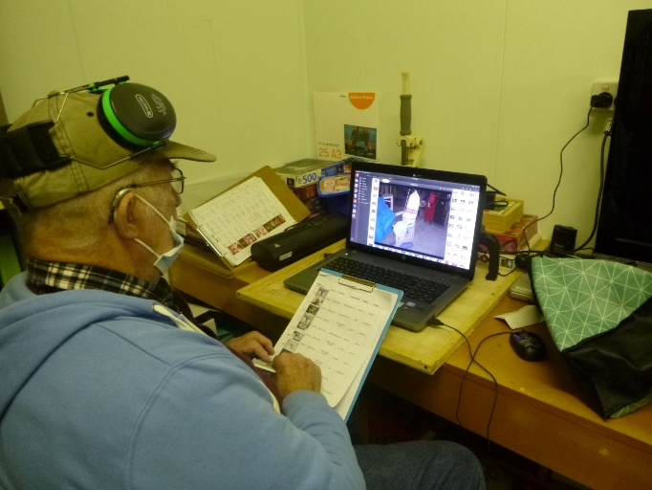

Rod checking the inventory of the shed equipment.

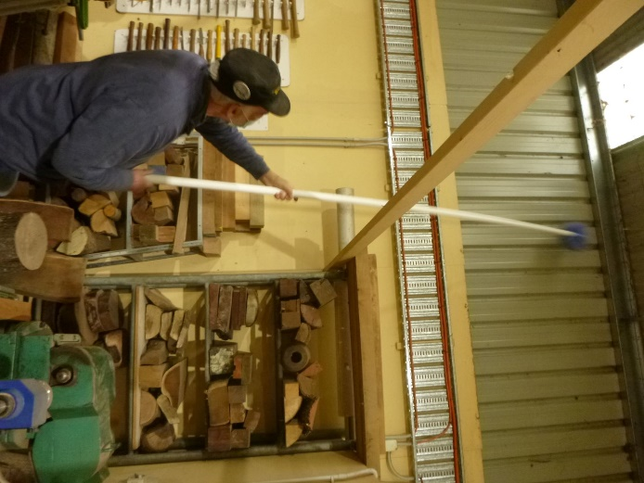

Rob cleaning cobwebs up high in the shed on clean-up day.

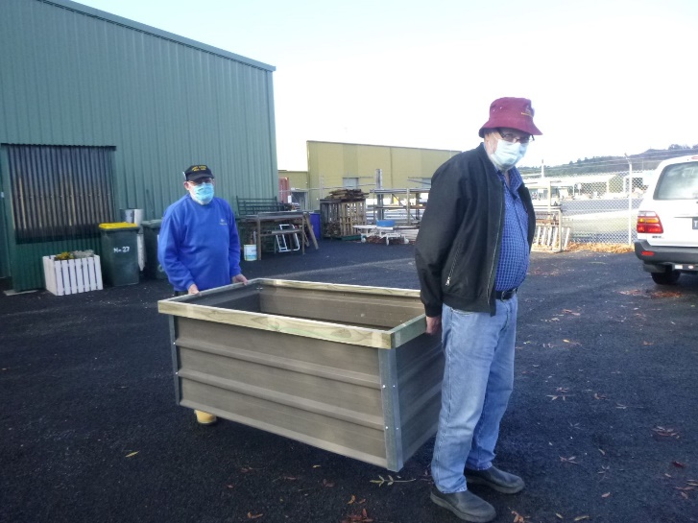

Geoff and Frank showing off the new raised garden beds.

**FOR SALE:**

1 planer/jointer and 1 thicknesser

3 phase, $500 each

Contact: Don 7-9pm 0467333642

**Pictures are below.**

**JOKES**









 





**Big supporters of Mount Gambier Mens Shed.**

**SUPPORT YOUR LOCAL BUSINESSES**

**THAT SUPPORT YOU.**