[mgmensshed@gmail.com](mailto:mgmensshed@gmail.com)

**EXECUTIVE MEMBERS FOR 2021**

**PRESIDENT**:

**VICE PRESIDENT**: Ben Katris

**TREASURER**: John Plunket

**SECRETARY**: Paul Edgeworth 0887256385

**FACEBOOK**

Shed broadcasts are now available on Facebook

*[Image result for facebook logo](https://www.google.com.au/url?sa=i&rct=j&q=&esrc=s&source=images&cd=&cad=rja&uact=8&ved=2ahUKEwjO9cWTtajeAhUafisKHT6JAHoQjRx6BAgBEAU&url=http://www.seacliffeinn.com/spa-boutique/find-us-on-facebook-logo/&psig=AOvVaw0duNjpvsqixE3Pzu1qEwe2&ust=1540791326821108)*

**Safety: - Remember Safety begins at home.**

**BIRTHDAY”S**

Bernard R 02/2

Ansi N 04/2

Ross S 04/2

Craig V 15/2

Gary A 19/2



**Remember Sugar ‘n Spice support the Men’s shed with Birthday cakes so support them where you can.**

 

**While mentioning our supporters always remember how much Bunnings help our shed, so support them as well when you need a product they can supply for you.**



Thanks Sharp Cranes and Steeline for supporting our Mens Shed.



WHEN YOU BUY FROM A SMALL BUSINESS YOU'RE NOT HELPING A CEO BUY A THIRD HOLIDAY HOME, YOU'RE HELPING LITTLE BOYS AND GIRLS GET DANCE LESSONS OR FOOTY JUMPERS, AND A FAMILY PUT FOOD ON THE TABLE.



How to prevent black spot on your roses.

NOTE As this is American Baking Soda is actually Bi- Carb soda.

**PROFILE:-**

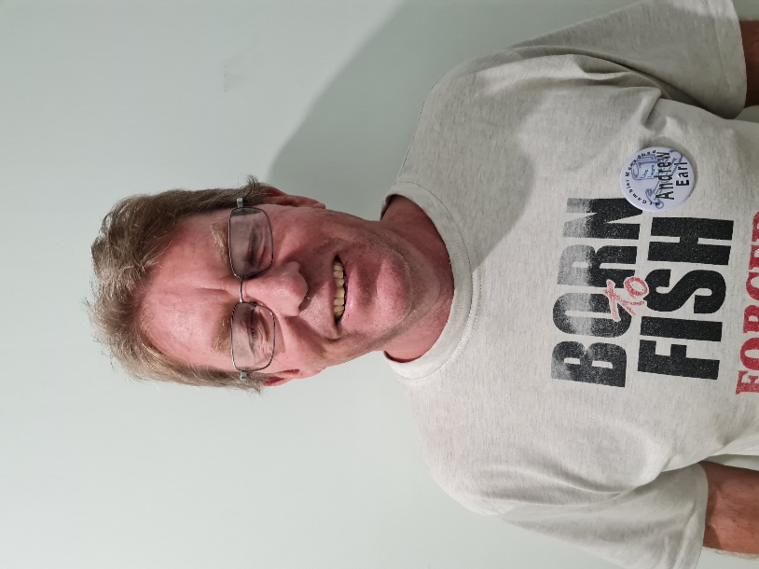

**Name: -** Andrew Earl.

**Where have you worked in your life**: - Mount Schank Meat Co., Softwoods, Self-employed.

**Something about you that others at the shed don’t know**: - Natural therapist specialising in dogs and is a knife maker.

**What do you wish to achieve at the shed**: - Friendship and socialising.

**Recipe**

**Bailey’s Fruit Cake**

1 kg mixed dried fruit.

¾ Cup Bailey’ Irish Cream.

400 gm tin of Condensed Milk.

2 Cups SR Flour.

1. In a large bowl, combine dried fruit, condensed milk, Baileys and 1/2 cup water. Mix well, cover and refrigerate overnight.
2. Remove from the fridge and stir well, allowing it to come to room temperature. Preheat oven to 150C. Grease and line a deep 20cm round cake tin with baking paper.
3. Fold flour through soaked fruit. Pour into prepared tin and smooth the top. Bake for 2 hours until a skewer inserted into the centre comes out clean.
4. Cupcakes cook for 30 mins and check as before.

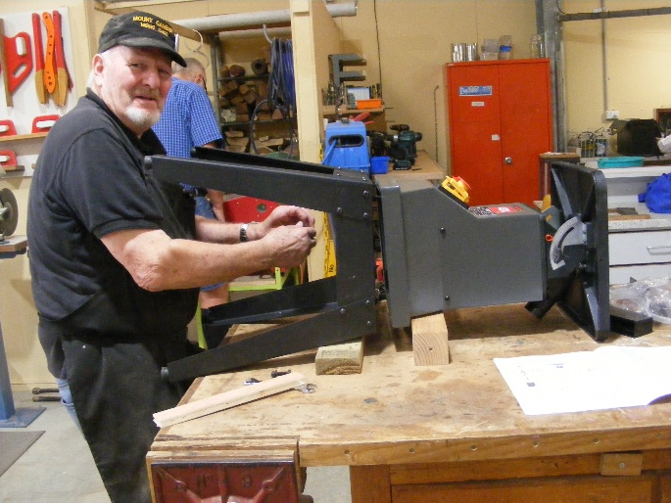

Allen putting the finishing touches on the spindle sander.

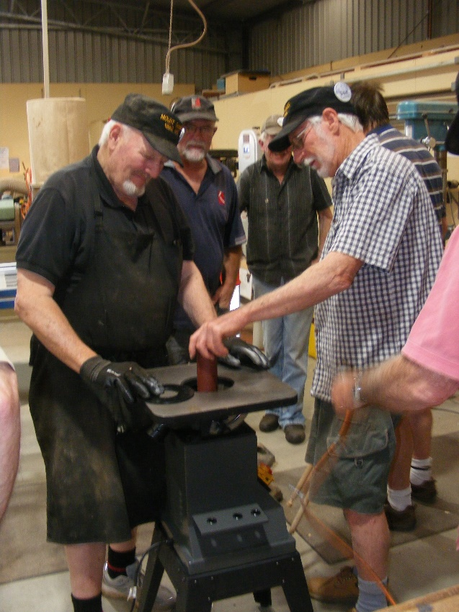

New sander being installed by Don and Allen while everyone else is just watching as per normal.

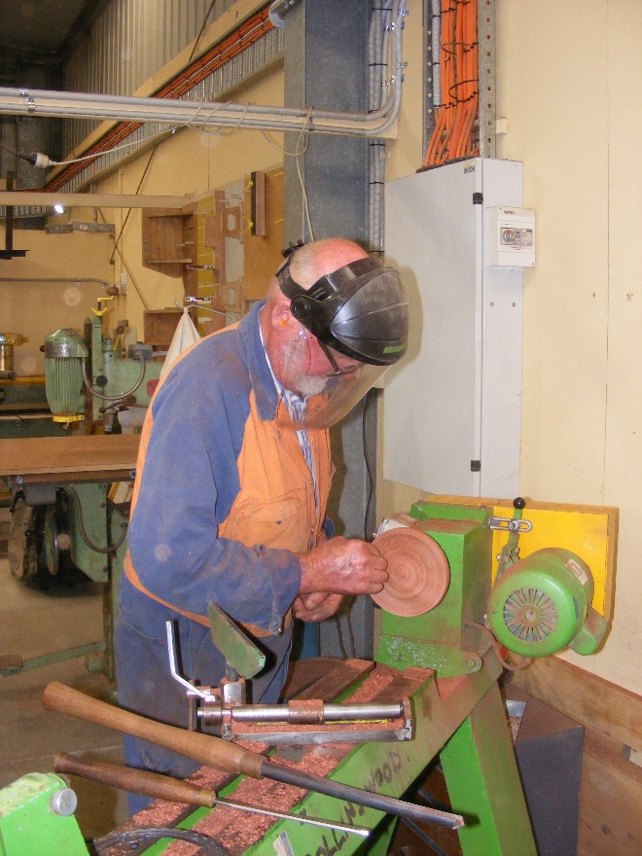

Bruce finishing of a turned plate.

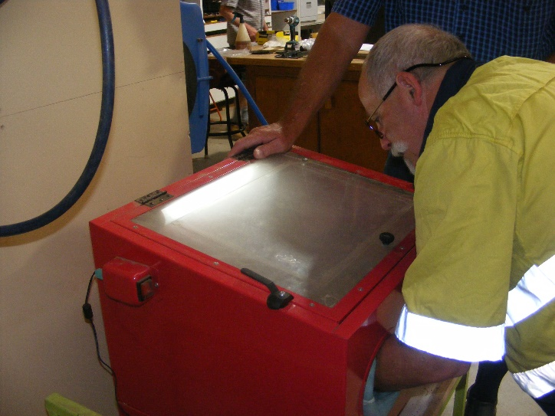

The small sand blaster is getting a bit of use from Andrew.

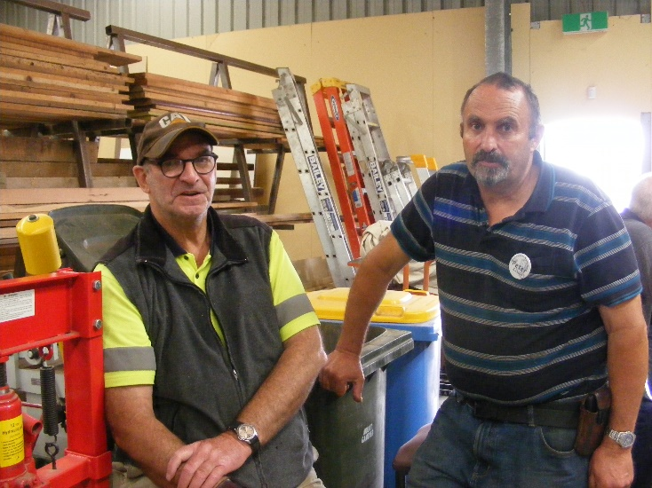

Not much work going on here with Dave and Peter. Better start on another of those picnic tables Dave.

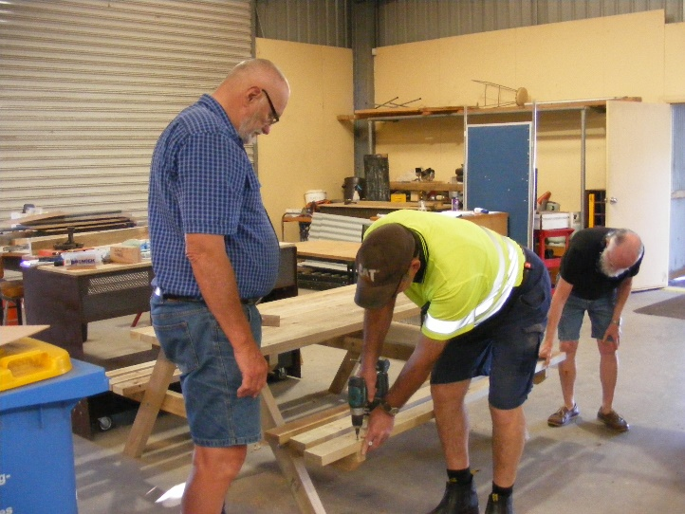

Much better Dave just needed someone like Geoff to show you.

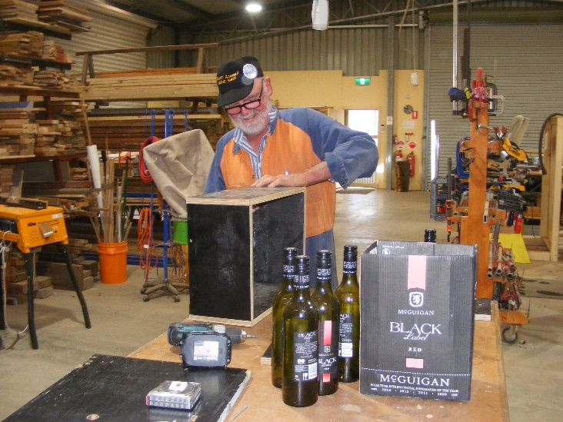

Bruce working on a wine bottle carrier. But rather than share he only bought the empties in.

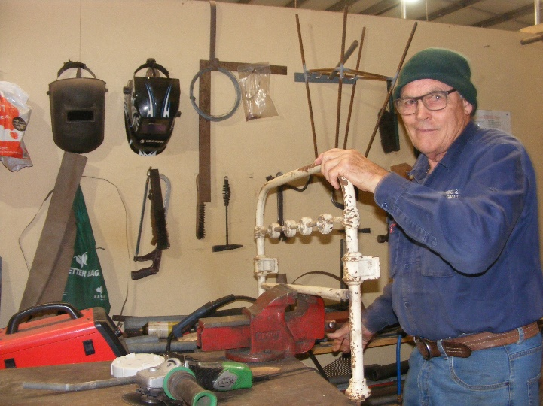

Trevor repairing a wrought iron bed head.



















A husband is someone who, after taking the rubbish out, gives the impression that he just cleaned the whole house.

I hate sex in the movies. Tried it once. The seat folded up, the drink spilled and that ice, well, it really chilled the mood.

Definition of a teenager? God's punishment...for enjoying sex.