[mgmensshed@gmail.com](mailto:mgmensshed@gmail.com)

**EXECUTIVE MEMBERS FOR 2021**

**PRESIDENT**:

**VICE PRESIDENT**: Ben Katris

**TREASURER**: John Plunket

**SECRETARY**: Paul Edgeworth 0887256385

**FACEBOOK**

Shed broadcasts are now available on Facebook

*[Image result for facebook logo](https://www.google.com.au/url?sa=i&rct=j&q=&esrc=s&source=images&cd=&cad=rja&uact=8&ved=2ahUKEwjO9cWTtajeAhUafisKHT6JAHoQjRx6BAgBEAU&url=http://www.seacliffeinn.com/spa-boutique/find-us-on-facebook-logo/&psig=AOvVaw0duNjpvsqixE3Pzu1qEwe2&ust=1540791326821108)*

**Safety: - Remember Safety begins at home.**

**BIRTHDAY”S**

Kevin M 13/3

Jeff R 14/3

Norman C 15/3

Roger T 16/3

Denis M 21/3



**Remember Sugar ‘n Spice support the Men’s shed with Birthday cakes so support them where you can.**

 

**While mentioning our supporters always remember how much Bunnings help our shed, so support them as well when you need a product they can supply for you.**



Thanks Sharp Cranes and Steeline for supporting our Mens Shed.



WHEN YOU BUY FROM A SMALL BUSINESS YOU'RE NOT HELPING A CEO BUY A THIRD HOLIDAY HOME, YOU'RE HELPING LITTLE BOYS AND GIRLS GET DANCE LESSONS OR FOOTY JUMPERS, AND A FAMILY PUT FOOD ON THE TABLE.



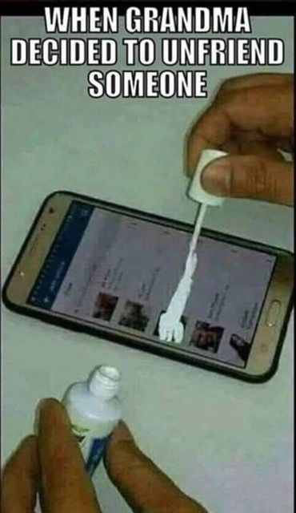



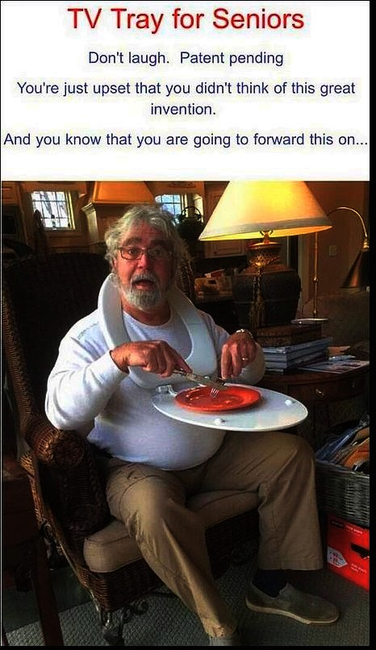

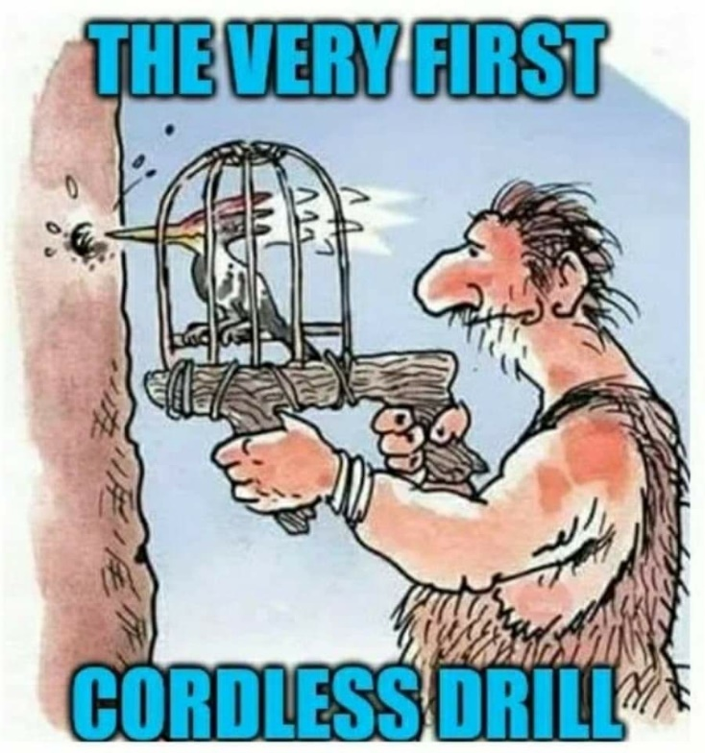

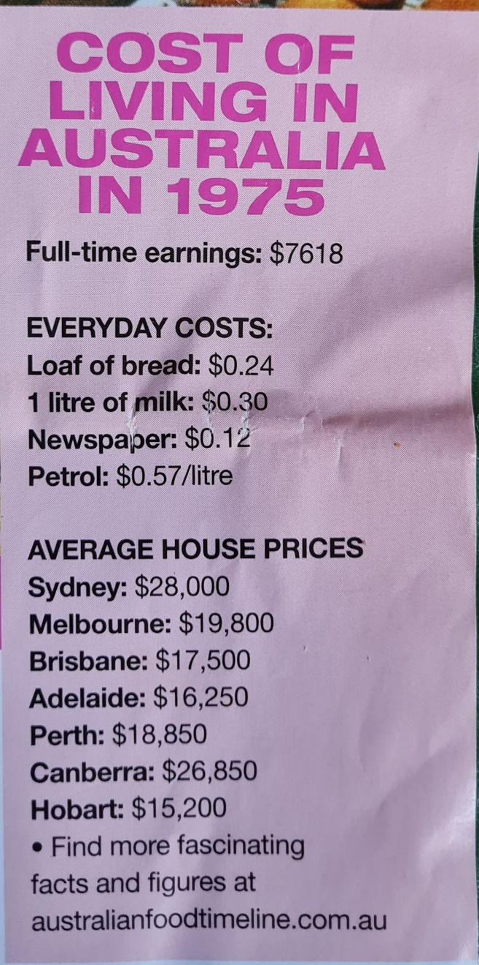

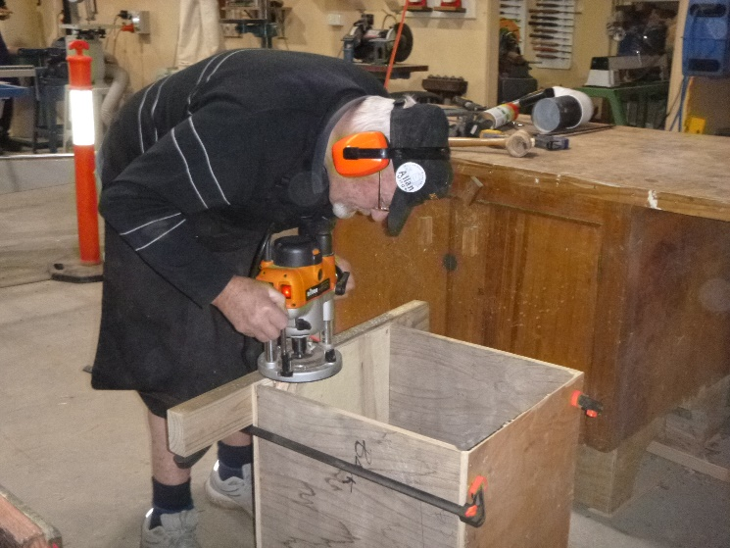

Allan working on his box.

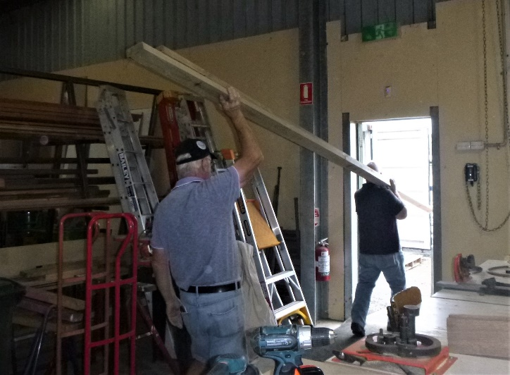

Clear out begins. Tim and Geoff starting to remove timber to the container ready to start moving the Welding bay over to new area.

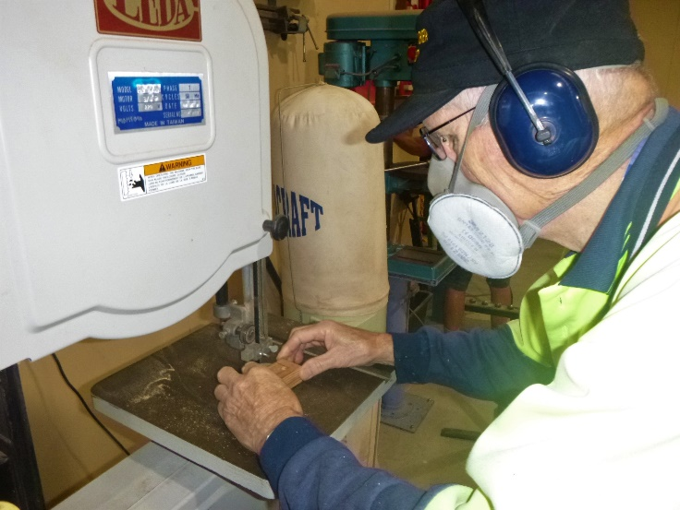

Ian working on an intricate part.

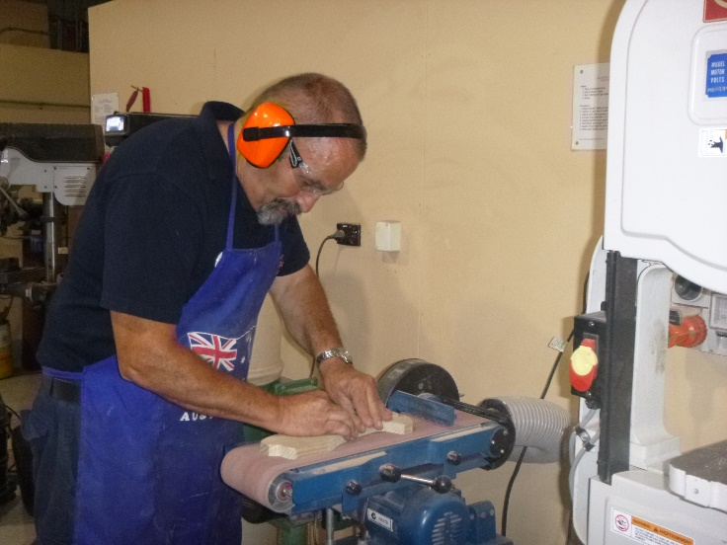

Peter K sanding a toy plane.

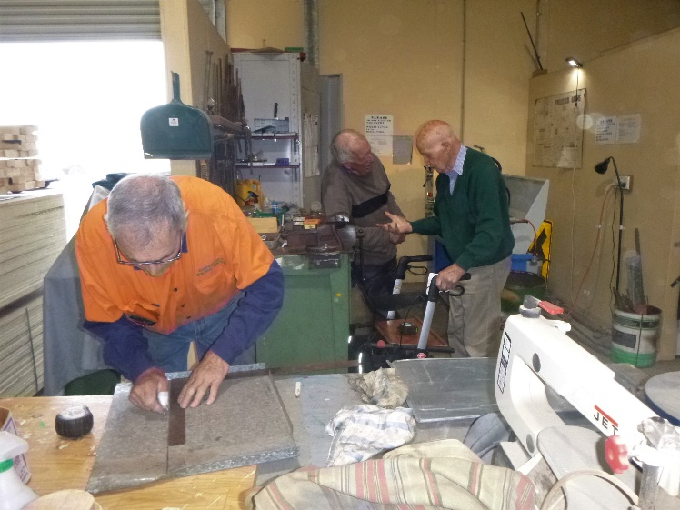

Trevor working on a drip tray for the metal lathe.

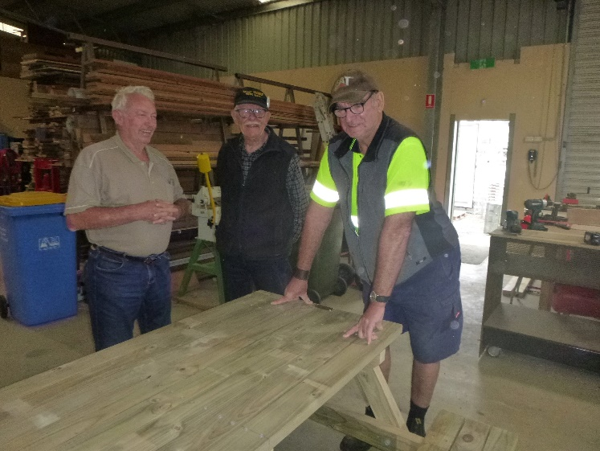

Another picnic table finished is being inspected by Roger, Ray and Dave and ready to go.

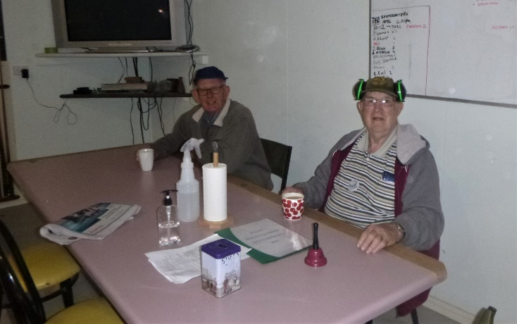

David and Rod having a cuppa.

**NEW PROJECTS/ONGOING**

Wine barrel halves fixed - but not refurbished.

Plastic pods in cages halved for garden beds or as containers – looking for more pods.

Garden beds – orders continuing.

Picnic tables - orders continuing.

Toys already well under way.

Dust extractor funnel.

**DIARY DATES**: 2021

March 2nd Tuesday AGM proxy forms available

March 9th Tuesday (end of day) AGM proxy forms return closes

March 10th Wednesday Tea with partners -6.30 Gourmet India Commercial St East

March 11th Thursday 10.15 AGM

March 11th Thursday (after AGM) New Management Committee meets

March 25th Thursday 10.30 Management Committee meeting

BBQ lunch 11.30 free

March 27th Saturday Garage Sale

April 8th Thursday 10.15 Members Meeting