[mgmensshed@gmail.com](mailto:mgmensshed@gmail.com)

**EXECUTIVE MEMBERS FOR 2020**

**PRESIDENT**: Ansi Nitz 0439816074

**VICE PRESIDENT**: Ben Katris

**TREASURER**: John Plunket

**SECRETARY**: Paul Edgeworth 0887256385

**FACEBOOK**

Shed broadcasts are now available on Facebook

*[Image result for facebook logo](https://www.google.com.au/url?sa=i&rct=j&q=&esrc=s&source=images&cd=&cad=rja&uact=8&ved=2ahUKEwjO9cWTtajeAhUafisKHT6JAHoQjRx6BAgBEAU&url=http://www.seacliffeinn.com/spa-boutique/find-us-on-facebook-logo/&psig=AOvVaw0duNjpvsqixE3Pzu1qEwe2&ust=1540791326821108)* Mens Shed Mount Gambier

Thanks to all Shedders for phoning and emailing others. Remember to keep in touch with those members in facilities’ lockdowns and those in self or required isolation. Check for those needing groceries and other essential supplies and leave them at the door-step

**We know that the Shed is an important part of the week for many of your members, but the health and wellbeing of our community is the priority.** Try to connect with isolated members in other ways – via a phone call, online or drop over any supplies if they may be running short. Every Shedder now has the ‘Contact List’ for every other Shedder either hand delivered (8) or emailed (64). For our mental health and wellbeing please keep in contact with others and stay healthy. We know that there are lots of clusters of Shedders operating outside shed hours so keep these going. Think of those who may not be attached to one and give them a call or send an email.

**We want to see every one back when this is over.**

**BIRTHDAYS**

Glen B 05/06/1953

Andrew K 05/06/1951

Mat J 10/06/1953

Allan C 14/06/1936

Graham P 27/06/1951

**Safety: - Remember Safety begins at home.**

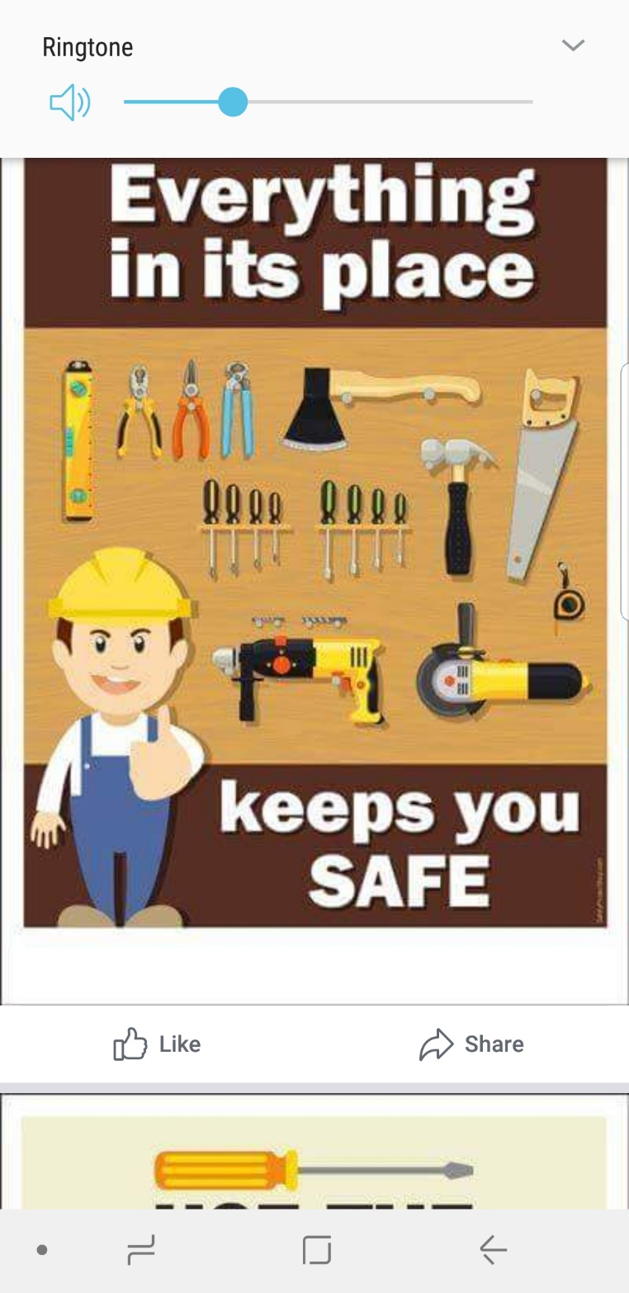



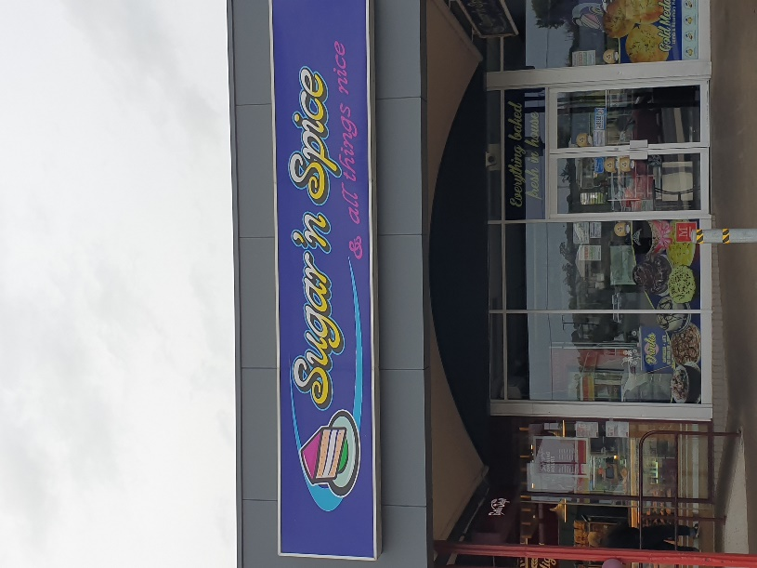

Remember Sugar ‘n Spice support the Men’s shed with Birthday cakes so support them where you can.

Hi all Editor here it is always good to get good feedback for your work, it makes you feel appreciated. Thanks from Peter Heness. To the Mayor Lynette Martin for taking time out of her schedule to read our email and to Colin from Mallala shed.

From: **Mayor Martin** <[MayorMartin@mountgambier.sa.gov.au](mailto:MayorMartin@mountgambier.sa.gov.au)>  
Date: Mon, May 4, 2020 at 11:11 AM  
Subject: Re: Mt Gambier Mens Shed Newsletter May 2020  
To: Secretary MGMS Inc <[mgmensshed@gmail.com](mailto:mgmensshed@gmail.com)>

Dear Gentlemen

I always look forward to your newsletters and none more so than now given COVID-19 and the climate in which we all find ourselves.

It looks as though you are all keeping busy and even achieving jobs around your homes and spending time with your family, which is lovely.

I note that despite some logistical difficulties you are proceeding with the making of toys for the Mayor's Community Christmas Appeal and I wanted to say how grateful I am for your perseverance with this, as I agree that unfortunately this Christmas could see an even greater demand for assistance in our community.

Thank you all, stay safe, stay well and I look forward to when I can enjoy scones with you.

Kind regards

Lynette

|  |  |
| --- | --- |
| **Lynette MARTIN** OAM  MAYOR |  |

Hi Editor, I always enjoy reading your informative newsletter thanks.

**Colin Castanelli Mallala Men's Shed**

Community Development Grant Mt Gambier City Council

From something Ian Bond found last Monday and with Timothy Clarke's interpretation of the background information supplied, the Management Committee decided to apply for a grant which needed to be submitted by Friday 29th May. (4 days away)

It was a 'minor' Community Development Grant offered by the City Council to support businesses and work in the community.

The Management Committee chose to apply for a 20' shipping container to relieve some of the congestion in the workshop area as well as to be able to better manage Covid-19 restrictions.

The application was lodged in the morning and the grant was approved late in the afternoon.

Our thanks have been conveyed to Ash, the Administration Officer who assisted in the process, and the CEO Andrew, who approved it and Council for offering the grant.

We are engaging local companies SW Freight and Sharps Cranes with the transport and lifting and our Shedders will do the fit out.

We still have to lodge a Development Plan with council for the shipping container's location.

Wel done all Shedders involved.

**JOKES**



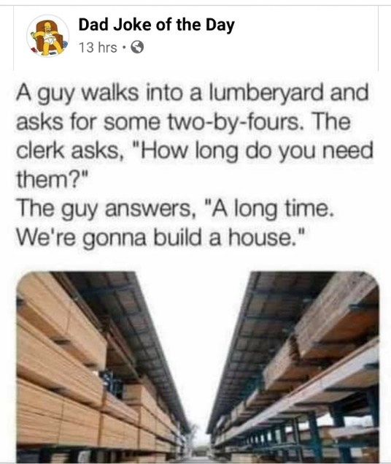



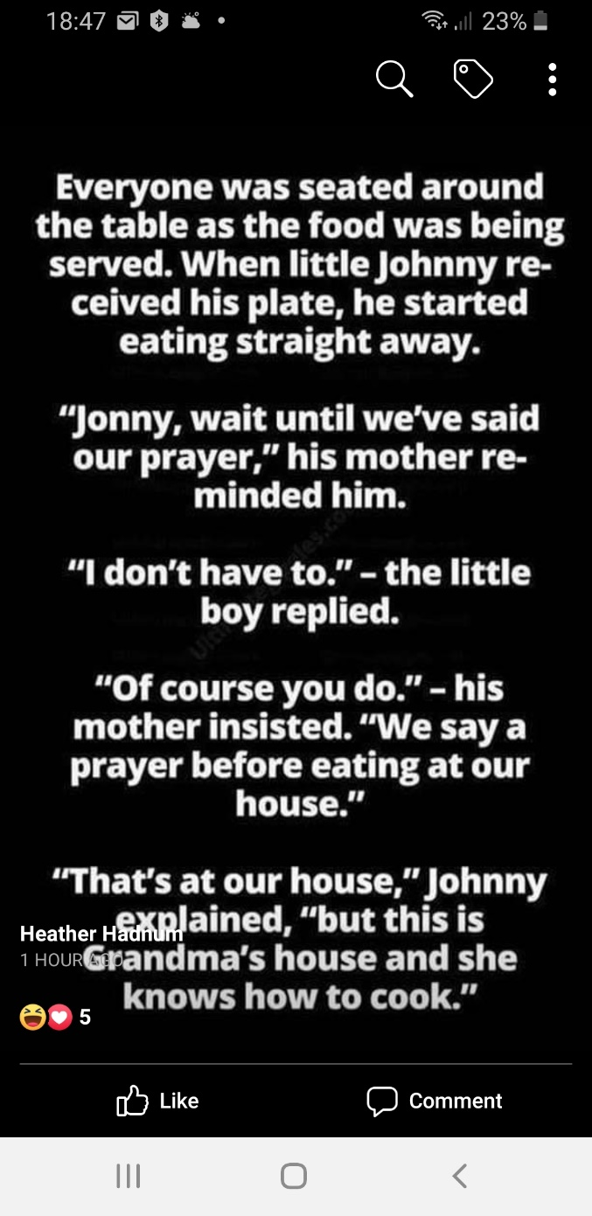

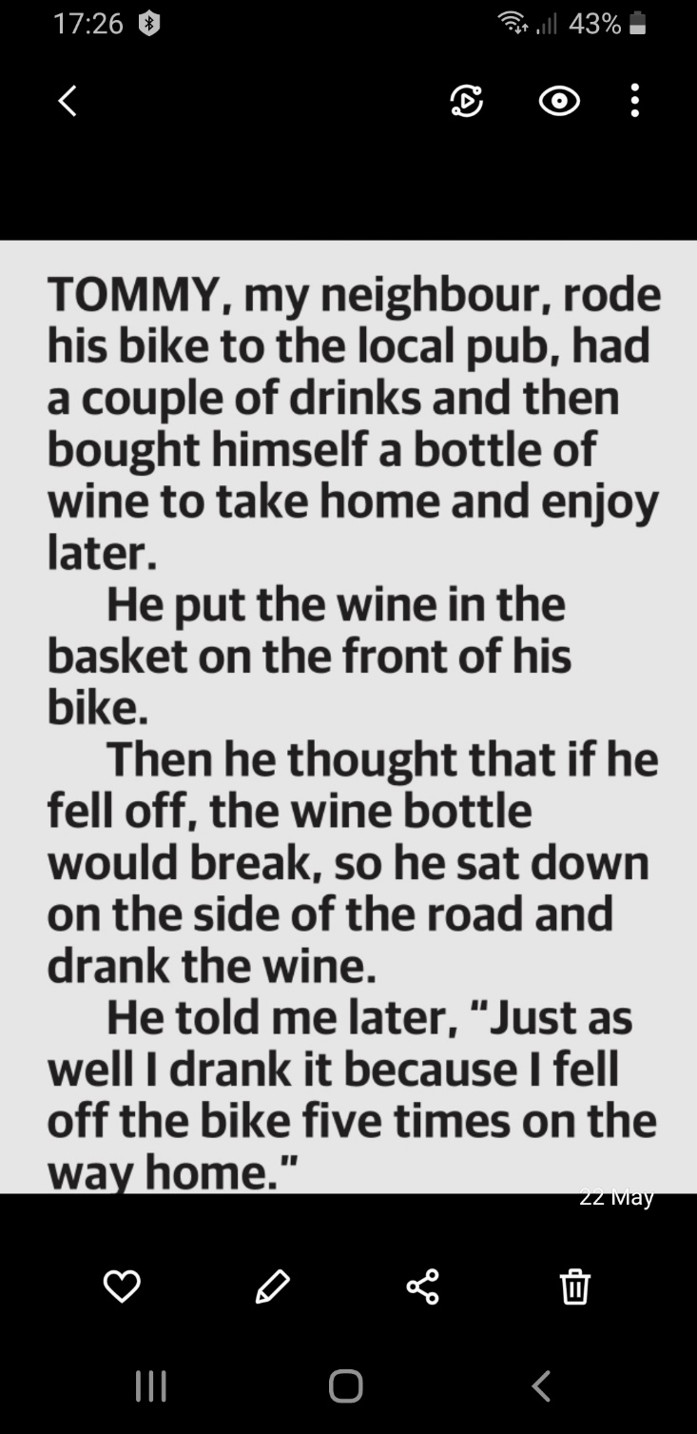

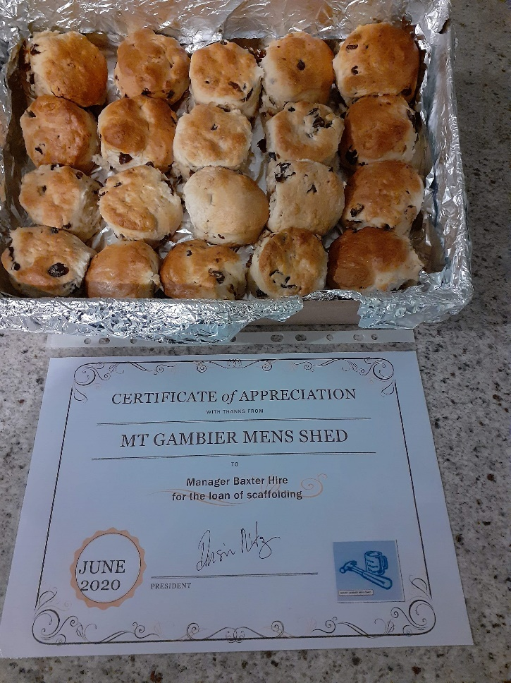

Ben K looking after the shed interest pity we can’t enjoy ourselves.

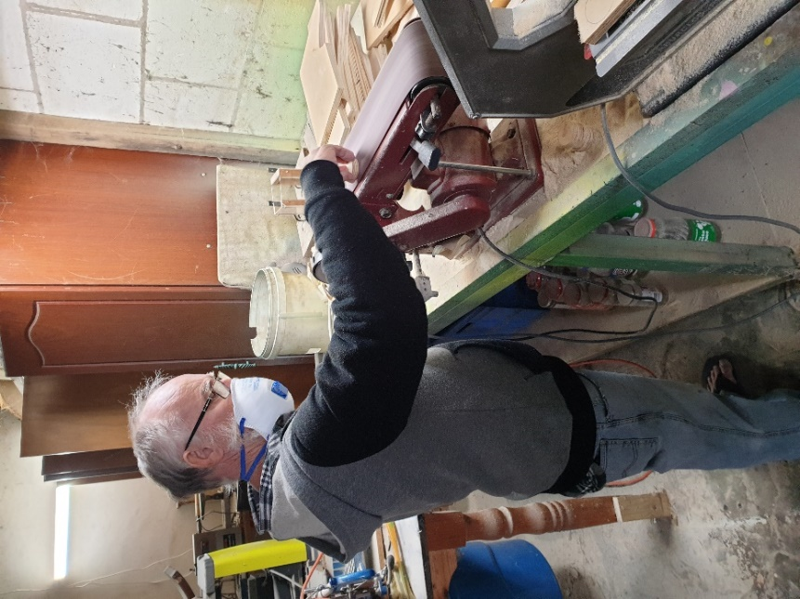

Glen helping with toy making.

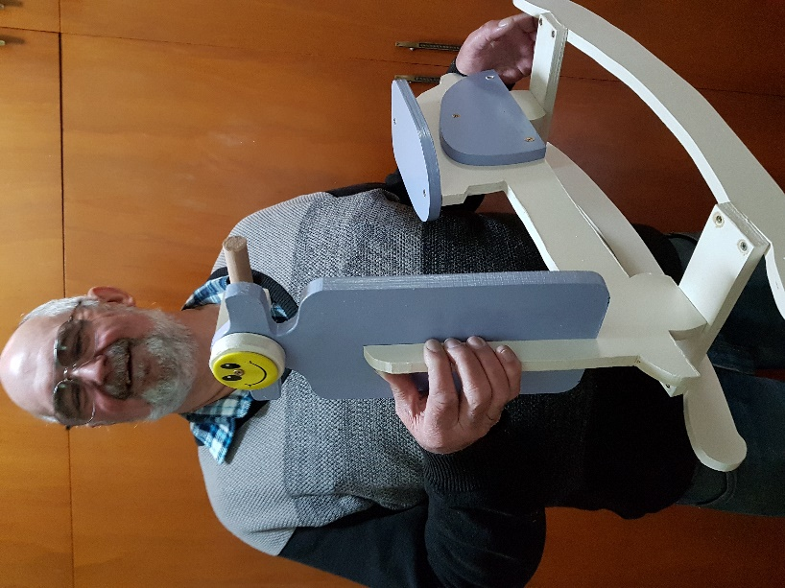

Top and below some of the new toys.

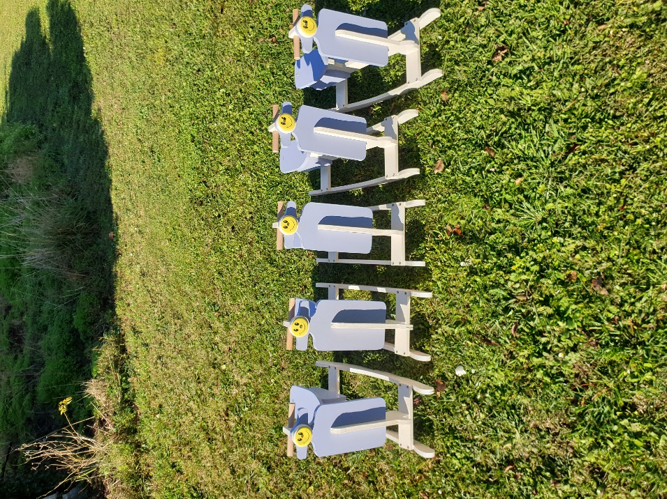

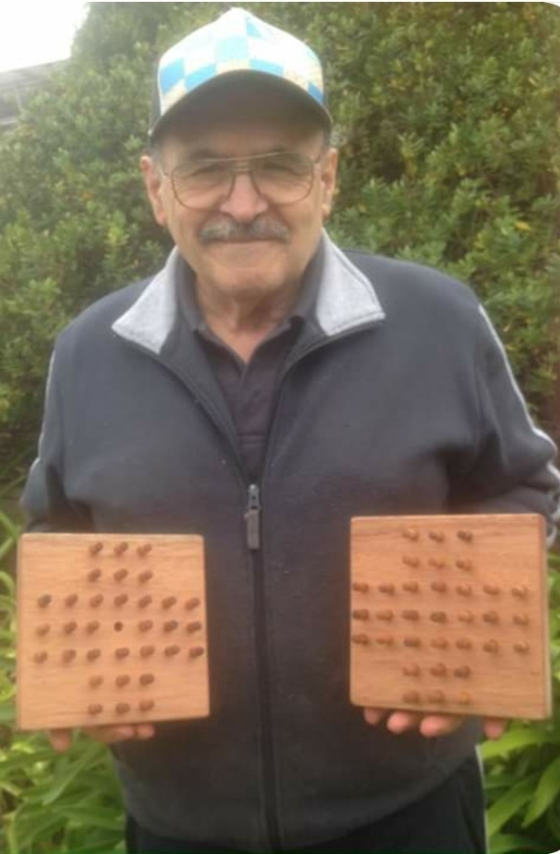

Ben with two of his 10 solitaire games he made.

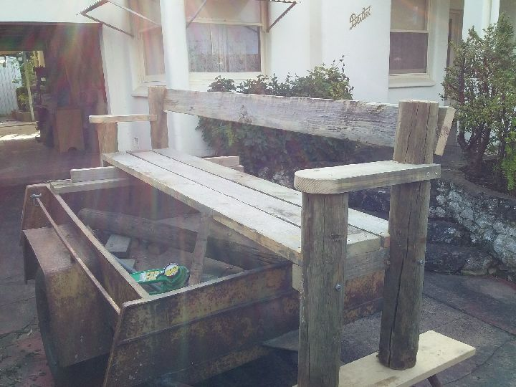

Trevor with the outdoor seat he has made for his daughter.

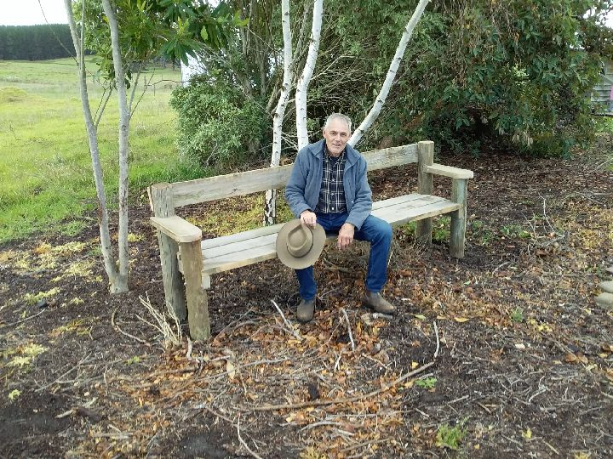

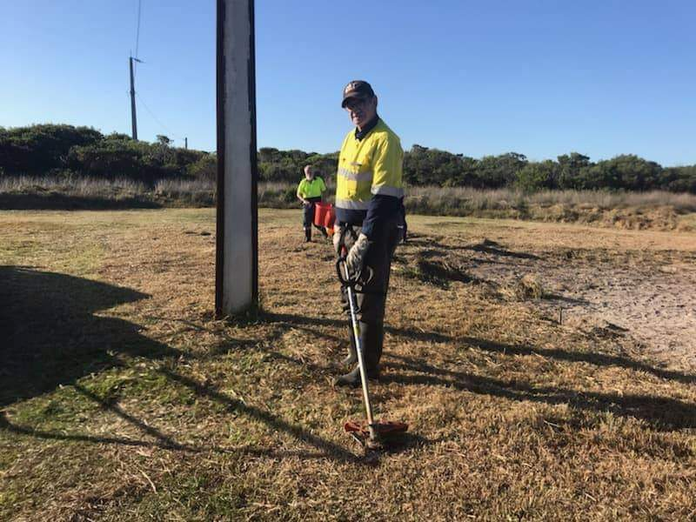

Dave working at Cape Douglas

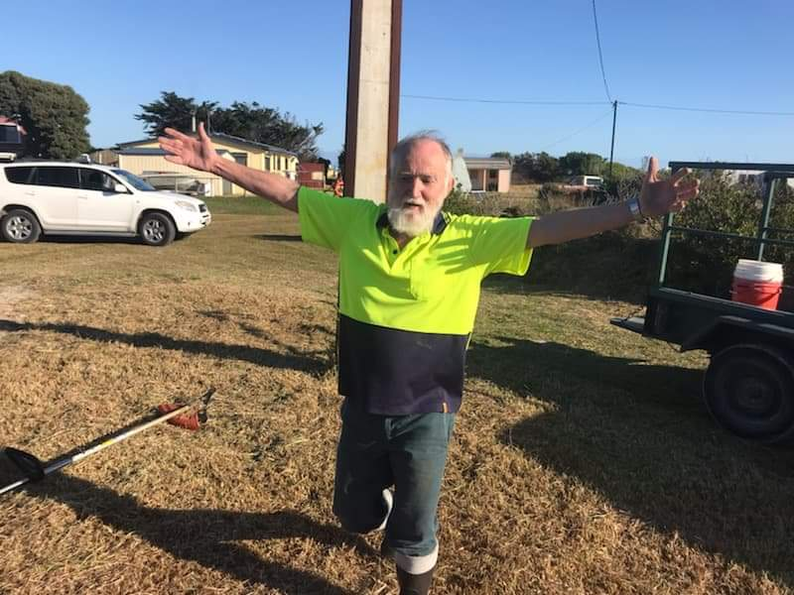

Glen also working at Cape Douglas. Bragging about how big the snake was that he saw.

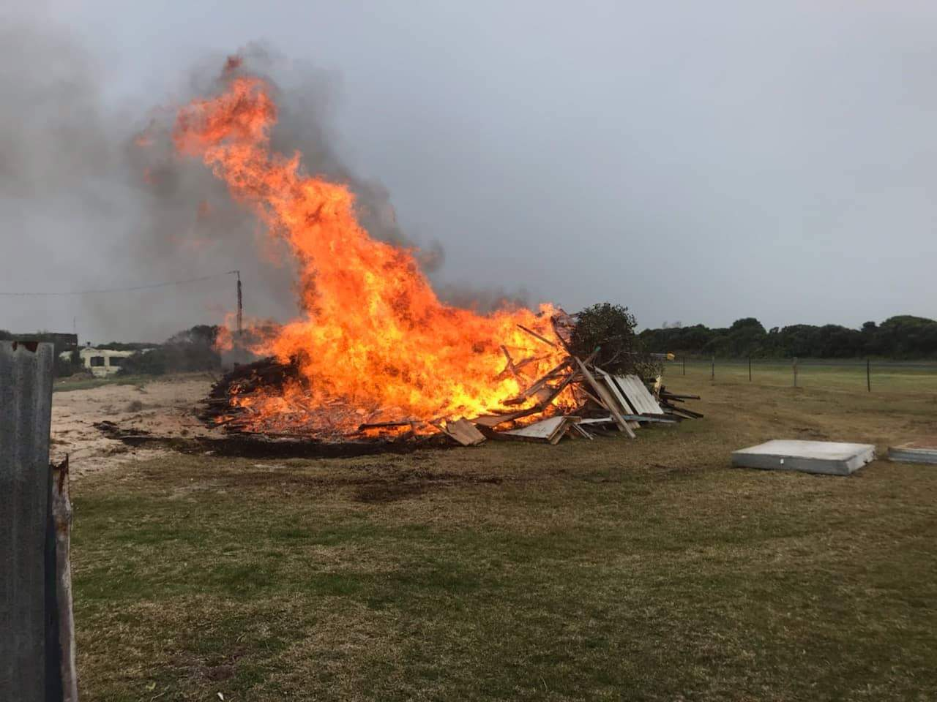

All cleaned up now the big bon-fire.

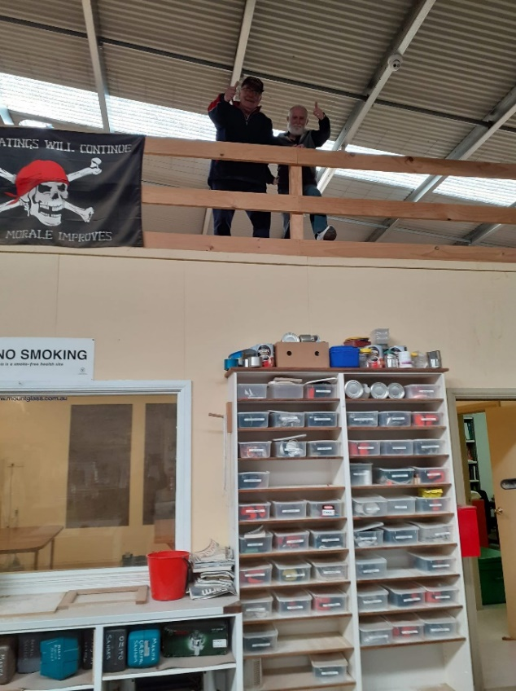

Couple of cheeky monkey’s in the loft, Ansi and Glen

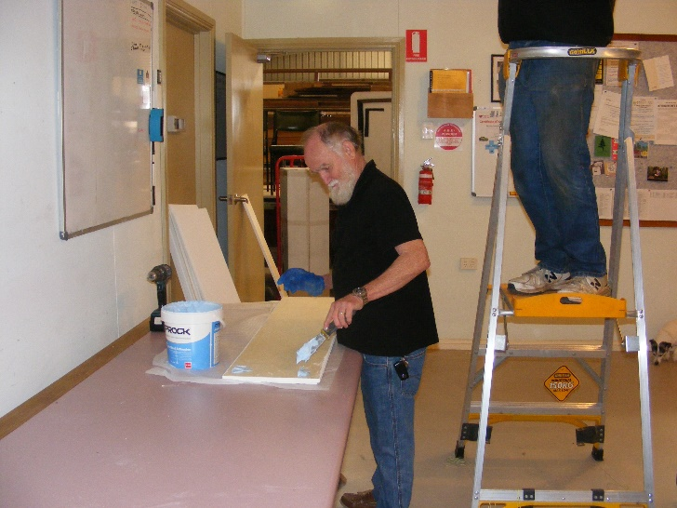

Above and below Glen and Bruce putting glue on sound proof ceiling bats.

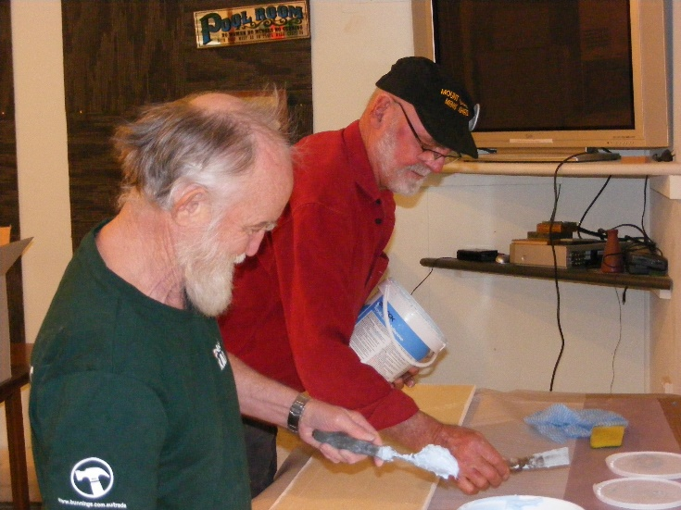

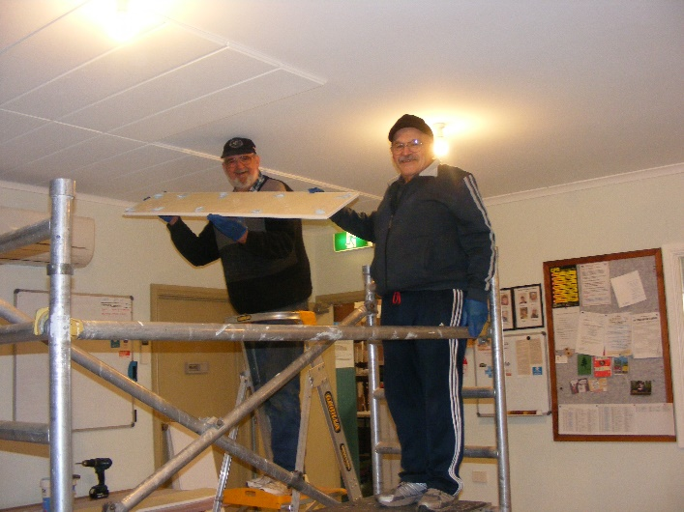

Next 4 photos are Peter, Ben, Glen and Dave putting up the sound proof ceiling bats.

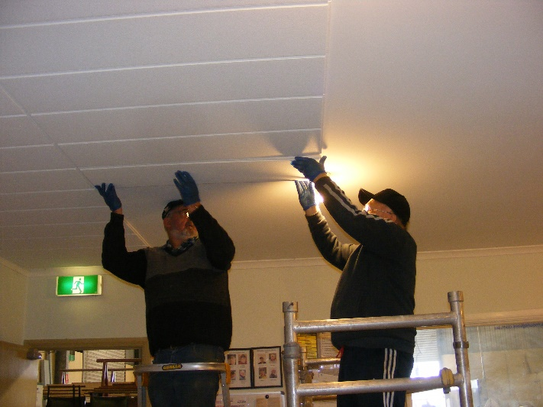

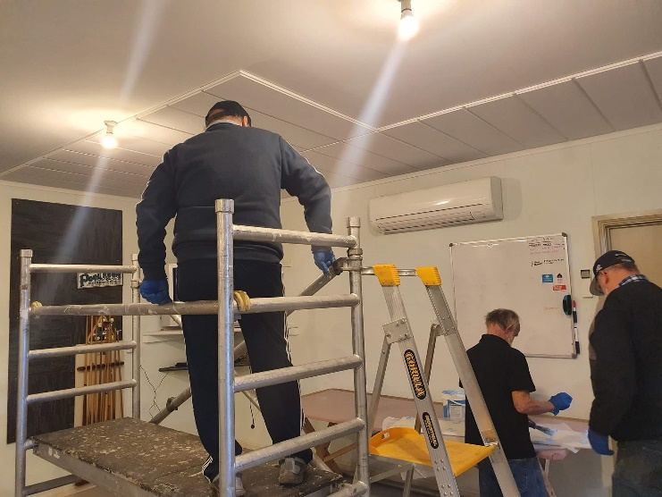

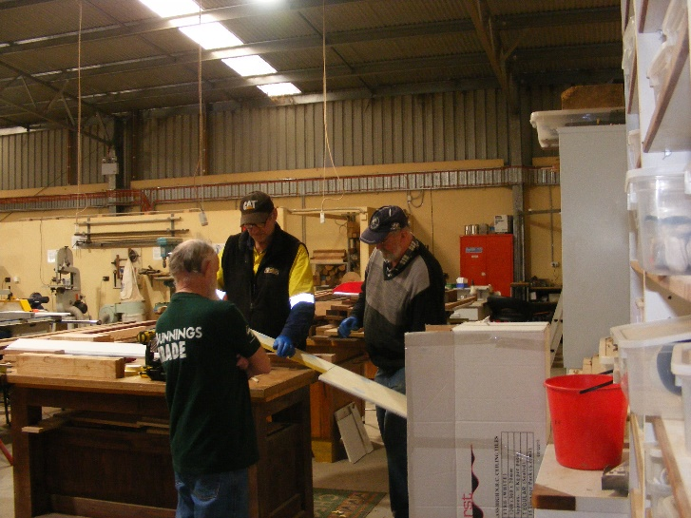

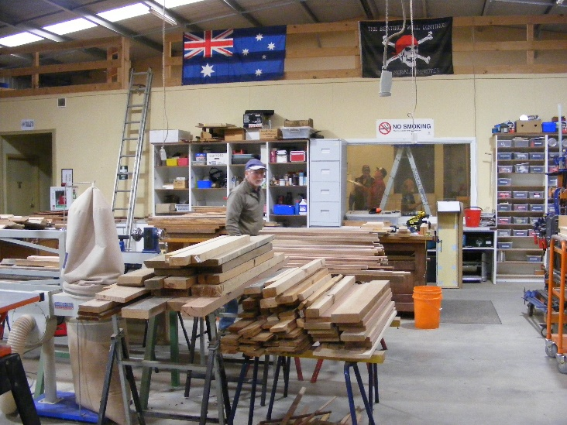

Don sorting out timber.

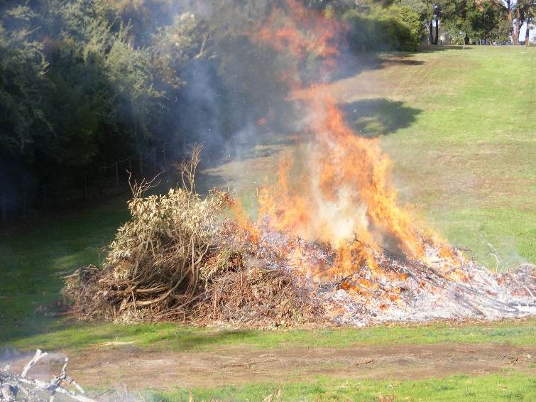

Paul has been piling up and burning his fire heap.